OPERATING SYSTEM

WINDOWS 10

LEC.5

What each of the following operations used for?
- Ctrl+ A : select all
- Ctrl + S : save as
- Fn + F2: rename
- Ctrl + Z : undo
- Shift + windows+S: screenshot
- Ctrl + C: copy
- Shift + ALT: changed language
- Shift + delete: final delete
- Ctrl + x: cut
- Shift + F4: shotdowm
- Ctrl + v: pasts
- Alt + P: view information the folder
- ctrl + shift + N: New Folder

shutdown 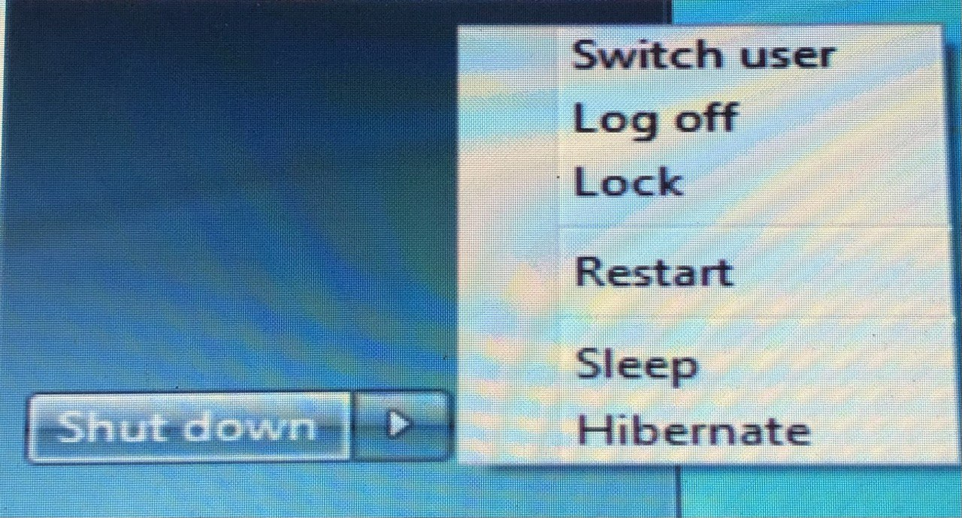

shuutdown

1-Hibernate mode is very similar to sleep, but instead of saving your open documents and running applications to your RAM, it saves them to your hard disk. This allows your computer to turn off entirely, which means once your computer is in Hibernate mode, it uses zero power. Once the computer is powered back on, it will resume everything where you left off. It just takes a bit longer to resume than sleep mode does
2- User Switch : keeps programs open behind the window for the user The new one when he logs in until he finishes his work and logs out
3- Off Log Here all programs are closed, but the calculator is kept on.
So that another user can log in to it again.
4- Lock It prevents anyone from entering except for the person who has the password
5- Restart which turns off the calculator and then restarts it
6- Down Shut so that all programs close and stop working.
7- Sleep Here the operating system saves the working interface and remains in a sleep state.

USER ACCOUNT MANAGEMENT
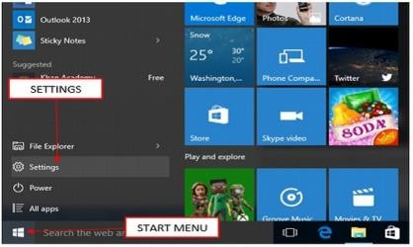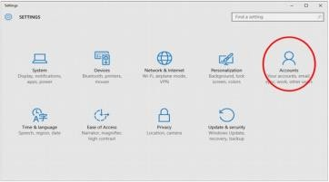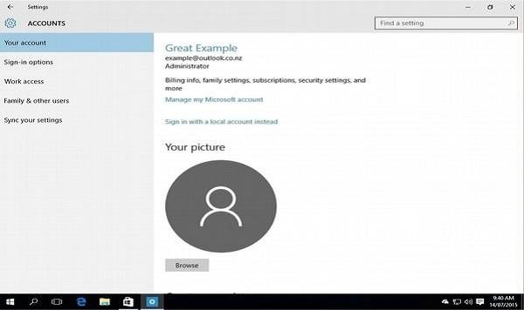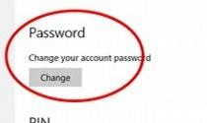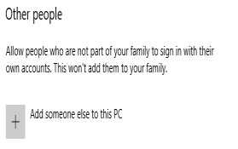3
- Step 1 − Open the Start Menu. 2
- Step 2 − Click on Settings.
- Step 3 − From the SETTINGS window,
1
choose Accounts option.
- Step 4 − In the ACCOUNTS window, choose the
account setting you want to configure. If you want to change your sign-in options, like your password,
4
select Sign-in options. 5
- Step 5- To add new account press on Family& other 6
users then, add someone else to this PC

Add New Account Through Control Panel

- 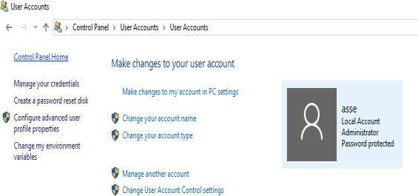Step 1 − Open the Control Panel by searching for it in the Search bar.
3
- Step 2 − After the Control Panel is open, choose User Accounts.
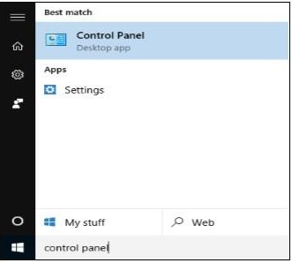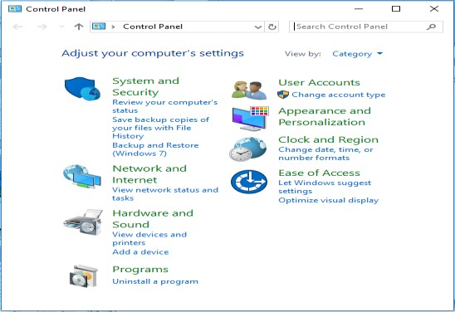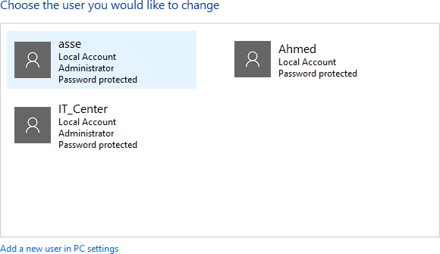
2
1
4

- File Explorer is the file management application used by Windows operating systems to browse folders and files. It provides a graphical interface for the user to navigate and access the files stored in the computer.
- 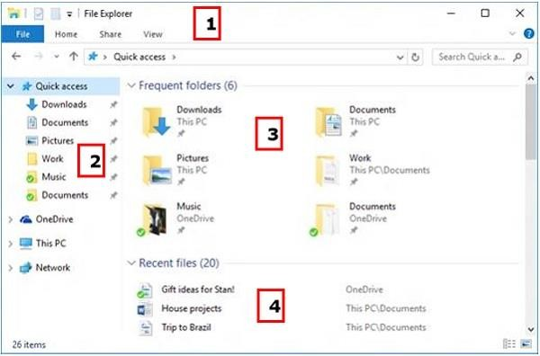The main way to access the File Explorer is by clicking the folder icon in the Taskbar. After clicking the icon, the File Explorer window will open.
The initial File Explorer window is comprised of the following sections −
- The File Explorer ribbon, which resembles the ribbon featured in Microsoft Office. The ribbon contains buttons for common tasks to perform with your files and folders.
- The Navigation Pane gives you access to your libraries of documents and pictures, as well as your storage devices. It also features frequently used folders and network devices.
- The Frequent folders section on the right features the folders you’ve worked with recently to allow for quick access to them.
- The Recent files section in the lower part of the window features files and documents that you’ve opened recently.

THE FILE EXPLORER
This ribbon contains buttons and commands for the most common tasks.
The Ribbon features four tabs, each with different commands. Among the tasks you can perform from the Home tab are −
- Copying and pasting files and folders from one place to another.
- Moving files and folders to another location.
- Copying files and folders to another location.
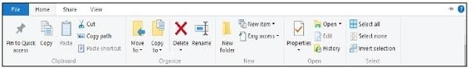
- Deleting a file or folder permanently or sending it to the Recycle Bin.
- Renaming a file or folder.
- Creating a new folder or other new items.
- Verifying or modifying the Properties of a document or folder.
- Opening a file or folder.
- Different options to select one or various files and folders.

The Share ribbon gives you different options to share your files and folders. For example −
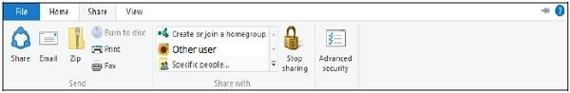
- E-mailing or messaging a file.
- Compressing (“Zip”) a folder to take less space.
- Printing or faxing documents.
- Sharing with other users or networks.
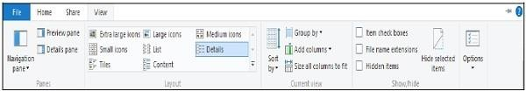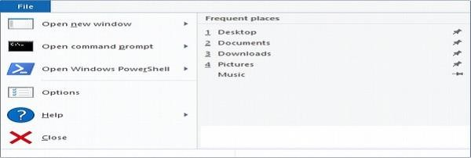The View ribbon allows you to change the way Windows displays your files and folders. Some of the changes you can make here are −
- Adding additional panes to show a preview or details of your files.
- Changing the layout of the files and folders from icons to list, and o
thers.
- Sorting and arranging the contents of your folder.
- Hiding selected folders or files.
The File tab opens a menu with different options like −
- Opening an additional File Explorer window.
- Opening command windows for advanced users.
- Changing or configuring options about how File Explorer behaves
.

APPS MANAGEMENT

How To uninstall app?
- There are three ways in which you can remove an unwanted application −

From the Start Menu
- From the Settings window

From the Control Panel

- 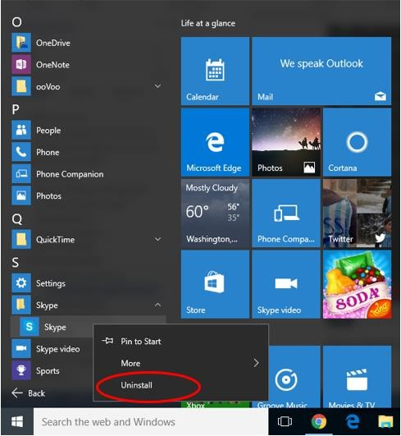Uninstalling an Application from the Start Menu

APPS MANAGEMENT

Step 1 − Open the Start Menu
- Step 2 − Find the application you want to

uninstall on the list, and right-click on it.
- Step 3 − On the menu, choose Uninstall. After this, follow the steps needed to complete the process. These steps will vary for each application.

APPS MANAGEMENT
- Uninstalling an Application from the Settings
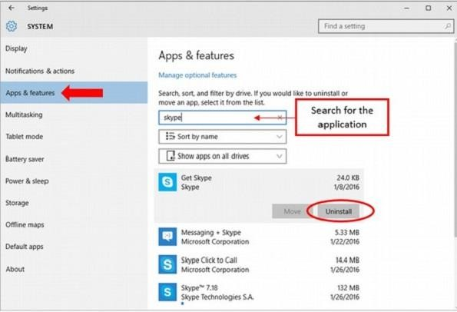
window
- Step 1 − Open the Start Menu and click Settings.
- Step 2 − On the SETTINGS window, choose System.
- Step 3 − On the SYSTEM window, choose Apps & features.
- Step 4 − On the Apps & features window, search for the application you want to uninstall in the search box.
- Step 5 − From the results, click on the
application and choose Uninstall.

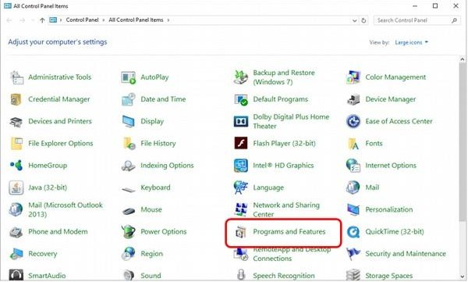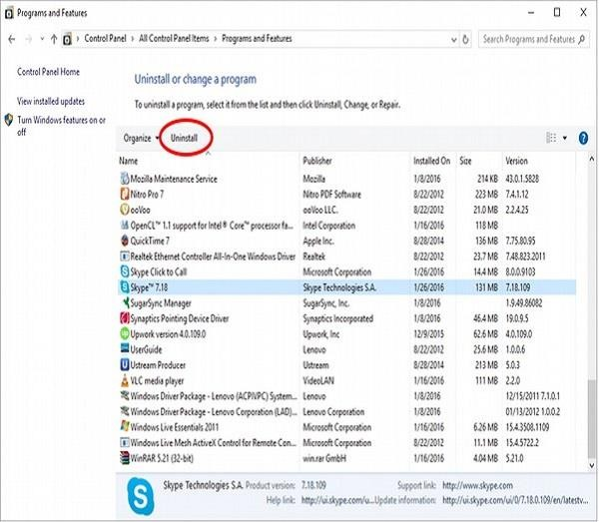

APPS MANAGEMENT

- Uninstalling Applications from the Control Panel
- Step 1 − Open the Control Panel by searching for it in the Search bar.
- Step 2 − After the Control Panel is open, choose Programs and Features.
- Step 3 − The Programs and Features window will present a list of all the applications installed in your computer. To uninstall an application, just click on it and use
the Uninstall button.
- An alternate way is to right-click the application on the list.
- This window also gives you other details about the applications you have installed like −
- The date it was installed.
- The size it occupies on the hard disk.
- The specific version of this application.

