

Radiology Techniques Department

The Radiological Anatomy

Lecture 1

Vertebral Column

By
MS.c Zeyad Tareq & MS.c Salman Mohammed

3rd Stage

Spine Terminology
In medical English, some doctors and texts refer to the dorsal spine, D-spine and D1-D12, however, we discourage this usage on Radiopaedia preferring thoracic spine, T-spine and T1-T12. This is consistent with Terminologia Anatomica, which solely employs the thoracic designator to refer to this part of the spine. However, in French-speaking parts of the world, D1-D12 are commonly used interchangeably with T1-T12

Gross anatomy of Vertebrae
Vertebrae, apart from those that are atypical, have a similar basic structure which can be described as an anterior vertebral body and a posterior neural (or vertebral) arch. These basic characteristics vary depending on the function of each individual vertebra.
The vertebral body is the large anterior cylindrical portion that is predominantly responsible for bearing the weight of the spine and body above it. The size of the vertebral bodies increases down the spine as the size and weight of the body it has to support above it increase. Each vertebra articulates with the vertebrae above and below it via an intervertebral disc.
The neural arch is comprised of the bone posterior to the vertebral body which has several individual components that are fused to form a ring (the vertebral foramen) that encloses the spinal canal.
- The spine of the fetus is flexed in a smooth C shape. This is referred to as the 'primary curvature' and is retained in the adult in the thoracic and Sacro coccygeal areas. Secondary extension results in lordosis-known as the 'secondary curvature' of the cervical and lumbar spine.
A typical vertebra
- The vertebral column has 33 vertebrae 7 cervical, 12 thoracic, 5 lumbar, 5 sacral (fused) and 4 coccygeal (fused) vertebrae.
- A typical vertebra has a vertebral body anteriorly and a neural arch posteriorly.
- The neural arch consists of pedicles laterally and of laminae posteriorly.
- The pedicles are notched superiorly and inferiorly so that adjoining pedicles are separated by an intervertebral foramen, which transmits the segmental nerves.

- There are 31 segmental spinal nerves: - 8 cervical, 12 thoracic, 5 lumbar, 5 sacral and 1 coccygeal
- A transverse process arises at the junction of the pedicle and the lamina and extends laterally on each side.
- The laminae fuse posteriorly as the spinous process. Articular processes project superiorly and inferiorly from each lamina.
- Articular facets on these processes face posteriorly on the superior facet and anteriorly on the inferior facet.
- The part of the lamina between the superior and inferior articular facets on each side is called the pars inter articular.
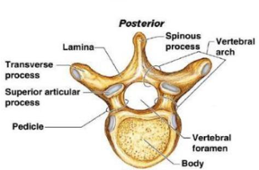
The cervical vertebrae

The atlas-C1
- The atlas has no body as it is fused with that of the axis to become the odontoid process.
A lateral mass on each side has a superior articular facet for articulation with the occipital condyles in the atlanto-occipital joint, also an inferior articular facet for articulation with the axis in the atlantoaxial joint.
- The posterior arch is grooved behind the lateral mass by the vertebral artery as it ascends into the foramen magnum.

The axis -C2
- The odontoid process, which represents the body of the atlas, bears no weight.
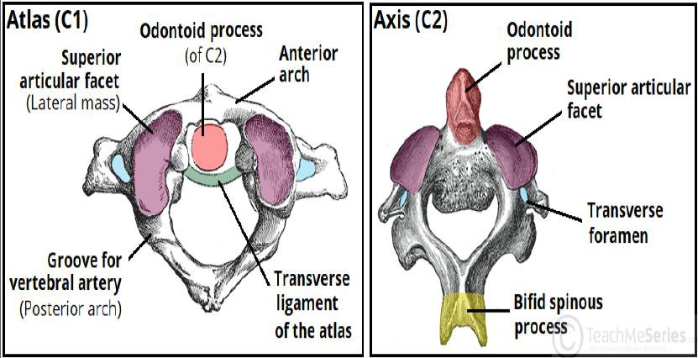
- Like the atlas, the axis has a large lateral mass on each side that transmits the weight of the skull to the vertebral bodies of the remainder of the spinal cord.

The vertebra prominens-C7
- This name is derived from its long, easily felt, non-bifid spine.
- Its foramen transversarium’s small or absent and usually transmits only vertebral veins.
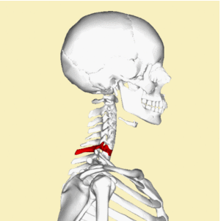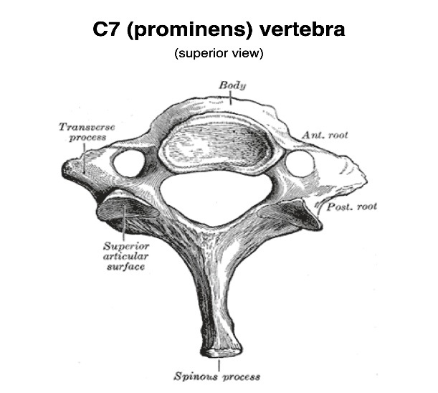

The thoracic vertebrae
- The thoracic spine (often shortened to T-spine) forms the middle part of the vertebral column. It extends from below C7 of the cervical spine to above L1 of the lumbar spine. There are 12 thoracic vertebra, termed T1-T12.
- The thoracic spine is unique due to its articulation with ribs via costal facets. The ribs restrict the movement of the thoracic spine somewhat. The thoracic spine is otherwise the most mobile of all spinal column segments.

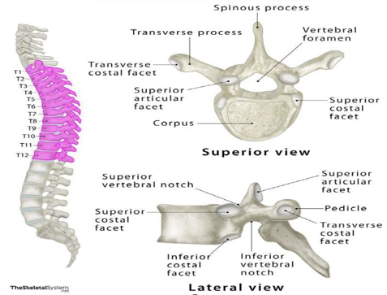

The lumbar vertebrae
- These have larger vertebral bodies and strong, square, horizontal spinous processes.
- The transverse processes of the upper four lumbar vertebrae are spatulate and increase in size from above downwards.
- The transverse process of the fifth lumbar vertebra is shorter but strong and pyramidal.

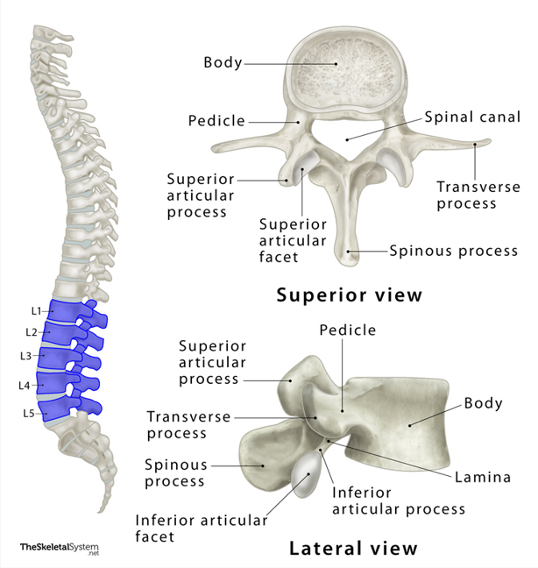

The sacrum vertebra
  - This is composed of five fused vertebrae.
  - It is triangular in shape and concave anteriorly.
  - At each end of the transverse ridges, are the four anterior sacral foramina.
  - Diminishing in size in line with the smaller vertebral bodies.

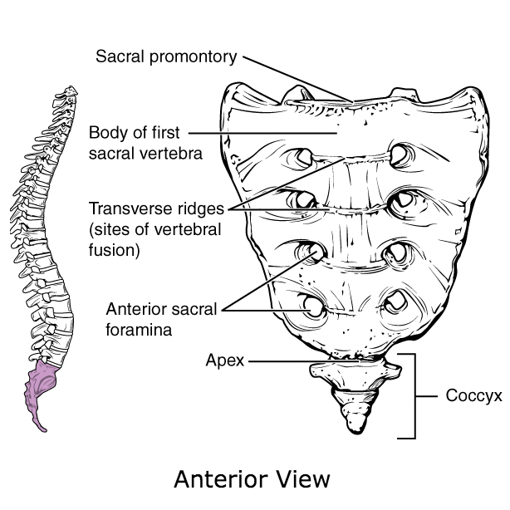
The coccyx vertebrae

- The coccyx is formed from four rudimentary vertebrae and does not contain a spinal canal, pedicles, laminae or spinous processes.
- The first segment is the largest, and the subsequent are smaller in size.
- Structure of the coccygeal vertebral junctions is variable and age-related, ranging from fully developed to rudimentary intervertebral discs with varying degrees of cystic or fibrotic change, to fusion of the vertebrae in the later decades.

