
The Islamic University
Department of Medical Laboratory Techniques
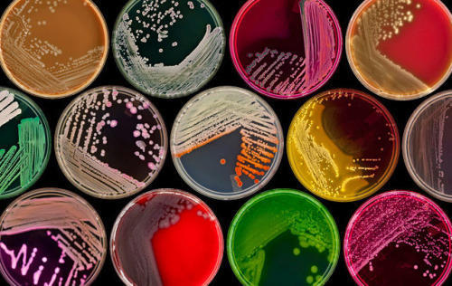practical microbiology
M.S.C. Dhuha Haider

Second Class

Lab.1 : Instructions in the lab
1) Lab coat should be worn before the entry to the lab over street clothes and remove before leaving
2) In typical way, laboratory workers should wear goggles, mask and gloves.
3) Do not eat, drink or smoke inside the lab, these should be done in isolated room or rest room.
4) Do not bite the nail or put the pen into the mouth.
5) Do not mouth pipette, rubber teat or mechanical pipette should be used.
6) Assume that patients are infectious for HIV or blood borne disease.
7) Wash the hands thoroughly after removing the gloves or if there is any contamination

Essential requirement of microbiological laboratory
Equipment used for sterilization
Autoclave
The autoclave is an example of moist heat sterilization. The primary purpose of the autoclave is sterilizing culture media and laboratory supplies. Saturated steam under pressure above 100℃ is used for sterilization in autoclaves.
Hot Air Oven
A hot air oven applies dry heat for sterilization. Its main application is sterilizing glassware like pipettes, flasks, metallic instruments, and scissors.
Incinerator
An incinerator is the best way to discard those dangerous waste. Incinerators use heat to eliminate solids; powder, pastes, pills, sludges, liquids, boxes, and tubes.

Instruments for Culture and Identification
Analytical Balance
An analytical balance measures the precision in determining the mass of solid objects, powders, and granular substances.
Biological Safety Cabinets
A Biological Safety Cabinet (BSC), also known as a Biosafety Cabinet is mainly used for handling pathogenic biological samples or for applications that require a sterile work zone.
Bunsen Burner
The Bunsen burner is a gas burner that uses dry heat to sterilize materials. The materials are heated by holding them almost vertically in the flame until red hot.

Centrifuge
A centrifuge is a laboratory device that helps separate fluids, or liquid-based on their density. The spinning of a vessel containing material at high speed helps achieve the separation.
VITEK 2 Compact system
uses disposable cards. One card is required for identification of one bacteria. So enabling the identification of several bacteria at a time.
Colony Counter
A colony counter is a machine that automatically counts colonies in the agar plate in the microbiology laboratory.
Gel Electrophoresis Apparatus
Electrophoresis is a process that separates nucleic acid and protein-based on their size and charge.
Hot Plate
A hot plate provides heat to solutions and materials uniformly. It is much safer than a Bunsen burner because an open flame is not present in the hot plate.
Incubator
An incubator is an instrument that provides the desired temperature for in vitro culture of microorganisms.
Laboratory Freezer
A Laboratory freezer is used to store samples, specimens, and other materials at -10℃ to -30℃. whereas ultra low-temperature freezer can freeze samples to almost -80℃.
Microscope
Microscope used to examine objects that are too small to be seen by the naked eye.
Micropipette
Micropipettes are semi-automatic instruments that use disposable pipette tips to withdraw and dispense the liquid sample.
PCR Thermocycler
Thermocyclers are the instrument that helps in amplifying DNA and RNA samples by the process of polymerase chain reaction (PCR).
pH Meter
A pH meter measures the acidity/alkalinity of the solution.
Refrigerator
The refrigerator provides a low-temperature environment. The use of refrigerators is to store cultures, media prepared, blood, serum, antibiotics, and other chemicals.
Vortex Mixers
A vortex mixer mixes laboratory samples in test tubes, well plates, or flasks.
Water Bath
A water bath is an instrument that provides constant temperature to a sample.
Instruments for Antibiotic Susceptibility Testing
Antibiotic Disc Dispenser
The antibiotic disc dispenser is the laboratory equipment that helps accurately place the antibiotic disc in the media of choice.
Antibiotic Zone Reader
An antibiotic zone reader is a laboratory instrument that helps to obtain an accurate reading of the diameter of the zone of inhibition of the used antibiotic.
Glassware
Beaker
A beaker is a glass container that has a flat bottom. The use of beakers in a microbiology laboratory is holding or storing liquids.
Conical flask
A conical flask is a cone-shaped flask with a flat round bottom and a cylindrical neck. Its purpose in the microbiology laboratory is to prepare media.
Glass Rods
A glass rod is a piece of laboratory equipment used to mix chemicals and liquids. Measuring Cylinder
A measuring cylinder is an instrument made of glass or plastic used to measure the volume of different liquids.
Microscopic Slide
It is used in staining and observing under a microscope.
Petri Dish
A petri dish is made up of glass/plastic. It is an apparatus in which culture media is poured, providing a suitable environment for the growth of microorganisms.
Test Tube
A standard test tube has high utility in the microbiology laboratory. It helps grow microorganisms by providing an artificial environment, preparing stock cultures, and performing various biochemical tests.
Inoculating Loop and Needle
An inoculating loop and needle transfer microbial growth from one container to another without introducing any unwanted organisms.
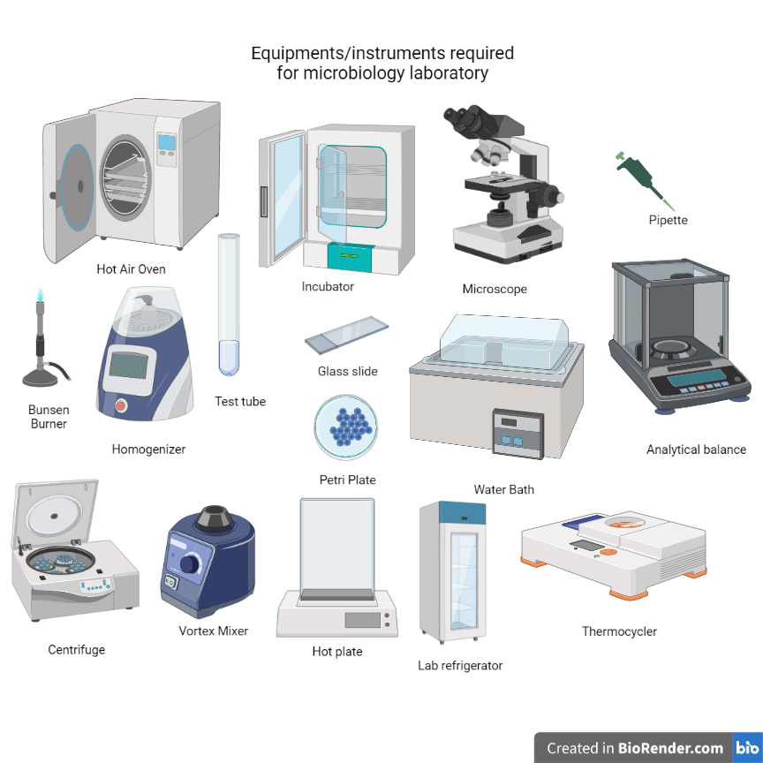
Lab.2 Sterilization & Disinfection
Sterilization: The processes by which all forms of microbial life, including vegetative and spore forming bacteria are destroyed or killed.
Disinfection: The processes that result in the destruction of only the vegetative forms of microbial life (pathogenic organisms) but not spores .
Antisepsis: Destruction or inhibition of microorganisms on living tissues by chemicals (non-toxic and non-irritating) known as Antiseptics .
Bacteriostatic : is a condition where the multiplication of the bacteria is inhibited without killing them.
Bactericidal : is that chemical that can kill or inactivate bacteria. Such chemicals may be called variously depending on the spectrum of activity, such as bactericidal, virucidal, fungicidal, microbicidal, sporicidal, tuberculocidal or germicidal.
Antibiotics : are substances produced by one microbe that inhibits or kills another microbe. Often the term is used more generally to include synthetic and semi-synthetic antimicrobial agents.
Importance of sterilization and disinfection:
1. Safety of laboratory workers and patients.
2. Accuracy and validity of microbiological tests.
Methods of sterilization and disinfection:
There are several methods of sterilization and disinfection. They are very broadly classified into physical and chemical methods .Figure ( )
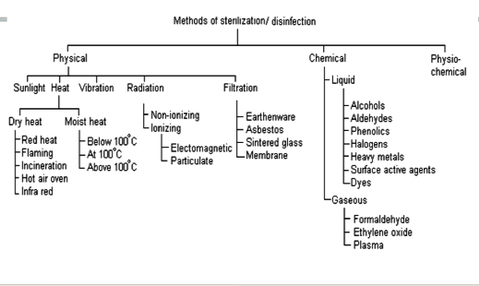

Methods of sterilization:
- Physical Sterilization (by sun light , heat, filtration or radiation):
A.Sunlight:
The microbicidal activity of sunlight is mainly due to the presence of ultra violet rays in it. It is responsible for spontaneous sterilization in natural conditions.
B. Heat:
The most effective and a rapid method of sterilization and disinfection is Heat. Excessive heat acts by thickening or clotting of cell proteins. Less heat interferes metabolic reactions. The two most common methods for sterilization
i. Sterilization by Dry Heat
Dry heat : Temperature of 160 degree for 2 h. or 170 degree for 1 h. ( Oven, flaming and Incineration) .
•Red heat : Articles such as bacteriological loops, straight wires, tips of forceps and searing spatulas are sterilized by holding them in Bunsen flame till they become red hot.
• Flaming: The object is passed through flame without allowing it to become red hot, e.g. scalpel. Temperature is not high to cause sterilization. mouth of test tubes, flasks, glass slides and cover slips are passed through the flame a few times. Even though most vegetative cells are killed.
• Incineration :Incineration is the process of sterilization along with a significant reduction in the volume of the wastes. It is usually conducted during the final disposal of the hospital or other residues.
• Infrared radiation : Infrared radiation (IR) is a method of thermal sterilization in which the radiation is absorbed and then converted into heat energy. IR is applicable for mass sterilization of packaged items like syringes and catheters.
ii. Sterilization by Moist Heat
Moist heat sterilization describes sterilization techniques that utilize saturated steam. Moist heat can denature and coagulate the protein. It can cause breakage of DNA strands and loss of functional integrity of cell membrane. Methods include:
• Boiling: Boiling at 100°C is done in a water bath for 30 minutes. By this method Syringes, rubber goods and surgical instruments can be sterilized. The method is effective against all bacteria and some spores.
• Steaming: Moist heat sterilization usually involves the use of steam at temperatures in the range 121–134°C. An autoclave is a device that works on the principle of moist heat sterilization through the generation of steam under pressure.
The 2 common sterilization temp.
a) 121c for 15 min for sterilizing items such as media, liquid and medical instruments.
b) Infectious waste such as unused portion of patients’ specimens, patients’ culture, sharp disposable sharp instruments such as scalpels, needles sterilized at 132 C for 30-60 Min.
• Steam Sterilizer At temperatures below 100°:
Pasteurization- In this process, all non-spore forming microbes are killed in milk by subjecting the milk to a temperature of 63°C for 30 minutes (the holder method) or 73°C for 20 seconds (the flash method).

C. Filtration :

Sterilization by filtration is done mainly for thermolabile solutions. These may be sterilized by passage through sterile bacteria-retaining filters, for e.g. membrane filters (cellulose derivatives, etc.), plastic, porous ceramic, or suitable sintered glass filters, or combinations of these. Filters containing Asbestos should not be used. Normally, the membranes of not greater than 0.22 μm having, nominal pore size is used.

D. Radiation:
Two types of radiation, ionizing and non-ionizing.
- Non-ionizing rays: Rays having the wavelength longer than the visible light are non-ionizing. A high-pressure mercury vapor lamp is used to generate UV rays. UV rays induce the formation of thymine-thymine dimers and eventually inhibit the replication of DNA. UV radiation induces mutations in cells of bacteria, viruses, yeast, etc. When exposed to the effective UV radiation is inactivated within seconds.
- Ionizing rays: ionizing rays are high-energy rays which have good penetrative power. It is termed as “cold sterilization”, as the radiation does not generate heat There are two types of ionizing rays; particulate and electromagnetic rays. Electron beams are particulate in nature while gamma rays are electromagnetic in nature

- Chemical sterilization:

Disinfectants are those chemicals that destroy pathogenic bacteria from inanimate surfaces.
ALCOHOLS
A 70% aqueous solution is more effective at killing microbes than absolute alcohols. they are used as antiseptic on skin. Alcohols dehydrate cells, disrupt membranes and cause coagulation of
protein
ALDEHYDES:
It kills all microorganisms, including spores. Formaldehyde, Gluteraldehyde

HALOGENS:
widely used antiseptics and disinfectants; iodine acts by oxidizing cell constituents and iodinating cell proteins; chlorine acts primarily by oxidizing cell constituents

PHENOL:
Act by disruption of membranes, precipitation of proteins and inactivation of enzymes .

- Physiochemical Methods of Sterilization:

A physiochemical method includes both physical and chemical method. Use of steam-formaldehyde is an example of physiochemical method of sterilization.

Lab.3 Routine microbiology specimen collection procedures

General considerations
All specimens must be properly marked with the following:
- Patient name
- Patient identification number
- Source of specimen
- Date and time of collection

NOTE\Samples should be collected before the start of any treatment

1-Respiratory tract specimens

A-Nasopharyngeal swab
• Insert a sterile swab into the nose until resistance is met at the level of the turbinate.
• Rotate the swab against the nasal mucosa.
• Place into swab transport system, and deliver promptly to the lab. Rayon / Dacron Swab to collect samples
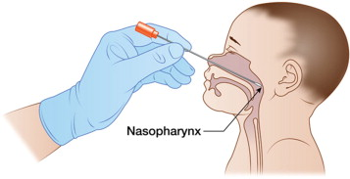

B-Sputum

Have patient rinse mouth and throat with fresh water, cough deeply and expectorate into Sputum Collector. An early morning specimen is usually more productive. 5-10 cc of specimen is desired.
Label specimen and send to laboratory immediately.
If there is a delay in transport to the lab, specimen should be refrigerated.
C-Throat
Do not obtain throat samples if epiglottis is inflamed (sampling may cause serious respiratory obstruction)
1. Depress tongue gently with tongue depressor.
2. Extend sterile swab between the tonsillar pillars (Avoid touching cheeks, tongue or lips).
3. Sweep the swab back and forth across the posterior pharynx, tonsillar areas and any inflamed or ulcerated areas to obtain sample.
4. Return swab to swab transport system.
5. Transport as soon as possible.
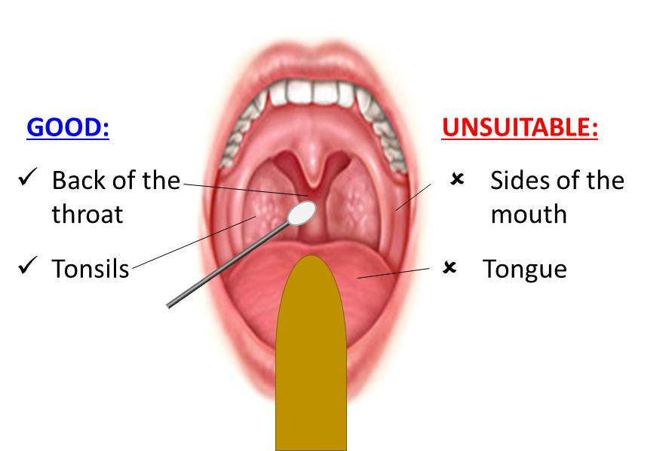

2-Eye specimens
- Where possible ask the patient to look upwards and gently pull the lower lid down or gently part the eyelids.Use a sterile cotton wool swab and gently role the swab
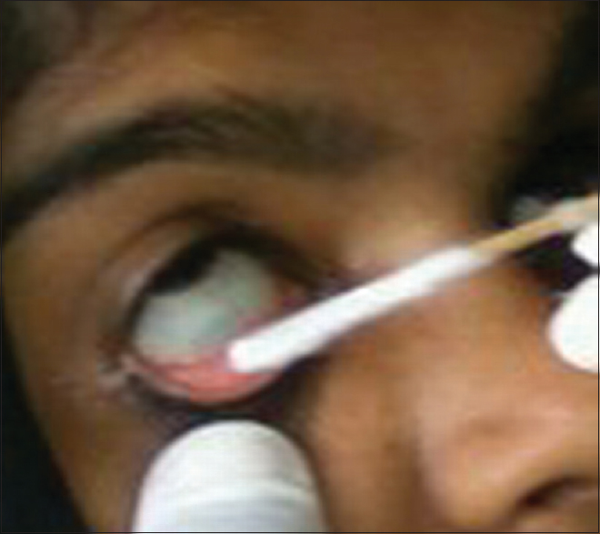
- over the conjunctival sac inside the lower lid or using gauze. Hold the swab parallel to the cornea to avoid injury if the patient moves.
- Place the swab in the transport medium.

3-Ear swabs
- If there is purulent discharge this should be sampled.
- Place a sterile swab into the outer ear and gently rotate to collect the secretions.
- Place swab in transport medium.
- For deeper ear swabbing a speculum may be used

4-wound and miscellaneous specimens
Use a sterile swab and gently rotate on the area to collect exudate from the wound and place into transport medium. Where there is pus collect as much as possible in a sterile syringe or sterile container (do not use a swab) and send to the laboratory.

5-Cerebrospinal fluid
Sampling of cerebrospinal fluid is essential for the accurate diagnosis of infective meningitis and may aid in the diagnosis of encephalitis.


6-Urinary tract specimens (Midstream or 'clean catch' specimen)
- Ask the patient to void a small amount of urine into the toilet first.
- Then ask the patient to urinate 10-20 ml directly into the specimen container.
- Instruct the patient that the remaining urine can passed into the toilet.
- Place the lid securely on the specimen container

7-fecal specimens
Collect feces from patients as soon after onset of illness as possible, and before the start of treatment. For liquid stool specimens, no more than 10 ml should be added to the Cary Blair medium and mixed.
8-Genital tract specimens
Use swab to obtain a sample of end cervical, vaginal, or urethral discharge. Return the swab to the transport tube and break the media ampule at the base of the tube to moisten the swab.
9-Fungal samples of hair, nail and skin
Special containers (Dermapak® : folded dark paper squares, secured with a paper clip ) may be obtained from the microbiology department:
- Samples of infected hair should be removed by plucking the hair with forceps or gloves. The root of the hair is infected not the shaft.
- Samples of the whole thickness of the nail or deep scrapings should be obtained.
- The skin should be cleaned with an alcohol swab. Epidermal scales scraped from the active edge of a lesion or the roof of any vesicle should be obtained.
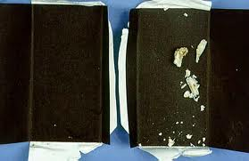

Rejection
Samples will be rejected if they are:
- Unlabeled - All specimens must have a unique patient identifier.
- Insufficient in Quantity - No specimen received, no specimen in container, or insufficient specimen to perform testing.
- Improperly Preserved - Specimens must be received in the transport media as defined by the laboratory.
- Damaged - Specimen leaked or broken in transit.
- Too Old - Aged specimens are diagnostically unreliable .

Lab.4 Culture media
Bacterial Growth: Bacterial Growth: refers to an increase in the numbers of individuals.
Culture media : Is a liquid (broth) or solid (agar) to support the growth of microorganisms or cells. A culture medium is composed of different nutrients (Carbohydrate , lipids, amino acids, vitamins as well as inorganic compounds) .
Types of Culture Media
Culture media can be classified based on the :
A. Based on their consistency( physical state):
- 1- Solid medium: contains 2% agar, Colony morphology, pigmentation, hemolysis can be appreciated ex. Blood agar, nutrient agar ect…. .
- 2- Liquid medium sometimes referred as "broth": no agar for inoculum preparation, Blood culture, for the isolation of pathogens from a mixture. The bacteria grow uniformly producing turbidity
- 3- Semi solid medium: 0.5% agar used to check for motility and also used as a transport media .
B .Based on the purpose of use (Types of culture media):
1-Simple media The most common growth media for microorganisms are nutrient broths and agar plates; specialized media are sometimes required for microorganism and cell culture growth. Nutrient agar, and Plate count agar,
2- Selective Media They are the media containing a specific composition of ingredients, which supports the growth of some target bacteria and inhibits the growth of the others. They are used to isolate specific groups of bacteria. e.g : MacConkey agar for Gram-negative bacteria, it's contain on crystal violet and bile salt which is inhibit Gram positive bacteria and some fastidious gram-negative bacteria. Eosin methylene blue (EMB) enteric isolation media.
3-Differential media Distinguish one microorganism type from another growing on the same media. E.g: MacConkey agar (MCK), which is differential for lactose fermentation. Mannitol Salt Agar (MSA): Mannitol fermentation by pathogenic staphylococci is indicated by a yellow halo surrounding the colonies. Sodium chloride is the inhibitor agent .
4-Enriched media fortified with blood, yeast extract or brain or heart infusion are useful in growing of fastidious organisms. For example sheep blood agar contain protein sources, sodium chloride and 5% sheep blood and supports the growth of most gram-positive and gram-negative bacteria. However some bacteria are highly fastidious organisms. They required Chocolate agar which contain red blood cells (RBCs) that have been lysed. Enriched media are useful for culturing normally sterile body fluids such as blood and CSF
5-Assay media Support the growth of most microorganism. Ex.: Mueller Hinton Agar is commonly used for antibiotic susceptibility testing: disk diffusion antibiotic susceptibility
6-Indicator media They provide additional information for the identification of the bacterium Ex: Triple sugar iron agar (TSI)
7-Transport media Transport media should fulfill the following criteria: Temporary storage of specimens being transported to the laboratory for cultivation and maintain the viability of all organisms in the specimen without altering their concentration. e.x: Thioglycolate broth for strict anaerobes, Stuart transport medium and Cary Blair medium .
How to prepare the culture medium:
  - The weight of the culture medium.
  - Melt the medium using heat with stirring Then Autoclave sterilization
  - Cool the medium after sterilization.
  - The nozzle of the beaker is inflamed before pouring.
  - Pour the medium into a Petri dish
  - Flaming the petri cap after casting.
  - Let the agar harden Then placed in the incubator upside down

Simple media
1.Nutrient Agar (NAP) :Nutrient agar media is used as a general-purpose medium for the growth of a wide variety of non-fastidious microorganisms. It consists of peptone, beef extract, and agar. This relatively simple formulation provides the nutrients necessary for the replication of a large number of non-fastidious microorganisms .
Preparation of Nutrient Agar
- Dissolve the dehydrated medium in the appropriate volume of distilled water i.e., 23 gm dehydrated nutrient agar in 1000 mL distilled water.
- Heat with frequent agitation and boil for 1 minute to completely dissolve the powder
- Sterilize the medium by autoclaving (121°C for 15 min)
- Dispense the medium into tubes (i.e. 3 ml to make nutrient agar slopes, 5 ml to make nutrient agar deeps) or plates.
- Leave the agar medium to solidify.
- Date the medium and give it a batch number.
- Store in a cool dark place .
2.Nutrient broth : is the nutrient agar that lack of the solidifying agent, agar powder. They remain in liquid form at room temperature and are usually used to maintain the stocks of microorganisms, cultivation and maintenance of non-fastidious organisms as well as enumeration of organisms in water, sewage, dairy products, feces, and other materials.
Preparation of Nutrient broth :
- Add 13g of nutrient broth powder in 1L of distilled water.
- Mix and dissolve them completely.
- Pour them into the final containers (eg. conical flask)
- Sterilize by autoclaving at 121°C for 15 minutes.
- When cool, tighten the bottle caps or tubes .
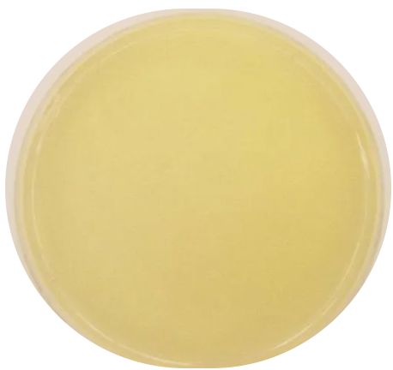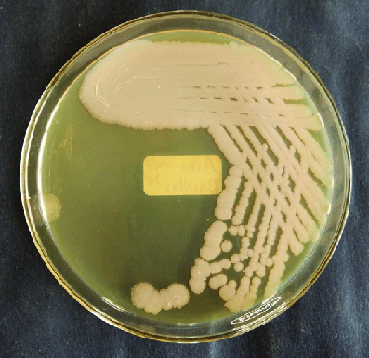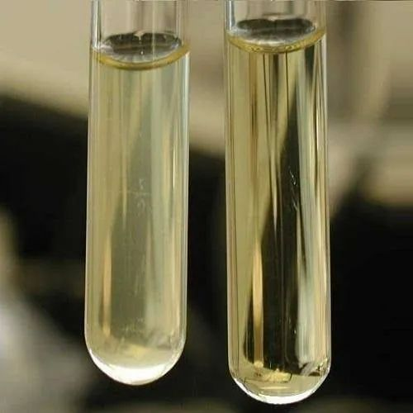
Unincolulated NA plate incolulated NA plate Unincolulated NB
Lab.5 Selective and Differential Medium
1. Mannitol Salt Agar (MSA) :
Mannitol Salt Agar (MSA) is selective and differential medium used for the isolation and identification of Staphylococcus aureus from clinical and non-clinical specimens. It encourages the growth of a group of certain bacteria while inhibiting the growth of others.
Principle of Mannitol Salt Agar :
Mannitol Salt Agar contains peptones and beef extract, which supply nitrogen, vitamins, minerals and amino acids essential for growth. The 7.5% concentration of sodium chloride results in the partial or complete inhibition of bacterial organisms other than staphylococci. Mannitol is the fermentable carbohydrate, fermentation of which leads to acid production, detected by phenol red indicator, aids in the differentiation of staphylococcal species. Staphylococcus aureus produce yellow colonies and a surrounding yellow medium , others staphylococci produce red colonies and no color change of the phenol red indicator.
Preparation of Mannitol Salt Agar
- Suspend 111.025 gm of MRS media in 1000 ml of distilled water.
- Boil to dissolve the media completely.
- Autoclave at 121°C for 15-20 minutes.
- Cool to 45-50°C and pour into petri dishes.
Result Interpretation on Mannitol Salt Agar:
Organisms | Results
Staphylococcus aureus | Yellow colonies with yellow zones.
Staphylococci other than S. aureus (e.g. Staphylococcus epidermidis ) | Colorless or Red colonies with red zones.

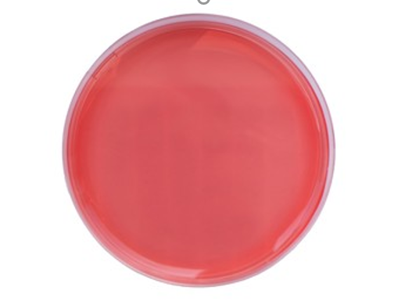
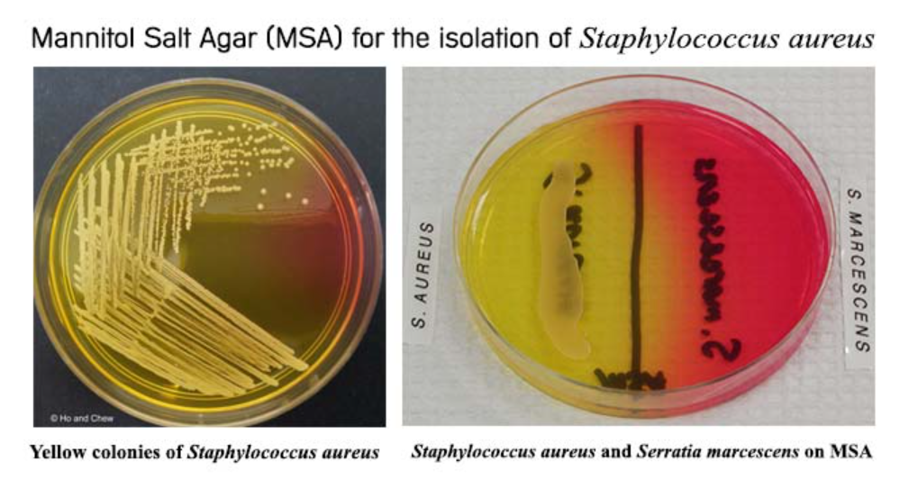
Unincolulated MSA plate Mannitol fermenter Mannitol non fermenter

2. MacConkey Agar (MCK):
MacConkey agar is a selective and differential media used for the isolation of gram-negative enteric bacteria and the differentiation of lactose fermenting from lactose non-fermenting gram-negative rods, particularly members of the family Enterobacteriaceae .
Principle of MacConkey Agar
MacConkey agar is used for the isolation of gram-negative enteric bacteria , Lactose monohydrate is the fermentable source of carbohydrate) The selective action of this medium is attributed to crystal violet and bile salts, which are inhibitory to most species of gram-positive bacteria. Neutral red is a pH indicator that turns red at a pH below 6.8 and is colorless at any pH greater than 6.8.
Preparation of MacConkey Agar
- Suspend 49.53 grams of dehydrated medium in 1000 ml purified/distilled water.
- Heat to boiling to dissolve the medium completely.
- Sterilize by autoclaving at 15 lbs pressure (121°C) for 15 minutes.
- Cool to 45-50°C.
- Mix well before pouring into sterile Petri plates.
Result Interpretation on MacConkey Agar :
Lactose fermenting strains grow as red or pink and may be surrounded by a zone of acid precipitated bile. The red color is due to production of acid from lactose, absorption of neutral red and a subsequent color change of the dye when the pH of medium falls below 6.8. such as Escherichia coli and Klebsiella spp .
Lactose non-fermenting strains, are colorless and transparent and typically do not alter appearan ce of the medium. such as Shigella and Salmonella .
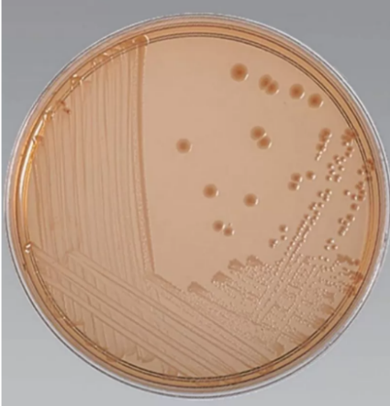
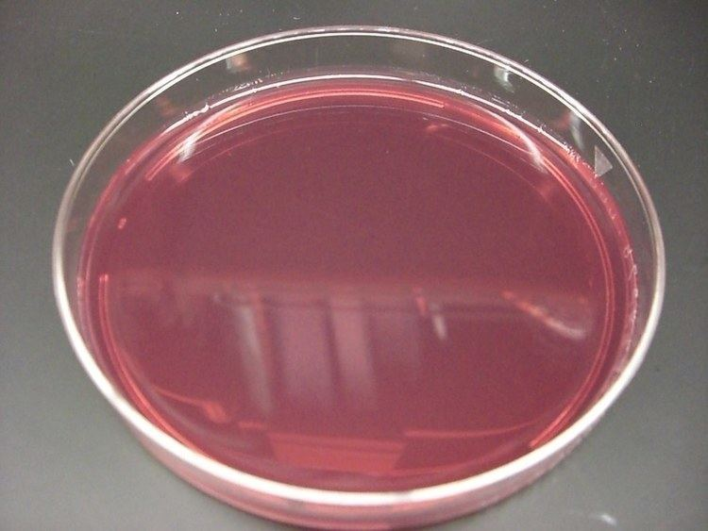
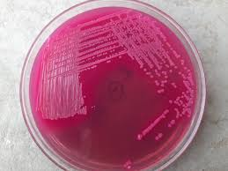

Unincolulated MCK plate Laclose fermenter Laclose non fermenter
Lab. 6 Enriched Media
1.Blood Agar (BA):
Blood Agar (BA) are enriched medium used to culture those bacteria or microbes that do not grow easily. Such bacteria are called “fastidious” as they demand a special, enriched nutritional environment as compared to the routine bacteria.
It is also a differential media in allowing the detection of hemolysis (destroying the RBC) by cytolytic toxins secreted by some bacteria.
Principle of Blood Agar
The blood that is added to the base adds nutrients to the medium, by providing growth factors that are required by these species that are extremely meticulous. It also assists in the visualization of hemolytic reactions of diverse bacteria.
Hemolysis is the process of destroying red blood cells within the blood because of hemolysins extracellular enzymes that are produced by specific bacteria.
three types of hemolysis are produced in sheep blood agar namely;
- alpha (α) hemolysis: is defined as partial hemolysis , the result is the appearance of a brown or green discoloration within the medium.
- beta (β) hemolysis : is defined as complete or true lysis of red blood cells. A clear zone, approaching the color and transparency of the base medium, surrounds the colony.
- gamma (γ) hemolysis : is also known as non-hemolysis because there is no hemolysis of red blood cells is observed.
Preparation of Blood Agar
- Suspend 28 g of nutrient agar powder in 1 litre of distilled water.
- Heat this mixture while stirring to fully dissolve all components.
- Autoclave the dissolved mixture at 121 degrees Celsius for 15 minutes.
- Once the nutrient agar has been autoclaved, allow it to cool but not solidify.
- When the agar has cooled to 45-50 °C, Add 5% sterile defibrinated blood that has been warmed to room temperature and mix gently but well .Avoid Air bubbles.
- Dispense into sterile plates while liquid.
Result Interpretation on Blood Agar
The media’s basal layer appears like a light amber color, which could appear transparent to appear slightly opalescent gel. After adding the 5%, v/v, defibrinated sterile blood, however the opaque cherry red gel develops on Petri plates.
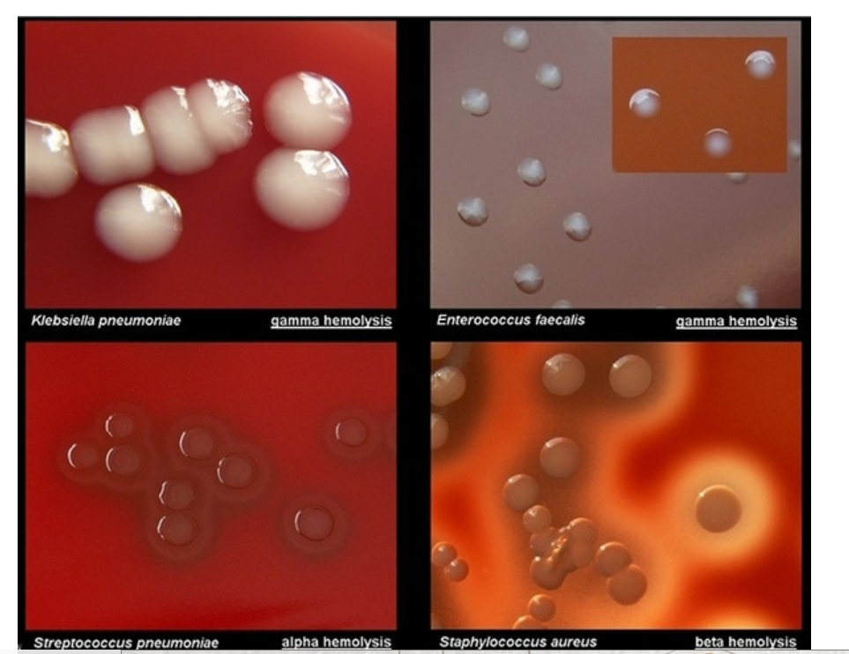

Pictures of Blood Agar
2. Chocolate Agar (CAP or CHOC) :
Chocolate Agar is a nonselective, enriched medium used for the isolation and identification of fastidious pathogens. Chocolate agar is prepared by heating blood agar, which in turn ruptures the red blood cell (RBC) and releases nutrients that aid in the growth of fastidious bacteria .
Principle :
In-house prepared chocolate agar is modified blood agar which is heated to lyze the RBC. The lysis of RBC releases intracellular nutrients such as hemoglobin, hemin (X factor), and the coenzyme nicotinamide adenine dinucleotide (NAD or V factor) into the agar for utilization by fastidious bacteria.
Preparation of Chocolate Agar
- Prepare the blood agar base as instructed by the manufacturer.
- Sterilize by autoclaving at 121°C for 15 minutes.
- Add 5-7% v/v of defibrinated blood (horse or sheep blood) and place the media in a water bath of 75 -80°C, and keep swirling gently until the color changes to dark brown.
- Pour into sterile Petri plates under aseptic conditions after the media has cooled to 50-55°C.
- Label the plates with the name of the media, and date of preparation, and store them invertedly at 2-8°C until use.

Colony Morphology
Almost all organisms grow on chocolate agar giving grey colonies of various sizes. However, since it is used specifically to isolate fastidious pathogens such as Neisseria and Haemophilus.
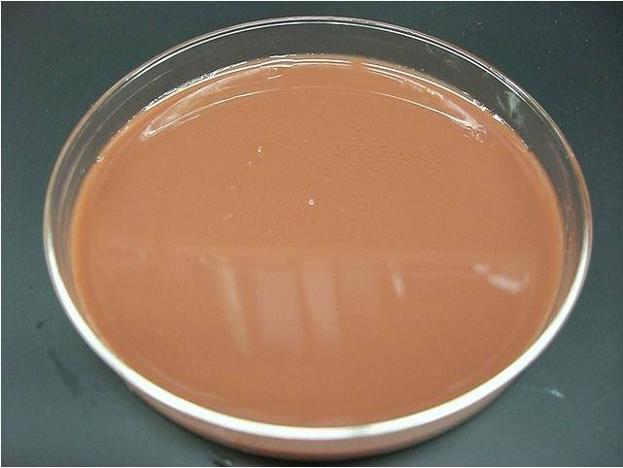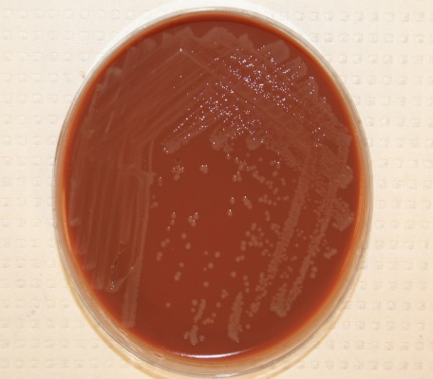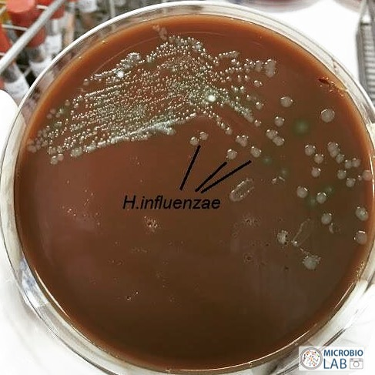
Unincolulated plate Neisseria gonorrhoeae Haemophilus Influenzae

Lab. 7 Isolation and pure culture techniques
A pure culture theoretically contains a single bacterial species. There are A number of procedures available for the isolation of pure cultures from mixed Populations.
A pure culture may be isolated by the use of special media with pacific chemical or physical agents that allow the enrichment or selection of one organism over another.
There are several different microbiology methods that scientists can use to isolate pure cultures of bacteria:
1.Spread Plate Technique:
In this technique, the number of bacteria per unit volume of sample is reduced by serial dilution before the sample is spread on the surface of an agar plate. It is useful for antibiotic susceptibility testing by disc diffusion method.
Procedure for Spread Plate Technique
A: Serial dilution
- Prepare a series of at least 6 test tubes containing 9 ml of sterile distilled water.
- Using a sterile pipette,add 1ml of sample to the first tube of the set. Label it as 10⁻¹.
- Mix the contents well by swirling the tube upside down a few times.
- Take 1ml of the sample from the first tube and transfer it to the second tube. Label it as 10⁻².
- Repeat the procedure with all the remaining tubes labeled until 10⁻⁶.
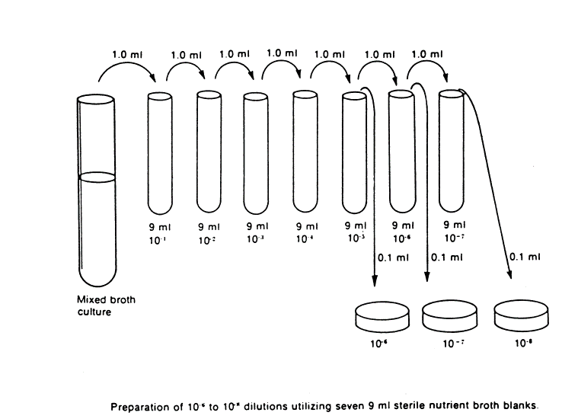
Serial dilution method
B.Plating
- Pipette out 0.1 ml* from the appropriate desired dilution series onto the center of the surface of an agar plate.
- Dip the L-shaped glass spreader (hockey stick) into ethanol. Ethanol is used to sterilize the glass spreader.
- Flame the glass spreader over a bunsen burner.
- Spread the sample evenly over the surface of agar using a cool alcohol-flamed glass rod spreader, carefully rotating the Petri dish underneath at an angle of 45o at the same time.
- Incubate the plate at 37°C for 24-48 hours.
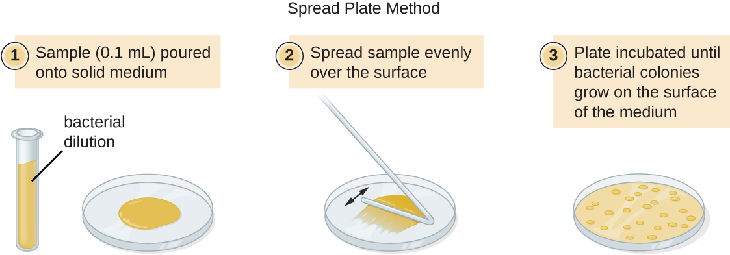
Spread-plate technique with a turntable and glass spreader.
2. Streak Plate Technique :
The streak plating technique isolates individual bacterial cells (colony-forming units) on the surface of an agar plate using a wire loop. The streaking patterns result in continuous dilution of the inoculum to give well separated surface colonies. Once again, the idea is to obtain isolated colonies after incubation of the plate.

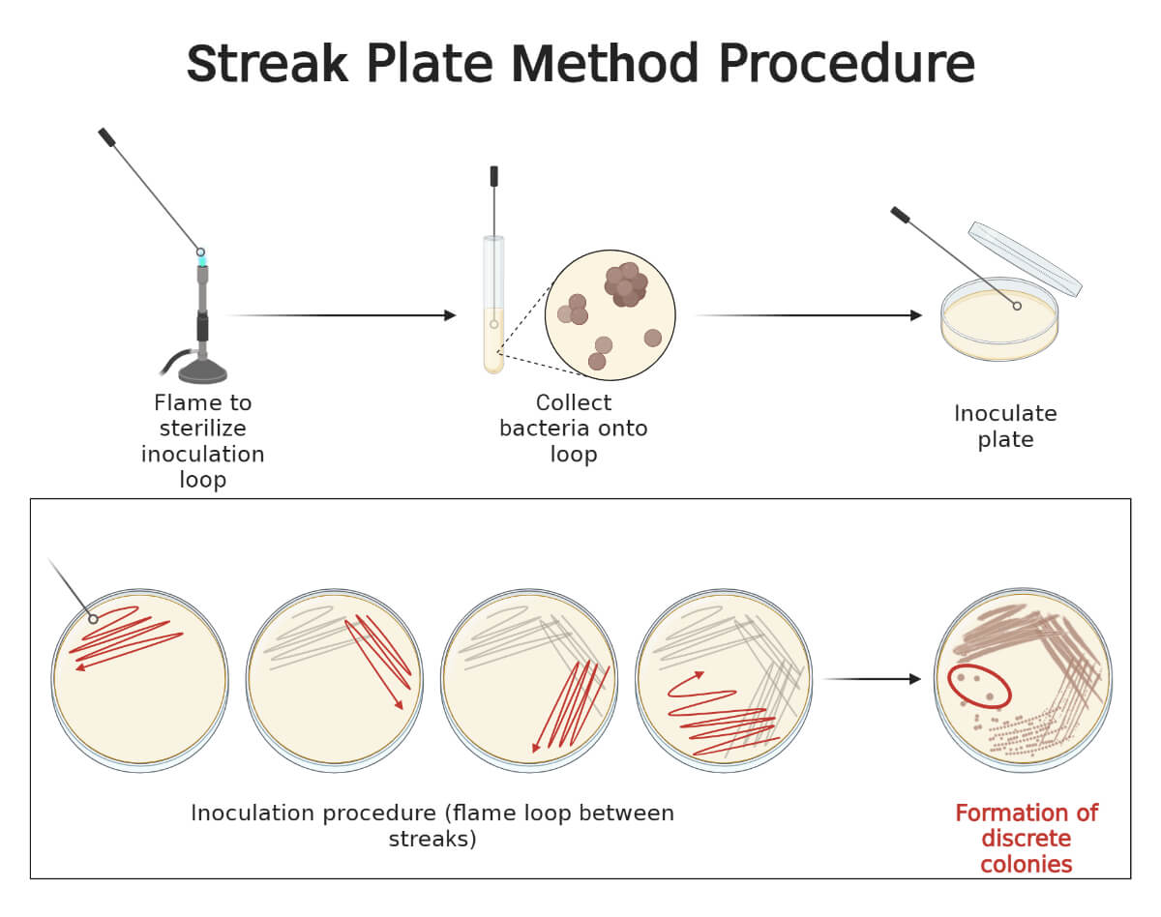
3.Pour plate technique:
Pour plate method is usually the method of choice for counting the number of living bacteria or groups of bacteria in a liquid culture or suspension. Because the sample is mixed with the molten agar medium, a larger volume can be used than the spread plate.
Procedure
In the pour plate method, a fixed amount of inoculum (generally 1 ml) from a broth/sample is placed in the center of a sterile Petri dish using a sterile pipette. Molten cooled agar (approx. 15mL) is then poured into the Petri dish containing the inoculum and mixed well. After the solidification of the agar, the plate is inverted and incubated at 37°C for 24-48 hours.
The number of microorganisms present in the particular test sample is determined using the formula:
CFU/mL= CFU * dilution factor * 1/aliquot
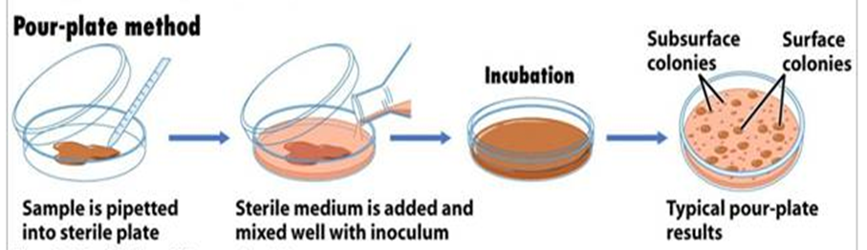
Pour plate method
Lab. 8 Colony Morphology of Bacteria
Characteristics of Bacterial colonies
Colony morphology can sometimes be useful in bacterial identification. Colonies are described as to such properties as size, shape, texture, elevation, pigmentation, effect on growth medium. In this lab you will find common criteria that are used to characterize the bacterial growth.
Colony Shape: It includes form, elevation and margin of the bacterial colony.
  - Form of the bacterial colony: – The form refers to the shape of the colony. e.g. Circular, Irregular, Filamentous (has individual thin projections), Rhizoid (has thin, branching projections) etc.
  - Elevation of bacterial colony: These are the most common. e.g. Flat, raised, umbonate , Crateriform, Convex, Pulvinate (Cushion-shaped).
  - Margin of bacterial colony: The margin or edge of a colony. Common examples are Entire (smooth), irregular, Undulate (wavy), Lobate, Curled, Filiform etc.
Colonies that are irregular in shape and/or have irregular margins are likely to be motile organisms. Highly motile organism swarmed over the culture media. Such as Proteus spp.

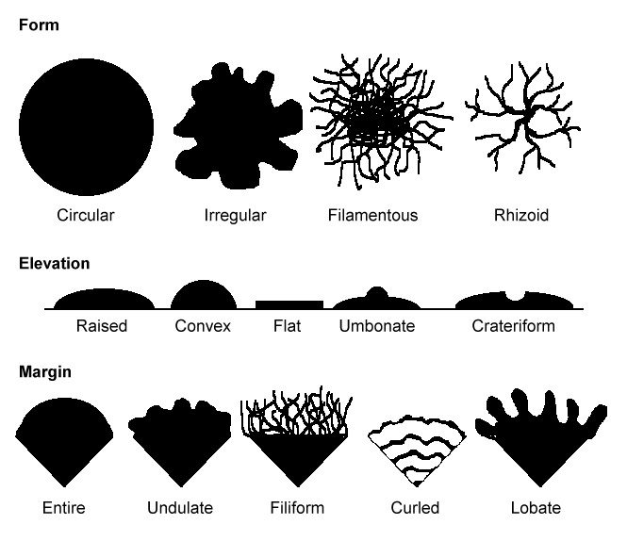
Characteristics of bacterial colonies

Size of the bacterial colony: The size of the colony can be a useful characteristic for identification. The diameter of a representative colony may be measured in millimeters: pinpoint , small, medium, large. Colonies larger than about 5 mm are likely to be motile organisms. Tiny colonies are referred to as punctiform (pin-point) .
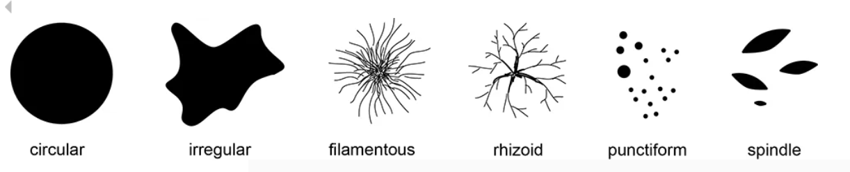
Consistency/Texture: Several terms that may be appropriate for describing the texture or consistency of bacterial growth are: dry, moist, mucoid (sticky, mucus-like).

Color of the colonies (pigmentation): Some bacteria produce pigment when they grow in the medium e.g., green pigment produces by Pseudomonas aeruginosa.

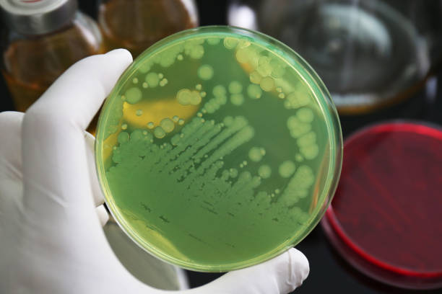
Pseudomonas aeruginosa

Broth culture characteristics (growth in liquid medium)
When bacteria are grown in broths such as trypticase soy broth (TSB), they may exhibit patterns of growth ranging from a sediment at the bottom of the tube, turbid growth throughout the tube, or a pellicle(thick growth at the top of the tube).
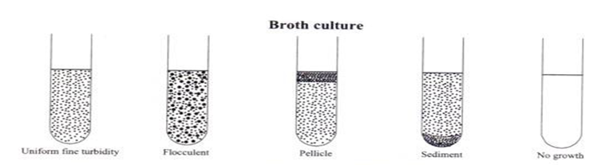
Clear No Growth
Pellicle
Flocculent
Sediment
Turbid (Cloudy)

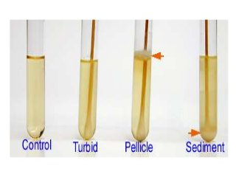
Growth in nutreient broth

Lab. 9 The smear and staining techniques
Microorganisms are small, transparent and motile in fluids hence it is very difficult to observe under microscope unless these are immobilized (fixed) and stained with a suitable stain. Placing and spreading of sample on microscopic slide is called a smear.
Preparation of Smear :
The air-dried smear is fixed to glass to avoid it being washed when treated with liquid stain. Fixation is accomplished by passing the smear through the top part of Bunsen burner flame 2-4 times taking care that glass slide is quite hot. Alternatively the smear can be chemically fixed by covering the smear with 95% methanol for 1-5 min.
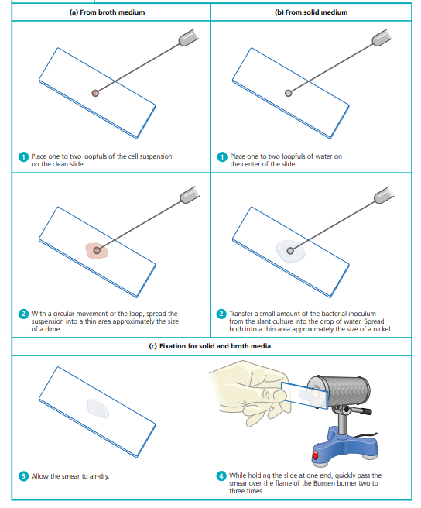
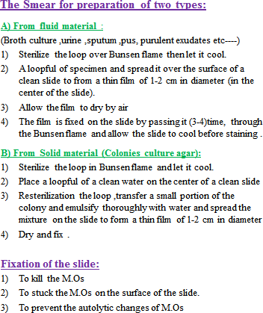
Fixation is a process of killing, immobilizing, and preserving the bacterial cells by coagulating the cytoplasmic proteins to make them more visible. In addition, the process adheres the cells to the slide so they do not wash off of the slide during staining.

Bacterial smear preparation

Types of staining techniques :
1. Simple staining: use of a single stain, used to reveal cell morphology, size, and arrangement.
- Types of Simple Stain: methylene blue, malachite green, crystal violet, basic fuchsin, safranin.
2. Differential staining: use of two contrasting stains separated by a decolorizing agent, to distinguish between two different types of cells or different parts of cells.
- Types of differential Stains: Gram stain, Acid fast stain.
3. Special stains: used for surface structures (such as capsules or flagella) and internal components (e.g., endospores) identification.
- Types of Special stains: Capsule stain, flagella stain, Spore stain .
Simple Staining :
Principle :
In simple staining, the bacterial smear is stained with a single reagent, which produces a distinctive contrast between the organism and its background. The purpose of simple staining is to elucidate the morphology and arrangement of bacterial cells .The most commonly used basic stains are methylene blue, crystal violet, and carbol fuchsin.
Materials :
1.Cultures : Twenty-four–hour nutrient agar cultures
2.Reagents : Methylene blue, crystal violet, and carbol fuchsin.
3.Equipment : Bunsen burner, inoculating loop, staining tray, microscope, lens paper, and glass slides .
Procedure :
Prepare separate bacterial smears of the organisms
Note: All smears must be heat fixed prior to staining.
Simple Staining
The following steps
- Place a slide on the staining tray and flood the smear with one of the indicated stains, using the appropriate exposure time for each: carbol fuchsin, 15 to 30 seconds; crystal violet, 20 to 60 seconds; methylene blue 1 to 2 minutes.
- Gently wash the smear with tap water to remove excess stain. During this step, hold the slide parallel to the stream of water; in this way you can reduce the loss of organisms from the preparation.
- Repeat this procedure with the remaining two organisms, using a different stain for each.
- Examine all stained slides under oil immersion.
- In the chart provided in the Lab Report, complete the following:
  - Draw a representative field for each organism.
  - Describe the morphology of the organisms with reference to their shapes (bacilli,cocci, spirilla) and arrangements (chains, clusters, pairs).
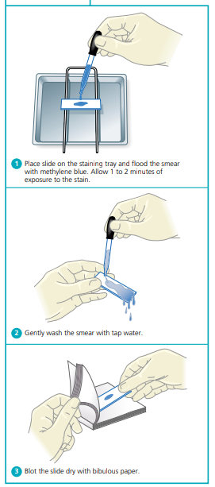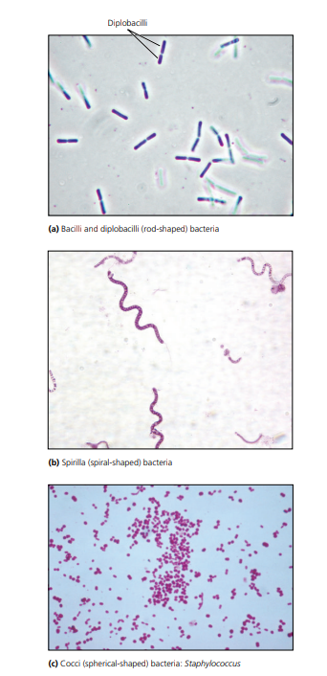
Simple staining procedure Micrographs showing bacteria morphology

Differential staining :
- Gram stain :
The Gram stain uses four different reagents.
Primary Stain Crystal Violet : This violet stain is used first and stains all cells purple.
Mordant Gram’s iodine : This reagent serves not only as a killing agent but also as a mordant, a substance that increases the cells’ affinity for a stain. The reagent does this by binding to the primary stain, thus forming an insoluble complex. The resultant crystal-violet–iodine (CV-I) complex serves to intensify the color of the stain. At this point, all cells will appear purple-black.
Decolorizing Agent : Ethyl Alcohol, 95% This reagent serves a dual function as a protein-dehydrating agent and as a lipid solvent. Its action is determined by two factors, the concentration of lipids and the thickness of the peptidoglycan layer in bacterial cell walls.
In gram-negative cells : the alcohol increases the porosity of the cell wall by dissolving the lipids in the outer layers. Thus, the CV-I complex can be more easily removed from the thinner and less highly cross-linked peptidoglycan layer. Therefore, the washing-out effect of the alcohol facilitates the release of the unbound CV-I complex, leaving the cells colorless or unstained.
In gram-positive cells : The much thicker peptidoglycan layer is responsible for the more stringent retention of the CV-I complex, as the pores are made smaller due to the dehydrating effect of the alcohol. Thus, the tightly bound primary stain complex is difficult to remove, and the cells remain purple.
Counterstain Safranin This is the final reagent, used to stain pink those cells that have been previously decolorized. Since only gram-negative cells undergo decolorization, they may now absorb the counterstain.

Materials
1.Cultures Twenty-four–hour nutrient agar slant cultures
2.Reagents Crystal violet, Gram’s iodine, 95% ethyl alcohol, and safranin.
3.Equipment Microincinerator or Bunsen burner, inoculating loop or needle, staining tray, glass slides, lens paper, and microscope.
Procedure :
Prepared fixed smear .
1. Gently flood smears with crystal violet and let stand for 1 minute.
2. Gently wash with tap water.
3. Flood smears with the Gram’s iodine mordant and let stand for 1 minute.
4. wash with tap water.
5. Decolorize with 95% ethyl alcohol. Note: Do not over-decolorize. Add reagent drop by drop until the alcohol runs almost clear, showing only a blue tinge.
6. wash with tap water.
7. Counterstain with safranin for 45 seconds.
8. Gently wash with tap water.
9. Blot dry with paper and examine under MICROSCOPE.
10. As you observe each slide under oil immersion, complete the chart provided in the Lab Report.
a. Draw a representative microscopic field.
b. Describe the cells according to their morphology and arrangement.
c. Describe the color of the stained cells.
d. Classify the organism as to the Gram reaction: gram positive or gram negative.
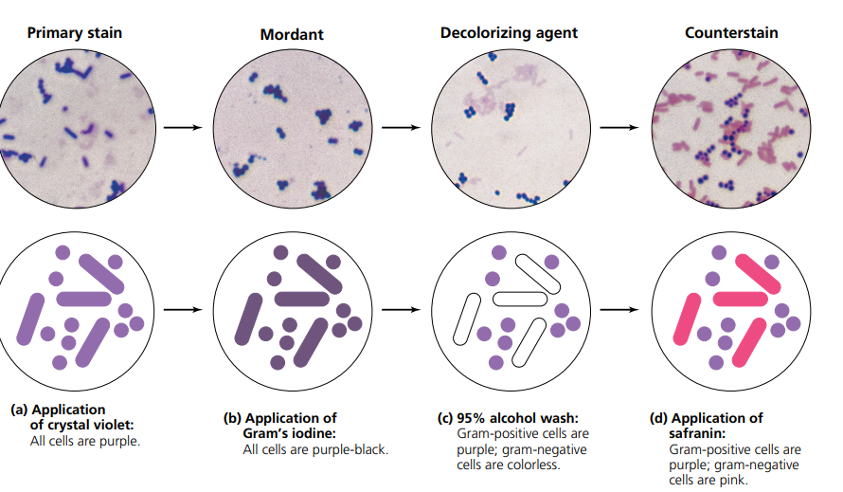

Microscopic observation of cells following steps in the Gram staining procedure

- Acid-Fast Staining :
Principle
The acid-fast stain uses three different reagents
Primary Stain Carbol Fuchsin Unlike cells that are easily stained by ordinary aqueous stains, most species of mycobacteria are not stainable with common dyes such as methylene blue and crystal violet. Carbol fuchsin, a dark red stain in 5% phenol that is soluble in the lipoidal materials that constitute most of the mycobacterial cell wall, does penetrate these bacteria and is retained. Penetration is further enhanced by the application of heat, which drives the carbol fuchsin through the lipoidal wall and into the cytoplasm. This application of heat is used in the Ziehl-Neelsen method. The Kinyoun method, a modification of the Ziehl-Neelsen method, circumvents the use of heat by addition of a wetting agent (Tergitol®) to this stain, which reduces surface tension between the cell wall of the mycobacteria and the stain. Following application of the primary stain, all cells will appear red.
Decolorizing Agent Acid-Alcohol (3% hCl + 95% Ethanol) Prior to decolorization, the smear is cooled, which allows the waxy cell substances to harden. On application of acid-alcohol, acid-fast cells will be resistant to decolorization since the primary stain is more soluble in the cellular waxes than in the decolorizing agent. In this event, the primary stain is retained and the mycobacteria will stay red. This is not the case with non–acid-fast organisms, which lack cellular waxes. The primary stain is more easily removed during decolorization, leaving these cells colorless or unstained.
Counterstain Methylene Blue This is used as the final reagent to stain previously decolorized cells. As only non–acid-fast cells undergo decolorization, they may now absorb the counterstain and take on its blue color, while acid-fast cells retain the red of the primary stain.
Materials
- Cultures Seventy-two– to 96-hour Trypticase™ soy broth culture of Mycobacterium smegmatis.
- Reagents Carbol fuchsin, acid-alcohol, and methylene blue.
- Equipment Microincinerator or Bunsen burner, hot plate, 250-ml beaker, inoculating loop, glass slides, bibulous paper, lens paper, staining tray, and microscope.
Procedure
Prepared fixed smear .
1. Flood smears with carbol fuchsin and place over a beaker of water on a warm hot plate, allowing the preparation to steam for 5 minutes. Note: Do not allow stain to evaporate; replenish stain as needed. Also, prevent stain from boiling by adjusting the hot-plate temperature.
2. For a heatless method, flood the smear with carbol fuchsin containing Tergitol® for 5 to 10 minutes. 2. Wash with tap water. Heated slides must be cooled prior to washing.
3. Decolorize with acid-alcohol, adding the reagent drop by drop until the alcohol runs almost clear with a slight red tinge.
4. Wash with tap water.
5. Counterstain with methylene blue for 2 minutes.
6. Wash smear with tap water.
7. Blot dry with bibulous paper and examine under oil immersion.
8. In the chart provided in the Lab Report, complete the following:
a. Draw a representative microscopic field for each preparation.
b. Describe the cells according to their shapes and arrangements.
c. Describe the color of the stained cells.
d. Classify the organisms as to reaction: acidfast or non–acid-fast.
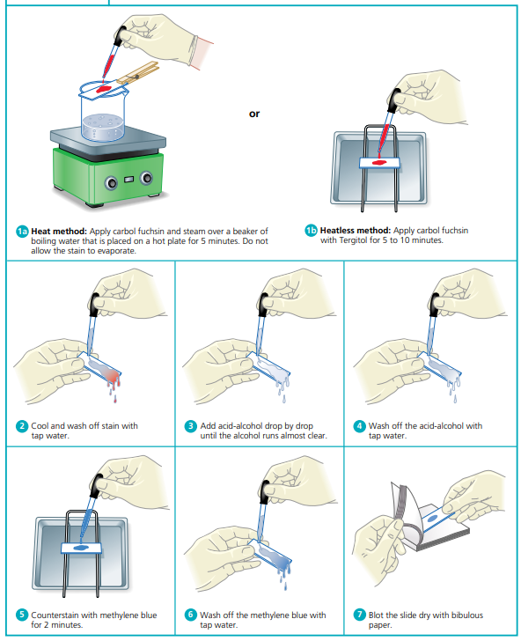
Acid-fast staining procedure
Special stains :
- spores staining ( malachite green staining) :
Members of the anaerobic genera Clostridium and the aerobic genus Bacillus are examples of organisms that have the capacity to exist either as metabolically active vegetative cells or as highly resistant, metabolically inactive cell types called spores .
The main purpose of endospore staining is to differentiate bacterial spores from other vegetative cells and to differentiate spore formers from non-spore formers.
Principle :
In the Schaeffer-Fulton`s method, a primary stain-malachite green is forced into the spore by steaming the bacterial emulsion. Malachite green is water soluble and has a low affinity for cellular material, so vegetative cells may be decolorized with water. Safranin is then applied to counterstain any cells which have been decolorized. At the end of the staining process, vegetative cells will be pink, and endospores will be dark green.
Materials :
1. Cultures : Forty–eight- to 72-hour nutrient agar slant culture of Bacillus cereus and thioglycollate culture of Clostridium sporogenes.
2. Reagents : Malachite green and safranin. Equipment Microincinerator or Bunsen burner, hot plate, staining tray, inoculating loop, glass slides, bibulous paper, lens paper, and microscope.
Procedure
1.Smear Preparation
2.Flood smears with malachite green and place on top of a beaker of water sitting on a warm hot plate, allowing the preparation to steam for 2 to 3 minutes. Note: Do not allow stain to evaporate; replenish stain as needed. Prevent the stain from boiling by adjusting the hot plate temperature.
3. Remove slides from hot plate, cool, and wash under running tap water.
4. Counterstain with safranin for 30 seconds.
5. Wash with tap water.
6. Blot dry with bibulous paper and examine under oil immersion.

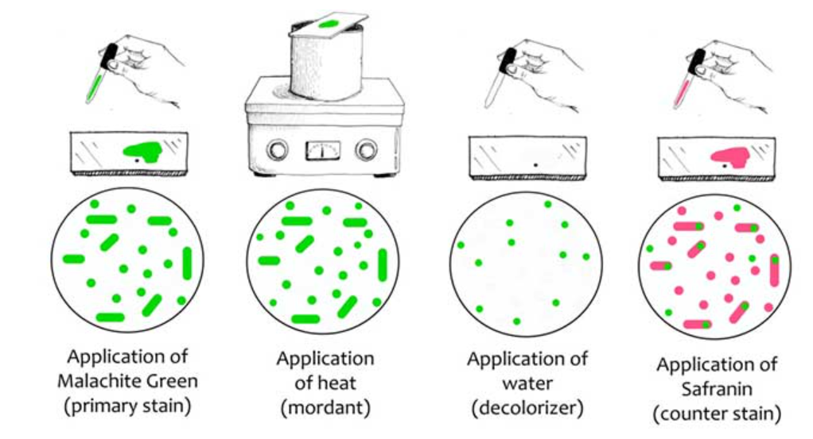
Spore staining procedure
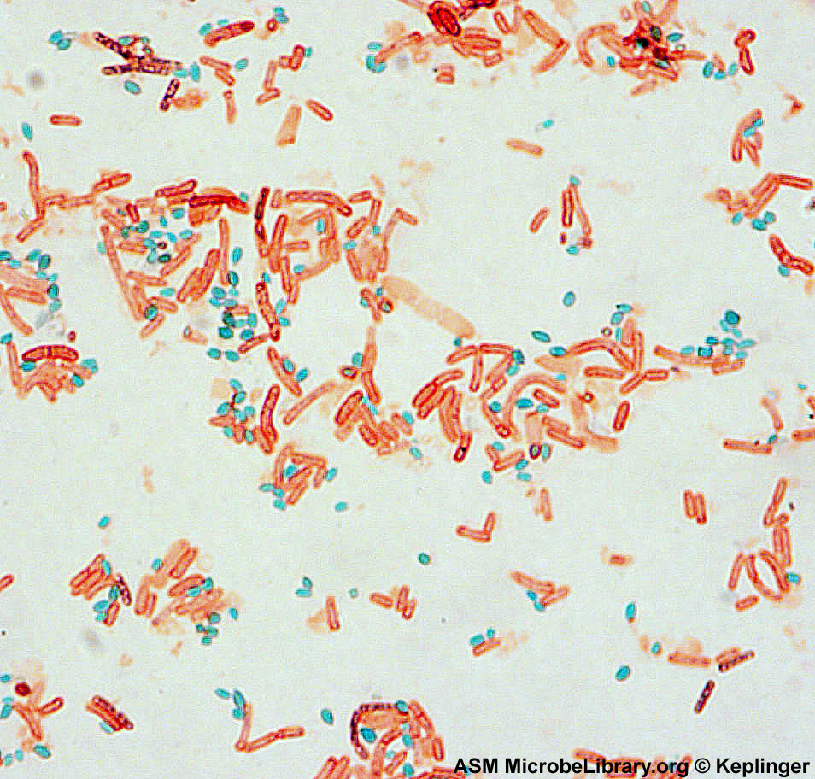

Malachite green staining

- Capsule stain (Negative staining ) :
Most capsulated bacteria have a capsule made up of a polysaccharide layer, but some bacteria have a capsule made up of polypeptide or glycoprotein. Capsules are associated with virulence in several microorganisms, including Streptococcus pneumoniae and Neisseria meningitides, because capsules resist phagocytosis.
The purpose of negative staining is to determine if an organism possesses a capsule although it can also be used to demonstrate spore formation.

Principle
Negative staining requires the use of an acidic stain such as India ink or nigrosin. The acidic stain, with its negatively charged chromogen, will not penetrate the cells because of the negative charge on the surface of bacteria. Therefore, the unstained cells are easily discernible against the colored background.
Materials :
1.Cultures :Twenty-four–hour agar slant cultures .
2. Reagent : Nigrosin.
3.Equipment : burner, loop, staining tray, glass slides, lens paper, and microscope.
Procedure :
1. Place a small drop of nigrosin close to one end of a clean slide.
2. Using aseptic technique, place a loopful of inoculum from the culture in the drop of nigrosin and mix .Place a slide against the drop of suspended organisms at a 45° angle and allow the drop to spread along the edge of the applied slide.
4. Push the slide away from the drop of suspended organisms to form a thin smear. Air-dry. Note: Do not heat fix the slide
5.Examine the slides under oil immersion, and record your observations in the Lab Report.
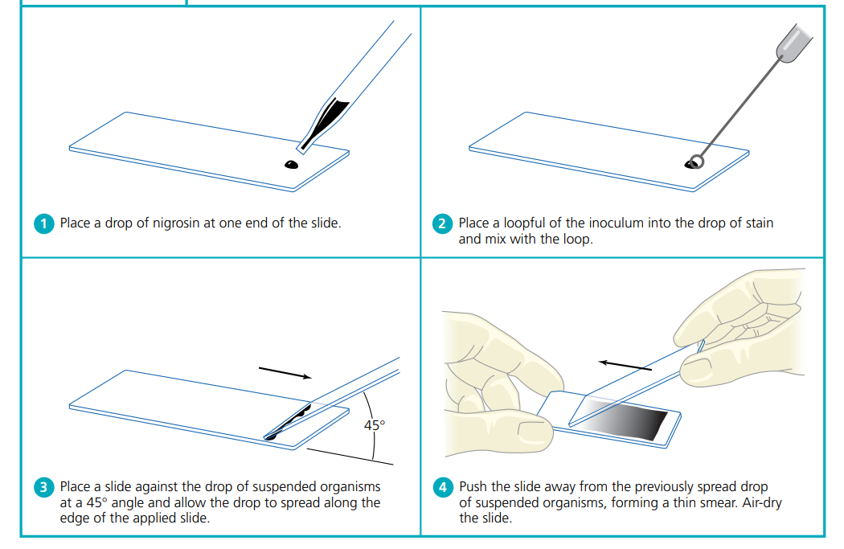
Negative staining procedure

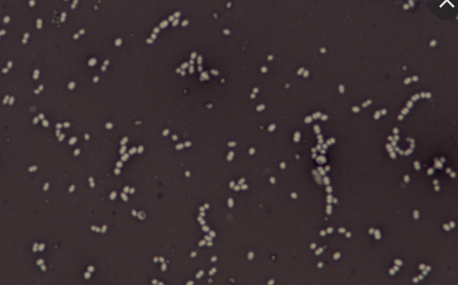
Negative stain 0f E.coli
Lab : 10 Bacterial Enzyme
1.Catalase :
Catalase is an enzyme, which is produced by microorganisms that live in oxygenated environments to neutralize toxic forms of oxygen metabolites; H₂O₂.
Principle
During aerobic respiration, microorganisms produce hydrogen peroxide and, in some cases, an extremely toxic superoxide. Accumulation of these substances will result in death of the organism unless they can be enzymatically degraded. These substances are produced when aerobes, facultative anaerobes, and microaerophiles use the aerobic respiratory pathway, in which oxygen is the final electron acceptor, during degradation of carbohydrates for energy production. Organisms capable of producing catalase rapidly degrade hydrogen peroxide as illustrated:
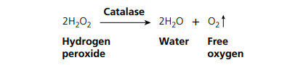
Aerobic organisms that lack catalase can degrade especially toxic superoxides using the enzyme superoxide dismutase; the end product of a superoxide dismutase is H2O2, but this is less toxic to the bacterial cells than are the superoxides.

Materials
1.Cultures 24- to 48-hour
2.Reagent 3% hydrogen peroxide.
3.Equipment
a. Tube method: Bunsen burner, inoculating loop, test tube rack, and glassware marking pencil .
b. Slide method: Bunsen burner, inoculating loop, glassware marking pencil, glass microscope slides , Petri dish and cover.
Procedure tube method
1. Using aseptic technique, inoculate each experimental organism into its appropriately labeled tube by means of a streak inoculation. The last tube will serve as a control.
2. Incubate all cultures for 24 to 48 hours at 37°C.
3. Allow three or four drops of the 3% hydrogen peroxide to flow over the entire surface of each slant culture .
4. Examine each culture for the presence or absence of bubbling or foaming. Record your results in the chart in the Lab Report.
5. Based on your observations, determine and record whether or not each organism was capable of catalase activity.
Procedure Slide method
1. Label slides with the names of the organisms.
2. Using a sterile loop, collect a small sample of the first organism from the culture tube and transfer it to the appropriately labeled slide.
3. Place the slide in the Petri dish.
4. Place one drop of 3% hydrogen peroxide on the sample. Do not mix. Place the cover on the Petri dish to contain any aerosols.
5. Observe for immediate presence of bubble formation. Record your results in the chart in the Lab Report.

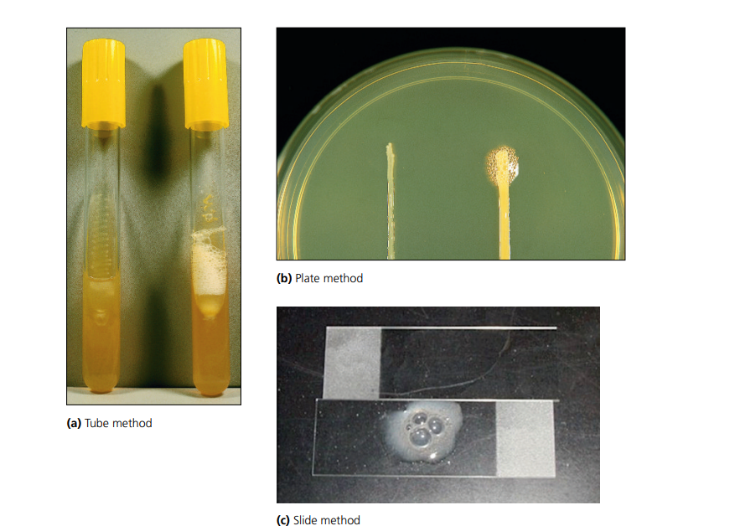
Catalase test. Negative results are shown on the left and positive results on the right in the (a) tube method and (b) plate method. Negative results are shown on the top and positive results on the bottom in the (c) slide method .
2. Oxidase test :
Oxidase is an enzyme in involved in electron transport system of aerobic bacteria. Is present in aerobic, facultative anaerobes and microaerophilic microbes.
Principle :
The oxidase test detects the presence of a cytochrome oxidase system that will catalyse the transport of electrons between electron donors in the bacteria and a redox dye- tetramethyl-p-phenylene-diamine. The dye is reduced to deep purple color.
Cytochrome oxidase catalyzes the oxidation of a reduced cytochrome by molecular oxygen (O2), resulting in the formation of H2O or H2O2.
Materials :
- Cultures 24- to 48-hour .
- Reagent : p-Aminodimethylaniline oxalate
- Equipment : Filter paper method: All of the above and filter paper
Filter Paper method
1. Prepare Petri dishes as described in Lab One Steps 1a and 1b.
2. Place filter paper in Petri dish.
3. With a sterile loop, obtain a heavy loopful of the first test organism and gently smear it on the filter paper.
4. Drop one or two drops of paminodimethylaniline oxalate reagent on the test organism. 5. Observe the organism for the appearance of a purple color within 30 seconds of contact with the oxidase reagent, indicating a positive test.
6. Record your results in the chart in the Lab Report.
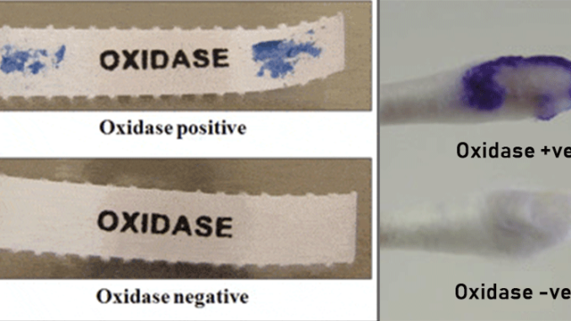
Oxidase test
3. Urease test :
Urease is a hydrolytic enzyme that attacks the nitrogen and carbon bond in amide compounds such as urea and forms the alkaline end product ammonia.
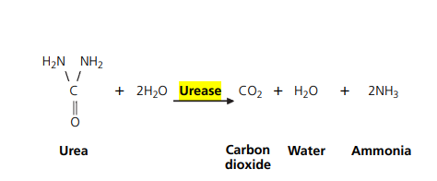

Materials :
1.Cultures 24- to 48-hour
2.media : Urea broth or urea agar slants
2.Equipment : Bunsen burner, inoculating loop, test tube rack, and glassware marking pencil.
Procedure of Urease Test
A. Preparation of media
- About 24.52 grams of the dehydrated medium is dissolved in 950 ml distilled water in a beaker.
- The solution is heated to bring it to a boil in order to dissolve the medium completely.
- The prepared suspension is sterilized by autoclaving at 15 lbs pressure, 121°C for 15 minutes.
- The beaker is taken out following the autoclaving and cooled to 50°C. To the beaker, 50 ml of sterile 40% urea solution is added and mixed well.
- The medium is dispensed into tubes and set in a position to obtain agar slants.
B. Urease Activity
- A loopful of a well-isolated colony is taken with an inoculating loop and inoculated on the agar slants. The inoculation should be done on just the slant, and the butt shouldn’t be stabbed.
- The tubes are then incubated with loosened caps at 35 to 37°C. For non-fermenters, the tubes are incubated at 30°C.
- The tubes are observed for the development of pink color for as long as 7 days.
- If no growth is seen on the slant, further inoculation with heavy inoculum should be done.
- The tube is then observed for the change in color from yellow to pink.
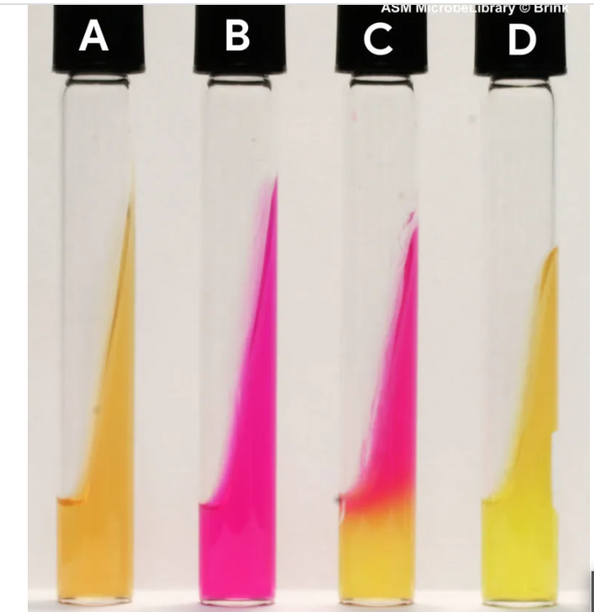
Urea agar test (a) uninoculated, (b) Proteus mirabilis (rapidly urease positive), (c) Klebsiella pneumoniae (delayed urease positive), (d) Escherichia coli (urease negative).

4.Coagulase Test :
The coagulase test helps to identify Staphylococcus aureus which produces the enzyme coagulase (coagulates) plasma from coagulase-negative staphylococci (CONS). Coagulase is also the virulence factor of S. aureus .

Principle
Coagulase is an enzymatic protein that is a thermostable thrombin-like substance, which converts fibrinogen into fibrin resulting in clotting or clumping. In S.aureus produces two forms of coagulase (i.e., bound coagulase and free coagulase). Bound coagulase, otherwise known as "clumping factor", can be detected by carrying out a slide coagulase test, and free coagulase can be detected using a tube coagulase test.
Procedure of Coagulase Test
Coagulase can be detected by two different methods; tube test and slide test.
a.Slide Test
- About 10 µl of deionized water or physiological saline is added to a slide.
- Several colonies from a fresh culture are collected with an inoculating loop and are emulsified into the water to obtain a smooth milk-colored suspension.
- A drop of a rabbit or human plasma is added to the slide, and the clumping is observed immediately, not to exceed 10 seconds.
- A positive test is the demonstration of the agglutination of the bacterial cells after the plasma is added.
A negative test is demonstrated by the lack of agglutination.
b.Tube Test
- The plasma is diluted with physiological saline. (Add 0.2 ml plasma in 1.8 ml saline)
- 5 ml of the diluted plasma is then added to a test tube. About 5 drops of the test organism culture are added to the test tube.
- The test tube is mixed and incubated at 37°C for an hour.
- The tube is finally observed for clot formation. If no clotting is observed, the tube should be examined at 30 minutes intervals of up to 6 hours.
- A positive test :Complete clot formation or any degree of clot formation before 24 hours.
A negative test :A lack of clot formation at 24 h at 25°C.
Coagulase Positive organisms: Staphylococcus aureus
Coagulase Negative organisms: Staphylococcus epidermidis and S. saprophyticus
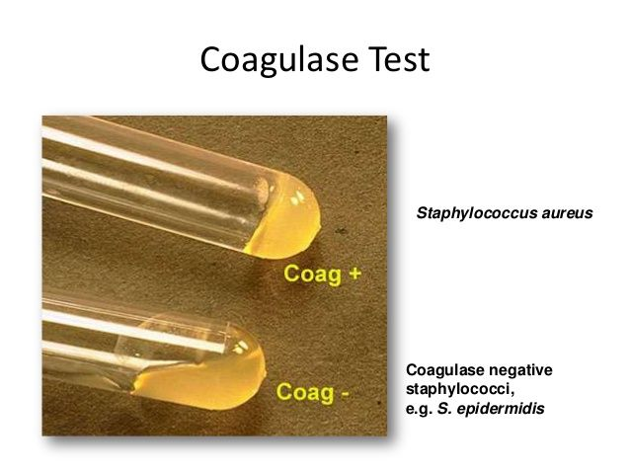
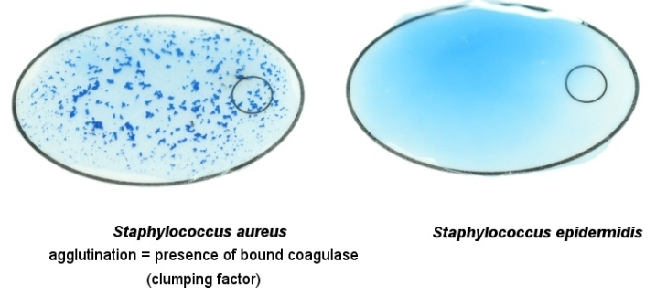

Slide coagulase test Tube coagulase Test

