Ministry of Higher Education & Scientific Research

Islamic University
College of Education
Department of English Language

Course Title: Introduction to Linguistics
Stage: 3rd Year
Tutor: Asst. Lect. Saif Hakim
Lecture Topic: Morphology

( 2022 - 2023 )

- Morphology
Morphology is the field of linguistics that studies the internal structure of words. It is the study and analysis of the basic elements of words in language which are called “morphemes”.
- Morphemes
A morpheme is defined as a minimal unit of meaning or grammatical function, that can’t be broken down any further.
e.g.
- (Talk, talks, talker, talked, talking)
• consist of (one element ‘talk’ + other elements ‘ -s, -er, -ed, -ing’)
• All these elements are described as morphemes.
- The word renewed consists of three morphemes. One minimal unit of meaning (new). Another minimal unit of meaning (re = again). And a minimal unit of grammatical function –ed (= past tense)
- The word tourists also contains three morphemes: There is one minimal unit of meaning which is tour, Another minimal unit of meaning -ist (marking “person who does something”); And a minimal unit of grammatical function -s (indicating plural).

  - Free and bound morphemes.
- Free morphemes are morphemes that can stand by themselves as single words, for examples, new and tour.
- Bound morphemes are morphemes that cannot normally stand alone and are typically attached to another form, exemplified as- re, - ist , -ed, -s .

Notes :
- These Bound morphemes were described in chapter 5 as affixes. So, we can say that all affixes (prefixes and suffixes) in English are bound morphemes.
- The free morphemes can generally be identified as the set of separate English word forms such as basic nouns, adjectives, verbs, adverbs.
- When free morphemes are used with bound morphemes, the basic word forms are known as stems.
undressed carelessness
un dress –ed care – less -ness
prefix stem suffix stem suffix suffix
(bound) (free) (bound) (free) (bound) (bound)

  - Free morphemes: Lexical and Functional
Free morphemes fall into two categories: lexical and functional.
- Lexical morphemes are that set of ordinary nouns, adjectives and verbs. that we think of as the words that carry the “content” of the messages we convey.
Some examples are: girl, man, house, sad, long, yellow, sincere, open, look, follow, break. New lexical morphemes can easily be added to the language, so they are treated as an open class of words.

- Functional morphemes are a set of functional words in the language such as conjunctions, prepositions, articles and pronouns.
Examples are and, but, when, because, on, near, above, in, the, that, it, them. Because we almost never add new functional morphemes to the language, they are described as a closed class of words.
  - Bound morphemes: Derivational and Inflectional
Bound morphemes fall into two categories Derivational and inflectional.
- Derivational morphemes are bound morphemes used to make new words or to make words of a different grammatical category from the stem.
For example, the addition of the derivational morpheme -ness changes the adjective good to the noun goodness.
A list of derivational morphemes will include suffixes such as the -ish in foolish, -ly in quickly, and the -ment in payment. The list will also include prefixes such as re-, pre-, ex-, mis-, co-, un and many more.
- Inflectional morphemes are bound morphemes which are not used to produce new words in the language, but rather to indicate aspects of the grammatical function of a word. Inflectional morphemes are used to show if a word is plural or singular, if it is past tense or not, and if it is a comparative or possessive form, if it is possessive or not, etc.
English has only eight inflectional morphemes illustrated as the following:
1. Noun
-s plural e.g. books
-'s possessive e.g. The girl’s book
2.Verb
- s 3rd person singular simple present e.g. walks
-ing present progressive e.g. walking
-ed past tense e.g. walked
-en past participle e.g. written
3. Adjective
-er comparative e.g. taller
-est superlative e.g. the tallest
3.Morphological description
Notes:
- An inflectional morpheme never changes the grammatical category of a word.
e.g. old, older, oldest are all adjectives
- A derivational morpheme can change the grammatical category of a word.
e.g. teach (v.) >> teacher (n).
- The suffix -er in Modern English can be an inflectional morpheme as part of an adjective and also a distinct derivational morpheme as part of a noun Just because they look the same (-er) doesn’t mean they do the same kind of work.
e.g. (Famer , colder )
- Bound morphemes always appear in order, first derivational then inflectional. (e.g. teachers)
- Armed with all these terms for different types of morphemes, we can now take most sentences of English apart and list all the “elements.”
e.g. ( The child’s wildness shocked the teachers), we can identify eleven morphemes.
The | child | 's | wild | ness | shock | ed | the | teach | Er | S
Functional | lexical | Inflectional | lexical | Derivational | lexical | Inflectional | functional | lexical | Derivational | Inflectional
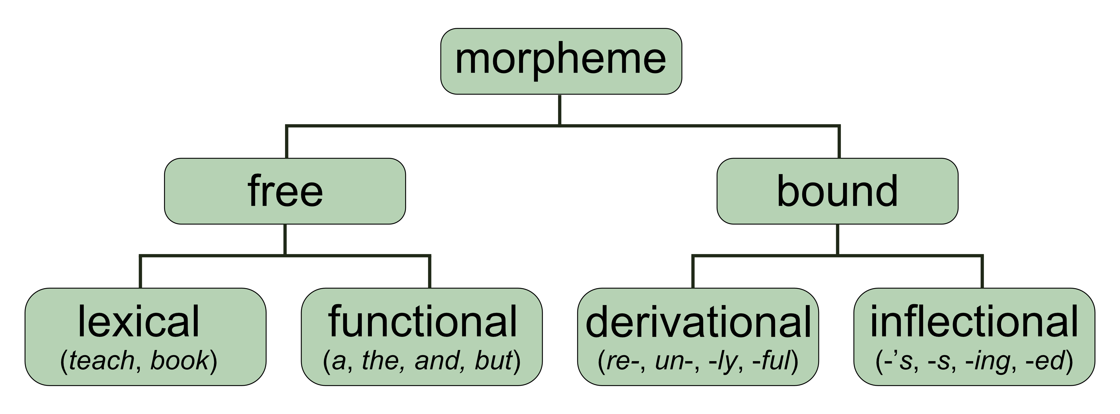

3.1. Problems in morphological description
The chart presented here conceals a number of problems in the analysis of English morphology. We have only considered examples of English words in which the different morphemes are easily identifiable as separate elements. The inflectional morpheme -s is added to cat and we get the plural cats. What is the inflectional morpheme that makes sheep the plural of sheep, or men the plural of man? These two words are clearly exception to the general pattern and have to be treated as special cases.
4.Morphs and allomorphs
Morphs are the actual forms used to realize morphemes.
e.g. the form cats consists of two morphs, cat + -s, realizing a lexical morpheme and an inflectional morpheme (“plural”).
The form buses also consists of two morphs (bus + -es), realizing a lexical morpheme and an inflectional morpheme (“plural”).
So there are at least two different morphs (-s and –es, actually /s/ and /əz/) used to realize the inflectional morpheme “plural.”
When we find a group of different morphs, all versions of one morpheme, we can use the prefix ‘allo-” ( one of a closely related set ) and describe them as allomorphs of that morpheme.

Note that the morpheme “plural” can be attached to a number of lexical morphemes to produce structures like “cat + plural,” “bus + plural,” “sheep + plural” and “man + plural”.
In each of these examples, the actual forms of the morphs that result from the morpheme “plural” are different. Yet they are all allomorphs of the one morpheme.
So, in addition to /s/ and /əz /, another allomorph of “plural” in English seems to be a zero-morph because the plural form of sheep is actually “sheep + ø”.
When we look at “man + plural,” we have a vowel change in the word (æ→ɛ) as the morph that produces the “irregular” plural form men.

