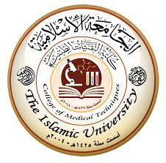
Radiology Techniques

Department

The Radiological Anatomy

Lecture 12

lung radiological anatomy

By
M.Sc. Zeyad Tareq & M.Sc. Salman Mohammed

3rd Stage
2022-2023

Lung

The lungs are the functional units of respiration and are key to survival. They contain 1500 miles of airways, 300-500 million alveoli and have a combined surface area of 70 square meters (half a tennis court). Each lung weighs approximately 1.1 kg. They are affected by a wide range of pathology that results in a diverse range of illnesses.

Gross anatomy
The lungs lie in the thoracic cavity, separated by the heart and mediastinum. While the two lungs are similar, they are not completely symmetrical, having a different number of lobes and a different bronchial and vascular anatomy. In most individuals, the right lung is composed of three lobes subdivided into 10 segments and the left is composed of two lobes and eight segments. They are surrounded by the pleura which separates them from the chest wall.
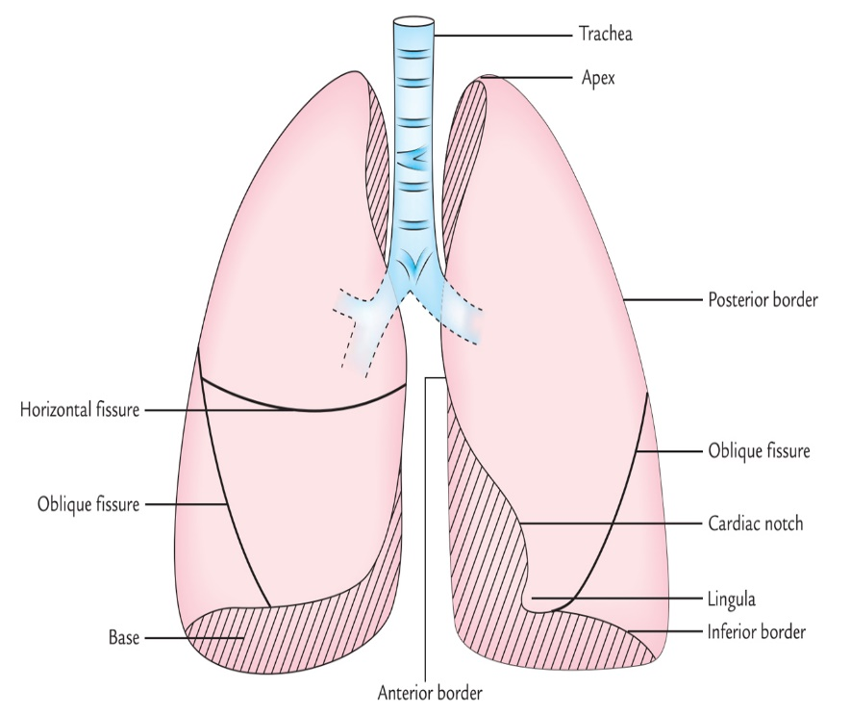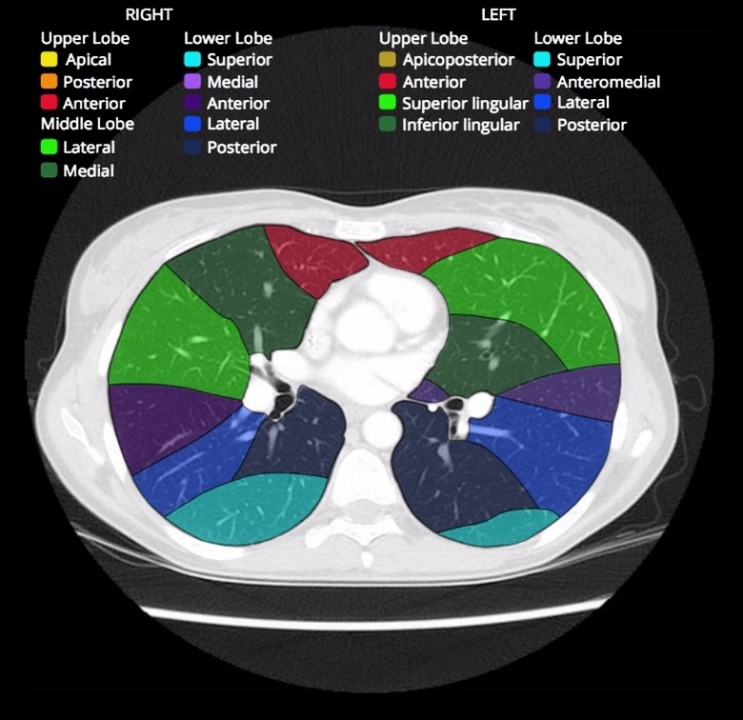

The lobes of the lungs are also incompletely separated by fissures. Each lung has an oblique fissure with a horizontal fissure also present in the right lung.

Tracheobronchial tree
The tracheobronchial tree is a branching structure of tubes of an ever decreasing diameter that start at the larynx and end in the alveoli. It can broadly be divided into conduction and respiratory zones.
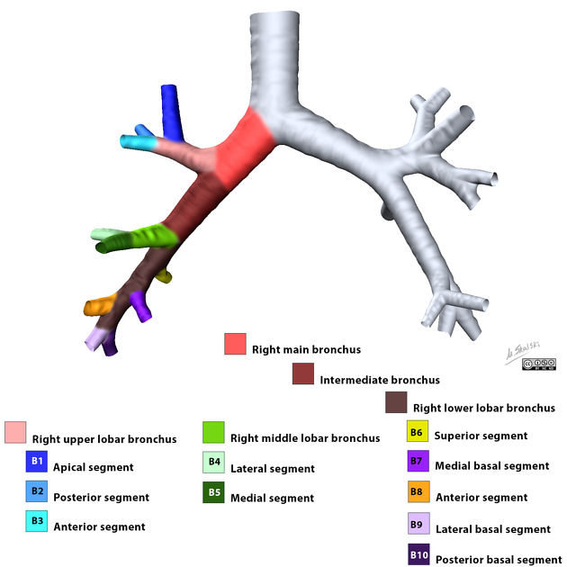

Conduction zone
Gas is warmed and humidified as it is conducted from the oropharynx to the functional portion of the lung where gas exchange occurs. The conduction zone is composed of the trachea, bronchi, bronchioles and terminal bronchioles. Their function is to optimize gas delivery to the functional portion of the lung. Their walls contain cilia to remove particulates from the inspired gas and cartilage to ensure that they do not collapse in expiration.

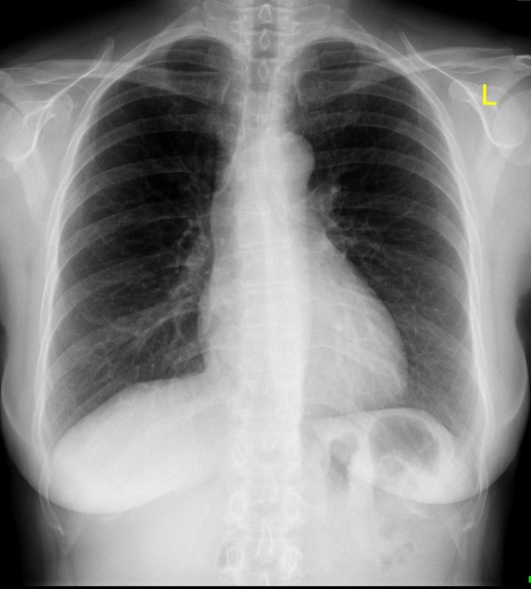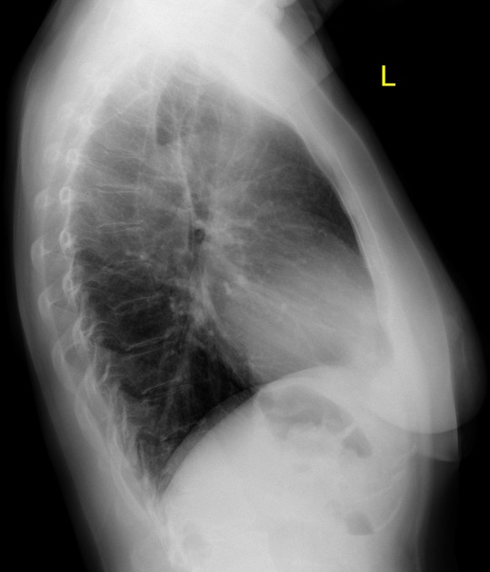
PA View Lateral View
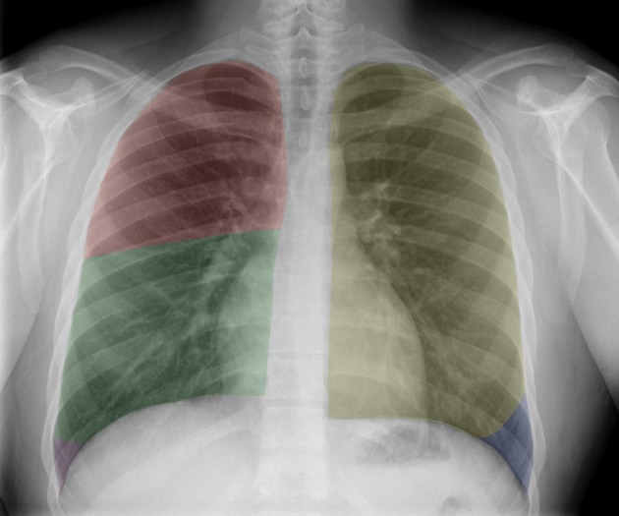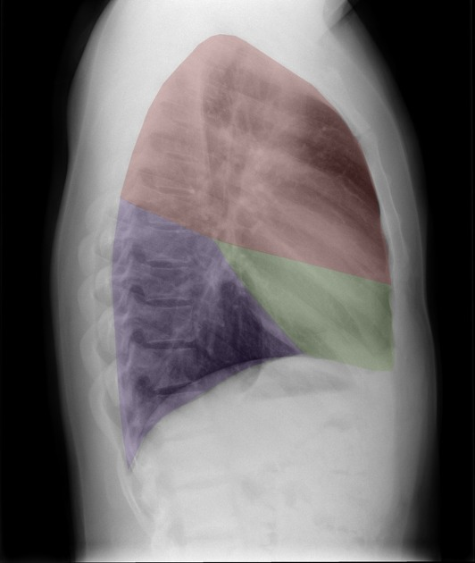
lobes on CXR lobes on lateral CXR

Respiratory zone
The respiratory zone is an extension of the tracheobronchial tree at the level of the terminal bronchioles. It is composed of respiratory bronchioles, alveolar ducts and alveoli, and is the location of gas transfer within the lung. In any organ, the parenchyma refers the functional tissues; thus, the strict definition of lung parenchyma only includes the alveoli, alveolar ducts, and respiratory bronchioles.

Arterial supply
The lungs have dual arterial supply and venous drainage: pulmonary arteries and veins as well as bronchial arteries and veins:
- pulmonary arteries: supply deoxygenated blood from the right ventricle
- bronchial arteries: branches of the thoracic aorta that supply oxygenated blood

Venous drainage
- pulmonary veins: drain into the left atrium
- bronchial veins: drain to the pulmonary veins, superior vena cava, and azygos venous system
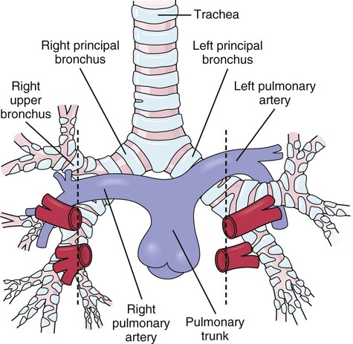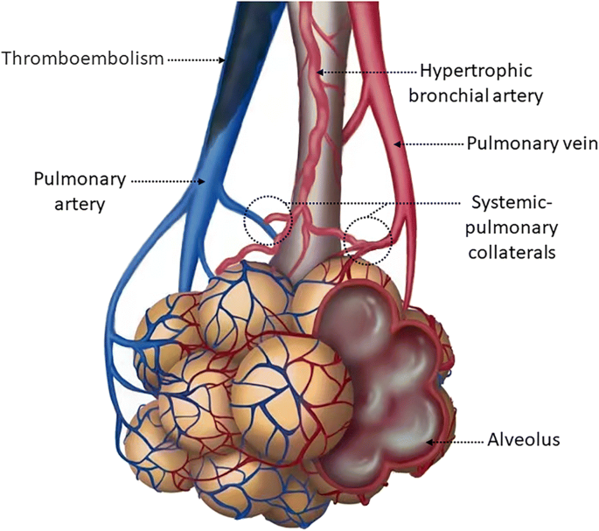

Physiology
Lung function can be controlled externally via innervation of the respiratory muscles and diaphragm. However, control of the bronchi significantly affects respiratory function and gas exchange.

Related pathology
- airway disease
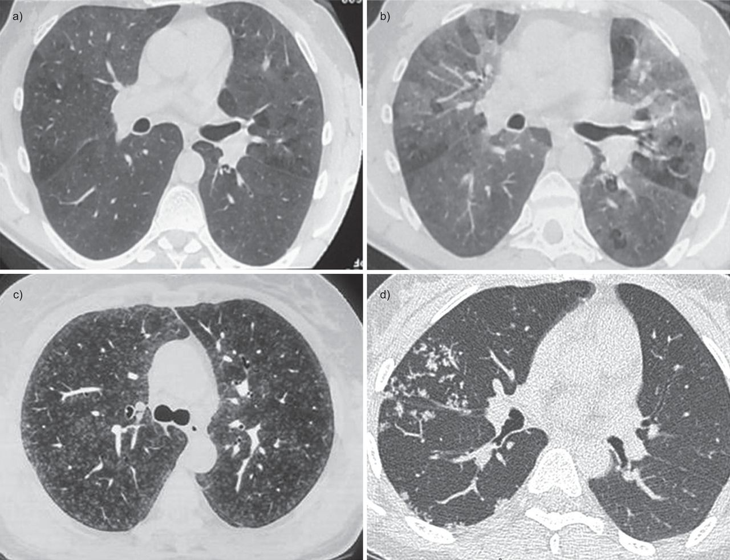

Small airways diseases, excluding asthma
- interstitial diseases
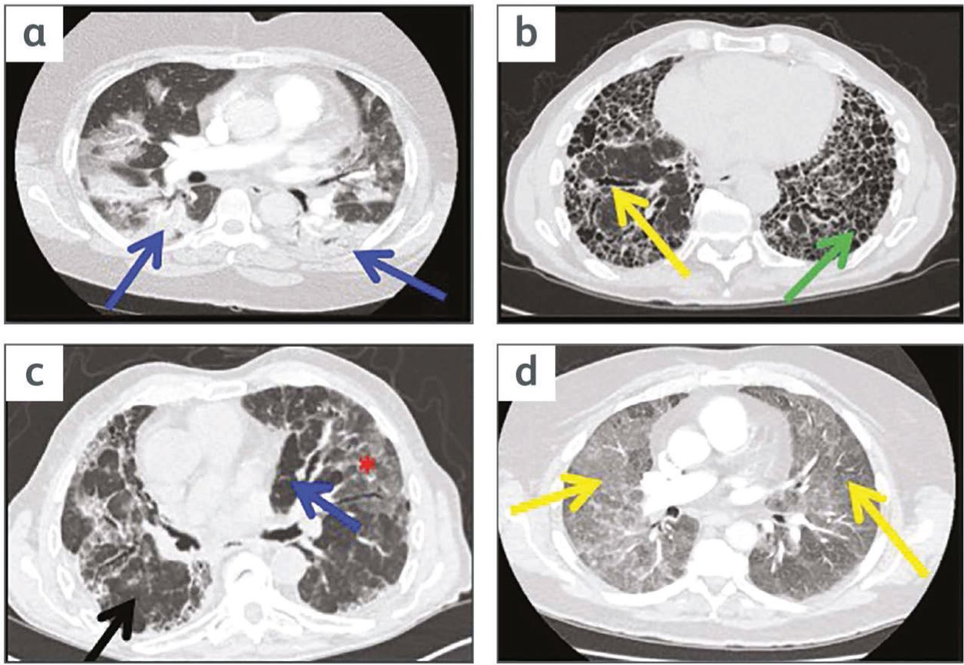

Interstitial lung disease on the acute take for the non-respiratory physician
Thanks

