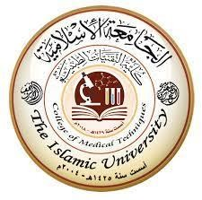

Radiology Techniques Department
The Radiological Anatomy Lecture 2
Liver and Biliary Tree
By
M.Sc. Zeyad Tareq & M.Sc. Salman Mohammed
3rd Stage

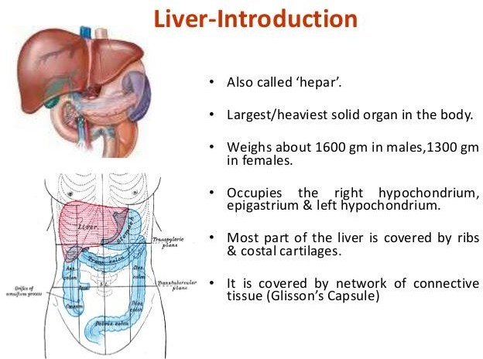
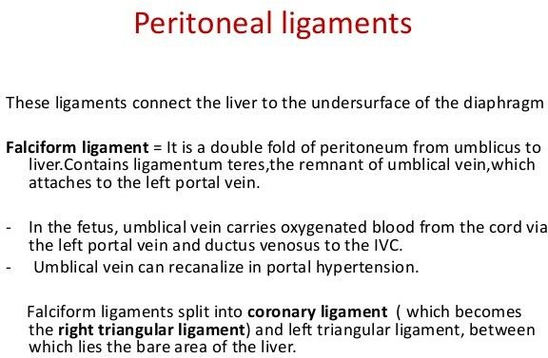

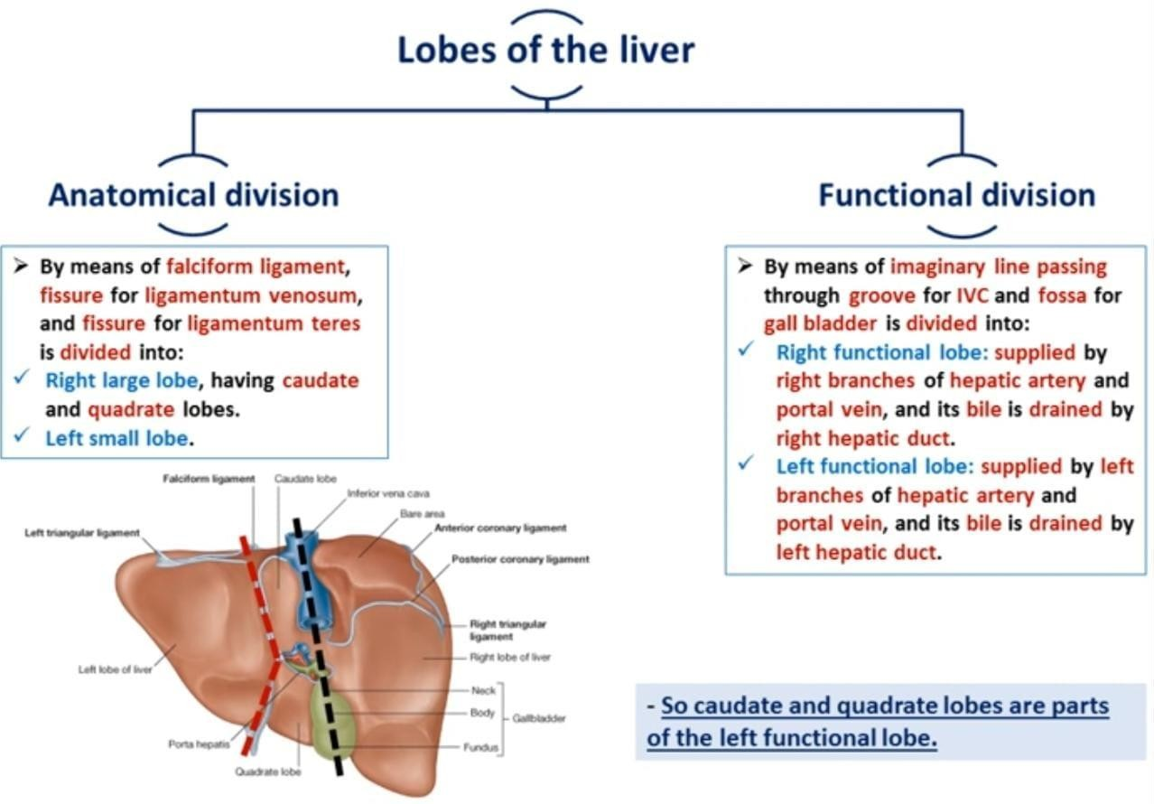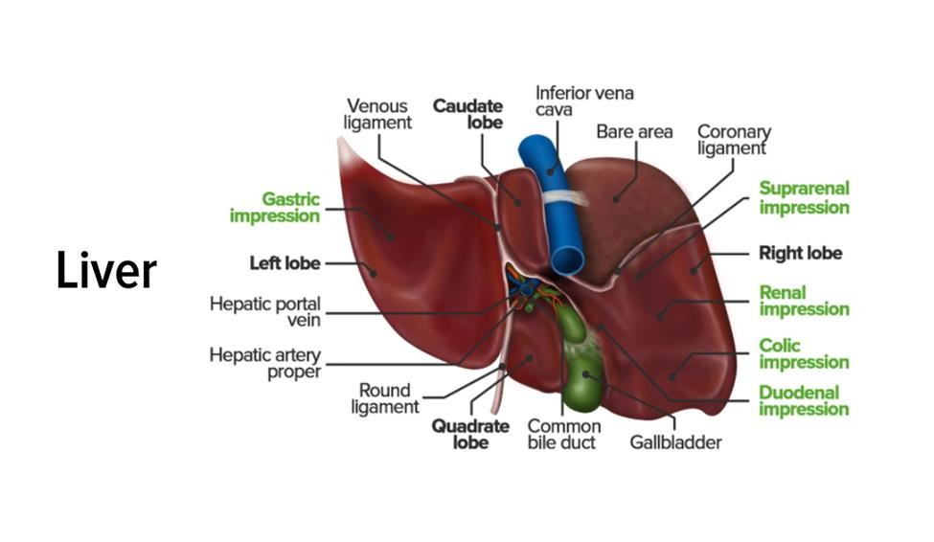

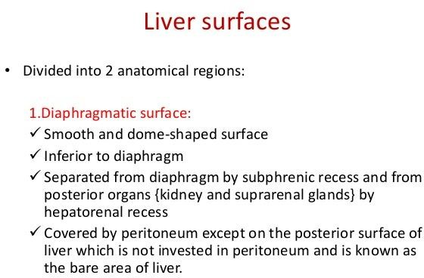

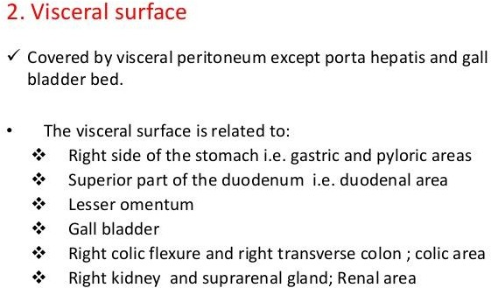

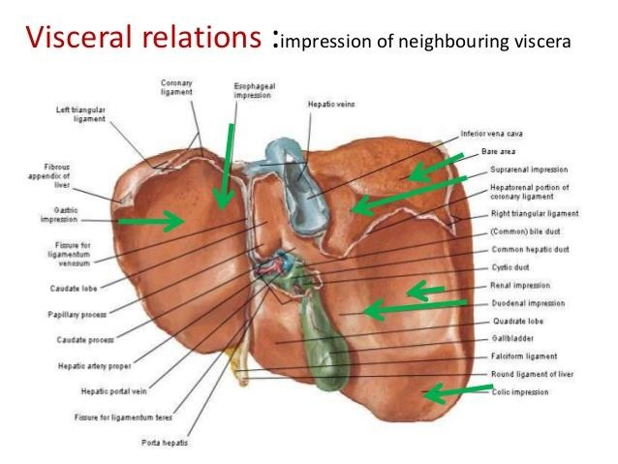

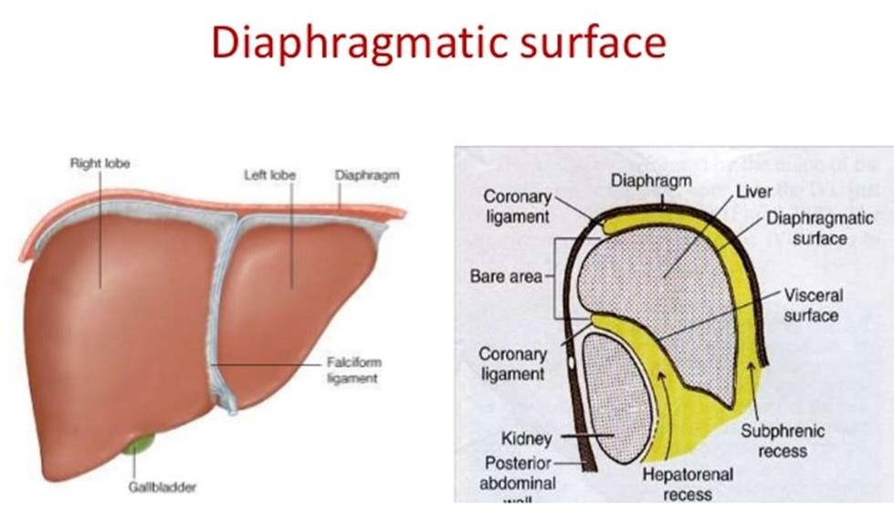

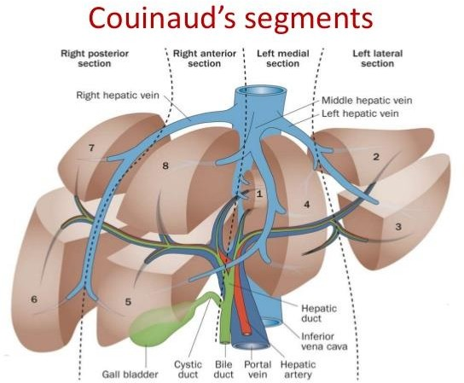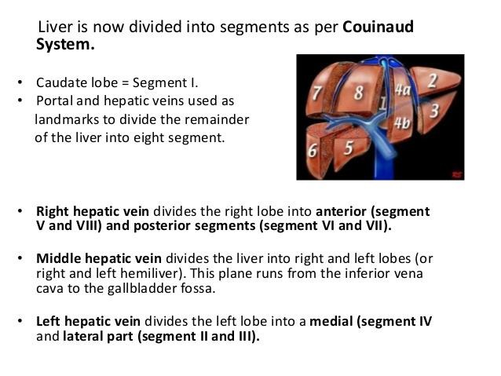

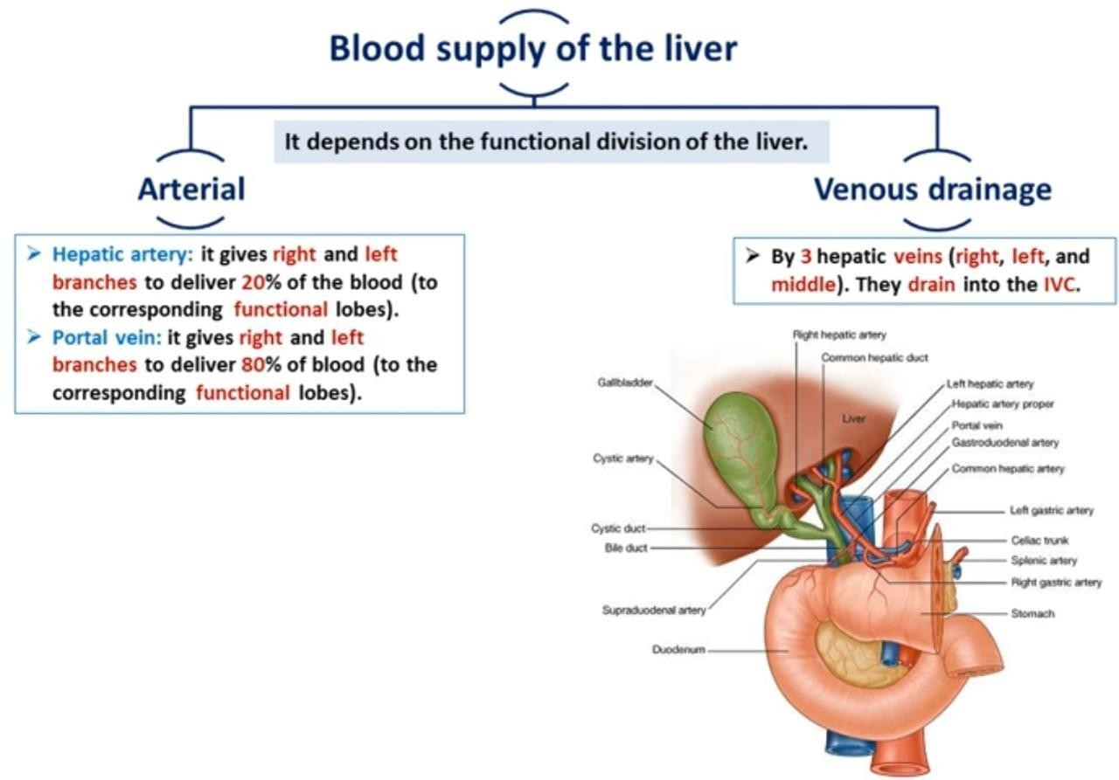

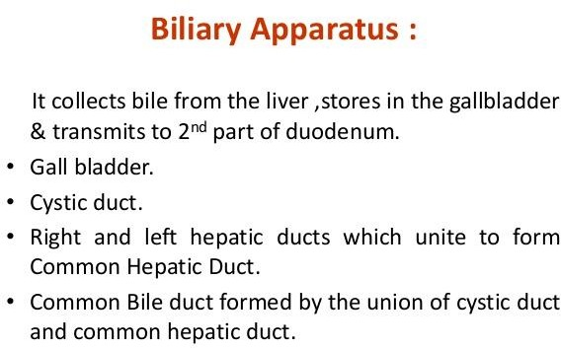

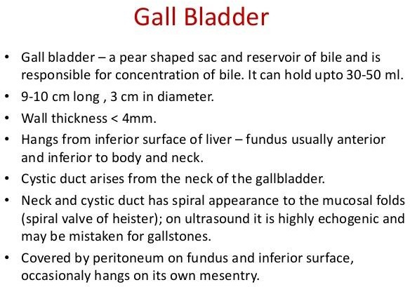

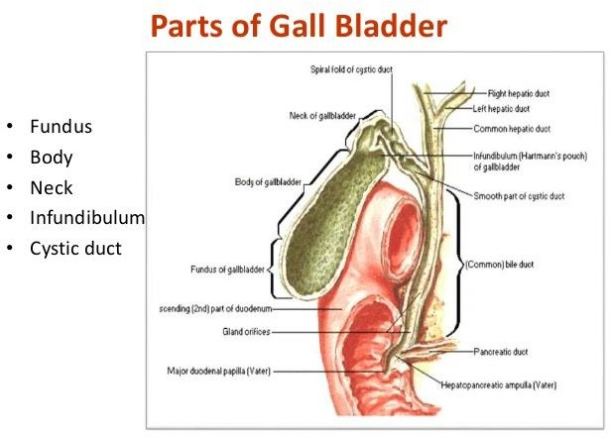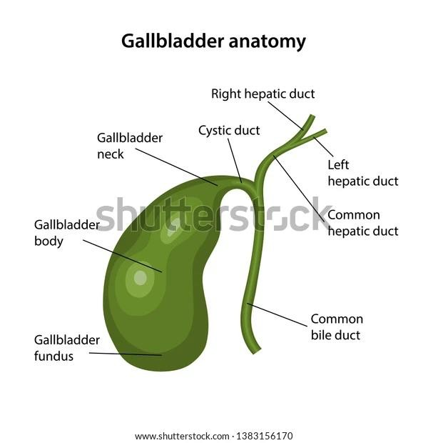

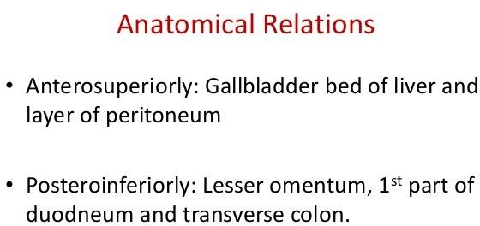

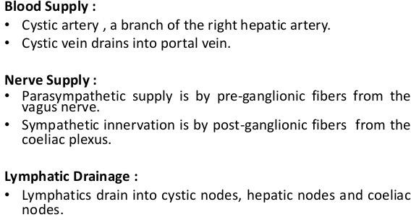

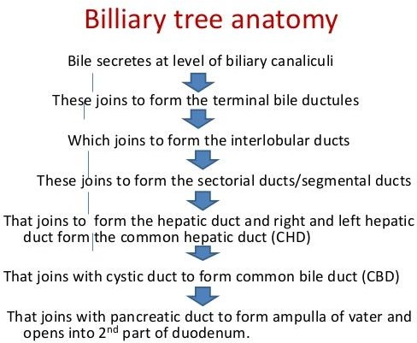

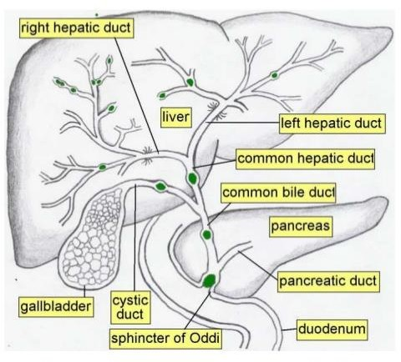

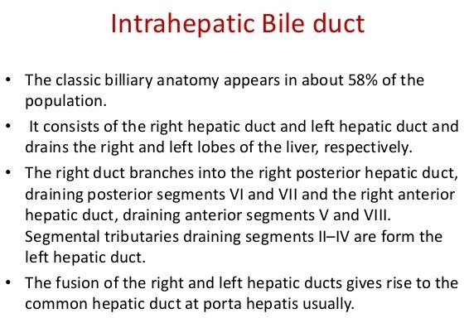

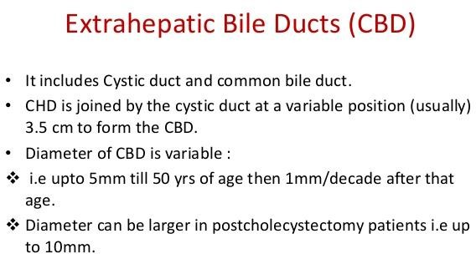

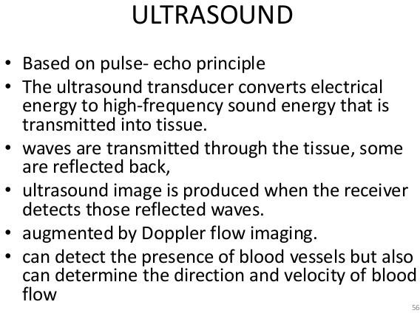

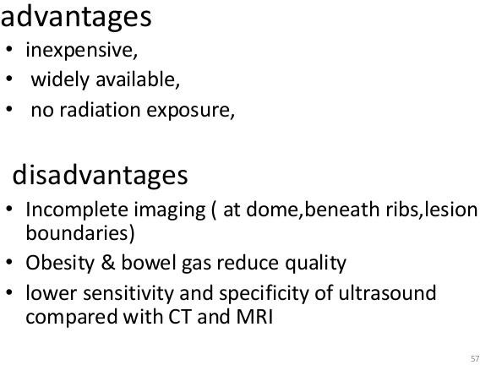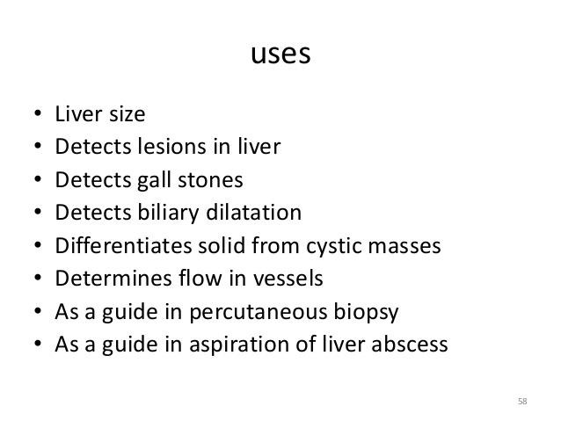

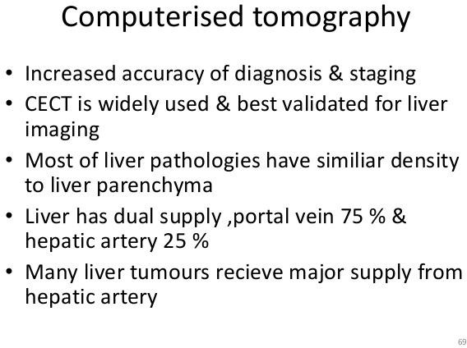
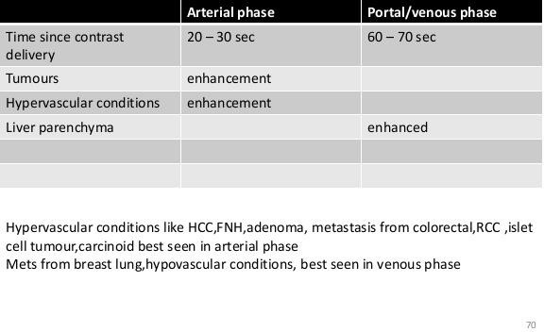

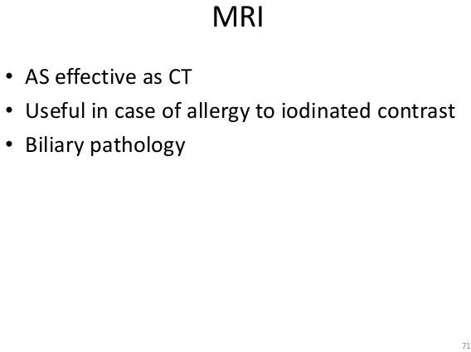

- On MRI the liver is of equal signal intensity to the pancreas and higher on T1- and lower on T2-weighted images the spleen.
- Normal hepatic vessels are seen as areas of signal void on standard imaging.
- The major hepatic veins and the secondary branches of the portal veins are visible.
- Hepatic arteries are less well seen unless intravenous contrast is given.
- The intrahepatic biliary radicals are seen on fluid-sensitive imaging in MR cholangiography.
- On T2-weighted images the ligamentum venosum and the ligamentum teres are of low intensity but the fat within their fissures is of high intensity.

- As with CT and ultrasound, the hepatic veins and these fissures aid in identification of segments and lobes of the liver than hepatic arteriography
- This is achieved via the aorta and the coeliac trunk with greater selectivity if the contrast agent is injected distal to the origin of the gastroduodenal artery.
- MR and CT angiography can also produce excellent images of the coeliac trunk and SMA.
- These are acquired after the injection of gadolinium or iodine contrast agents intravenously as a bolus, after several seconds to allow the contrast to pass into the arterial system.
- In both techniques axially acquired data can be displayed in any plane.
- With MR, angiographic images can also be acquired without contrast using flow-sensitive imaging techniques.

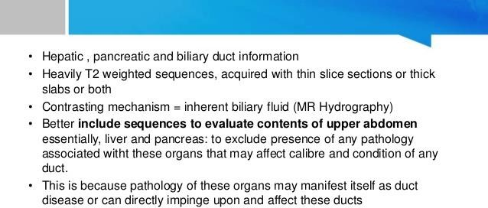
MRCP
