

Radiology Techniques Department

The Radiological Anatomy

Lecture 9

Portal venous system

By
MS.c Zeyad Tareq & MS.c Salman Mohammed

3rd Stage

2022-2023

PORTAL VENOUS SYSTEM

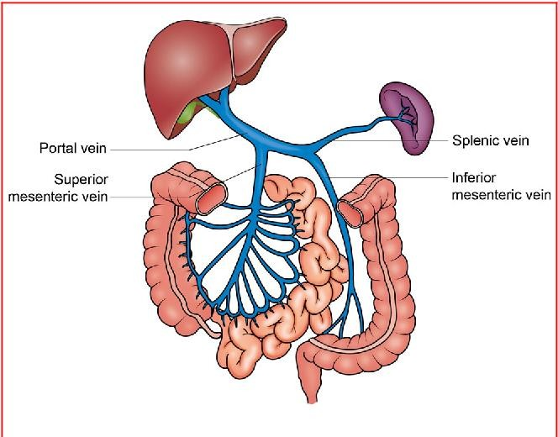
Portal venous system drain blood to Liver from:

Gastrointestinal tract (GIT)

Spleen
- Pancreas
- Gall bladder

PORTAL VENOUS SYSTEM

Inferior mesenteric vein
Superior mesenteric vein
Splenic vein
Unite together

Portal Vein

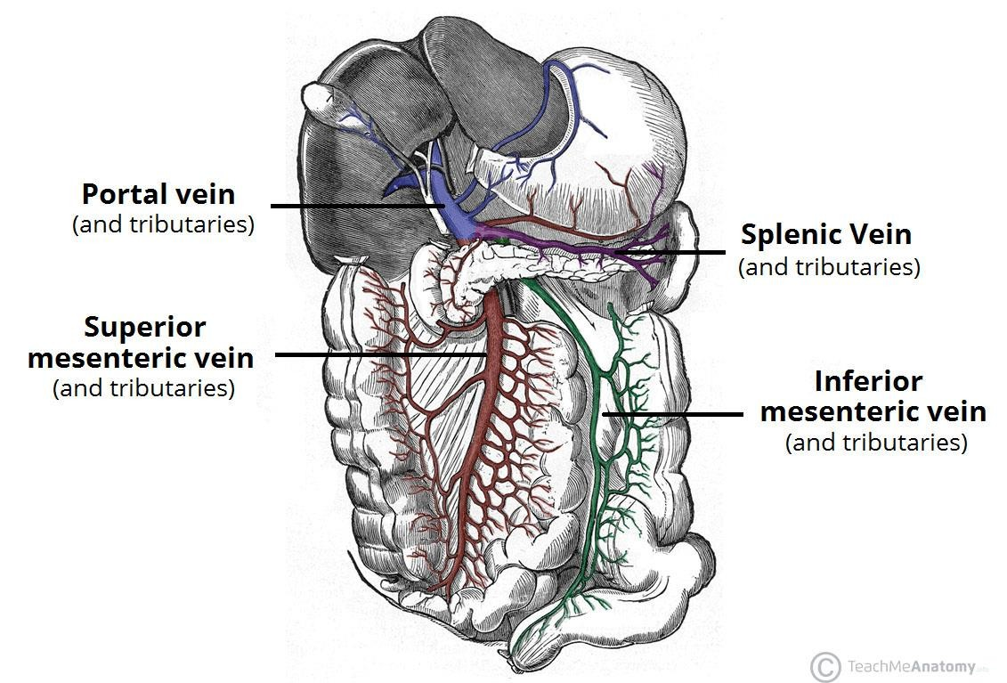


SUPERIOR MESENTERIC VEIN
- Lies to the Right of Superior Mesenteric Artery it Drains the:
  - Small Intestine
  - Cecum
  - Ascending and Transverse parts of the Colon

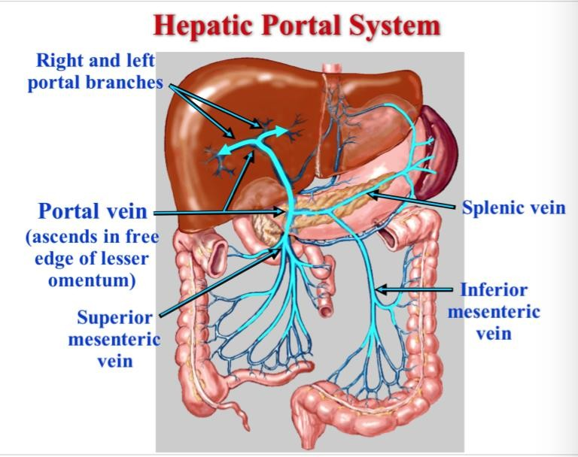


INFERIOR MESENTERIC VEIN
- LIES TO THE LEFT OF INFERIOR MESENTERIC ARTERY
- IT DRAINS THE HINDGUT COMPRISING OF:
1- Distal Transverse Colon
- Descending Colon
- Sigmoid Colon
- Rectum

SPLENIC VEIN
- 4 or 5 branches leave the splenic hilum and unite to form the splenic vein
unites with the superior and inferior mesenteric veins to form the portal vein behind the neck of the pancreas.

COURSE OF THE PORTAL VEIN
Is Formed By The Union Of Superior And Inferior Mesenteric Veins With The Splenic Vein Behind The Neck Of The Pancreas At The Level Of L1, L2 Lumbar Vertebrae
- Then it passes behind the first part of duodenum and receives the left and right gastric veins
- At porta hepatis it divided into right and left branches

RADIOLOGY
Plain abdomen: it is not visible
US :
  - Visible when it is posterior to the common bile duct and hepatic artery
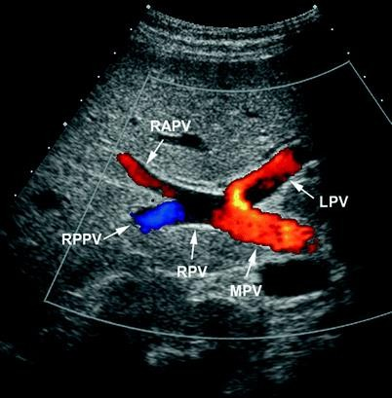
  - its diameter is greater than that of the common bile duct


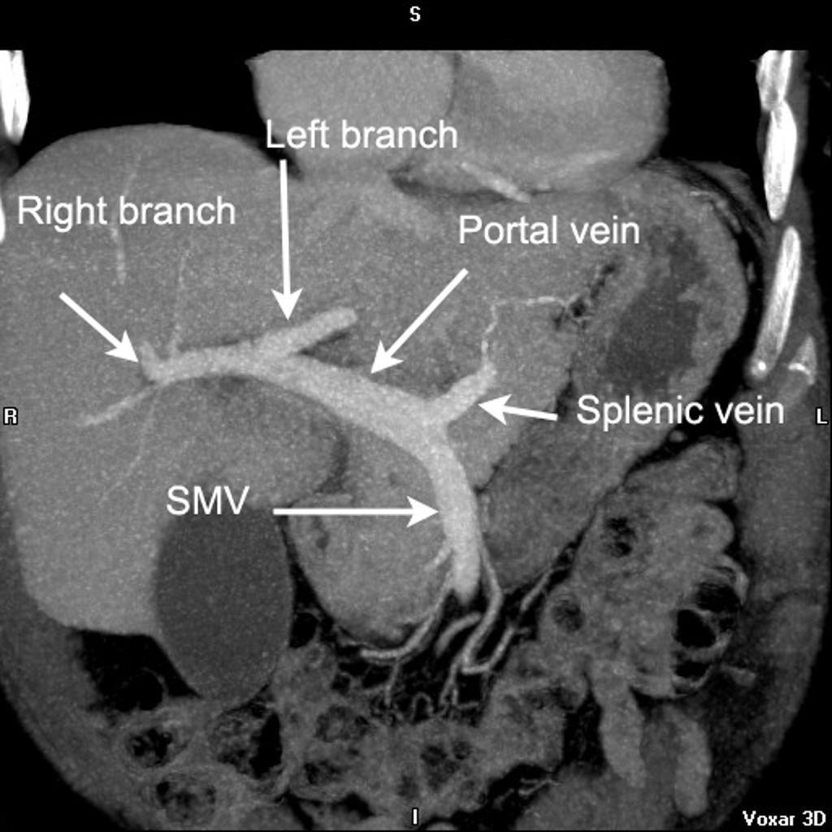



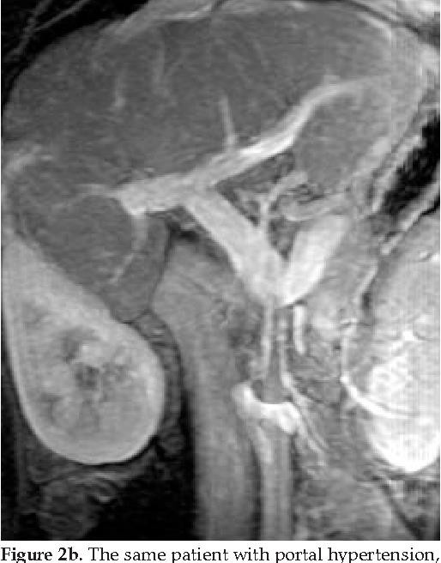

CT

MR



