

Radiology Techniques Department

The Radiological Anatomy

Lecture 8

Reproductive tract

By
MS.c Zeyad Tareq & MS.c Salman Mohammed

3rd Stage

2022-2023
Female reproductive tract
The vagina:
- Is an extra-peritoneal structure
- Superiorly the cervix of the uterus
- The cervix invaginates the upper vagina and divides it into anterior, posterior and lateral fornixes
- Anterior to vagina: base of bladder and the urethra.
- Posterior to upper vagina is the pouch of Douglas
- Posterior and below pouch of Douglas is the rectum
* Pouch of Douglas is a peritoneal reflection

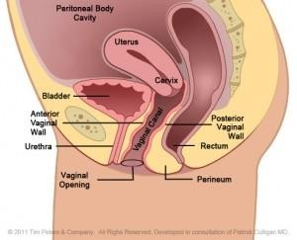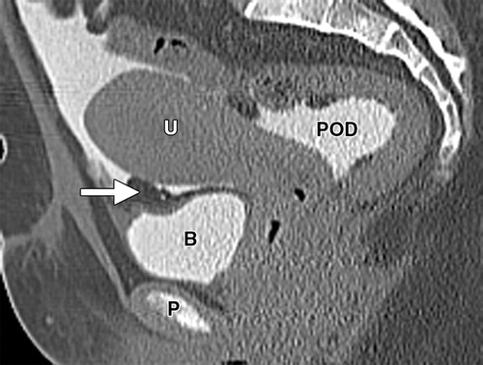
Pouch of Douglas

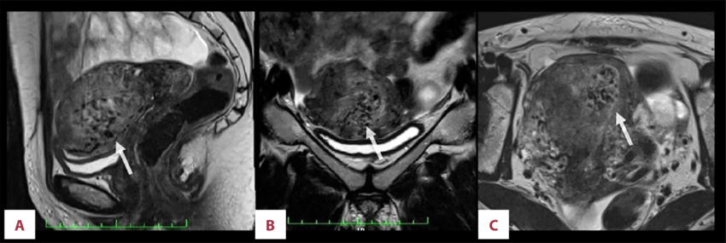
Sagittal coronal axial
The Uterus:
- Is extra peritoneal
- Pear shape organ
- Lies between the bladder and rectum
Consists from 3 parts: 1. Fundus 2. Body 3. Cervix

- The cavity of the uterus is triangular in coronal section
- The cervix contains the cervical canal with upper opining called (internal Os) and lower opining called (external Os)
- The inner lining of the uterus called the Endometrium
The cervical os is part of the cervix, which is in the lower part of the uterus.
It connects the main part of the uterus to the vagina.
The cervix is about 2 inches in length but can vary in length and width during a woman's lifetime.
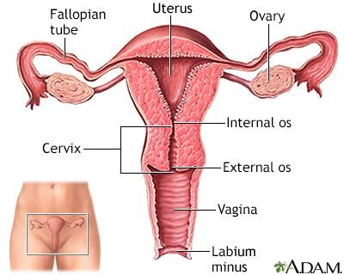
Lateral fornix

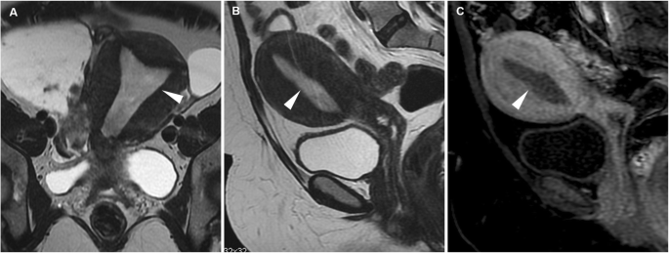
T2 T1 FS T1
- The peritoneum covers the fundus, cervix, and upper part of the vagina posteriorly then it is reflected to the anterior surface of the rectum forming the pouch of Douglas.
- On either side of the uterus the peritoneum is reflected to lateral pelvic walls covering the Fallopian tube, the fold of peritoneum formed is called the Broad ligament.

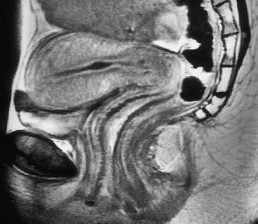
The uterus
The vagina
Hysterosalpingography
- This technique outlines the cavity of the uterus and tubes by injecting a water- soluble contrast via the cervical canal
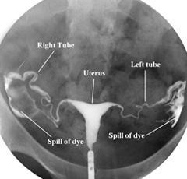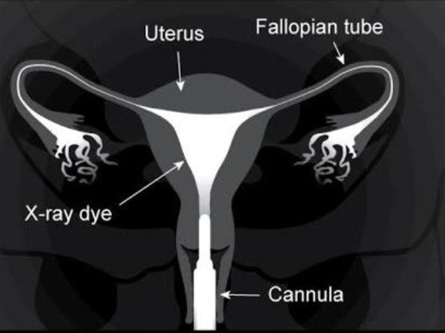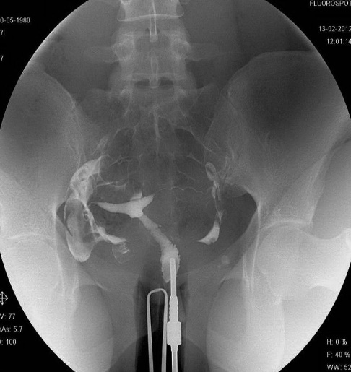
Cross sectional pelvic anatomy:
Mid sacral level (female).
- The level is above the bladder.
- The sigmoid colon may be seen close to its junction with the rectum.
- The sacrum lies posteriorly.
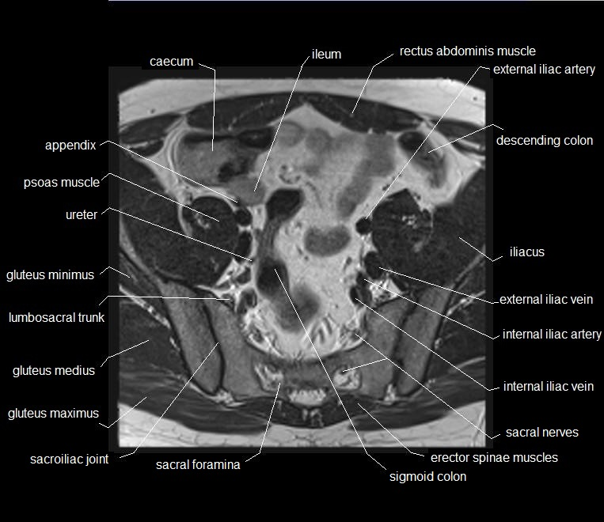
Cross sectional pelvic anatomy:
Lower sacral level (female)
- The uterus is seen in close contact with the posterior surface of the bladder
- The ovaries are either lateral to uterus or behind the ureters seen at posterior-lateral aspect of the bladder
- Perimetrium: The outer most, protective layer.
- Myometrium: The highly muscular middle layer. This is what expands during pregnancy and contracts to push baby out during normal labor.
- Endometrium: The inner layer or lining of the uterus (uterine lining). This layer of uterus is shed during the menstrual cycle.
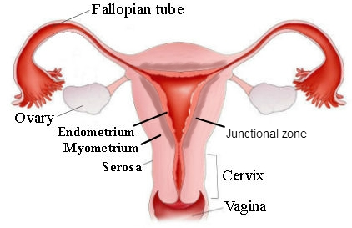
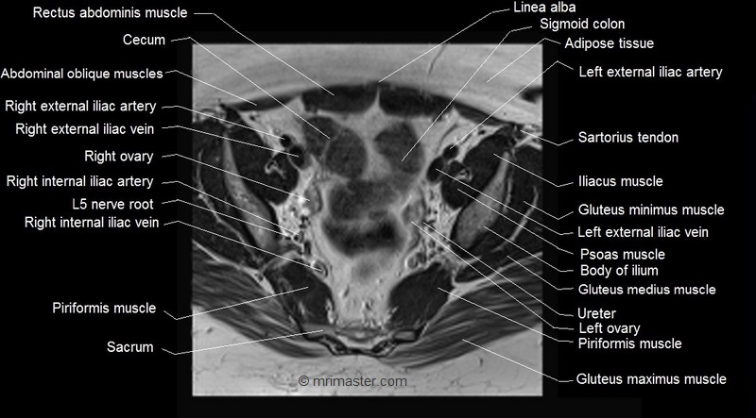
Cross sectional pelvic anatomy:
Lower sacral level (Male)
- The bladder seen to have square shape (when it contains urine).
- It extends anteriorly.
- Posteriorly are the seminal vesicles.
- The rectum is just behind the seminal vesicles.
- The ureters seen at posterior-lateral aspect of the bladder.




