

Radiology Techniques

Department

The Radiological Anatomy

Lecture 7

Urination System
By
M.Sc. Zeyad Tareq & M.Sc. Salman Mohammed
3rd Stage
2022-2023
The Kidneys

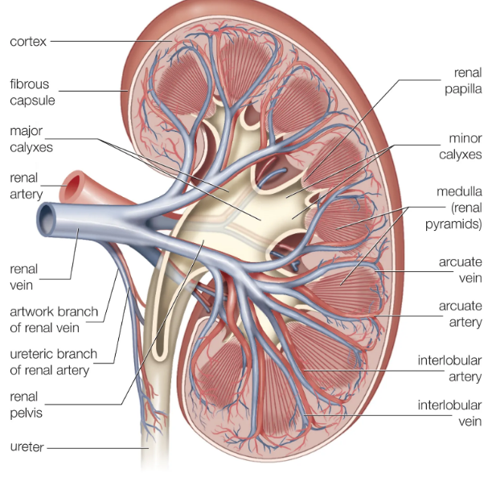
- The kidneys lie retroperitoneally in the paravertebral gutters of the posterior abdominal wall.
- They lie obliquely with their upper poles more medial and more posterior than their lower.
- The kidneys measure 10-15 cm in length.
- The left being commonly 1.5 cm longer than the right.
- Their size is approximately that of three-and-a-half lumbar vertebrae and their associated discs on a radiograph.
- On coronal cross-section each kidney is seen to have an outer cortex and an inner medulla.
- Extensions of the cortex centrally as columns separate the medulla into pyramids whose apices, jutting into the calyces, are called the papillae.
- Here are usually seven pairs of minor calyces, each pair having an anterior and a posterior calyx, although there is wide variation. Minor -calyx pairs combine to form two or three major calyces, which in turn drain via their infundibula to the pelvis.
- The hilum of the kidney lies medially, that of the left at L1 vertebral level and that of the right slightly lower at L1/L2 level, owing to the bulk of the liver above.
- At the hilum, the pelvis lies posteriorly and the renal vein anteriorly with the artery in between. The artery may branch early and a posterior arterial branch may enter the hilum posterior to the pelvis.
- Lymph vessels and nerves also enter at the hilum.
- The functional subunit of the kidney is called the nephron and consists of a glomerulus in the cortex and a tubule in the medulla. This drains to a collecting duct, which empties into the calyx at the tip of the medulla. The kidney has approximately 1 million nephrons.
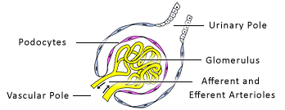

- The renal arteries normally arise from the aorta at L1/L2 level. The right renal artery is longer and lower than the left and passes posterior to the IVC.
- Both renal arteries usually have two divisions: one passes posterior to the renal pelvis and supplies the posterior upper part of the kidney; another anterior branch supplies the upper anterior kidney; a branch of the anterior division passes inferiorly and supplies the entire lower part of the kidney.

Venous drainage
- There is extensive anastomosis between the veins of the kidney. Five or six interlobular veins unite at the hilum to form the renal vein. The renal vein lies anterior to the pelvis at the hilum. The renal veins drain directly to the IVC.
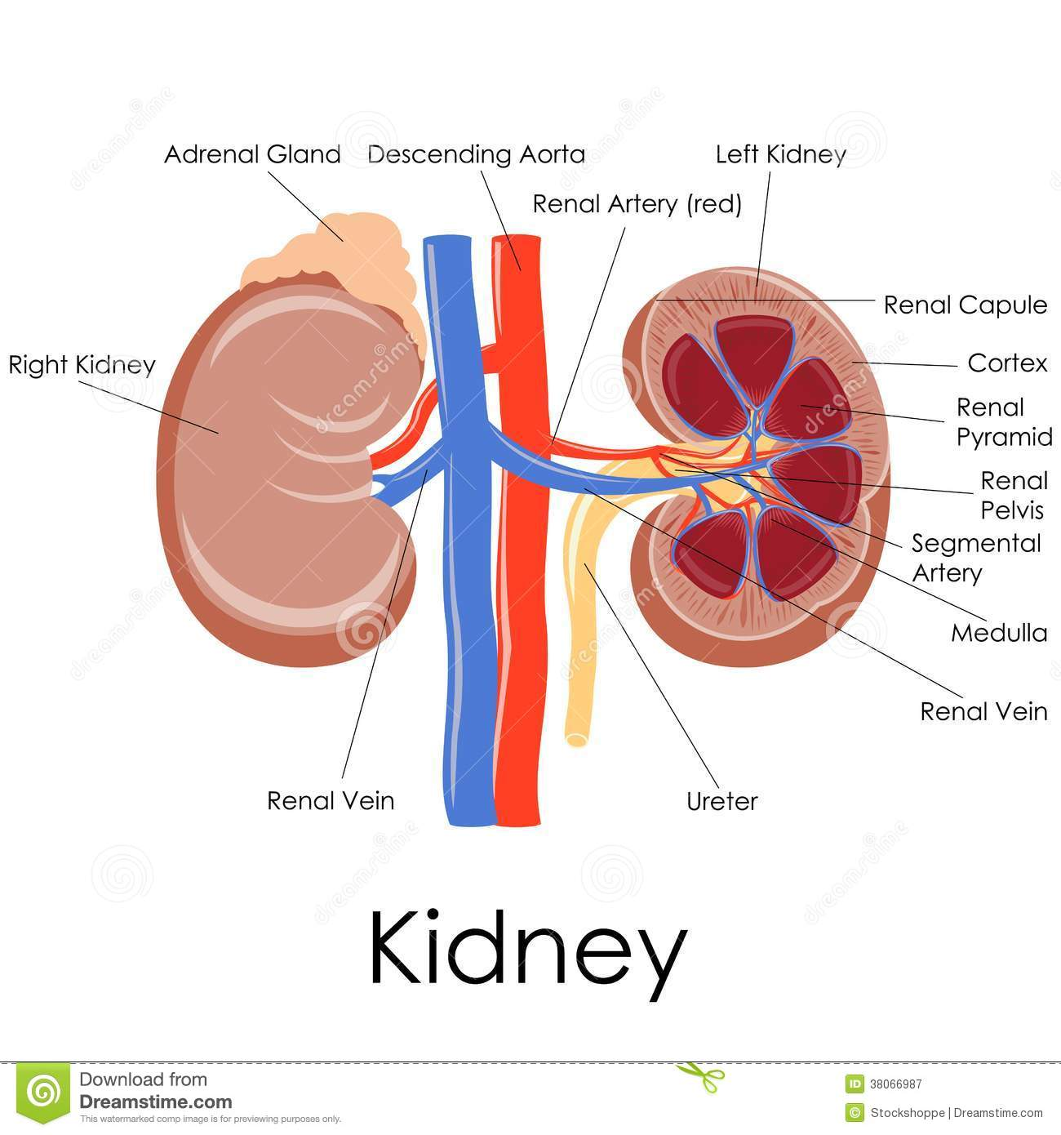
- The left renal vein is much longer than the right and asses anterior to the aorta to reach the IVC. It also receives the inferior phrenic, adrenal and gonadal veins of that side. The right renal vein receives no extrarenal tributaries.

Fascial spaces around the kidneys
- A true fibrous capsule surrounds the kidney. This, in turn, is surrounded by perirenal fat, which separates the kidney from the surrounding organs including the adrenal gland.
- A condensation of fibro areolar tissue around these fat forms the renal fascia. Thus the retroperitoneum is divided into three compartments: the perirenal space within the renal fascia, and the anterior and posterior pararenal spaces anterior and posterior to the renal fascia.
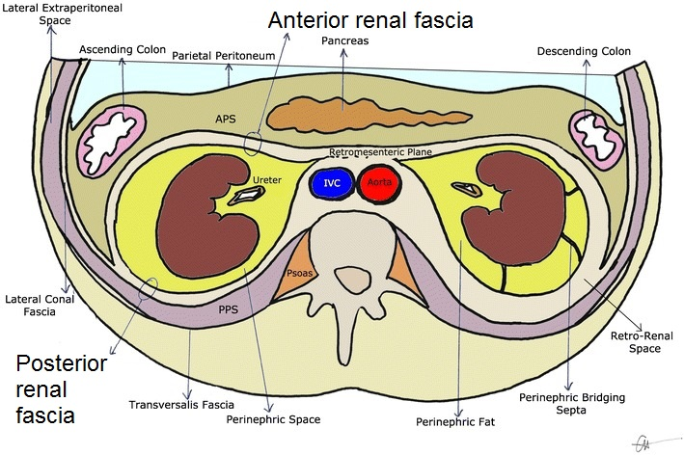

- The ureters convey urine from the kidneys to the bladder. Each is 25-30 cm long and is described as having a pelvis and abdominal, pelvic and intravesical parts.
- The pelvis has been described with the kidney.
- The remainder of the ureter has a diameter of about 3 mm but is narrower at the following three sites:
- The junction of the pelvis and ureter
- The pelvic brim
- The intravesical ureter where it runs through the muscular bladder wall.

The abdominal ureter passes on the medial edge of the psoas muscle, which separates it from the tips of the transverse processes.

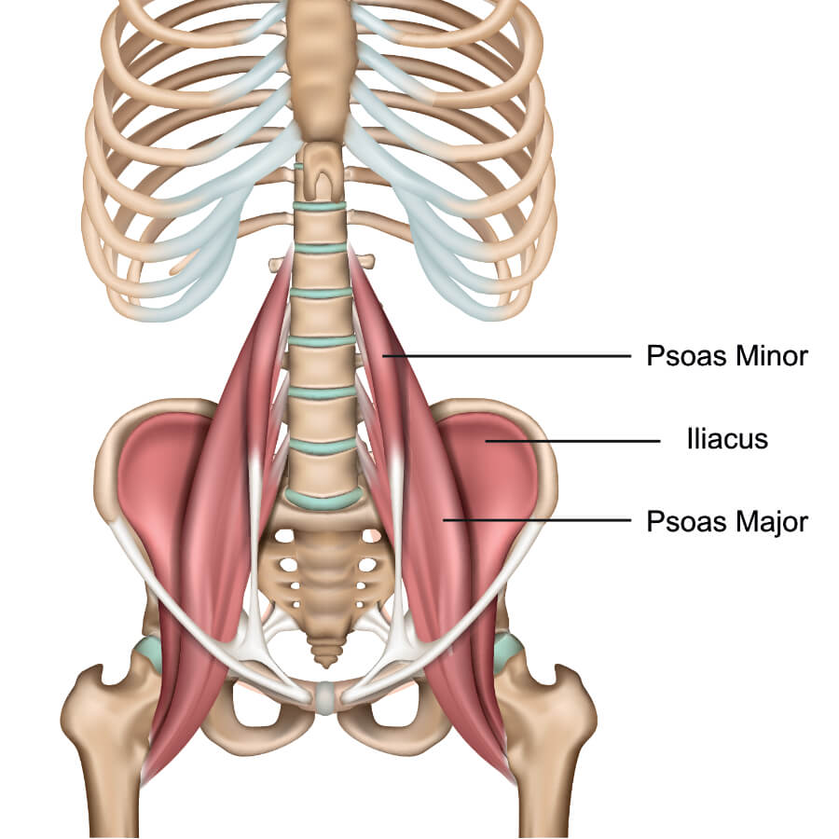
The intravesical portion of the ureter has an oblique course of 2 cm through the bladder wall. The vesical muscle has a sphincteric action and the obliquity has a valve-like action. The ureter opens into the bladder at the ureterovesical orifice.
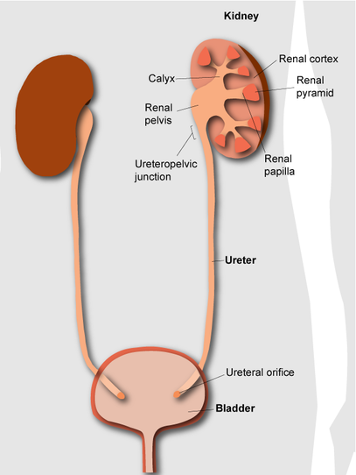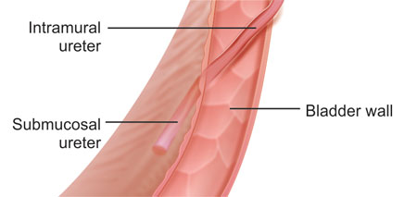
Adrenal Gland

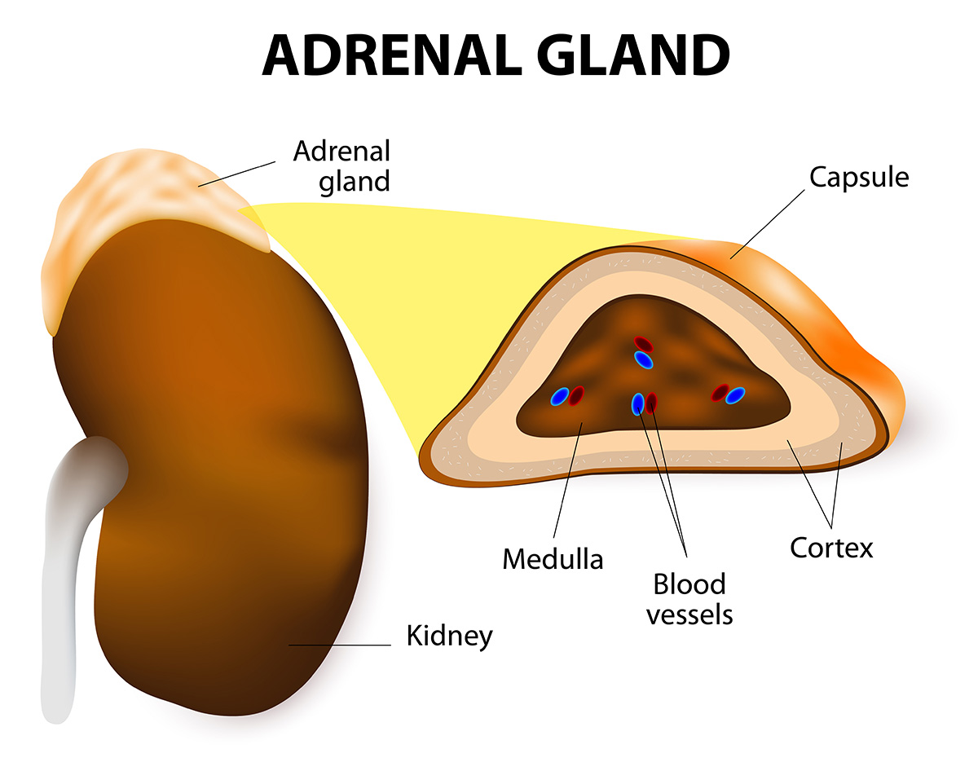

The adrenal glands lie retroperitoneally above each kidney. They are each enclosed within the perirenal fascia but in a separate compartment from the kidney. Each gland is composed of a body and medial and lateral limbs. The adrenal glands have an outer cortex derived from mesoderm and an inner medulla (10% of the weight of the gland), which is derived from the neural crest and is related to the sympathetic nervous system.
The right adrenal gland tends to have a consistent location. It lies posterior to the inferior vena cava, medial to the right lobe of the liver and lateral to the right diaphragmatic crus. It is lower and more medial in relation to the spine than the left. On cross-section it is linear or V-shaped, with a larger medial limb and a smaller lateral limb.
The left adrenal gland lies posterior to the splenic vein and lateral to the diaphragmatic crus, but its position is less consistent than that of the right side.
The left adrenal gland is more semilunar than the right and it extends down the superomedial border of the kidney towards the hilum. On cross-section it is triangular or Y-shaped.
At birth the adrenal glands are relatively much larger than in the adult - one third the size of the kidney at birth and one-thirtieth in the adult. The size of the gland is somewhat variable.
Arterial Supply
Three arteries supply these glands on each side, namely:
- The superior adrenal artery from the inferior phrenic artery.
- The middle adrenal artery from the aorta, and
- The inferior adrenal artery from the renal artery.

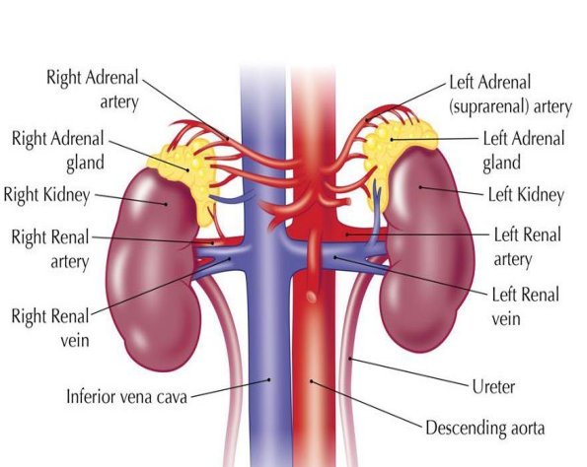
Venous drainage
One vein drains the adrenal gland on each side. The right adrenal vein drains to the IVC and the left adrenal vein drains to the left renal vein.

The bladder
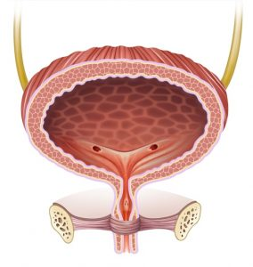
This is a pyramidal muscular organ when empty. It has a triangular-shaped base posteriorly. The ureters enter the posterolateral angles and the urethra leaves inferiorly at the narrow neck, which is surrounded by the (involuntary) internal urethral sphincter. It has one superior and two inferolateral walls, which meet at an apex behind the pubic symphysis.
Blood supply of the bladder
The bladder is supplied via the internal iliac artery via superior and inferior vesical arteries. Venous drainage is via a venous plexus to the internal iliac vein.
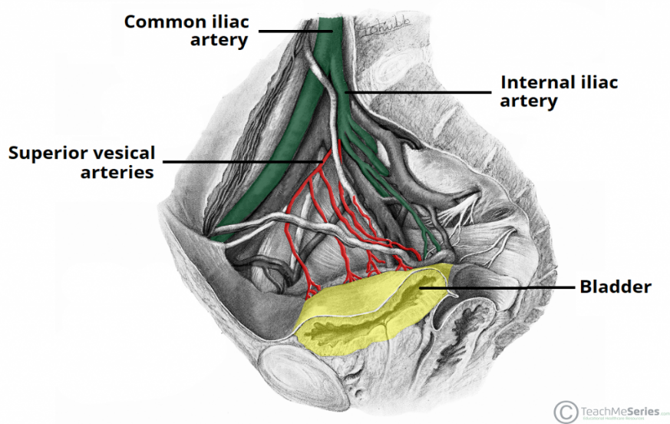
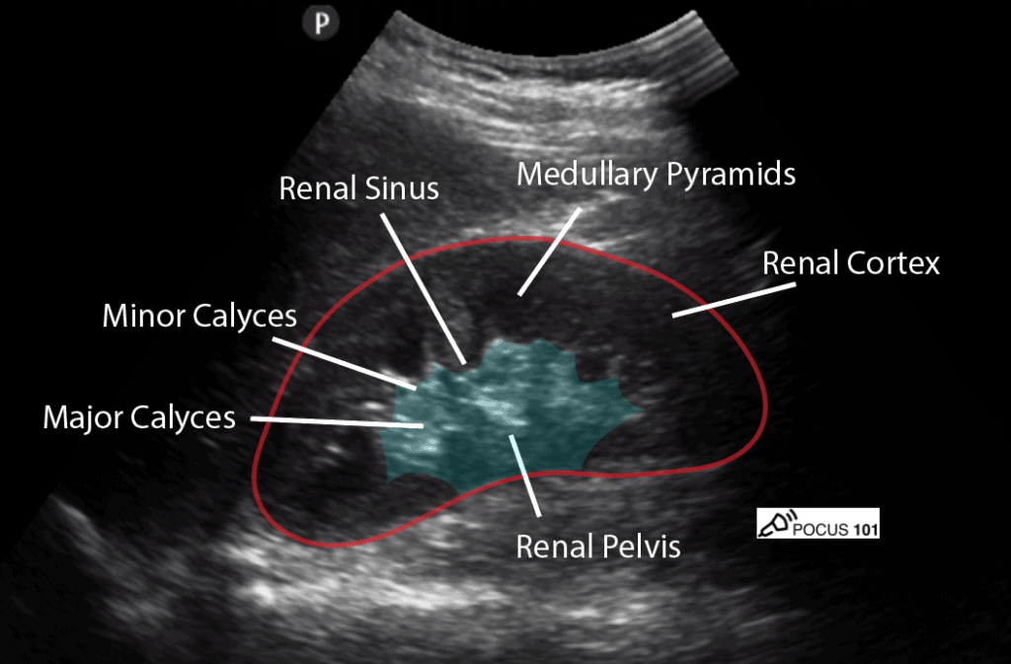
Ultrasound of kidney to show combinations and size of renal, there are some indicators for explain that important parts in picture.

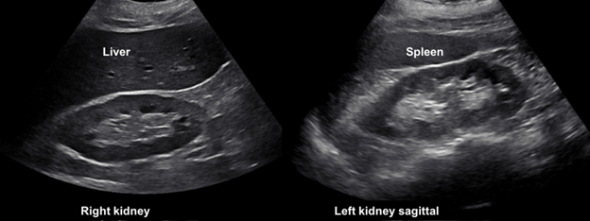
Ultrasound of normal both kidneys, liver and spleen to show size and parenchyma of these organs with high quality resolution.

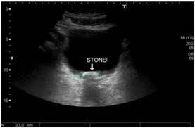
US of full bladder with stones
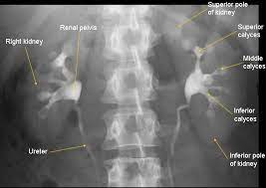
KUB view after venous injection and demonstrate excretion of contrast in renal pelvic and ureters, no any lesion, narrowing or obstruction in system.
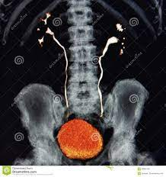
3D image of urinary system by CT scan with normal renal function and anatomy.
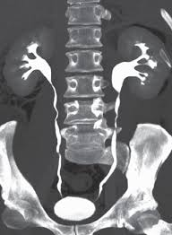
Multi planner reconstructions (MPR) image by CT scan of normal urinary system after iodine injection.
Thanks

