

Radiology Techniques Department

the Radiological Anatomy

Lecture 6

Pancreas

By
M.Sc. Zeyad Tareq & M.Sc. Salman Mohammed
3rd Stage

Pancreas
The pancreas (plural: pancreatic) is a retroperitoneal organ that has both endocrine and exocrine functions: it is involved in the production of hormones (insulin, glucagon, and somatostatin), and also involved in digestion by its production and secretion of pancreatic enzymes.

Gross anatomy

The pancreas may have the shape of a dumbbell, tadpole, or sausage.

It can be divided into four main parts:
- head: thickest part; lies to the right of the superior mesenteric vessels (superior mesenteric artery (SMA), superior mesenteric vein (SMV))
  - attached to "C" loop of duodenum (D2 and D3)
- neck: thinnest part; lies anterior to SMA, SMV
  - SMV joins splenic vein behind pancreatic neck to form portal vein
- body: main part; lies to left of SMA, SMV
  - anterior surface is covered with peritoneum forming the posterior surface of the omental bursa (lesser sac)
  - splenic vein lies in groove on posterior surface of body
- tail: lies between layers of the splenorenal ligament in the splenic hilum

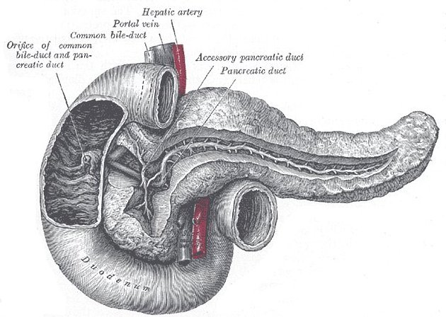
Pancreatic juice is secreted into a branching system of pancreatic ducts that extend throughout the gland. In the majority of individuals, the main pancreatic duct empties into the second part of duodenum at the ampulla of Vater.

Relations:
  - L2 vertebral body
  - right kidney hilum, portal vein, and IVC behind head
  - common bile duct grooves posterior surface of upper part of head close to duodenum
  - aorta behind neck and uncinate process
  - left kidney hilum, left suprarenal gland and right crus behind body
  - splenic vein joined by inferior mesenteric vein, and confluence of splenic vein and superior mesenteric vein to form portal vein.

Venous drainage
Venous return is by numerous small veins into the splenic hilum. From the head the superior pancreaticoduodenal vein drains into the portal vein and the inferior pancreaticoduodenal vein drains into the superior mesenteric vein.
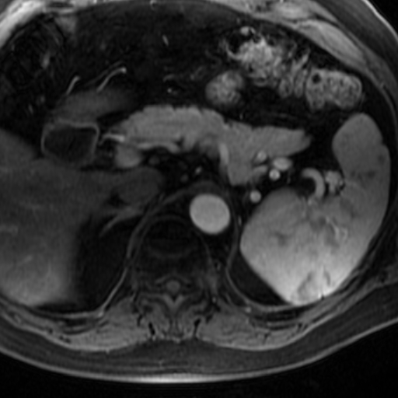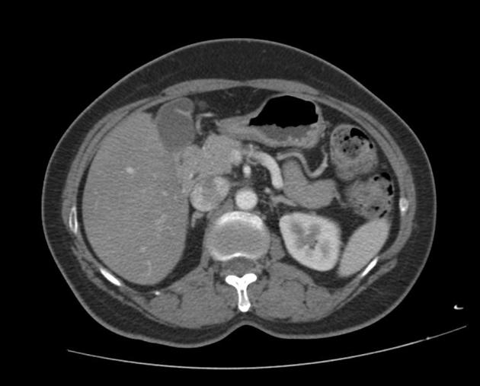
Case 1: variant - bifid pancreatic tail Case 2: variant - agenesis of the dorsal

Arterial supply
Arterial supply to the head is primarily from the inferior and superior pancreaticoduodenal arteries. Branches of the splenic artery supply the neck, body and tail via multiple branches including the dorsal pancreatic artery, greater pancreatic artery (arteria pancreatic magna) and transverse pancreatic artery.

Venous drainage
Venous return is by numerous small veins into the splenic hilum. From the head the superior pancreaticoduodenal vein drains into the portal vein and the inferior pancreaticoduodenal vein drains into the superior mesenteric vein.
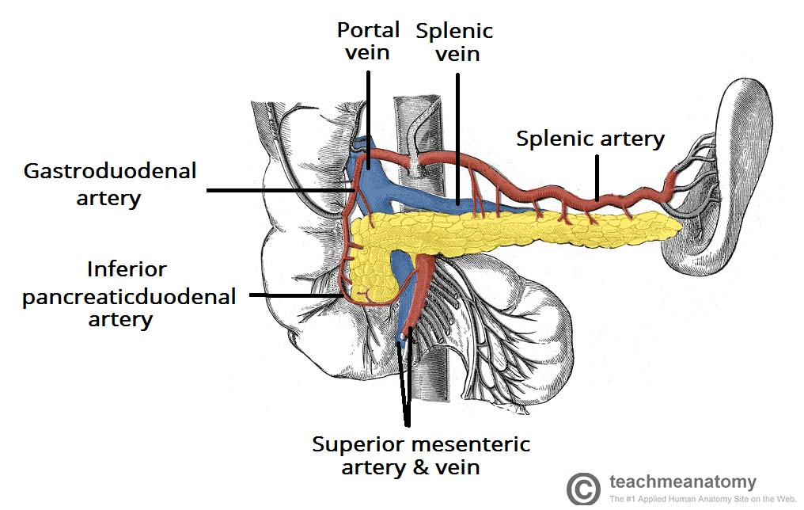
- the pancreas is a large accessory digestive gland.
- Covered with fine connective tissue but does not have a true capsule.
- Situated in the retroperitoneum in the anterior pararenal space.
- Lies in an oblique position posterior to the stomach.
- Extends across the abdomen, from the concavity of the duodenum to the splenic hilum at the level of T12/L1–L3.
- The pancreas is bordered by the lesser sac above, the transverse colon anteriorly, and the peritoneal cavity below.
- The shape of the pancreas is compared to the letter “J” turned sideways with the loop of the “J” around the duodenal C-loop.
- The average adult pancreas weighs 60–120 g and measures 15–20 cm in length.
- The pancreas’ dimensions vary from patient to patient depending on the patient’s age and habitus.
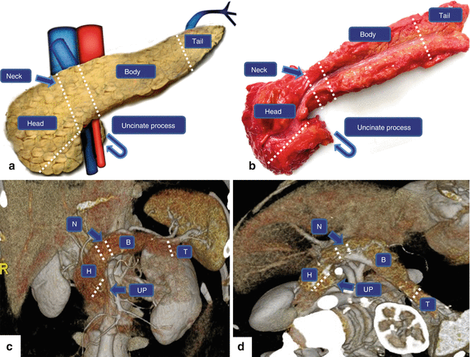

- Head
  - Widest portion of the gland; cupped by C-shaped curve of the duodenum.
  - The inferior vena cava, the right renal artery, and both renal veins lie posterior to the head of the pancreas.
- Uncinate process
  - Inferomedial extension (prolongation) of the head of the pancreas.
  - Has a triangular or wedge shape.
  - Lies between the superior mesenteric vessels and the aorta.
  - Size of the uncinate process varies.
- Neck
  - Arbitrary junction between the head and body of the pancreas
  - Lies directly over the junction of the splenic vein and superior mesenteric vein
- Body
  - Runs obliquely upward to the left of the superior mesenteric vessels
  - Located posterior to the lesser sac and anterior to the aorta, left adrenal gland, left kidney, and renal vessels
- Tail
  - Located close to the splenic hilum without a discernible junction point with the body.
  - Situated to median to the colonic flexure and anterior to the left kidney.
  - The most distal portion of the tail of the pancreas passes between the peritoneal layers of the splenorenal ligament along the splenic artery and the beginning of the splenic vein (intraperitoneal portion).
