

Radiology Techniques Department

the Radiological Anatomy

Lecture 5
THE SPLEEN

By
M.Sc. Zeyad Tareq & M.Sc. Salman Mohammed
3rd Stage

The spleen
- In the left upper quadrant or in the left upper abdominal flexure.
- It is normally in continuity with the diaphragm.
- It contacts the kidney and splenic flexure inferiorly and the stomach and tail of the pancreas medially.
- The splenic vein exits the spleen at the hilum.
- The splenic vein is located slightly inferior to the splenic artery
Normal Anatomy of Spleen
• Splenic size and configuration are variable.
Typical parameters for normal spleen are 12x7x4 cm, with a weight of 150 gm (100-200gm).
• The spleen closely relates anatomically to the fundus of the stomach, upper pole of left kidney, and tail of the pancreas.
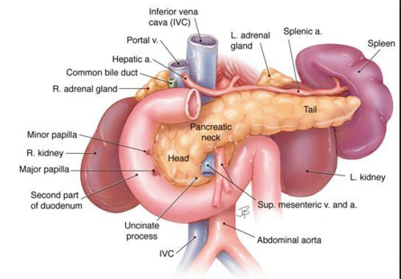

POSITION OF SPLEEN
Lies between fundus of stomach and diaphragm. Lies in It hypochondrium, extends in between 9th to 11th ribs.
EXTERNAL FEATURES
The spleen has: Two ends. Three borders. Two surfaces. Two angles. Hilum
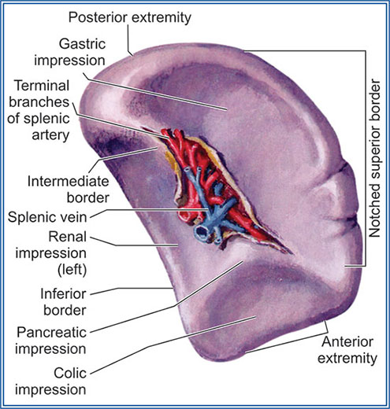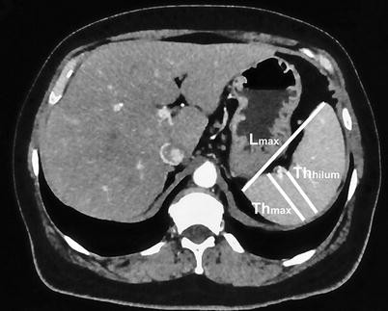
VENOUS DRAINAGE
Splenic Vein: Drains into portal vein.
FUNCTIONS
- Spleen forms parts of the reticuloendothelial system
- Main function is hematopoiesis in fetal life and in adults with reutilization of iron from hemoglobin of destroyed red blood cells.
- It has red and the white pulp, which are separated by the marginal sinus.
- Red pulp composed sinuses, splenic cord and marginal zone and main function to filter red blood cells and reserve monocytes.
- White pulp is composed of Malpighian corpuscles and help in active immune response.
Imaging investigations
- Plain radiograph of the abdomen AP view.
- Ultrasound Trans abdominal.
- MSCT.
- MRI.
Ultrasonography
On US, the spleen is homogeneous, slightly hyper echoic than normal renal cortex, and iso- to slightly hyperechoic than liver parenchyma.
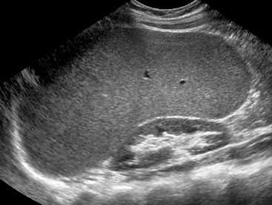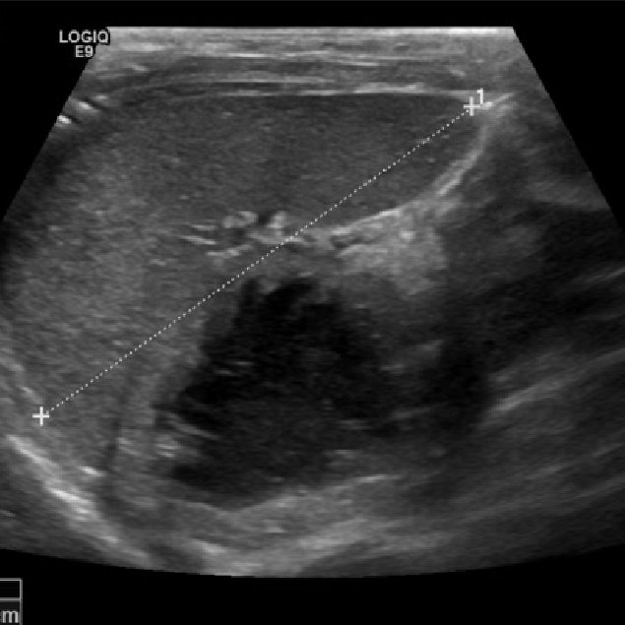
Spleen Ultrasonography
Some common indication for splenic ultrasound includes: -
✓ Splenomegaly
✓ Blunt abdominal trauma
✓ Left abdominal mass
✓ Left upper abdominal pain
✓ Jaundice combined with anemia.
MSCT Abdomen (Multislice Computed Tomography)
- On unenhanced CT, the spleen is homogeneous with attenuation values ranging between 40 and 60 Hounsfield units (HU) that is 5 10 HU less than the liver.
- The normal spleen enhances in a mottled pattern during the arterial and early portal venous phases.
- Delayed phase scans 3 min after contrast injection are helpful for excluding splenic lacerations in post-traumatic patients.
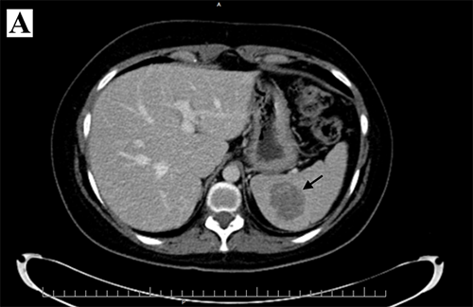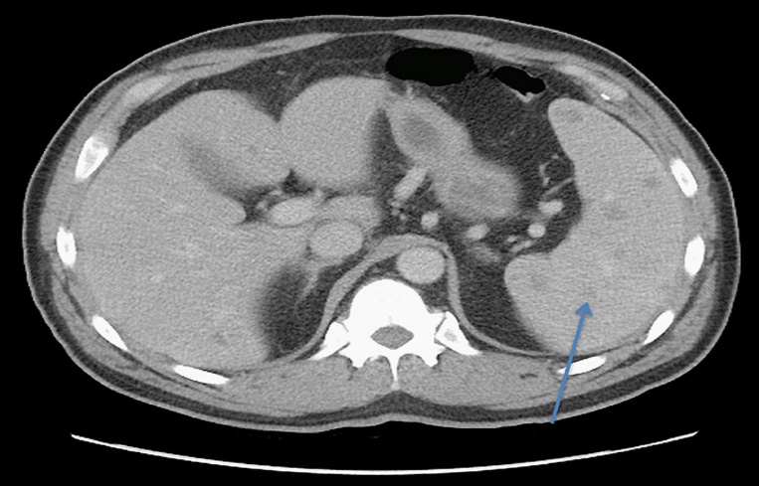
MRI of the Spleen CT of the Spleen
CT Examination
- CT attenuation of splenic tissue is homogeneous, typically measuring 40-60 HU on non-contrast material-enhanced scans.
- Splenic attenuation is normally 5-10 HU less than that of liver, a standard of reference used in evaluation of either hepatic or splenic disease.
- The spleen is optimally evaluated with use of intravenous contrast material.
- The spleen normally demonstrates heterogeneous enhancement, especially during the parenchymal phase of opacification after the administration of contrast.
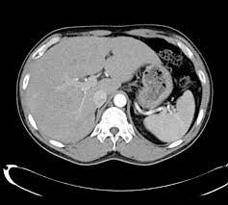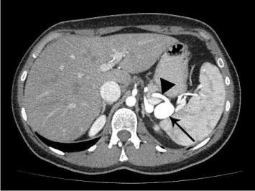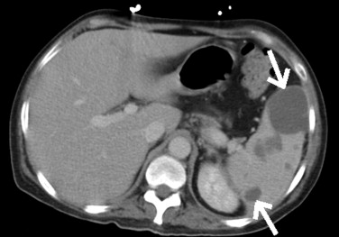
The spleen is usually evaluated with both T1 and T2-weighted spin-echo (SE) images.
• On T1-weighted images, the normal MRI signal intensity of the spleen is less than that of hepatic tissue and slightly greater than that of muscle.
• With T2-weighted images, the spleen demonstrates higher signal intensity, appearing brighter than liver.
• With splenic disease, high-signal-intensity areas on T1-weighted images may represent hemorrhage or high proteinaceous fluid.
• Cystic lesions or vascular masses (eg, hemangioma) have longer T2 relaxation values than those of the spleen and thus appear hyperintense relative to normal splenic tissue.
The spleen demonstrates heterogeneous enhancement with dynamic ''fast'' gradient- or spin-echo techniques after administration of Gd contrast.
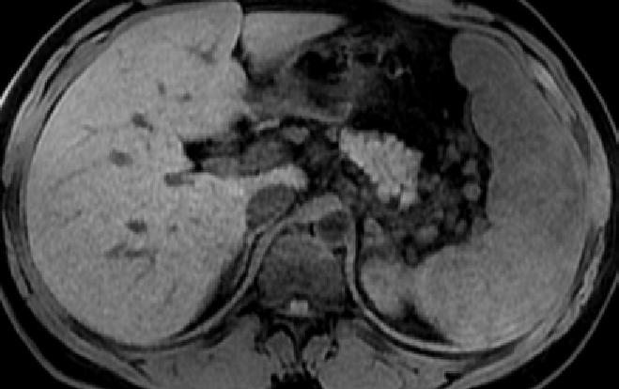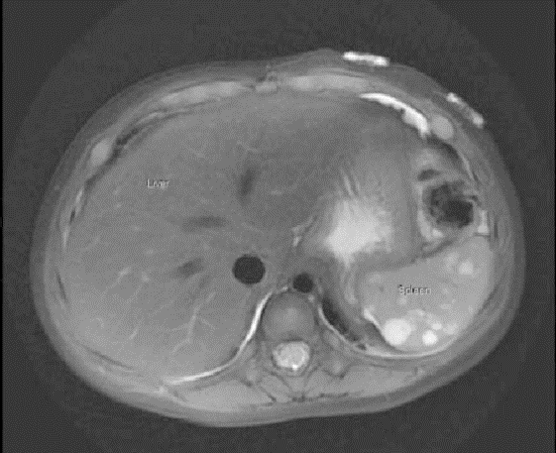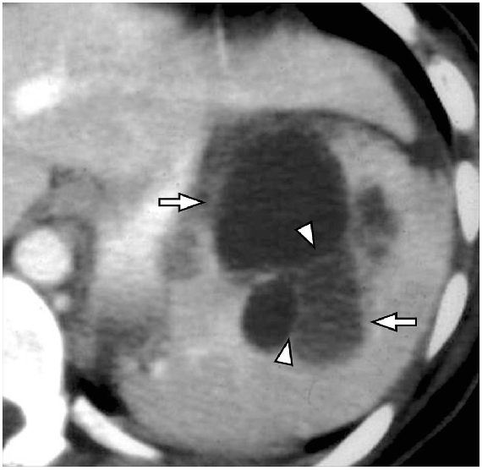
T1-weighted images T2-weighted images T2- hemangioma
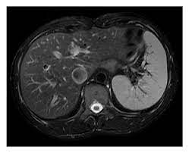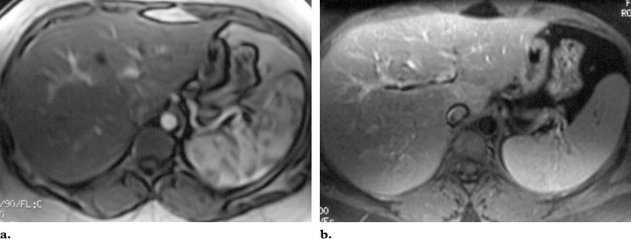

T1- dynamic study MR imaging appearance of the normal spleen. (a) Gadolinium-enhanced fast spoiled gradient echo image obtained during the arterial phase shows a mottled pattern of enhancement throughout the spleen. (b) Gadolinium-enhanced T1-weighted image obtained during the portal venous phase shows uniform high signal intensity throughout the spleen. (c) Fast spin-echo T2-weighted image shows high signal intensity throughout the spleen.


