

Radiology Techniques Department

the Radiological Anatomy

Lecture 4
Large Bowel

By
M.Sc. Zeyad Tareq & M.Sc. Salman Mohammed
3rd Stage

Regions of Large Intestine
- Cecum - pocket at proximal end with Appendix Colon
- Ascending colon - on right, between cecum and right colic flexure Transverse colon - horizontal portion
- Descending colon - left side, between left colic flexure and Sigmoid colon - S bend near terminal end

Rectum - terminal end is anal canal - ending at the anus which has internal involuntary sphincter and external voluntary sphincter.

The colon
- The colon (large intestine) is a distal part of the gastrointestinal tract, extending from the caecum to the anal canal.

- Anatomically, the colon can be divided into Five parts:
- The colon averages 150cm in length.
- Cecum.
- Ascending.
- Transverse.
- Descending and Sigmoid colon.

- Rectum.

The large intestine
The large intestine can easily be distinguished from the small intestine by:
- Taeniae coli, three thickened bands of longitudinal muscle.
- The sacculation’s of its walls between the taeniae, called haustra.
- Appendices epiploic (omental appendages), the small pouches of omentum filled with fat.
- Much greater caliber.
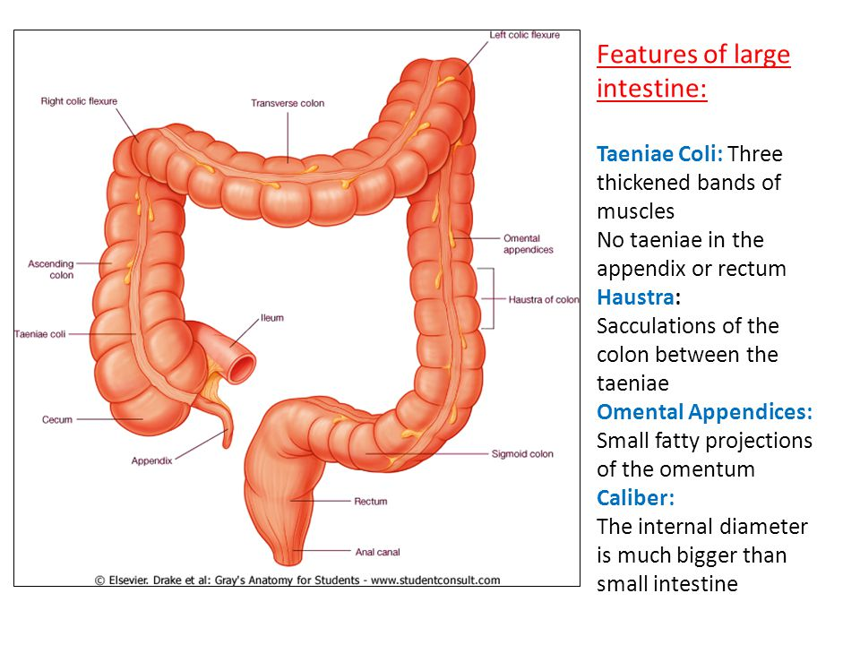
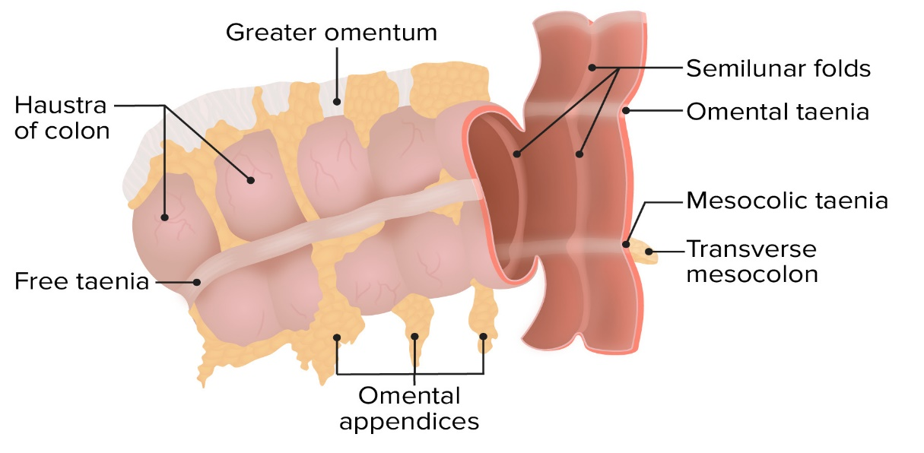

The cecum

The cecum is the first part of the large bowel and lies in the right lower quadrant of the abdomen

Gross anatomy
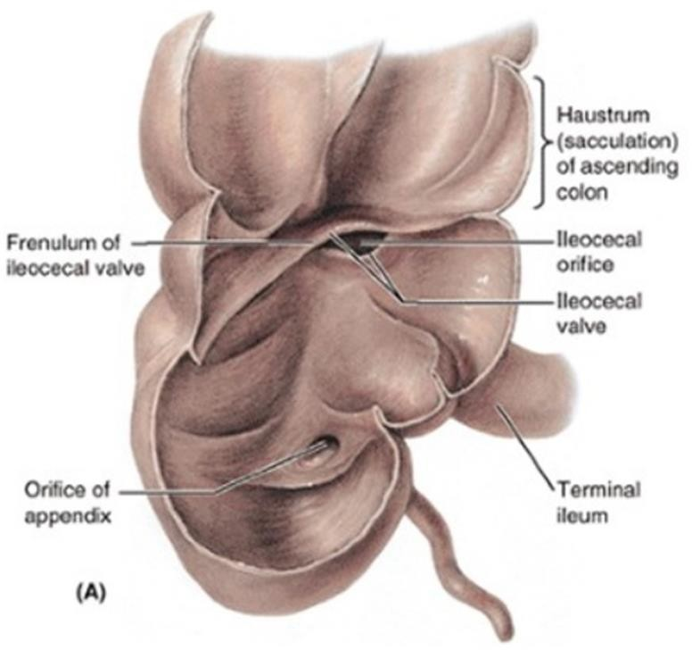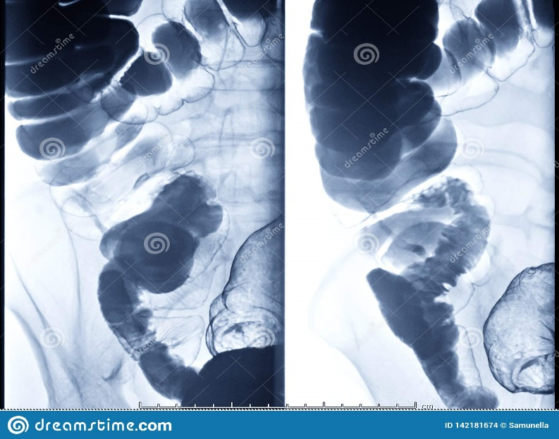
- The cecum measures 6 cm in length and can have a maximum diameter of 9 cm before it is considered abnormally enlarged. The vermiform appendix typically arises from the posteromedial surface, 2 cm inferior to the ileocecal valve.

The ascending
- The ascending colon is the continuation of the cecum superior to the ileocecal valve. ascending colon in approximately 25% of patients with 15 cm in length.

Gross anatomy
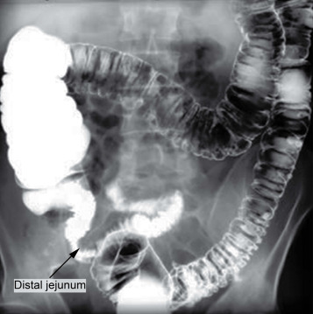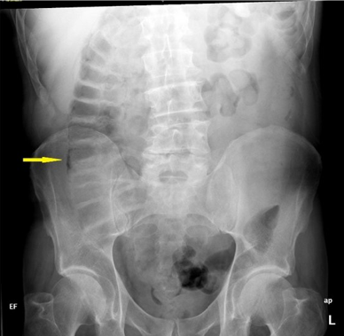
- The ascending colon courses up the right posterior abdominal wall until it reaches the level of the right kidney and courses anteromedially to form the hepatic flexure, where it continues as the transverse colon.

Transverse colon
- The transverse colon is the longest and most mobile part of the large intestine. It measures up to 45 cm in length.
Gross anatomy
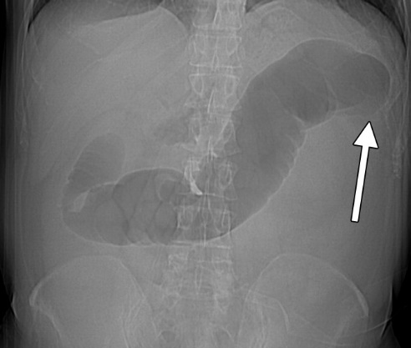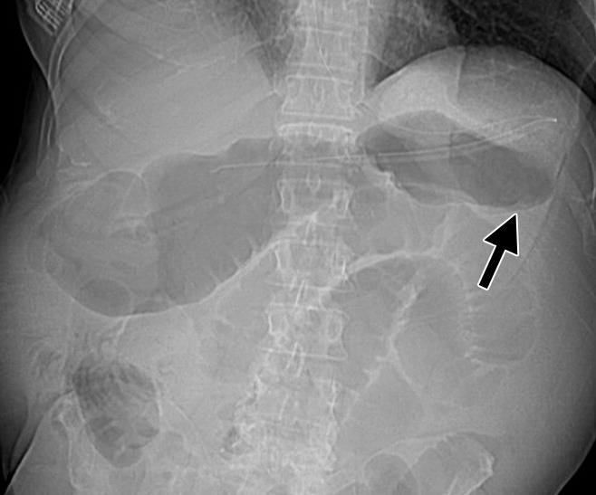
- The transverse colon is the continuation of the ascending colon from the right colic flexure.
- It passes from the right to left hypochondrium in a downward convex path crossing both the epigastric and umbilical zones.

In the left hypochondrium, it curves sharply on itself beneath the lower end of the spleen, forming the left colic flexure where it continues as the descending colon.
- Descending and Sigmoid colon
- It is the continuation of the transverse colon after the left colic flexure.
Gross anatomy
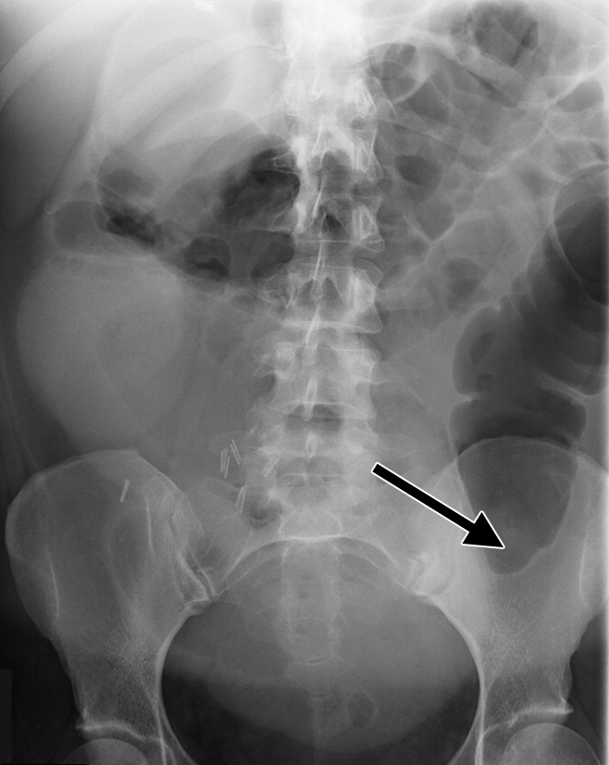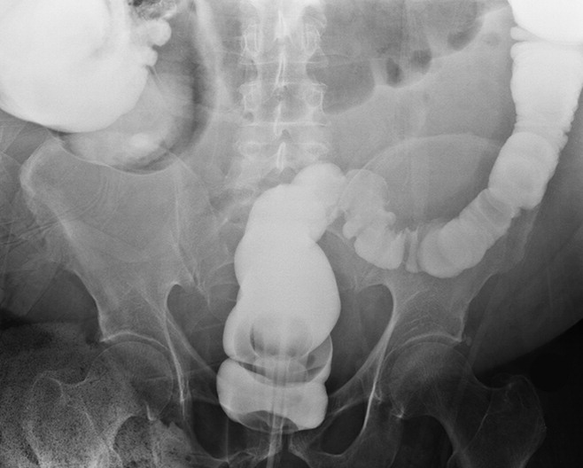
- The descending colon measures up to 25 cm in length.
- It descends down attached to the left posterior abdominal wall into the left iliac fossa where it continues as the sigmoid colon.
- The sigmoid colon is the continuation of the descending colon.
- After the distal descending colon has curved medially it enters the pelvis, where it gains a mesentery and is then called the sigmoid colon. It measures approximately 15 cm in length.
- Its apex may be as high as the umbilicus. The inverted V-shaped sigmoid mesocolon.
- The sigmoid colon continues as the rectum at approximately S3 level.

Right colic flexure
Junction of the ascending colon and the transverse colon. Right colic flexure lies anterior to the lower part of the right kidney and inferior to the right lobe of the liver; also known as: hepatic flexure.

Left colic flexure
Junction of the transverse colon and descending colon.
Left colic flexure lies anterior to the left kidney and inferior to the spleen; also known as: splenic flexure.

- The Rectum
- is the last part of the large intestine. It is located within the pelvis and is the continuation of the sigmoid colon after the rectosigmoid junction and continues as the anal canal at the anorectal angle created by puborectalis.

Gross anatomy

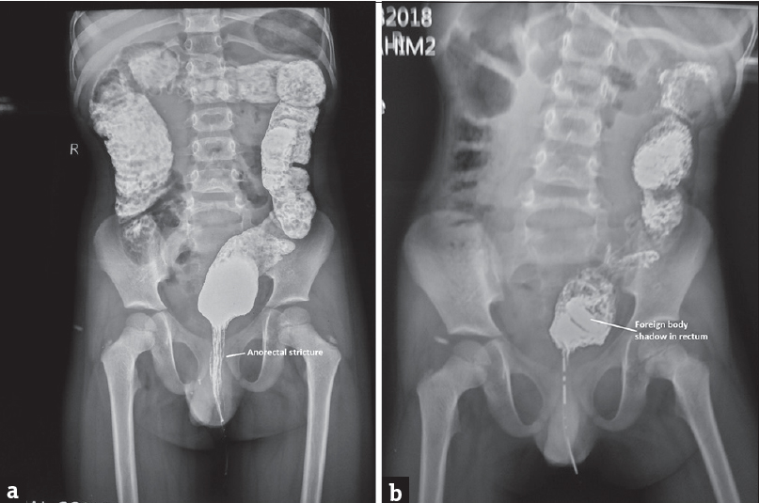
- At the level of the S3 vertebral body, the sigmoid colon loses its mesentery and becomes the rectum. As the rectum passes in front of the sacrum, it takes an AP concave shape. It is also sinuous with three alternating bends when viewed anteriorly. The taenia coli also flatten and fuse to form an outer longitudinal muscular layer, thus the rectum does not have the distinctive haustra nor epiploic appendages that the rest of the large intestine has. The rectum is approximately 15 cm long.
- The lower part of the rectum is dilated and is called the rectal ampulla and there are three semilunar transverse rectal folds (valves of Houston), which project into the rectal lumen.



