Slice Selection Gradient

- MR image is made up of series of parallel slices. This produces a controlled magnetic field gradient (SSG) along z axis.
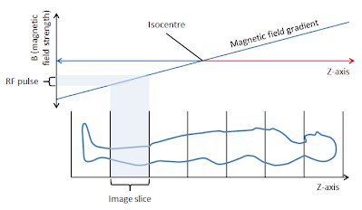
Fig (1): "slice selection"

A narrow band RF pulse is applied to the whole volume and only protons in the thinner slice are excited. The spins along the gradient that have a processional frequency equal to RF will absorb energy due to resonance.

The slice thickness depends on:
- RF bandwidth.
- Gradient strength across (field-of- view (FOV)).

slice thickness = bandwidth / Gradient
Slice thickness is reduced either by:
- Increasing the gradient magnetic field
- Decreasing the RF band width.

Properties of thinner slice:
1- gives better anatomical detail with lesser partial volume effect

2- takes longer time

3- Typical slice thickness range is 2–10 mm.

A gap equal to 10% of slice thickness should be kept in between slices, because RF may excite tissues on either side of the selected slice, since it has higher or lower frequency about the band width and generate signal.

