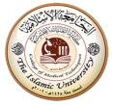

Computer application
Technical college
Medical laboratory Technologies
Lec.3 _Output device & Software
م.م. نورعامر

Output Device

Output Device is a piece of computer hardware that receives data from a computer and then translates that data into another form That form may be audio, visual, textual, or hard copy such as a printed document
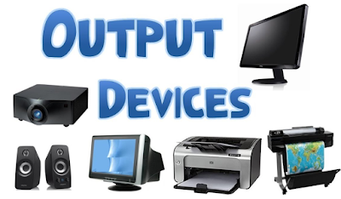
Example :.A few examples of output are given below:
Monitor, Printer, video card ,sound card, speaker, etc.
- The screen consists of a screen, a circuit, a power supply, buttons for adjusting screen settings, and a case containing all of these components. The screen displays the data from the computer on the screen so that the user can understand the information Computer monitors today are much smaller than those of yesteryear, and are now capable of producing higher quality color images.

- Printer It is a device that outputs text and graphics from a computer and transfers the information to paper, usually a standard size, 8.5 by 11 sheet of paper. Printers vary in size, speed, sophistication, and cost. In general, more expensive printers are used for repeat printing or high-resolution color printing. The most famous Brother, Canon, Epson
- video card is an expansion card that is inserted into the motherboard. The video card processes images and video, making it possible to see the visuals on the screen. Most computers have basic video and graphics capabilities built into the computer's motherboard, but for faster, more detailed graphics a video card is required.Well-known brands: NVIDIA, ASUS, MSI, EVGA

SOFTWARE

Software is a set of programs, which is designed to perform a well-defined function. A program is a sequence of instructions written to solve a particular problem.
There are two types of software :.
- Oprating System

Application Software

Operating System It is an integrated set of specialized programs that work with each other simultaneously to form a link between the user and the computer

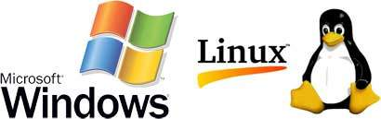

Following are some of important functions of an operating System.
- Managing input and output information.
2- Manage the work of applications and programs installed inside the computer.
3- Managing and organizing folders and files stored on the computer
4- The ability to share devices such as printers and scanners.
5- Help the user to protect all files and folders.
6- Operating system password protection, the data in the device can be kept safe.

Type of operating system:.
1- (DOS) The disk operating system) was the first operating system used for computer interfaces, and it was produced by (IBM), computers needed operating systems, and this system contains a set of different simple commands, and these commands enable the user to control the physical and software components of the computer.

The feauture of the DOS:.
Free operating system-a
b- It helps in managing files with high efficiency, due to its light weight and small size-c
d- Load files from the hard disk to the main memory quickly and efficiently.

2-Windows is one of the most famous and prominent operating systems for computers, and it is the most widely used operating system around the world because of its simplicity and ease of use in order to fully control the computer operating system without the need for manual entry for each command, in addition to that it created a new addition that was not available before, which is video playback and games.

Many versions of Windows have been released
Windows 98-
- Windows 2000
- Windows XP
- Windows 7
- Windows 8
- Windows 10

The feauture of the Windows:.
A-Ease of use
B-The best gaming operating system.
C-Software update automatically.
D-Great support for any problem the user faces from Microsoft, the manufacturer.

3-(LINUX) is one of the most popular and used operating systems, and it is similar to the way Windows works, but it is an open system, meaning that it allows users to access all applications.

LINUX is characterized by many characteristics, including::.
- Free and Easy to install.
- Difficult piracy and transmission of viruses to it.

4- (Mac OS)
The Mac operating system is an old system produced by Apple (Apple Inc). It has become mainly intended for Apple tablets and mobile devices. The system controls the interface for using these devices, and the operation, updating, and development of applications.

There are many features in Mac OS.
a-An integrated operating system that covers all the needs of Apple device users.
b- High protection from hacking and viruses.
c-It offers a lot of free applications attached to the system.

الترجمة طويلة جدًا ولا يمكن حفظها.
5-Android
The Android operating system (Android) was released by Google, and it is one of the most popular operating systems for smartphones and tablets, and it is supported by Google’s security and operating systems, and it has many free applications that can be downloaded by the user.
6- iOS
It is known as a special mobile operating system that works on mobile devices, desktop computers, laptops, and tablets belonging to Apple, and it is the second largest operating system in the world after the first Android system in the world, and its operating system is similar to the Mac and Android systems, but it does not have access to data Profiles and modified only by the designers of the system.
iOS has many features;
.The system interface is easy to use. More than 1.2 million applications are available in the system store
. Safe and stable operating system
. High quality of the captured image. A multilingual system, meaning .that it can be downloaded by choosing any popular language from the world's languages.

2-Application software A program that helps the user to accomplish a certain task such as searching online, setting an alarm, designing graphics, logging into an account, performing calculations, etc.

Examples of Application software are the following −
- Microsoft Word
- Facebook
- youtube

