

Computer application
Technical college
Medical laboratory Technologies
Lecture.2

م.م. نورعامر

Computer components:
In order for the computer to perform its work, two basic components must be present They are:
1 – Hardware
2 - Software

What is Computer Hardware?
Computer hardware refers to the physical parts or components which constitute the computer system.
The main hardware components of a computer are as under:
1. Micro Prosseser Unint (CPU , main memory)
2-Primary Memory (Hard disk , CD)
5. Input Unit (keyboard, mouse, scaneer )
6. Output Unit(headphone, printer, moniter)

Micro prosseser unit
-The brains of the computer , which performs all operations in the computer, and it consists of a chip made of silicon that is connected and coated with the main board in a specific way in order to receive data and information from parts of the computer processes it, and then give the information

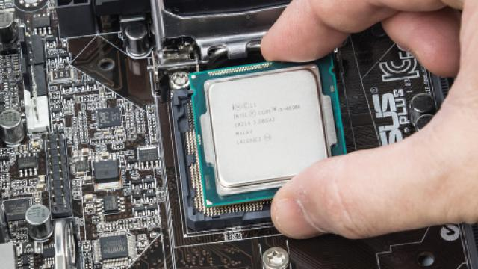

Micro prosseser main components
1-Cpu
A small electronic chip made of silicon containing millions of electronic circuits that process data and give us output .

Cpu Components:
1-Control unit (cu)
2-Arithmetic/logic unit (ALU)
3-Registers – high-speed storage areas that store data during processing
4-Buses – electrical data roadways where bits are transmitted within the
CPU and between the CPU and other motherboard components.

2- Main Memory :.
- RAM
- ROM
Random Access Memory (RAM) | Read Only Memory (ROM) | comparison
Read data quickly to run applications | stores the data necessary to start the device | the use
Its contents are lost when the device is turned off | The data remains there even when the device is turned off | Saving data
Data can be read and written | Data can only be read | reading and writing
Store data temporarily | Store data permanently | storage
very fast | Slower than the RAM speed | the speed
Its cost is high | Its cost is low compared to RAM | the cost
The slide size is large | Slide size is smaller | the size
- DRAM .(dynamic ram)  - SRAM. (static ram)  - SDRAM (Synchronous Dynamic RAM)  - DDR(Double Data Rate) | - EPROM( Erasable Programmable ROM,)  - PROM( Programmable ROM)  - EEPROM( Electrically Erasable Programmable ROM)  - MROM(Mask Rom) | Types of
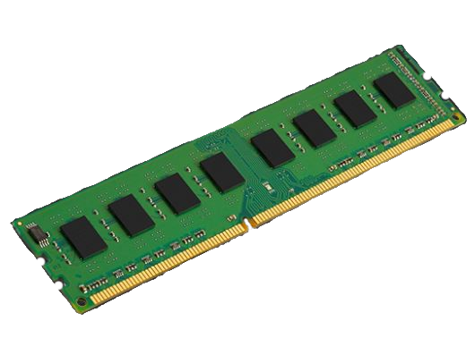 | 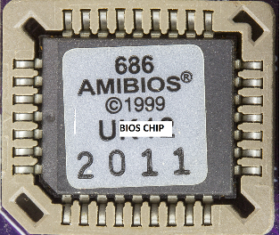

MOTHERBOARD
The motherboard is mounted inside the case and is securely attached via small screws through pre-drilled holes. Motherboard contains ports to connect all of the internal components. It provides a single socket for CPU, whereas for memory, normally one or more slots are available. Motherboards provide ports to attach the floppy drive, hard drive, and optical drives via ribbon cables. Motherboard carries fans and a special port designed for power supply .There is a peripheral card slot in front of the motherboard using which video cards, sound cards, and other expansion cards can be connected to the motherboard.
On the left side, motherboards carry a number of ports to connect the monitor, printer, mouse, keyboard, speaker, and network cables. Motherboards also provide USB ports,
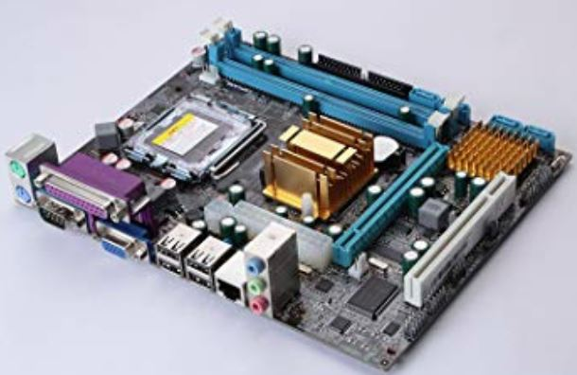

Hard disk drive
A Hard disk drive (HD or HDD) is a data storage device that is usually installed internally in a computer and connected directly to a controller on the computer's motherboard.
Examples of data stored on a hard disk any data, including photos, music, videos, text documents, and any files created or downloaded. Also, the hard disk stores the operating system files and programs running on the computer.
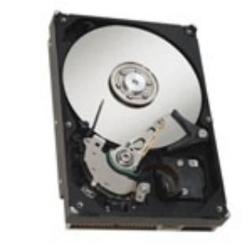
A hard drive consists of the following:
1- Magnetic platters - Platters are the round plates in the image above.
Each platter holds a certain amount of information.
2- Arm - The arm is the piece sticking out over the platters. The arms will
contain read and write heads which are used to read and store the magnetic
information onto the platters

3-Motor - The motor is used to spin the platters from 4,500 to 15,000
rotations per minute (RPM). The faster the RPM of a drive, the better
performance you will achieve from it

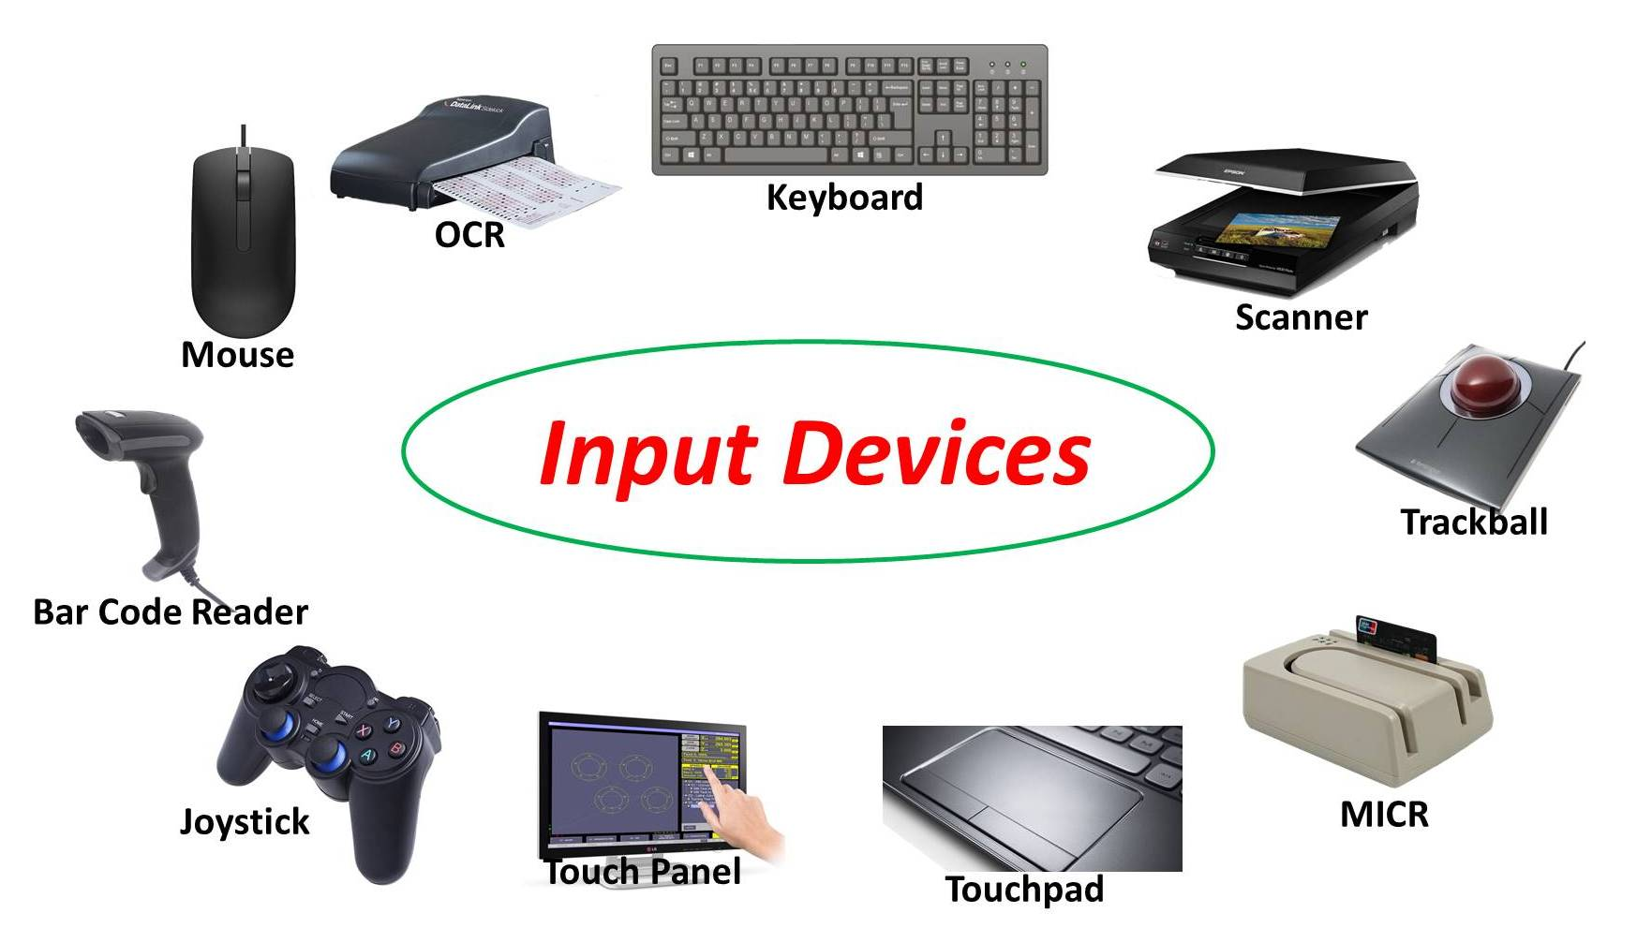

Keyboard
It is an input device connected to the computer through a cable or via a wireless connection, and this device contains keys for letters, numbers, and special symbols in addition to keys for specific functions. Instructions, functions, letters, and numbers are entered into the computer by pressing those buttons on the keyboard.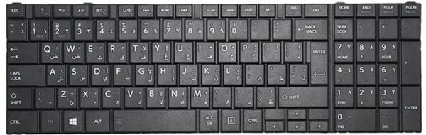

Mouse:
- A computer mouse is a device that is used to tell a computer what to do, including moving the cursor and choosing things on the screen. There are many types of mouse, these are:
- Mechanical mouse
- Optical mouse
- Cordless mouse
- Trackball mouse
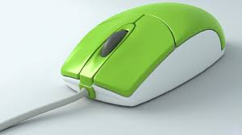

Scanner
- Devices that can read text or illustrations printed on paper and translates the information into a form the computer can use
- The scanner is often connected to the computer via a USB connection.

