

Computer application
Technical college
Medical laboratory Technologies
Lecture.1
Computer structure
م.م. نور عامر

- Introduction
- Computer structure

Computers
Computers are machines that perform tasks or calculations according to a set of instructions, or programs. Computers work through an interaction of hardware and software.
Computer features:
1-High-speed performance: The computer can perform the most complex arithmetic and logical operations required at high speed
2- Accurate performance of arithmetic and logical operations: A computer can perform complex arithmetic operations with the utmost accuracy
3- Storage and retrieval of data: The computer stores a huge amount of data, information and programs on various storage media, and it can locate the required information and output it directly to the user.
4- Presentation of information in multimedia: the ability of a computer to display information in written images, static images, moving images, or video images, and this is what is called multimedia.
5- Information exchange: Through a computer, information can be exchanged directly in multiple places of the world through computer networks such as the Internet
6- Diversity of input and output tools: it is possible to understand and communicate information to the computer through many tools such as input via keyboard, mouse, and scanner, and output through headphones, screen and printer
7- Continuity: It is the ability of the computer to work for long periods without fatigue or boredom.

Type of computer
Computers can be broadly classified by their speed and computing power.
No. | Type | Specifications
1 | PC (Personal Computer) | A personal computer is a type of computer, usually used by individuals or small organizations for computing and data storage, and has a relatively limited processing capacity, and this device is often considered single-use and tasks, meaning that it is used by one individual to run a specific program on the computer
2 | Workstation | It is an advanced computer with high specifications and is designed to be durable and work for a long time and for technical or scientific applications. It is a type of computer that is intended primarily for use by one person at a time, and it can usually be connected to a network of computers (local network) and run by multi-user operating systems.
3 | Mini Computer | Its specifications are always high and its price is cheap compared to desktop computers and laptops.  Its parts can be updated to keep pace with the latest updates offered by manufacturers.  It is small in size and can be carried with you wherever you want.  You can link the screen you want using CABLE and display its content on it.  It can be used as a channel receiver through some programs that transform it as a receiver for any type of these channels on the Internet.  You can watch movies through it on the Internet or connect it to a CD player.
4 | Main Frame | It is a type of computer that is used in giant institutions in industry, statistics and economic operations. These computers were placed in huge rooms and were wrapped in metal boxes.
5 | Supercomputer | It is an extremely fast computer, which can execute hundreds of millions of instructions per second.

Laptops are lightweight mobile PCs with a thin screen. Laptops can operate on batteries, so you can take them anywhere. Unlike desktops, laptops combine the CPU, screen, and keyboard in a single case. The screen folds down onto the keyboard when not in use.
Netbooks (also referred to as mini notebooks), are small, affordable laptops that are designed to perform a limited number of tasks. They're usually less powerful than laptops, so they're used mainly to browse the web and check email. 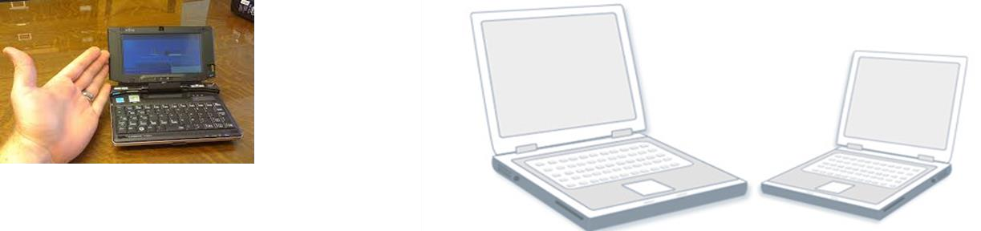
Smartphones are mobile phones that have some of the same capabilities as a computer. You can use a smartphone to make telephone calls, access the Internet, organize contact information, send email and text messages, play games, and take pictures. Smartphones usually have a keyboard and a large screen.
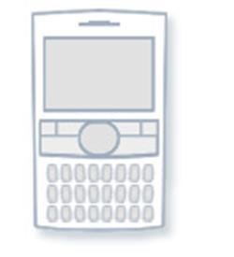

-Basic computer structure
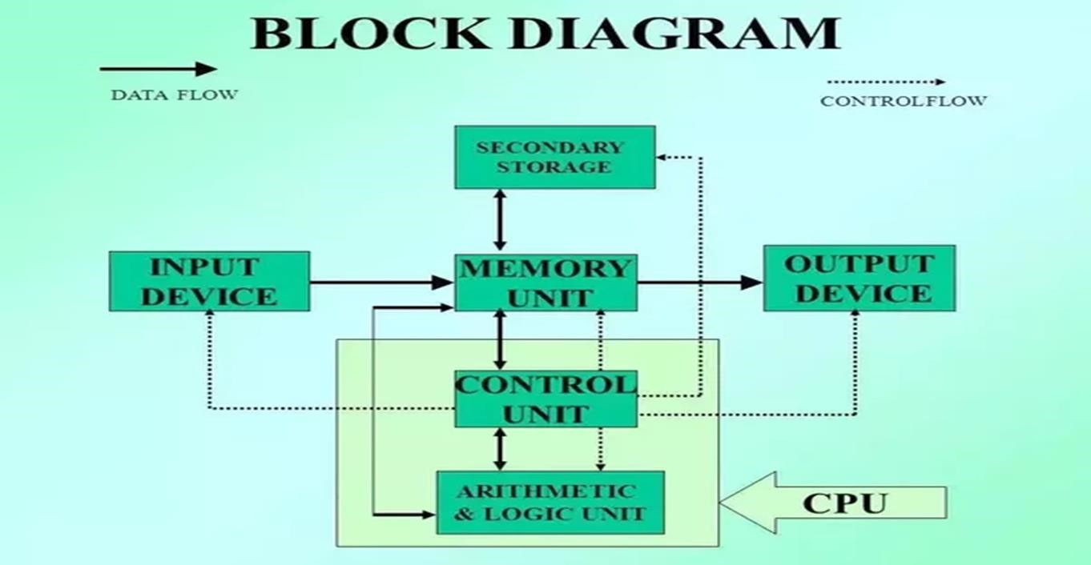

- Input: this is the process of entering data and programs into the computer system, and input unit is responsible.
- Memory Unit: Computer is used to store data and instructions.
- Control Unit (CU): The process of input, output, processing and storage is performed under the supervision of a unit called 'Control Unit'. It decides when to start receiving data, when to stop it, where to store data, etc. It takes care of step -by-step processing of all operations inside the computer
- Arithmetic Logic Unit (ALU): The major operations performed by the ALU are addition, subtraction, multiplication, division, logic and comparison.
- Output: This is the process of producing results from the data for getting useful information, and the output unit is responsible.

The ALU and the CU of a computer system are jointly known as the central processing unit (CPU). You may call CPU as the brain of any computer system.

