Spatial encoding

In MRI the signal is localised in the 3D space by manipulating the magnetic properties of the nuclei in a predictable way. The signals are then returned with a particular frequency and phase and these are slotted into their respective locations.
The key concept of spatial encoding is the use of gradients.

There are three steps involved in identifying where in a 3D location a signal is arising from:

- Slice selected along z-axis (slice selection gradient (SSG)).
2. Segment of slice along x-axis selected by frequency encoding
( frequency encoding gradient (FEG)).
3. Part of segment along y-axis selected by phase encoding (phase encoding gradient (PEG))

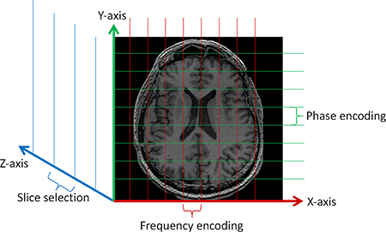

Figure 1: Spatial localization

The first step of spatial encoding consists in selecting the slice plane,to do this:

1- A magnetic field gradient, the Slice Selection Gradient (GSS), is applied perpendicular to the desired slice plane.

2- This is added to B0, and the protons present a resonance frequency variation proportionate to GSS.

3- An RF wave is simultaneously applied, with the same frequency as that of the protons in the desired slice plane.

4- This causes a shift in the magnetization of only the protons on this plane.

5- As none of the hydrogen nuclei located outside the slice plane are

excited, they will not emit a signal.
6- These protons located in the slice plane will again be stimulated by the magnetic field gradients to encode their position in horizontal and vertical directions.

