Tissue processing
Tissue processing: describes the steps required to take an animal or human tissue from fixation to the state where it is completely infiltrated with a suitable histological wax and can be embedded ready for section cutting on the microtome.
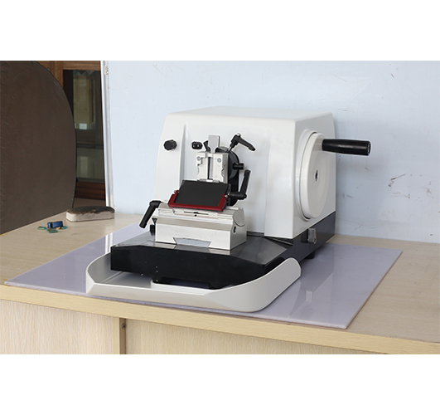picture (1) microtome
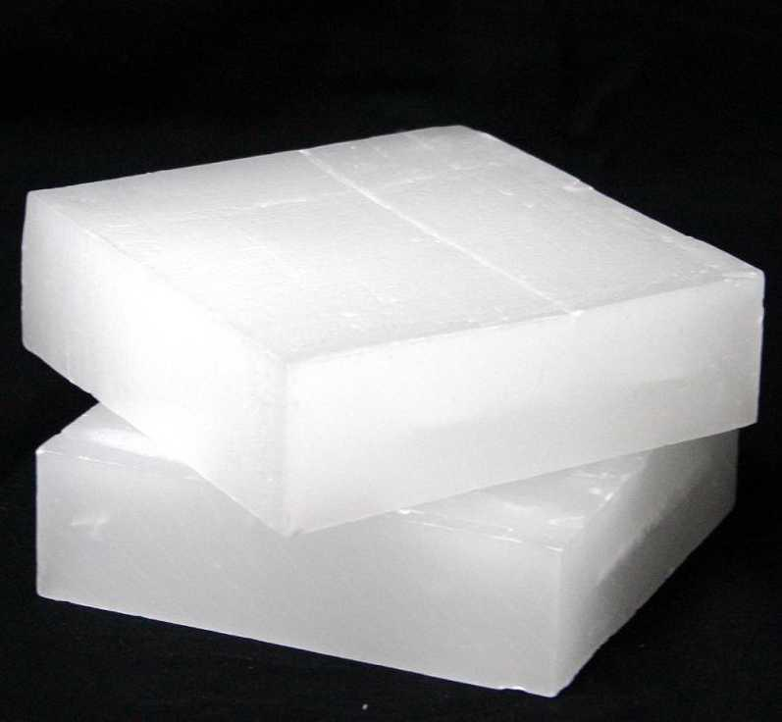
Picture (2) paraffin wax
The steps of tissue processing:
1- Obtaining a fresh specimen: Fresh tissue specimens will come from various sources.
2- Fixation: the specimen is placed in a liquitheirixing agent (fixative) such as formalin to ensure preservation of tissues in its original condition. For 24 hours.
3-Dehydration: removal of water from tissues by immersing specimens in a series of ethanol. Because the paraffin wax is hydrophobic (immiscible with water), most of the water in a specimen must be removed.
A typical dehydration sequence for specimens not more than 4mm thick would be:
- 70% ethanol 15 min
- 90% ethanol 15 min
- 100% ethanol 15 min
- 100% ethanol 15 min
- 100% ethanol 30 min
- 100% ethanol 45 min

4- Clearing: use an intermediate solvent (xylene) that is fully miscible with both ethanol and paraffin wax. This solvent will displace the ethanol in the tissue, then will be displaced by paraffin wax. A typical clearing sequence; xylene 20 min, xylene 20 min and xylene 45 min
5- Wax embedding: A typical wax is liquid at 60°C and can be infiltrated into tissue at this temperature in three steps (30 min, 30 min, 45 min.) then allowed to cool to 20°C. Now that the specimen is thoroughly infiltrated with wax, it must be formed into a “block” which can be clamped into a microtome for section cutting.
6- Microtomy: preparing a thin slice of tissue.
7- Staining the tissue: Staining is used to highlight important features of the tissue as well as to enhance the tissue contrast. Hematoxylin is a basic dye that is commonly used.

- Phosphotungstic acid-iron-hematoxylin staining method for osteoid, boundary bone and bone components in paraffin sections.
- Trichrome stains are used to stain and identify muscle fibers, collagen and nuclei. They can be used to contrast skeletal, cardiac or smooth muscle
- Leishman's stain, which consists of: Eosin stain, Methylene blue stain and Acetone are used to stain the blood film.
- Hematoxylin and eosin are used to stain liver and skin cells.

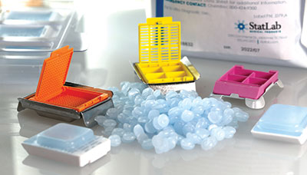
Picture (3) Wax embedding
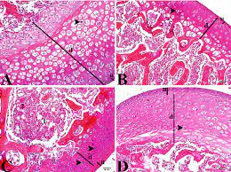
Picture (4) Histopathological section of bone tissue
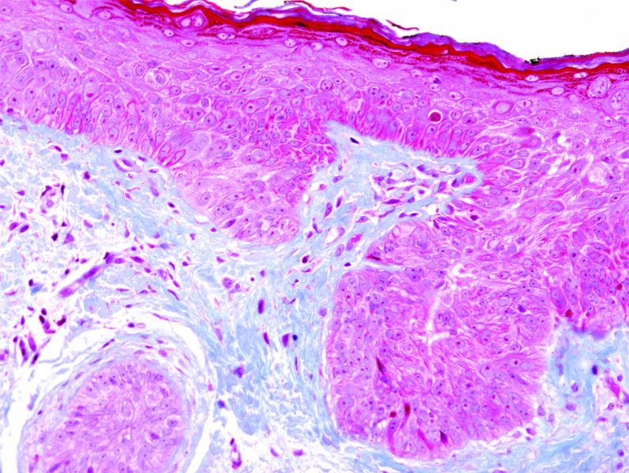
Picture (5) Histopathological section of muscle

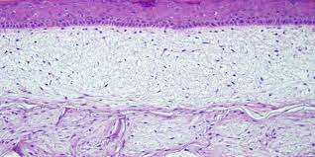
Picture (6) Histological section of skin

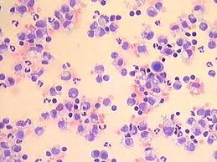
Picture (7) blood smear

