LAP Name: Study X-OR Gate
X-OR Gate:
XOR gate or Exclusive OR gate is a widely used logic gate in digital electronics. It is one of the logic gates which is available in IC form.
In general, an X-OR gate will give an output value of logic “1” ONLY when there are an odd number of 1’s on the inputs to the gate.
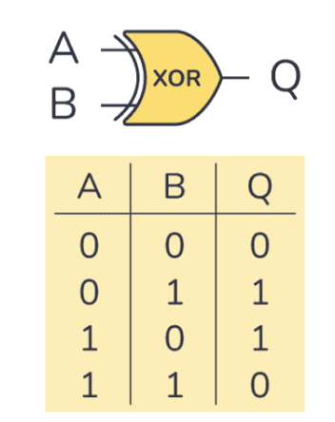
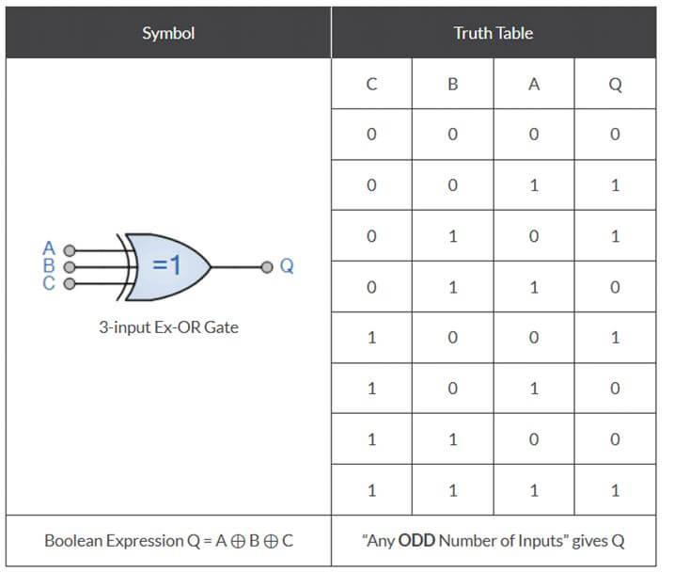
Oscilloscope: oscilloscope displays the magnitude and frequency variations of electronic signals. It can provide a graph of one or two signals over time.The displayed waveform can then be analyzed for properties such as amplitude, frequency, rise time, time interval, distortion, and others.
A function generator: is usually a piece of electronic test equipment or software used to generate different types of electrical waveforms over a wide range of frequencies. Some of the most common waveforms produced by the function generator are the sine wave, square wave, triangular wave.

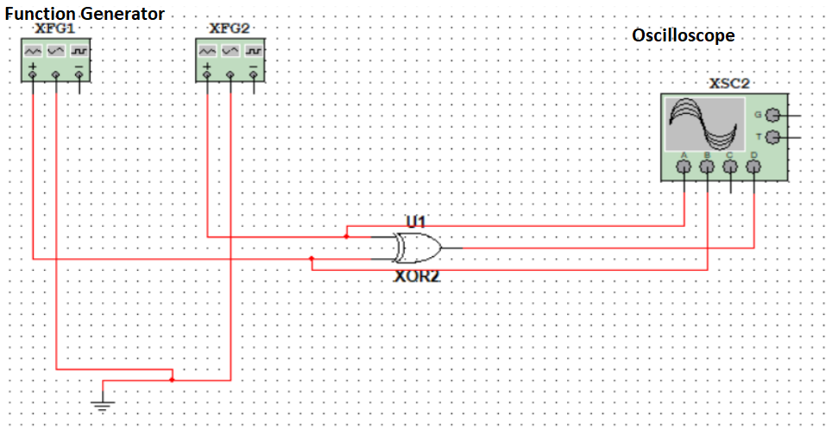
The timebase is 1 ms/Div, meaning that the width of the wave.
The scale of channels means that the height of a wave
X pos. (div) and Y pos. (div) are the coordinates.

