Steam Power Plants
5- DEVIATION OF ACTUAL VAPOR POWER CYCLES FROM IDEALIZED ONES

The actual vapor power cycle differs from the ideal Rankine cycle, as illustrated in Fig. 10–4a, as a result of irreversibilities in various components. Fluid friction and heat loss to the surroundings are the two common source of irreversibilities. Fluid friction causes pressure drops in the boiler, the condenser, and the piping between various components. As a result, steam leaves the boiler at a somewhat lower pressure. Also, the pressure at the turbine inlet is somewhat
lower than that at the boiler exit due to the pressure drop in the connecting pipes. The pressure drop in the condenser is usually very small. To compensate for these pressure drops, the water must be pumped to a sufficiently higher pressure than the ideal cycle calls for. This requires a larger pump and larger work input to the pump.
The other major source of irreversibility is the heat loss from the steam to the surroundings as the steam flows through various components. To maintain the same level of net work output, more heat needs to be transferred to the steam in the boiler to compensate for these undesired heat losses. As a result, cycle efficiency decreases.
Of particular importance are the irreversibilities occurring within the pump and the turbine. A pump requires a greater work input, and a turbine produces a smaller work output as a result of irreversibilities. Under ideal conditions, the flow through these devices is isentropic. The deviation of actual pumps and turbines from the isentropic ones can be accounted for by utilizing isentropic efficiencies, defined as
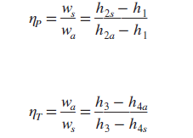
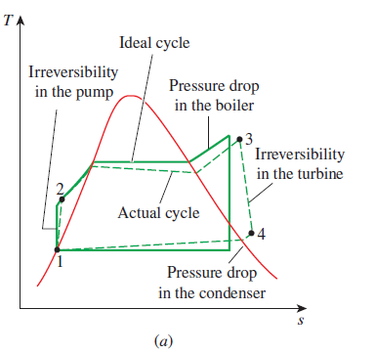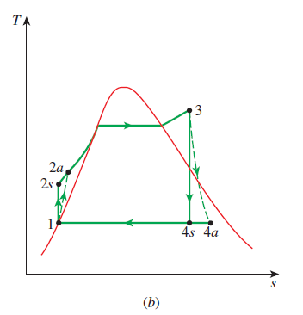

EXAMPLE 10–2 An Actual Steam Power Cycle
A steam power plant operates between 15 Mpa and 10 kpa. If the isentropic efficiency of the turbine is 87 percent and the isentropic efficiency of the pump is 85 percent, determine (a) the thermal efficiency of the cycle and (b) the net power output of the plant for a mass flow rate of 15 kg/s.

EXAMPLE 10–3 Effect of Boiler Pressure and Temperature
on Efficiency
Consider a steam power plant operating on the ideal Rankine cycle. Steam enters the turbine at 3 MPa and 350°C and is condensed in the condenser at a pressure of 10 kPa. Determine (a) the thermal efficiency of this power plant, (b) the thermal efficiency if steam is superheated to 600°C instead of 350°C, and (c) the thermal efficiency
if the boiler pressure is raised to 15 MPa while the turbine inlet temperature is maintained at 600°C.

