

Radiology Techniques Department

The Radiological Anatomy

Lecture 3

The stomach & duodenum and small intestine

By
MS.c Zeyad Tareq & MS.c Salman Mohammed

3rd Stage
- The stomach is J shaped but varies in size and shape
- It has 2 orifice cardiac sphincter and pyloric sphincter
- It has 2 curves 1- the greater curve
2- the lesser curve

- The stomach can be divided into 3 parts (regions):
- Upper the fundus
- Middle the body of stomach
- Lower the pyloric region

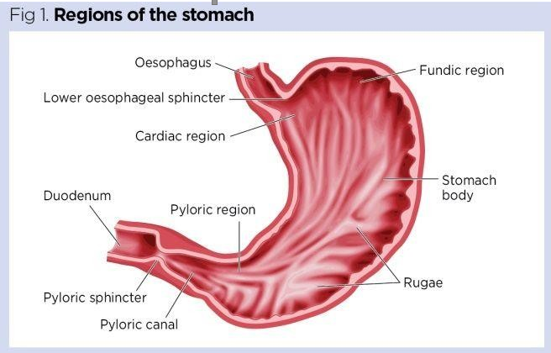

- The upper part of the stomach is covered by
- left lobe of the liver
- left diaphragm

- The remainder of the stomach by anterior abdominal wall

- Posteriorly the stomach is covered by peritonium (lesser sac)
- Organs lies posterior to the stomach are:
- Pancreas 2. spleen 3. kidney 4. Diaphragm

Inferior to the stomach is the transverse colon

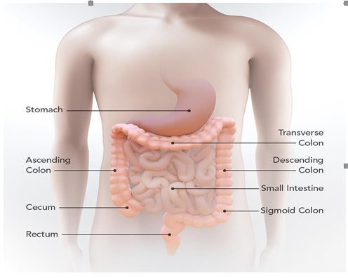


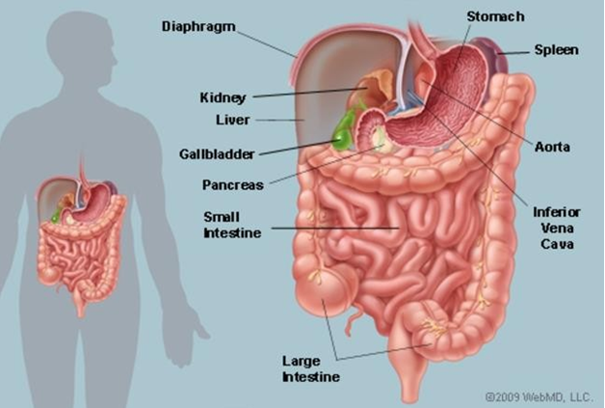

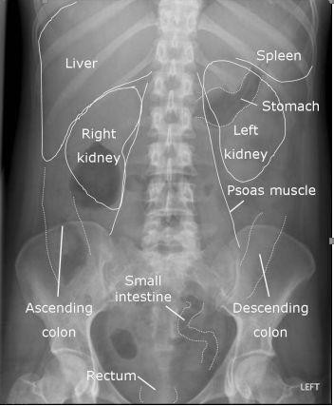


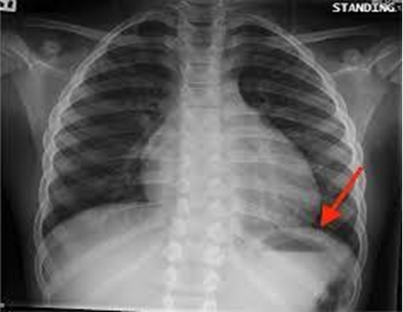

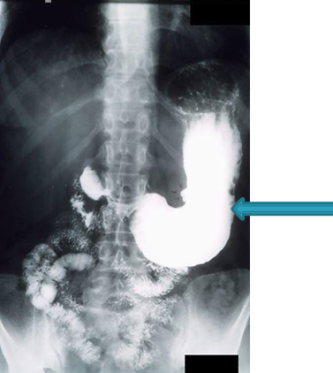
The duodenum

- Extends from the pylorus of the stomach to the duodeno-jejunal flexure
- It is a C shaped where the head of pancreas embeded
- Divided into 4 parts:
First part or superior part (2 cm) Second part or descending part (8 cm)
Third part or horizontal part (8 cm) Fourth part or ascending part (4 cm)

The duodenum
- The 1st part (duodenal bulb or cap) of the duodenum is at level of L1 lumbar vertebra
- The 2nd part at level L2 lumbar vertebra
- The 3rd part at level L3 lumbar vertebra
- The 4th part at level of L2 lumber vertebra


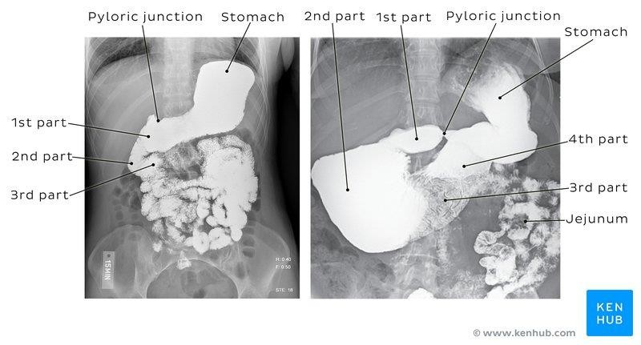




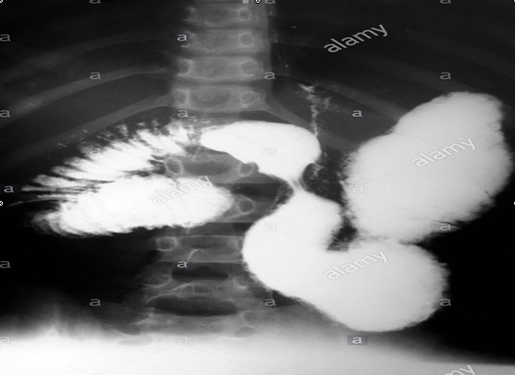



- Starts at the duodenojejunal junction and ends at the ileocecal junction
- From 3-10 meters (average of 6 meters)
- The proximal 2/5 is called the jejunum
- The distal 3/5 called the ileum
- The boundary between the 2 is not well defined

- The jejunum found at left upper abdomen
- The ileum found at lower abdomen and right iliac fossa

