
The Islamic University - College of Pharmacy

Synthesis of Alkenes

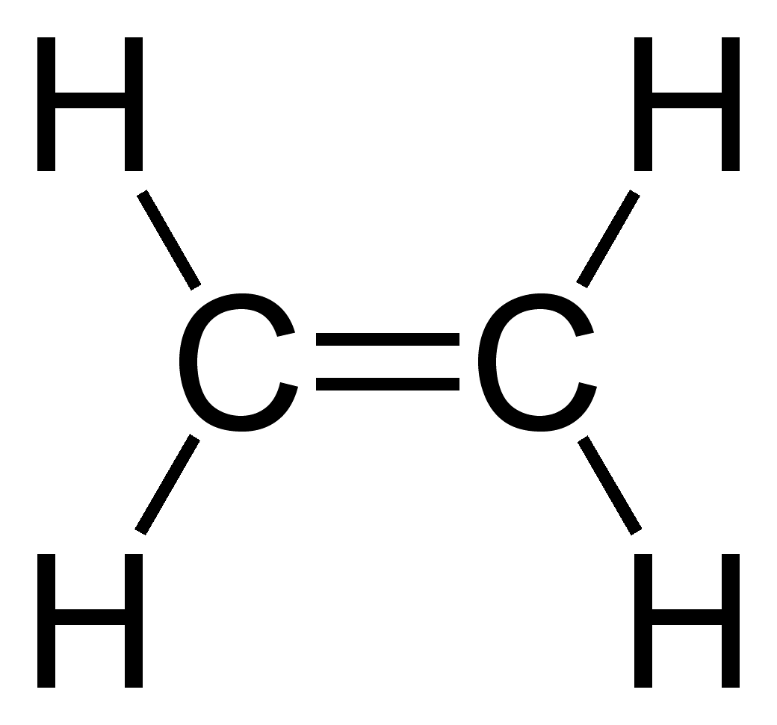

1.Dehydrohalogenation of alkyl halides: (Elimination of HX)

Mechanism ↓

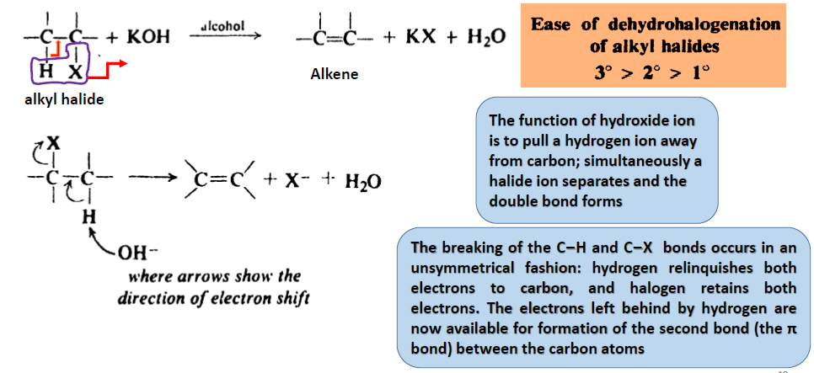

2.Dehydration of alcohols: (Elimination of H2O)

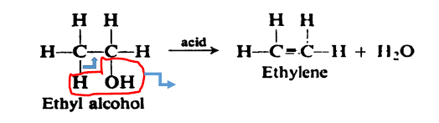
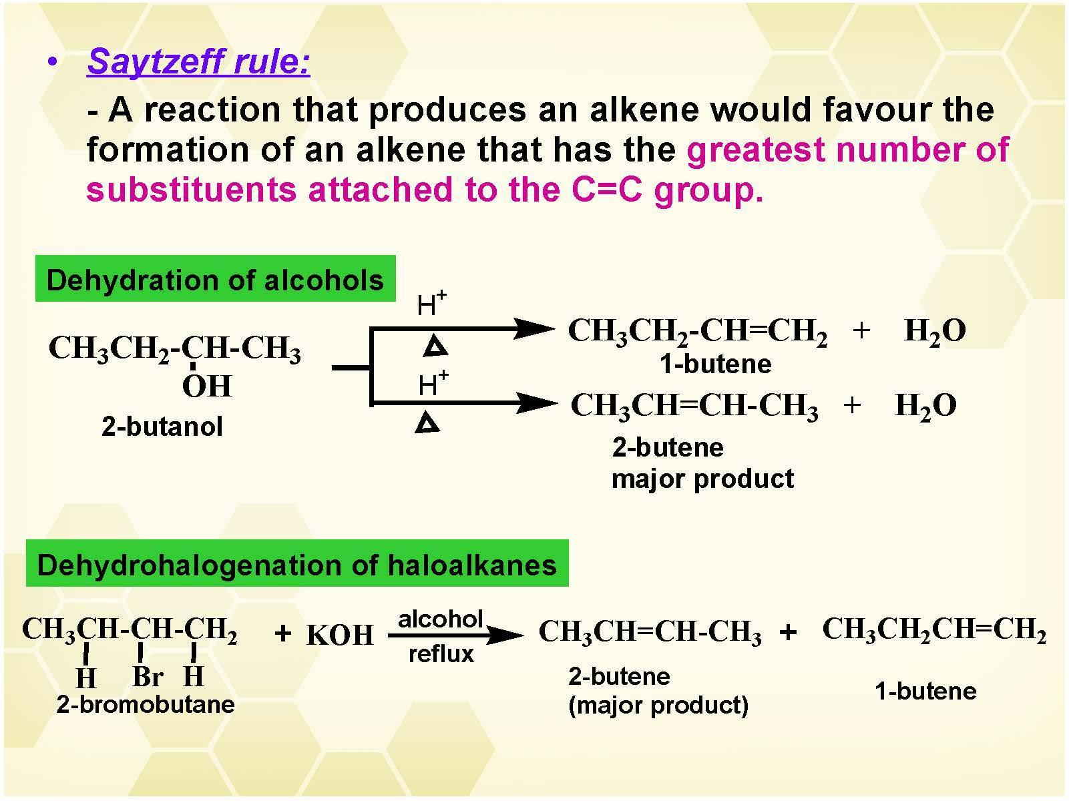

3. Dehalogenation of vicinal dihalides

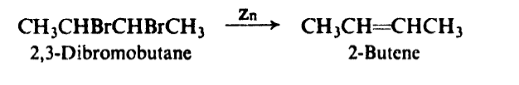

4. Reduction of alkynes

