Dynamic routing: In dynamic routing, the routing protocol operating on the router is responsible for the creation, maintenance and updating of the dynamic routing table. In static routing, all these jobs are manually done by the system administrator.
Note: in this lap will configure RIP version _2.
Routing information protocol (RIP): the routing information protocol (RIP) is an intra-domain (interior) routing protocol used inside an autonomous system. The metric used by RIP is very simple; the distance is defined as the number of links (networks) that have to be used to reach the destination. For this reason, the metric in RIP is called a hop count.
Configuration steps of RIP version-2
Router (config) #router rip
Router (config-router) #network <Network IP>
Router (config-router) #version 2

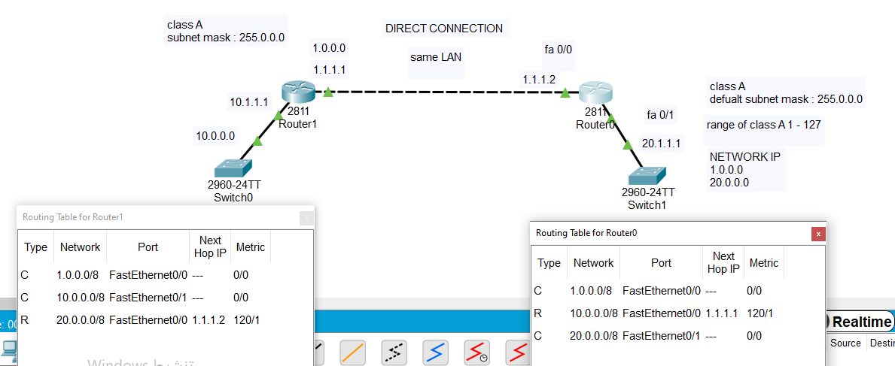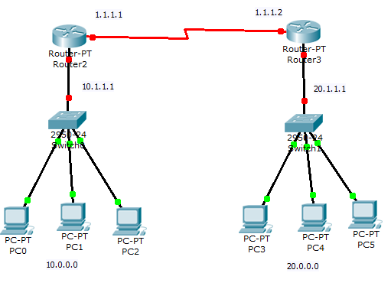
Configure router2
router2#config t
router2 (config) # router rip
router2 (config-router) #network 10.0.0.0
router2 (config-router) #network 1.0.0.0
router2 (config-router) #version 2
router2 (config-router) #exit
router2 (config) #exit
Configure router3
router3 #config t
router3 (config) #router rip
router3 (config-router) # network 20.0.0.0
router3 (config-router) #network 1.0.0.0
router3 (config-router) #version 2
router3 (config-router) #exit
router3 (config) #exit
Discussion:
Q1: what was the main idea of using routing protocol?
Q2: Do you think…. Is a good or bad thing of using another protocol at dynamic routing?

