Lap Name: NOT Gate
A NOT gate is a logic gate that inverts the digital input signal. For this reason, a NOT gate is sometimes is referred to as an inverter .NOT gate only has one input and one output.
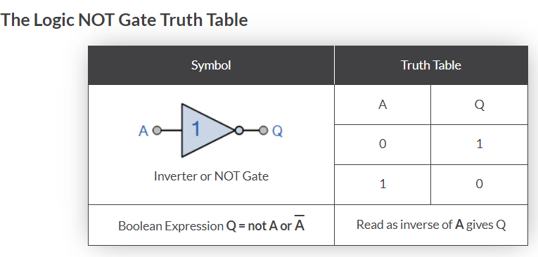
LAP Diagram:
- Function genertor
- Oscilloscope
- NOT gate
- Ground
NOTE:
Function genertor frequecny should n=be more that 400 HZ , by defulat the frequecy is 1 HZ and you can edit by double click on the function genertor and set the frequecy value.
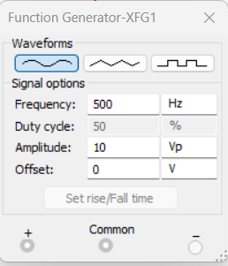
NOTE: Function genertor support three typs of waves
- Sine
- Trinagle
- Square
Frequency: in physics, the number of waves that pass a fixed point in unit time; also, the number of cycles or vibrations during one unit of time in periodic motion.
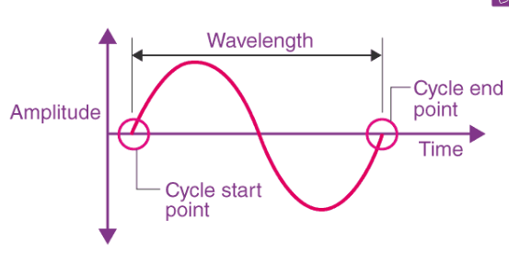

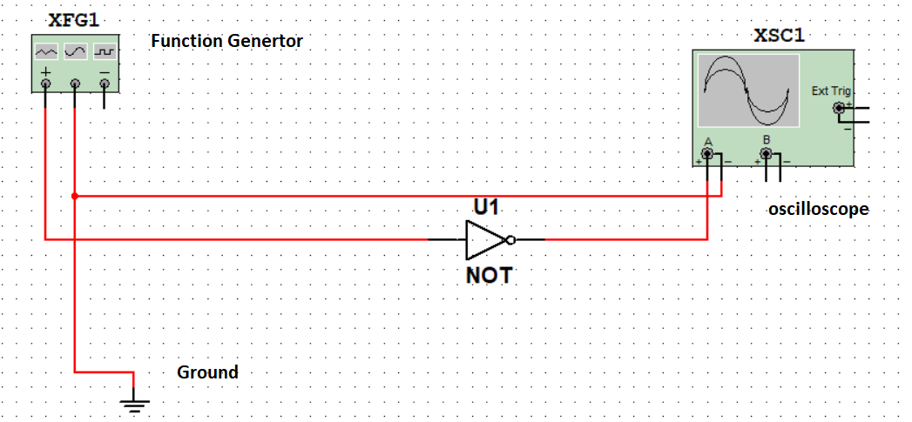
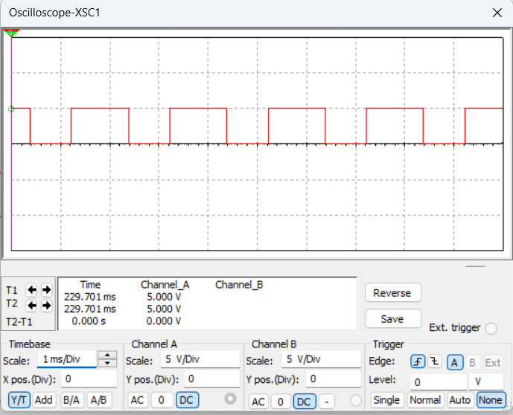

Oscilloscope Displaying setting:
Channel name | Purpose
Time base | Change wave width
Channel A | Change first wave height
Channel B | Change second wave height

