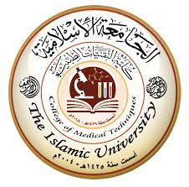

Radiology Techniques

Department

The Radiological Anatomy

Lecture 11

Mediastinum
By
M.Sc. Zeyad Tareq & M.Sc. Salman Mohammed

3rd Stage
2022-2023
mediastinum
the mediastinum is a space in the chest that holds the heart and other important structures. It’s the middle section of the thoracic cavity, between the left and right pleural cavities (which hold the lungs). Many conditions can affect the organs and tissues in the mediastinum, including tumors and infections.

What is the mediastinum?

The mediastinum is a space within the chest that contains the heart and other structures.

the mediastinum is one of the three main compartments that make up the thoracic cavity. The other two compartments are the left pleural cavity (holds the left lung) and the right pleural cavity (holds the right lung). the mediastinum is the space between these two pleural cavities.
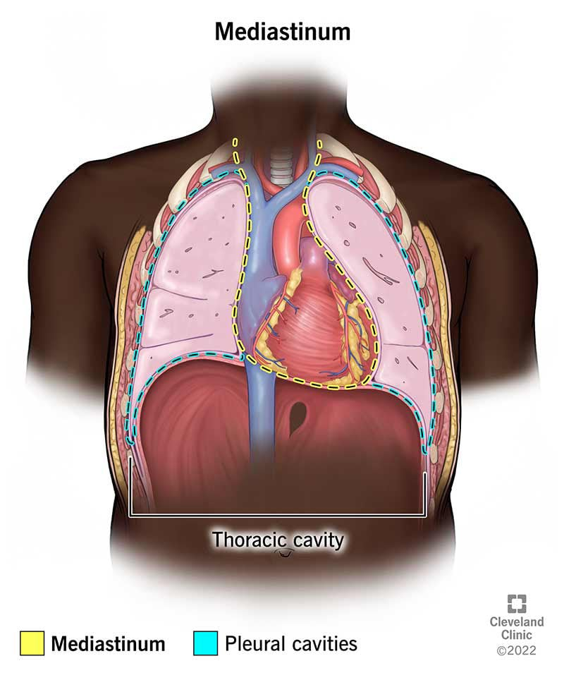
the mediastinum is the middle section of the thoracic cavity. It's located between the two pleural cavities (left and right).

What structures are in the mediastinum?

the mediastinum contains many different structures, including organs and blood vessels.
Organs in the mediastinum include the:
- Esophagus: the esophagus (food tube) passes through the mediastinum as it travels from the throat to the stomach.
- Heart: the heart is a muscular organ that pumps blood throughout the body. It’s located in the middle of the mediastinum. the heart is surrounded by a protective sac called the pericardium.
- Thymus: the thymus supports the immune system and is most active before puberty. It’s located in the front, upper part of the mediastinum.
- Trachea: the trachea (windpipe) helps the breath. It’s located just in front of the esophagus. It travels from the lower neck into the chest, before branching in two and traveling into each of the pleural cavities.

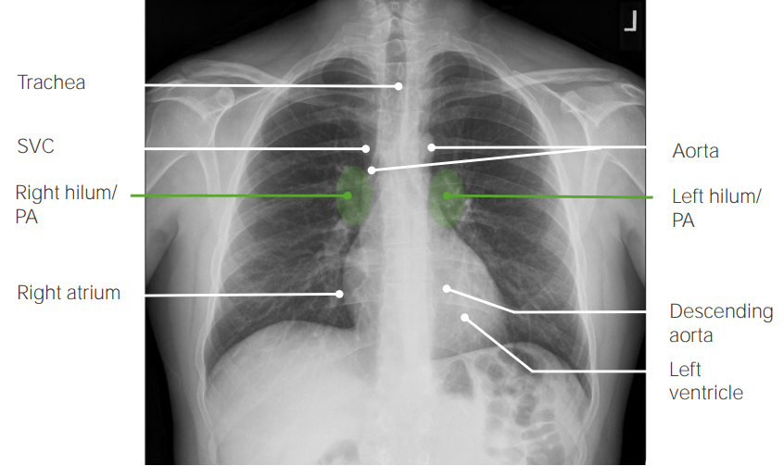
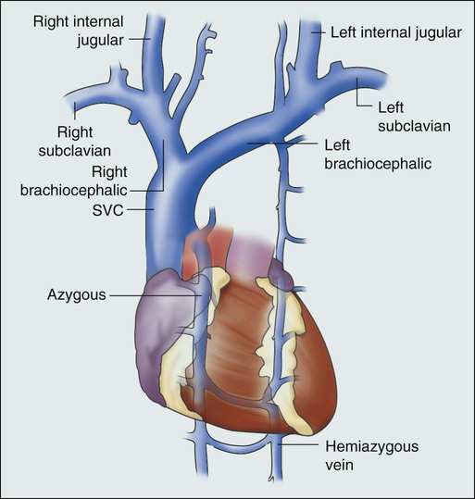
Blood vessels in the mediastinum include:
- Left brachiocephalic vein: the left brachiocephalic vein helps blood from the left side of the upper body return to the heart. It empties into the superior vena cava.
- Superior vena cava: the superior vena cava carries blood from the upper body to the heart. It empties directly into the right atrium (top right heart chamber).
- Pulmonary trunk: This blood vessel connects with the heart’s right ventricle at the pulmonary valve. After leaving the heart, the pulmonary trunk splits into the right and left pulmonary arteries. These vessels send blood to each of the lungs to gain oxygen.
- Thoracic aorta: the aorta is the largest artery in the body. It’s responsible for sending oxygen-rich blood to all the organs and tissues. the aorta connects with the heart’s left ventricle at the aortic valve. From there, it passes through the chest (thorax) and abdomen (belly). The section in the chest (thoracic aorta) is contained in the mediastinum. Segments of the thoracic aorta are the ascending aorta, aortic arch and descending thoracic aorta.
Other structures in the mediastinum include:
- Fatty and connective tissues.
- Lymph nodes.
- Nerves.
- Thoracic duct.
- Thoracic spine.

Gross anatomy

The mediastinum contains all the thoracic viscera except the lungs: heart and great vessels, internal mammary vessels, proximal aspect of azygos venous system, esophagus, trachea, phrenic nerve, cardiac nerve, supra-aortic and para-aortic bodies, thoracic duct, thymus, and mediastinal lymph nodes.

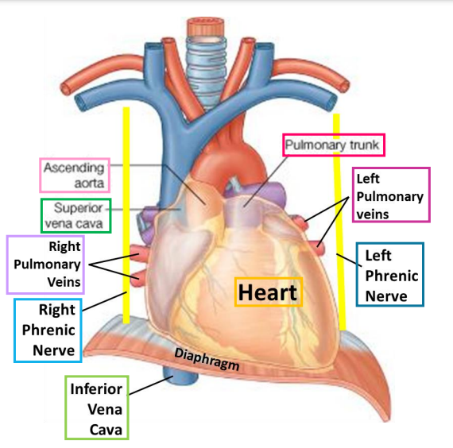

Anatomical division

Division of the mediastinum is generally conceptualized as comprising three or four compartments, depending on the schema. For example, the mediastinum can be divided into parts based on their relationship to the fibrous pericardium:
- superior mediastinum: above the upper level of the pericardium and plane of Ludwig
- inferior mediastinum: below the plane of Ludwig
  - anterior mediastinum: anterior to the pericardium
  - middle mediastinum: within the pericardium
  - posterior mediastinum: posterior to the pericardium

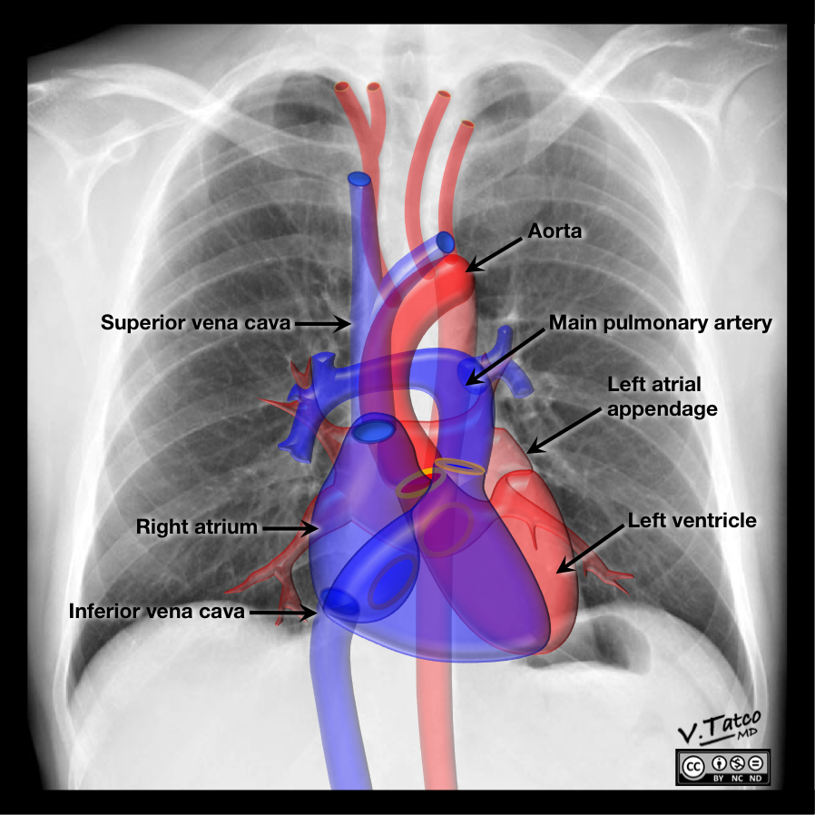

Pathology

Broadly, pathology that affects the mediastinum can be divided into those that result in a focal mass, or those that result in diffuse disease involving the mediastinum.

The differential diagnosis of a mediastinal mass is highly dependent on its location within the mediastinum, as this may reveal the structure of origin. Thus, there is a specific differential diagnosis for each compartment:
- thoracic inlet masses
- anterior mediastinal masses
- middle mediastinal masses
- posterior mediastinal masses
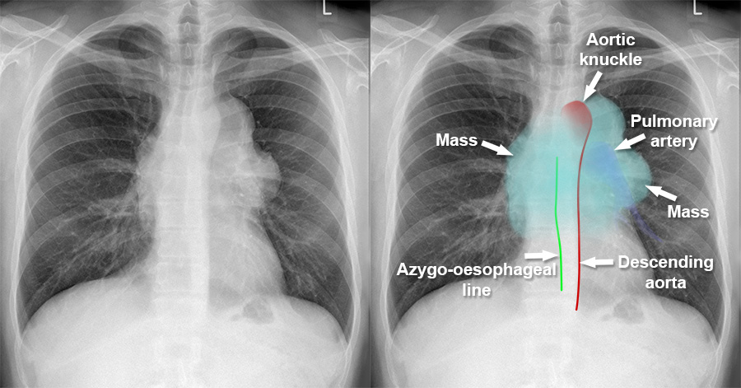
Anterior mediastinal mass
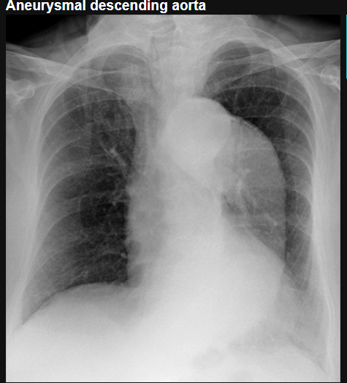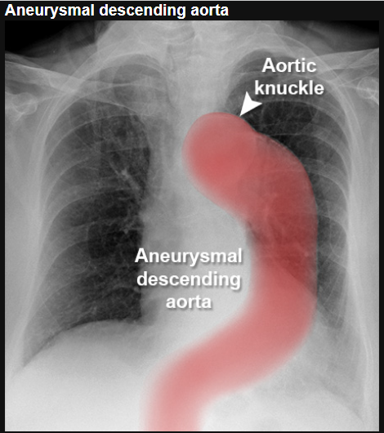 Aneurysmal descending aorta

