Types of Volume Coils
Among the common volume MRI coils types belong:
- Circularly Polarized Coil
- Quadrature coil
- Bird Cage Coil
- Crossed Coil
- Helmholtz Pair Coil
- Paired Saddle Coil
- Single Turn Solenoid
Crossed Coil
A crossed coil is an RF pair of coils arranged with their magnetic fields at right angles to each other in a way that minimizes their mutual magnetic interaction.
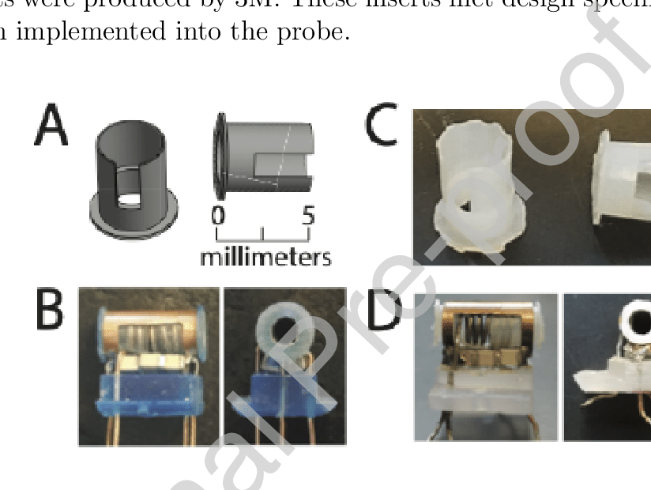Fig fig(1): Crossed Coil
Helmholtz Pair Coils
These coils consist of two identical circular coils parallel to each other. They are occasionally used as RF coils for pelvis imaging and cervical spine imaging. Named after the German physicist Hermann von Helmholtz.
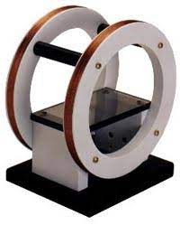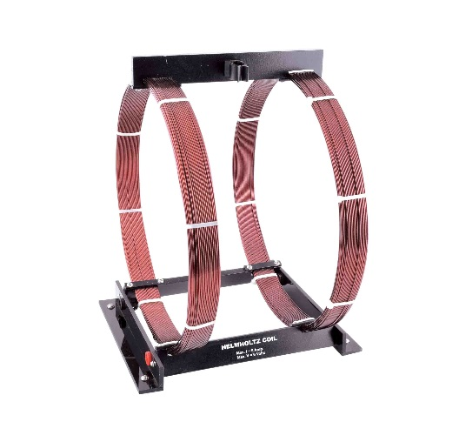
Fig (2): Helmholtz Pair Coils
Paired Saddle Coil
Paired saddle coils are used as the x- and y-axis of gradient coils as well as extremity coils. This configuration creates a very linear, homogeneous magnetic field along its central axis.
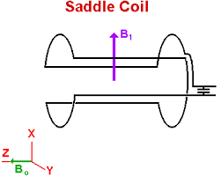
Fig (3): Paired Saddle Coil
Single Turn Solenoid Coil
These coils are transmit and receive RF imaging coils that generally have a cylindrical shape. In coil design, the imaged object is placed within one radius of the center of the coil. That improves imaging of extremities such as wrists or knees.

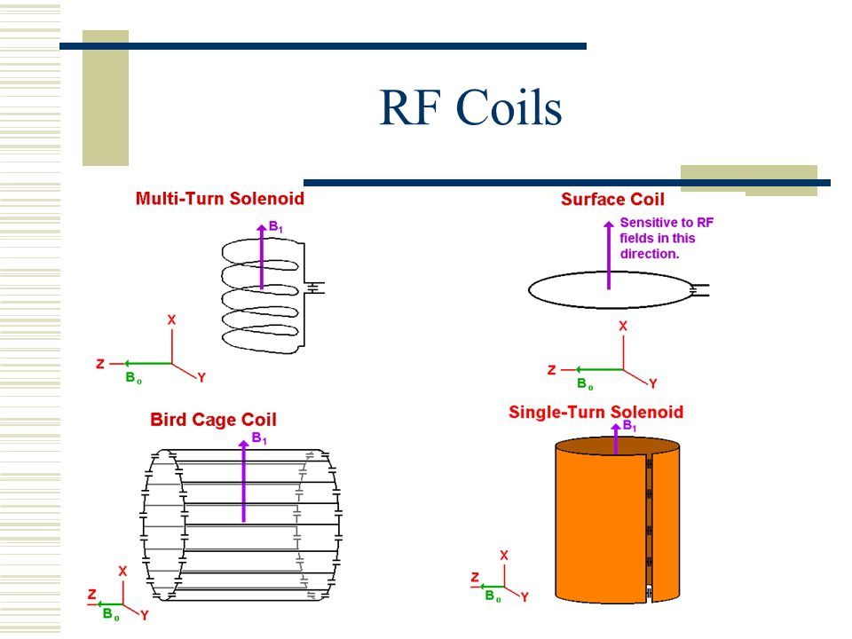
Fig (4): Single Turn Solenoid Coil

