Types of Volume Coils
It is possible to use the same volume coil to transmit and receive simultaneously. Nevertheless, you can also use two separate coils. The larger volume coil will be the body coil, typically a transmit and receive coil. If you are using two separate coils, the body coil acts as the transmitter while the smaller coil acts as the receiver.
In general, volume coils are great for transmitting, but less ideal when used for small regions of interest.
Among the common volume MRI coils types belong:
- Circularly Polarized Coil
- Quadrature coil
- Bird Cage Coil
- Crossed Coil
- Helmholtz Pair Coil
- Paired Saddle Coil
- Single Turn Solenoid
Circularly polarized coils
Circularly polarized coils have been designed to excite or detect electromagnetic fields by means of two orthogonal transmit and/or receive channels.
When it is a receiver coil, it has a better SNR than a linearly polarized coil (which belongs to the surface coils).
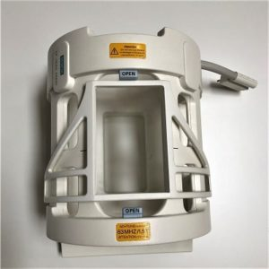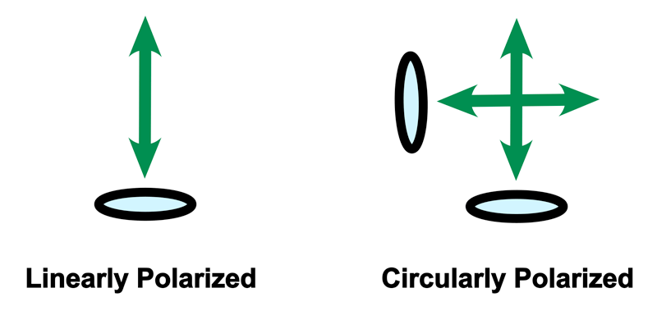
Fig (1):Circularly polarized coils
Quadrature Coil
They produce an RF field with circular polarization.The RF power that is obtained from the RF power amplifier comes in two signals and the RF transmit coil transforms the power into a circularly polarized RF magnetic field.
They can be used as both, transmit and/or receive coils.

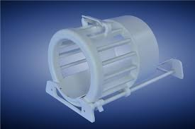
Fig (2): Quadrature Coil
Birdcage Coils : These coils provide the best RF homogeneity of all RF coils. Its name comes from the shape of a birdcage.
This coil is commonly used as a transmit-receive coil for imaging the head, it is used for imaging of extremities such as knees. The birdcage coil consists of two circular conductive loops referred to as end rings connected by an even number of conductive straight elements called rungs or legs. The number of rungs depends on the size of the coil (body coil > head coil) and typically ranges from about 8 to 32.
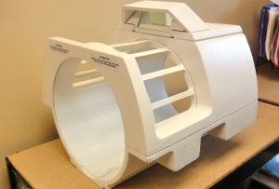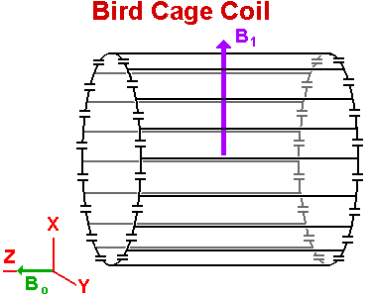
Fig (3): Birdcage Coils

