Radio Frequency Coils (RF)
Radio Frequency (RF) coils are needed to receive and/or transmit the RF signals used in MRI scanners.
Is the part of the MRI system that excites the aligned spins and receives an RF signal back from the sample. All the components are controlled and interfaced with the user via a console. In general, RF coils act like a broadcasting station: they transmit and receive signals.
RF coils system comprises the set of components for transmitting and receiving the radiofrequency waves involved in exciting the nuclei, selecting slices, applying gradients and in signal acquisition. RF coils are vital component in the performance of the radiofrequency system. They one of the most important components that affects image quality and obtaining clear images of the human body.
RF coils for MRI can be categorized into two different categories:
volume coils and surface coils.
1. Volume RF Coils
The design of a volume coil is to provide a homogeneous RF field inside the coil which is highly desirable for transmit, but is less ideal when the region of interest is small. The large field of view of volume coils means that by receiving the noise that they receive from the whole body, not just the region of interest. Volume coils need to have the area of examination inside the coil.


They can be used for transmit and receive, although sometimes they are used for receive only. Most clinical applications volume coil is built to perform whole-body imaging, and smaller volume coils have been constructed for the head and other extremities. These coils are requiring a great deal of RF power because of their size, so they are often driven in quadrature in order to reduce by two the RF power requirements.
Figure 1 : (A,B) shows two volume coils.


(A) The knee coil is receive only.
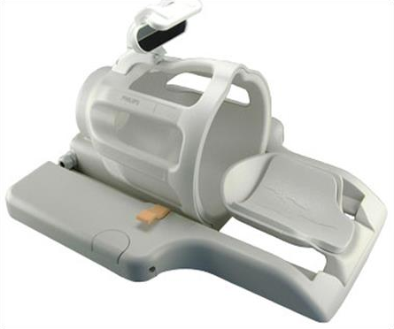

(B) The head coil is a transmit/receive.

