Shimming
MRI requires a very high homogeneous static magnetic field. In order to produce high- resolution images, the magnetic field inhomogeneity produced in a high performance MRI scanner must be maintained to the order of several ppm.
After manufacturing, the magnet must be adjusted in some points to produce a more uniform field by making small mechanical and/or electrical adjustments to the overall field. This process is known as shimming. Because the magnet itself is not adequately homogeneous, it is necessary to improve or “shim” the homogeneity of the static magnetic field (Bo).
A shim : Is a device used to adjust the homogeneity of a magnetic field.
(Shimming is a process that is carried out to correct any inhomogeneities in the applied magnetic field during a magnetic resonance).
Shimming (or adjustment of the static magnetic field homogeneity) is accomplished by two methods: (1) Passive shimming (2) Active shimming
- Passive shimming : Passive shimming: The mechanical adjustments, which add small pieces of iron or magnetized materials, are typically called passive shimming. Passive shimming involves pieces of steel with good magnetic qualities. The steel pieces are placed near the permanent or superconducting magnet. They become magnetized and produce their own magnetic field.
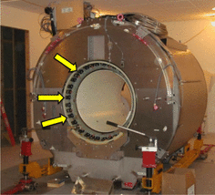
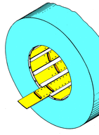
Fig (1) : Passive Shimming
(2) Active shimming : The electrical adjustments, which use extra exciting currents, are known as active shimming. Active shimming is performed with coils with adjustable current. Active shimming requires passage of electric current through coils with unique geometric configurations. The shim coils are designed to correct inhomogeneities of specific geometries.
In both cases (active and passive shimming), the additional magnetic fields (produced by coils or steel) add to the overall magnetic field of the superconducting magnet in such a way as to increase the homogeneity of the total field.

