Magnet Types
2. Electromagnets
B/ Superconducting Magnets
- Superconducting magnets are Today's most commonly used in MRIs.
- These superconductors, such as niobium-tin and niobium-titanium are used to make the coil windings for superconducting magnets.
- The magnetic field is generated by a passing electrical current through coils of wire. The wire is surrounded with a coolant, such as liquid helium, to reduce the electric resistance of the wire.
- At 4 Kelvin (-269 C) electric wire looses its resistance. Once a system is energized, it won't loose its magnetic field.
- Superconductivity allows for systems with very high field strengths up to 12 Tesla.
- The ones that are most used in clinical environments run at 1.5 Tesla. Most superconducting magnets are bore type magnets.
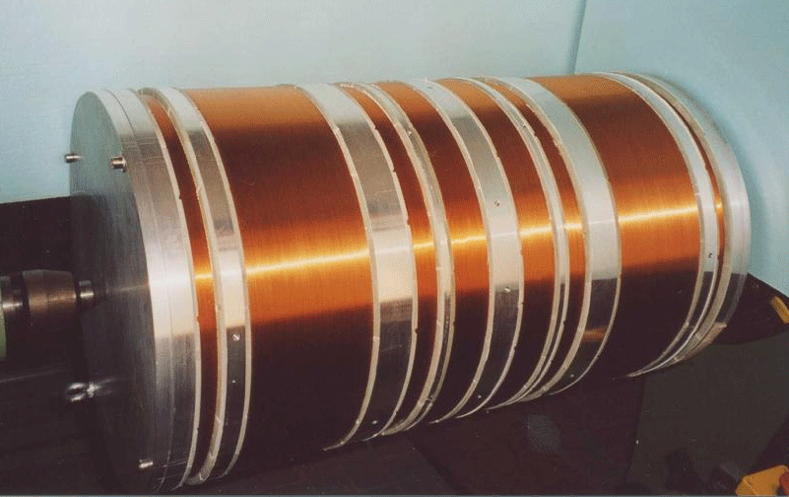
Figure (1) : Superconducting Magnets
- A number of vacuum vessels, which act as temperature shields, surround the core. These shields are necessary to prevent the helium to boil off too quickly.
- Another advantage of superconducting magnets is the high magnetic field homogeneity.
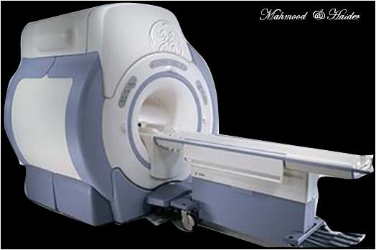
Figure (2) : bore type magnets.
ADVANTAGES
- High field strength
- High field homogeneity
- Low power consumption
- High SNR (SNR: The ratio of signal power to the noise power)
- Fast scanning
DISADVANTAGES
- High capital costs
- High cryogen costs
- Acoustic noise
- Motion artifacts
- Technical complexity

