Magnet Types
2. Electromagnets
There are two categories can be used in MR scanner:
A / Resistive Magnets and B/ Superconducting Magnets
A / Resistive Magnets :
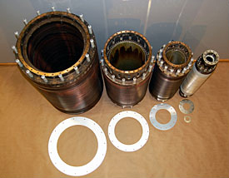
- Resistive magnets are made from loops of wire wrapped around a cylinder through which a large electric current is passed.

Figure (1) Resistive Magnets
- These magnets are very large that utilizes the principles of electromagnetism to generate the magnetic field, like the ones used in scrap yards to pick up cars.
- They are lower in cost, but need a lot of power to run that means, large current values which runs through loops of wire because of the natural resistance of the wire. Therefore they produce a lot of heat, which requires significant cooling of the magnet coils.
- Resistive magnets come in two general categories:
iron-core and air-core.
- Resistive magnets are typically limited to maximum field strengths can be up to 0.6 Tesla. They usually have an open design, which reduces claustrophobia.
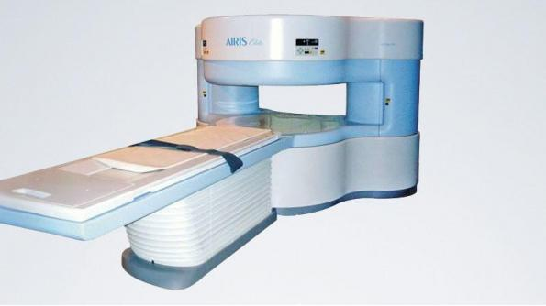
Figure (2) shows Hitachi's Airis 0.3 Tesla (air- core) system.
ADVANTAGES
- Low capital cost
- Light weight
- Can be shut off
DISADVANTAGES
- High power consumption
- Limited field strength (<0.2T)
- Water cooling required
- Large fringe field

