Surface Coils
- Surface coils are the coils with the simplest coil design.
- it is a loop of wire, either circular or rectangular, that is placed over the region of interest (around the surface of a patient) for increased magnetic sensitivity.
- It can be also slightly bent to conform to the imaged body part.
- They belong to the group of receive-only coils.
- The surface coils have a great SNR for tissues placed near the coil.The further the tissue is from the coil, the less sensitive it is.The possibilities of usage are wide.
- You can use the surface coils for spines, shoulders, the joint of the jaw (temporomandibular joint), and imaging of other smaller body parts. 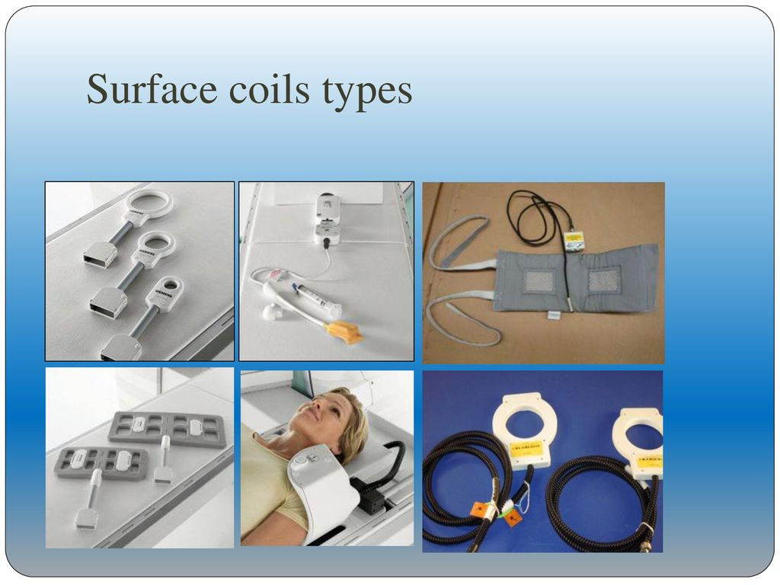
Fig (1) : Surface Coils
Among the common surface MRI coils types belong:
- Array Coil
- Body Wrap-Around Coil
- Linearly Polarized Coil
- Saddle Coil
Array Coil
These coils merge the benefits of smaller coils (high SNR) with the benefits of larger coils (large measurement field). Moreover, they consist of separate multiple smaller coils that you can use individually or combined.
Array coil systems are collections of small surface coils whose signals may be combined but generally feed into independent receiver circuitry.
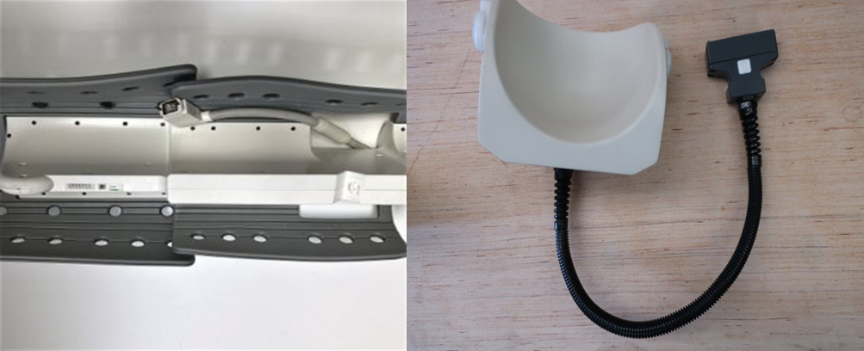
Fig (2) : Array Coil
Body Wrap Around Coils (BWA)
BWA coils are flexible surface coils for body imaging.
There are many tubular or rod-shaped organs and tissues within the human body. A miniature medical implant that wraps around such a biological structure can monitor or modulate its function. In order to provide the wrap-around implant with power, a solenoidal coil coupled wirelessly with a planar coil outside the human body can be used.
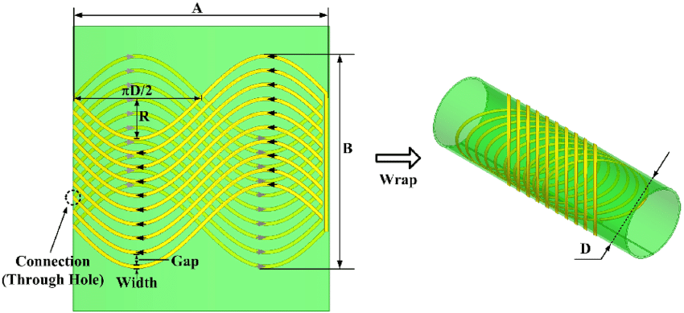
Fig(3): Body Wrap Around Coils (BWA)
Linearly polarized coils (LP)
These coils are designed to excite or detect electromagnetic fields using one RF transmit and/or receive channel, in contrast to circularly polarized MRI coils which are using two channels.
Primarily, the magnetic field of the LP coils has a single direction.
Linearly polarized RF coils detect the rotating magnetization (MR signal) along a single direction.
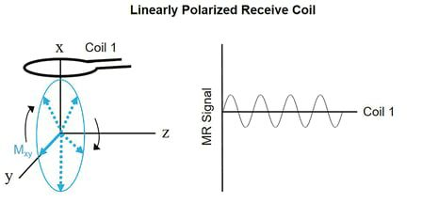
Fig (4): Linearly polarized coils (LP)
Saddle Coil
Saddle coils have cylindrical bodies with one or more turns of wire or foil on each side. The coils with foil are newer versions of saddle coils.
A saddle coil has a cylindrical body, with one or more turns of wire (older versions) or foil (newer versions) on each side. It generates a very homogenous field in the direction of its long axis. To achieve a higher B1 homogeneity there are different developments like Folded Litz-foil Saddle Coils or Etched Litz-foil Saddle Coils.
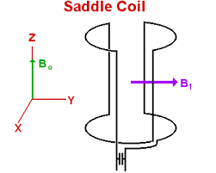
Fig(5): Saddle Coil

