Dr . Kais ALhadrawi Lec -1- Biology PHD. Ibtihal Riyadh

Cell and cell theory
Cell is the basic structural and functional unit of all living organisms. It is the smallest unit of life and can replicate independently. The study of cell is called Cell Biology.
Cells vary from individual “single cell” organisms (bacteria) to “multi cellular” structures (tissues, organs) and organisms (animals and plants).
Cell was discovered by Robert Hooke in 1665. The discovery of the cell was made possible through the invention of the microscope. He first observed cell in thin slices of bottle cork. Hooke discovered many tiny pores that he named "cells". This came from the Latin word “Cella”. He described the cells as tiny boxes or a honeycomb. He thought that cells only existed in plants and fungi.
Anton van Leeuwenhoek (1673): Used a handmade microscope to observe pond scum and discovered single-celled organisms. He called them “animalcules”. He also observed blood cells from fish, birds, frogs, dogs and humans. Between the Hooke/Leeuwenhoek discoveries and the mid 19th century, very little advancements in cell were made.
In 19th century; many doubted Spontaneous Generation and this was disproved by Louis Pasteur.
Development of cell theory
1838- German Botanist, Matthias Schleiden, concluded that all plant parts are made of cells.
1839- German physiologist, Theodor Schwann, who was a close friend of Schleiden, stated that all animal tissues are composed of cells.
1858- Rudolf Virchow, German physician, after extensive study of cellular pathology, concluded that cells must arise from preexisting cells.
Cell theory
- All organisms are composed of one or more cells .
- Cell is the basic unit of life in all living things.
- All cells are produced by the division of preexisting cells.
Modern cell theory
Modern Cell Theory contains four statements, in addition to the original Cell Theory:
❑ The cell contains hereditary information (DNA) which is passed on from cell to cell during cell division.
❑ All cells are basically the same in chemical composition and metabolic activities.
❑ All basic chemical and physiological functions are carried out inside the cells (movement, digestion etc) .
❑ Cell activity depends on the activities of sub-cellular structures within the cell (organelles, nucleus, plasma membrane etc(
Types of cell
Cells are of two types. i.e. Prokaryotic and Eukaryotic cell. Eukaryotic cell contains a nucleus and Prokaryotic do not. Prokaryotes are single-celled organisms, while Eukaryotes can be either single-celled or multi-celled.

Prokaryotic cell: (Pro- first formed, Karyo- nucleus)
Prokaryote is a single celled that lacks a membrane bound nucleus (karyon), mitochondria or any other organelles in the cytoplasm except ribosomes. Cell division occurs mainly by binary fission. E.g. Bacteria. Prokaryotic cells were the first form of life on Earth. They are simpler and smaller than Eukaryotic cells.
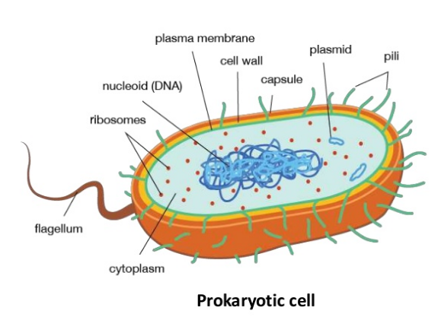
Eukaryotic cell: (Eu- true, Karyo- nucleus).
Eukaryotes have specialized organelles in the cytoplasm, a membrane bound nucleus enclosing genetic material organized into chromosomes. Their cell division occurs by mitosis and meiosis. eg. Plants, animals, fungi, protozoa and algae. These cells are larger than a typical prokaryote and can be as much as a thousand times greater in volume.
