Magnetic resonance imaging (MRI)
The Hardware
Scanners of magnetic resonance imaging (MRI) come in many varieties. There is a permanent magnet type, resistive, superconducting, and opening or bore, with or without helium, high field strength or low. The choice of magnet mainly governed by what you intend to do, and the cost. Field magnets offer high quality image better, faster scanning and a wider range of applications, but they are more cost than their counterpart's field is low.
Magnet Types
The static magnetic field (Bo) in MRI systems can be created by: Permanent magnets and Electromagnets.
- Permanent Magnets
A permanent magnet that originates from permanently ferromagnetic materials, which does not lose the magnet field, that remains over time without weakening. Due to weight considerations, these types of magnets are usually limited to maximum field strengths of 0.4 T (the unit for magnetic field strength is Tesla: 1 Tesla = 10000 Gauss). Permanent magnets have usually an open design system (see Figure 1) which has ample open space which is more comfortable for the patient. So, the open design accommodates extremely large patients and dramatically reduces anxiety for all patients especially those who have claustrophobic tendencies or have larger body structures.
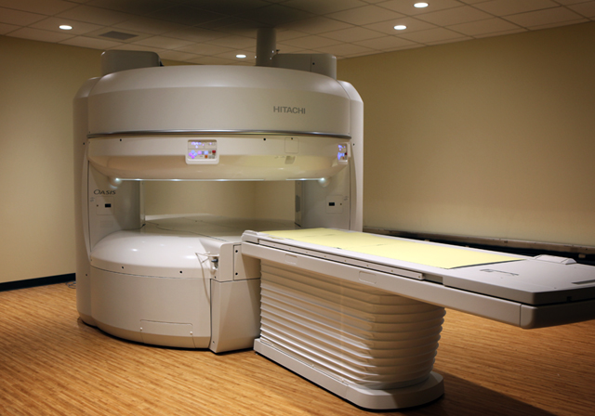
Fig (1) Open MRI system
ADVANTAGES
1. Low power consumption 2. Low operating cost
3. Small fringe field 4. No cryogen
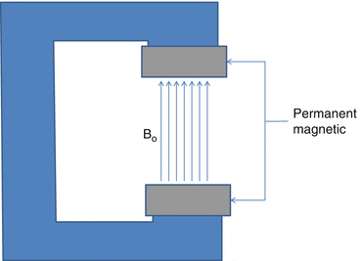
DISADVANTAGES
1.Limited field strength (<0.3T)
2.Very heavy
3.No quench possibility
Fig (2) Permanent Magnets

