Magnetic resonance imaging (MRI)
Magnetic resonance imaging (MRI) : An MRI is short for magnetic resonance imaging.
Is a type of scan that uses strong magnetic fields and radio waves to produce detailed images of the inside of the body.
Is a non-invasive imaging technology that produces three dimensional detailed anatomical images. It is often used for disease detection, diagnosis, and treatment monitoring.
It is based on sophisticated technology that excites and detects the change in the direction of the rotational axis of protons found in the water that makes up living tissues.
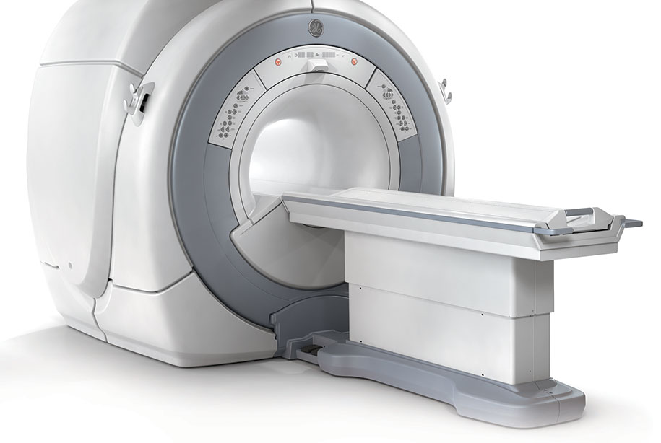
Fig (1) magnetic resonance imaging.
What is MRI used for?
MRI scanners are particularly well suited to image the non-bony parts or soft tissues of the body. They differ from computed tomography (CT), in that they do not use the damaging ionizing radiation of x-rays. The brain, spinal cord and nerves, as well as muscles, ligaments, and tendons are seen much more clearly with MRI than with regular x-rays and CT; for this reason MRI is often used to image knee and shoulder injuries.
Because MRI does not use x-rays or other radiation, it is the imaging modality of choice when frequent imaging is required for diagnosis or therapy, especially in the brain. However, MRI is more expensive than x-ray imaging or CT scanning.
Advantages Of an MRI
MRIs are used to take pictures of your organs in a way that x-ray’s cant accomplish. In more real terms, it provides a more vibrant picture of what’s going on within your body. The machine achieves this imaging technique by using strong magnetic scanners. No Radiation Risks .
Unlike x-rays, where you’re exposed to radiation waves, an MRI doesn’t put off these waves (known as ionizing radiation), so you’re not at risk. Some grave consequences come from being exposed to ionizing radiation.
H.W :
1- Make a report (2-3) pages ………………………….…….
2- Make a report (2-3) pages about ………………………..

