Laboratory Safety
Components of a Safety Program:
 Blood borne Pathogens (Biological safety).
 Chemical Safety.
 Fire safety.

- Blood borne Pathogens (Biological risk):
What are blood borne pathogens ?
Viruses, bacteria or other micro-organisms that are carried in the bloodstream and
are capable of causing disease.

Other body fluids that can spread blood borne pathogens include:
▪ Blood products (plasma, platelets, serum)
▪ Abdominal fluids
▪ Amniotic fluids
▪ Cerebrospinal fluids
Most Common Blood borne Pathogens:
Hepatitis B, Hepatitis C, HIV, Tuberculosis, Typhoid fever,Brucelosis, aspergilosis, Histoplasmosis, Malaria.
➢ Personal Protective Equipment (PPE)
1- Lab coats (should be fluid resistant)
2- Gloves
3- Safety glasses/Goggles
4- Face shields .
How much PPE should you use?
Wear as much or as little as you anticipate you will need to prevent blood and
other infectious materials from contact with your skin, mucus membranes and
clothing.

- Chemical Safety:
How Do Chemicals enter the body?
 Inhalation – breathing in (e.g. powders, fumes)
 Absorption – on skin or mucus membranes
 Ingestion – entry through the mouth
 Injection - through skin by foreign body.

Examples of Chemical Hazards:
➢ Carcinogens – cancer
➢ Hepatotoxins –liver damage
➢ Nephrotoxins – Kidney damage
➢ Neurotoxins – damage to the nervous system
➢ Tertatogens – birth defects

Material Safety Data Sheet (MSDS):
The following Data Can be found on MSDS sheets…
- Name of Chemical.
- Physical Characteristics and hazards.
- Health information.
- First Aid required if there is a spill or exposure.
- Date of most recent update

3 - Fire Safety.
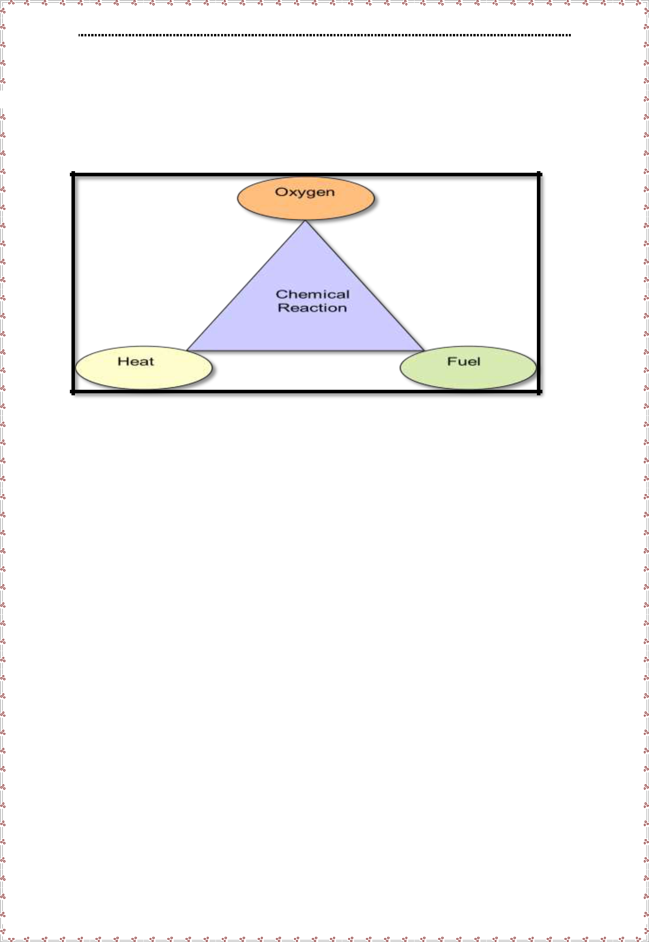

Types of Fire Extinguishers:
 A – Combustibles (paper, trash, cloth)
 B – Flammable liquids
 C – Electrical Equipment
 D – Combustible metals (not Common)

