

Radiology Techniques

Department
The Radiological Anatomy Lecture 12
Brain Anatomy
By
Dr. Safaa AL-Mosawy & M.Sc. Zeyad Tareq

2rd Stage
2022-2023

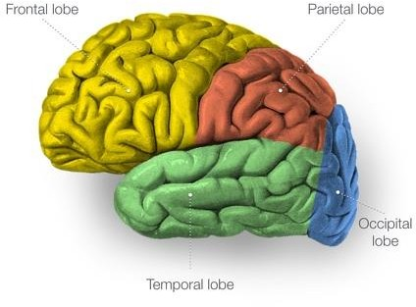
Overview of Brain Anatomy
The brain is semisolid and conforms to the shape of the skull. Its hemispheric surface is convoluted and has gyri and sulci. The brain consists of the cerebrum, cerebellum, and brainstem.
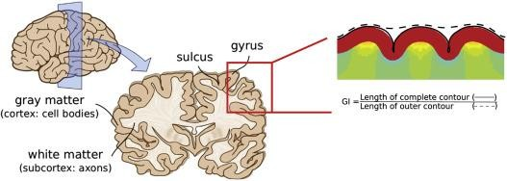

Dura and Dural Structures
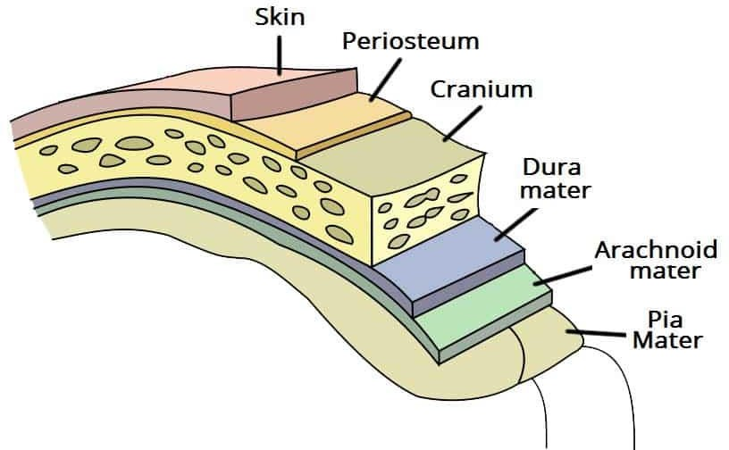
The brain is protected (from the outer to the inner layer) by the skull, meninges, and cerebrospinal fluid (CSF). The meninges are organized into dura mater, arachnoid membrane, and pia mater, in order of their proximity to the skull. The pia mater follows all the gyri and is separated from the arachnoid membrane by CSF.

Ventricles
There are four ventricles within the brain. They are lined with ependyma and contain the CSF, produced by the choroid plexus.
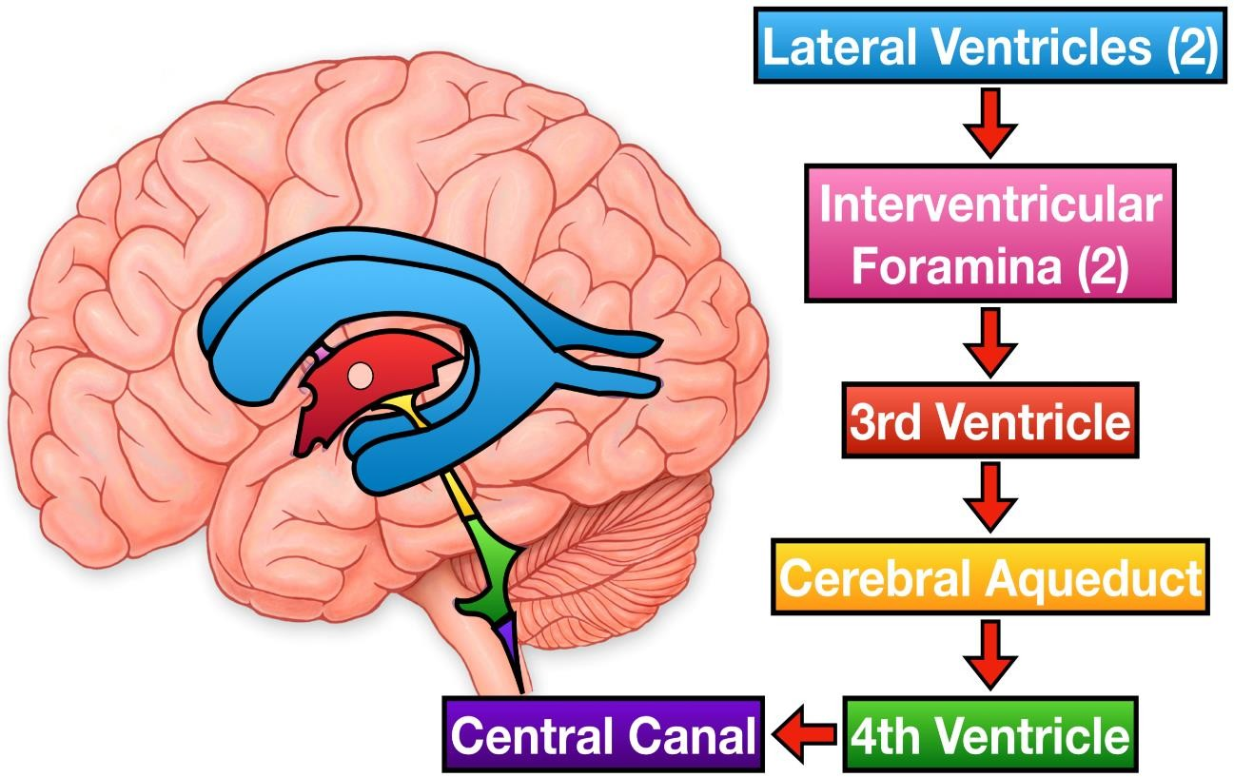

Lateral (Left and Right) Ventricles.
Lateral ventricles are formed by the two ependyma-lined cavities of the cerebral hemisphere and communicate with the third ventricle via the midline foramen of Monroe. They can be divided into five parts: the anterior (frontal) horn, the ventricular body, the collateral (atrium) trigone, the inferior (temporal) horn, and the posterior (occipital) horn.
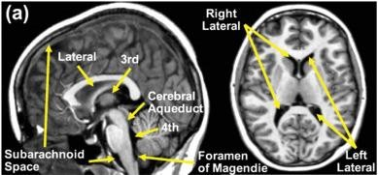

Third Ventricle.
The third ventricle is a slitlike ventricle midline cavity of the diencephalons. It communicates with the lateral ventricles via the interventricular foramina of Monro and with the fourth ventricle via the cerebral aqueduct. It contains choroid plexus in its roof.
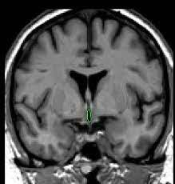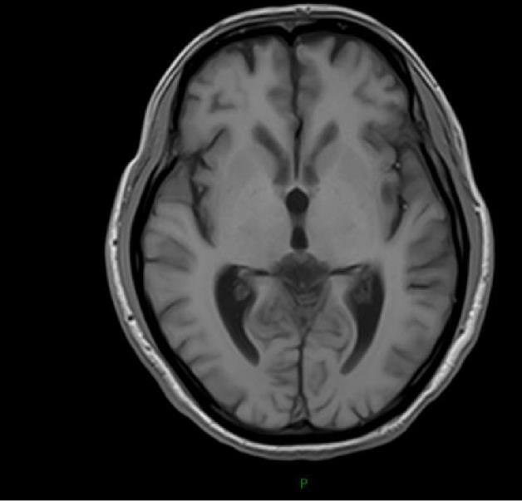

Fourth Ventricle.
The fourth ventricle is a rhomboid-shaped cavity overlying the pons and medulla, extending from the central canal of the upper cervical spinal cord to the cerebral aqueduct of the midbrain. There is a small lateral recess on each side of the fourth ventricle that contains choroid plexus that protrudes through the foramina of Luschka into the subarachnoid space. A small median aperture in the caudal part of the ventricle is known as the foramen of Magendie. Via the two lateral foramina of Luschka and the single medial foramen of Magendie, CSF flows into the ventricular system into the subarachnoid spaces.
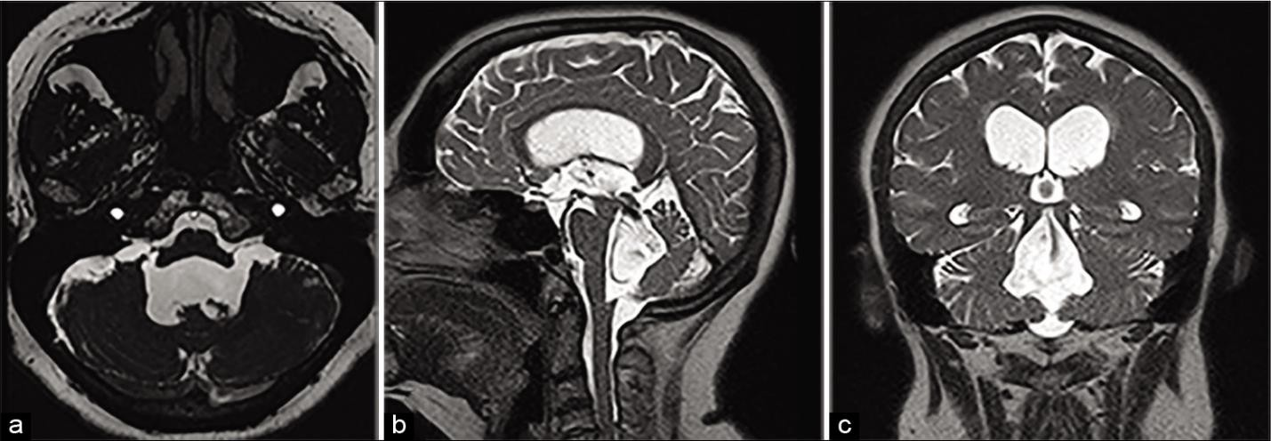

Cerebral Hemispheres
The two cerebral hemispheres are separated by interhemispheric fissures and falx cerebri. On the lateral surface of the brain, the sylvian fissure (lateral fissure) and the Rolandic fissure (central fissure) separate the cerebral hemisphere into the frontal lobe, temporal lobe, parietal lobe, and a line drawn from the parietooccipital sulcus onto the paraoccipital notch, delineating the boundaries of the parietal and temporal lobes from that of the occipital lobe.
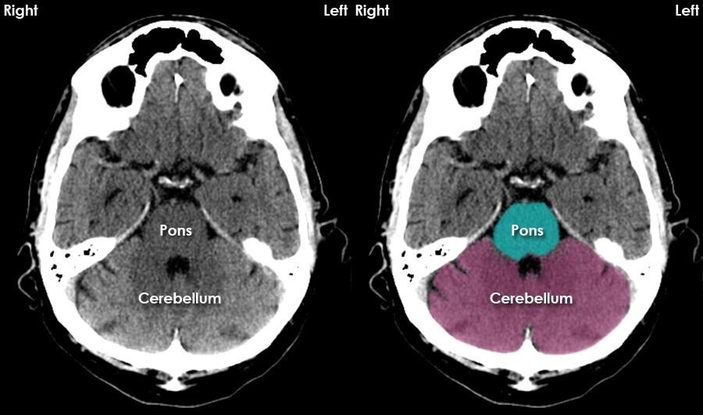

The frontal lobe, the largest of all the brain, has four principal gyri: the precentral gyrus and the superior frontal, middle frontal, and inferior frontal gyri . The precentral gyrus, parallel to the central sulcus, together with the anterior bank of the central sulcus comprises the primary motor area, which is one of the most important cortical areas for movement. Rostral to the precentral sulcus is the premotor area, another important area for movement. The middle frontal gyrus contains Brodmann’s area 8, known as the frontal eye field, which is important for conjugate eye movements. Another important motor area for speech, Broca’s area, is located at the triangular and opercular parts of the inferior frontal gyrus in the dominant hemisphere.

Thanks

