LAP Name:7-segment display

Introduction:
The idea of a seven-segment indicator for representing decimal numbers. Each segment of a seven-segment display is a small light-emitting diode (LED) or liquid-crystal display (LCD), as is shown below:
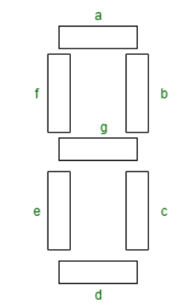
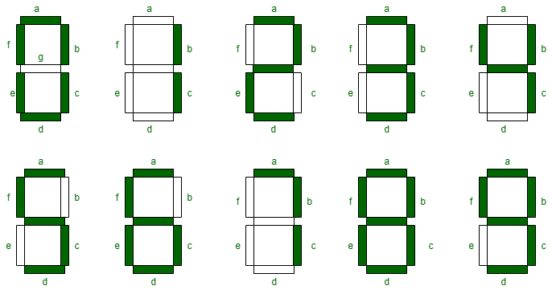
Binary-coded-decimal (BCD) is a common way of encoding decimal numbers with 4 binary bits as shown below:
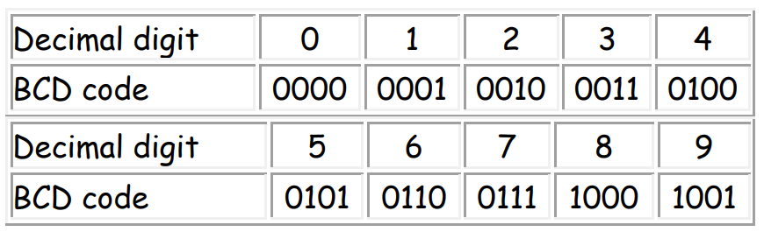

Truth table of 7 segment decoder
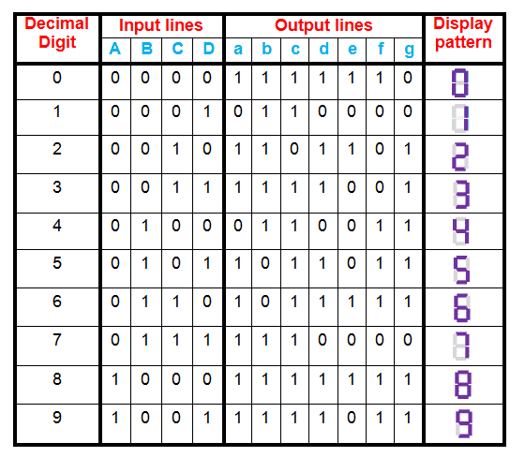
Components lap
1- Seven segment display
2- Switch DIPSW1
3- VCC
4-Decoder 74LS47D: A BCD to Seven Segment decoder is a combinational logic circuit that accepts a decimal digit in BCD (input) and generates appropriate outputs for the segments to display the input decimal digit.

LAP Design
