Gradient Coils
To produce an image, you must stimulate the hydrogen nuclei in the body, and then determine the location of those nuclei within the body. These tasks are accomplished using the gradient coil.
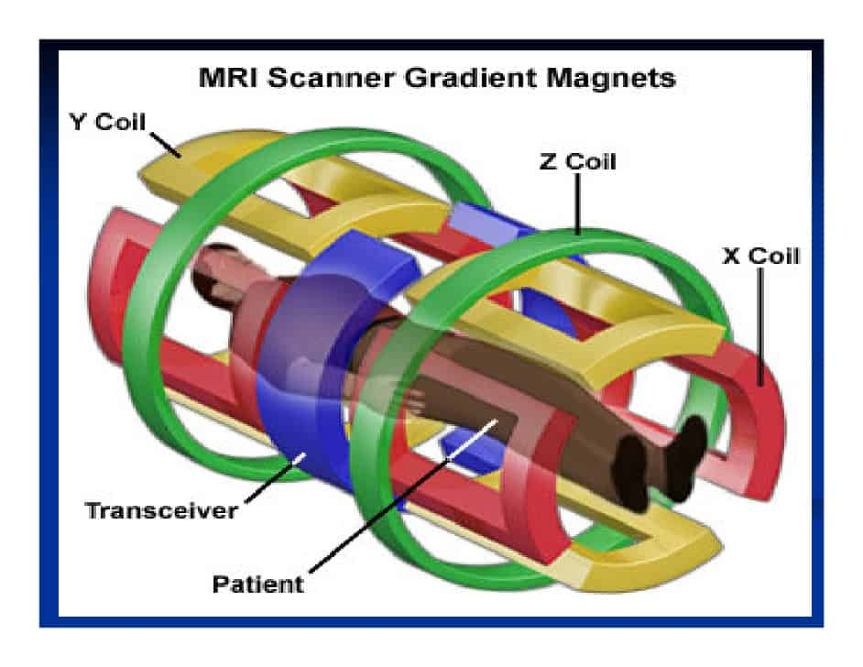
Fig (1) Gradient Coils
Gradients coils are loops of wire or thin conductive sheets on a cylindrical shell lying just inside the bore of an MR scanner. When current is passed through these coils a secondary magnetic field is created.
This gradient field slightly distorts the main magnetic field in a predictable pattern, causing the resonance frequency of protons to vary in as a function of position. The primary function of gradients, therefore, is to allow spatial encoding of the MR signal.
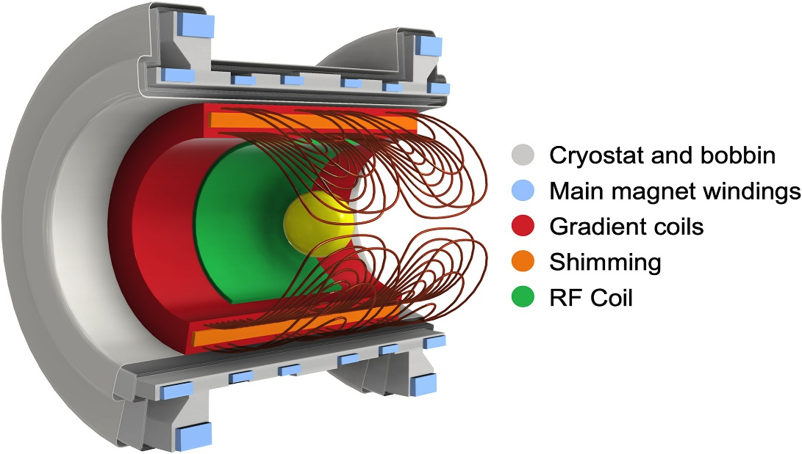
Fig (2): MRI device components.
In general, the magnetic field gradient produced by the gradient coils is required to be well-designed, also have low inductance, low resistance, high efficiency, etc. This is especially pertinent in high-field imaging and fast imaging when all the coils’ parameters must be highly optimized.
The three-axis gradient coils are fixed by epoxy resin in an encapsulated gradient assembly. In an integrated gradient assembly, there are also cooling devices and a shim tray installed. The hard epoxy resin largely impedes the vibration of the gradient coils, which avoids torsion and deformation of the gradient coils under strong Lorentz force.

1- Define Gradient Coils.
2- Why the gradient coils are fixed by epoxy resin?

