

Radiology Techniques

Department

The Radiological Anatomy

Lecture 2

HEART AND CORONORY ARTERIES
RADIOLOGICAL ANATOMY
By
M.Sc. Zeyad Tareq & M.Sc. Salman Mohammed

3rd Stage
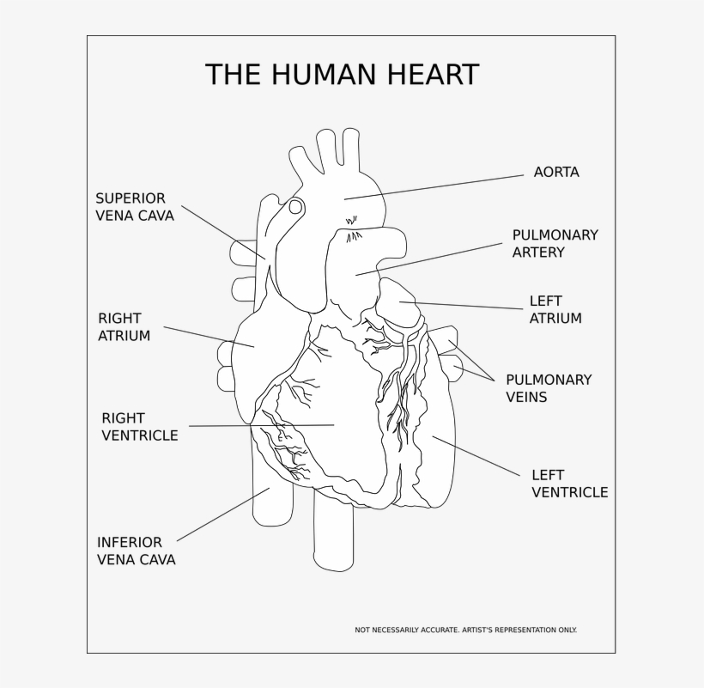

The Heart

Gross anatomy and orientation
The heart is pyramidal in shape and lies obliquely in the chest. Its square-shaped base points posteriorly and the elongated apex to the left and inferiorly.
The left atrium forms the base or posterior part, with the superior and inferior pulmonary veins draining into its four corners.
The right atrium forms the right border, with superior and inferior venae cava draining into its upper and lower parts.
The apex and left border are formed by the left ventricle.
The right ventricle forms the anterior part.
The inferior (diaphragmatic) part of the heart is formed by both ventricles anteriorly and a small part of right atrium posteriorly where the IVC enters this chamber.
The interatrial and interventricular septa are said to lie in the left anterior oblique plane
The plane of the valves is also inclined inferiorly and to the left.
Pericardium
This is a closed sac consisting of parietal and visceral layers that enclose a potential space which contains 20-25 mL of serous fluid. It is draped over the heart and great vessels.
The visceral layer adheres to the myocardium and is also known as the epicardium. The parietal layer is free, except inferiorly, where it is bound to the central tendon of the diaphragm, and superiorly where it fuses with the covering of the great vessels.
Some fat is present between the epicardium and myocardium. This increases with age. Fat is also present between the pericardium and mediastinal pleura, and it may be extensive in the anterior and lateral cardiophrenic angles, where it is known as the pericardial fat pad.

Cardiac chambers and valves
