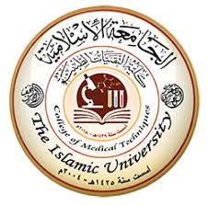
------------------------------------------------------------
Medical Physiology Lecture (8)
Dr. Ahmed Hussein Zwamel

The Islamic University, Najaf College of Medical Techniques Department of Radiology Techniques First Stage

Digestive System
Two groups of organs compose the digestive system (Figure 1): the gastrointestinal (GI) tract and the accessory digestive organs. The gastrointestinal (GI) tract, or alimentary canal (alimentary= nourishment), is a continuous tube that extends from the mouth to the anus through the thoracic and abdominopelvic cavities. Organs of the gastrointestinal tract include the mouth, most of the pharynx, esophagus, stomach, small intestine, and large intestine. The length of the GI tract is about 5–7 meters in a living person when the muscles along the wall of the GI tract organs are in a state of tonus (sustained contraction). It is longer in a cadaver (about 7–9 meters) because of the loss of muscle tone after death. The accessory digestive organs include the teeth, tongue, salivary glands, liver, gallbladder, and pancreas.
Teeth aid in the physical breakdown of food, and the tongue assists in chewing and swallowing. The other accessory digestive organs, however, never come into direct contact with food. They produce or store secretions that flow into the GI tract through ducts; the secretions aid in the chemical breakdown of food.
The GI tract contains food from the time it is eaten until it is digested and absorbed or eliminated. Muscular contractions in the wall of the GI tract physically break down the food by churning it and propel the food along the tract, from the esophagus to the anus. The contractions also help to dissolve foods by mixing them with fluids secreted into the tract. Enzymes secreted by accessory digestive organs and cells that line the tract break down the food chemically.

Overall, the digestive system performs six basic processes:
1. Ingestion. This process involves taking foods and liquids into the mouth (eating).
2. Secretion. Each day, cells within the walls of the GI tract and accessory digestive organs secrete a total of about 7 liters of water, acid, buffers, and enzymes into the lumen (interior space) of the tract.
3. Mixing and propulsion. Alternating contractions and relaxations of smooth muscle in the walls of the GI tract mix food and secretions and move them toward the anus. This capability of the GI tract to mix and move material along its length is called motility.
4. Digestion. Mechanical and chemical processes break down ingested food into small molecules. In mechanical digestion the teeth cut and grind food before it is swallowed, and then smooth muscles of the stomach and small intestine churn the food to further assist the process. As a result, food molecules become dissolved and thoroughly mixed with digestive enzymes. In chemical digestion the large carbohydrate, lipid, protein, and nucleic acid molecules in food are split into smaller molecules by hydrolysis. Digestive enzymes produced by the salivary glands, tongue, stomach, pancreas, and small intestine catalyze these catabolic reactions. A few substances in food can be absorbed without chemical digestion. These include vitamins, ions, cholesterol, and water.
5. Absorption. The entrance of ingested and secreted fluids, ions, and the products of digestion into the epithelial cells lining the lumen of the GI tract is called absorption. The absorbed substances pass into blood or lymph and circulate to cells throughout the body.
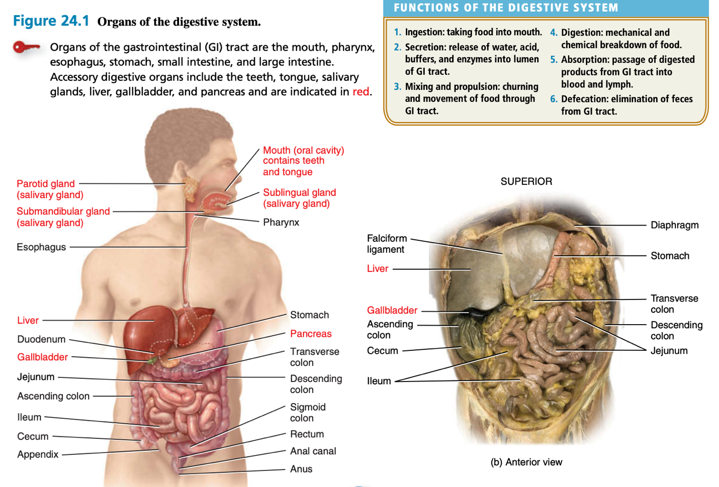
6. Defecation. Wastes, indigestible substances, bacteria, cells sloughed from the lining of the GI tract, and digested materials that were not absorbed in their journey through the digestive tract leave the body through the anus in a process called defecation. The eliminated material is termed feces or stool.

Figure 1: Organs of the digestive system

Layers of the GI Tract
The wall of the GI tract from the lower esophagus to the anal canal has the same basic, four-layered arrangement of tissues. The four layers of the tract, from deep to superficial, are the mucosa, submucosa, muscularis, and serosa/adventitia (Figure2).

Mucosa
The mucosa, or inner lining of the GI tract, is a mucous membrane. It is composed of (1) a layer of epithelium in direct contact with the contents of the GI tract, which functions in protection, secretion and absorption (2) a layer of connective tissue called the lamina propria containing many blood and lymphatic vessels, which are the routes by which nutrients absorbed into the GI tract and (3) a thin layer of smooth muscle fibers (muscularis mucosae) which increase the surface area for digestion and absorption.
Submucosa
The submucosa consists of areolar connective tissue that binds the mucosa to the muscularis. It contains many blood and lymphatic vessels that receive absorbed food molecules. Also located in the submucosa is an extensive network of neurons known as the submucosal plexus. The submucosa may also contain glands and lymphatic tissue.
Muscularis
The muscularis of the mouth, pharynx, and superior and middle parts of the esophagus contains skeletal muscle that produces voluntary swallowing. Skeletal muscle also forms the external anal sphincter, which permits voluntary control of defecation. Throughout the rest of the tract, the muscularis consists of smooth muscle that is generally found in two sheets: an inner sheet of circular fibers and an outer sheet of longitudinal fibers. Involuntary contractions of the smooth muscle help break down food, mix it with digestive secretions, and propel it along the tract. Between the layers of the muscularis is a second plexus of neurons, the myenteric plexus.
Serosa
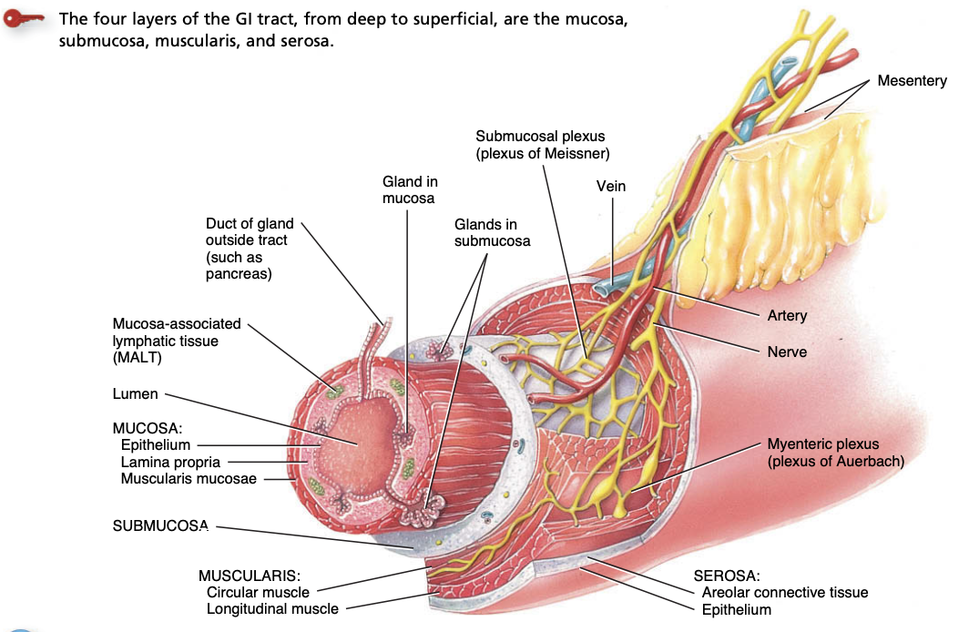
Those portions of the GI tract that are suspended in the abdominal cavity have a superficial layer called the serosa. As its name implies, the serosa is a serous membrane composed of areolar connective tissue and simple squamous epithelium (mesothelium). The serosa is also called the visceral peritoneum because it forms a portion of the peritoneum, which we examine in detail shortly. The esophagus lacks a serosa; instead, only a single layer of areolar connective tissue called the adventitia forms the superficial layer of this organ.

Figure 2: Layers of the gastrointestinal tract

Esophagus
The esophagus is a collapsible muscular tube, about 25 cm long, that lies posterior to the trachea. The esophagus begins at the inferior end of the laryngopharynx, passes through the inferior aspect of the neck, and enters the mediastinum anterior to the vertebral column. Then it pierces the diaphragm through an opening called the esophageal hiatus, and ends in the superior portion of the stomach (Figure 1).
The esophagus secretes mucus and transports food into the stomach. It does not produce digestive enzymes, and it does not carry on absorption.
Stomach
The stomach is a J-shaped enlargement of the GI tract directly inferior to the diaphragm in the abdomen. The stomach connects the esophagus to the duodenum, the first part of the small intestine (Figure 3). Because a meal can be eaten much more quickly than the intestines can digest and absorb it, one of the functions of the stomach is to serve as a mixing chamber and holding reservoir. At appropriate intervals after food is ingested, the stomach forces a small quantity of material into the first portion of the small intestine. The position and size of the stomach vary continually, the diaphragm pushes it inferiorly with each inhalation and pulls it superiorly with each exhalation. Empty, it is about the size of a large sausage, but it is the most distensible part of the GI tract and can accommodate a large quantity of food. In the stomach, digestion of starch and triglycerides continues, digestion of proteins begins, the semisolid bolus is converted to a liquid, and certain substances are absorbed.
Anatomy of the Stomach
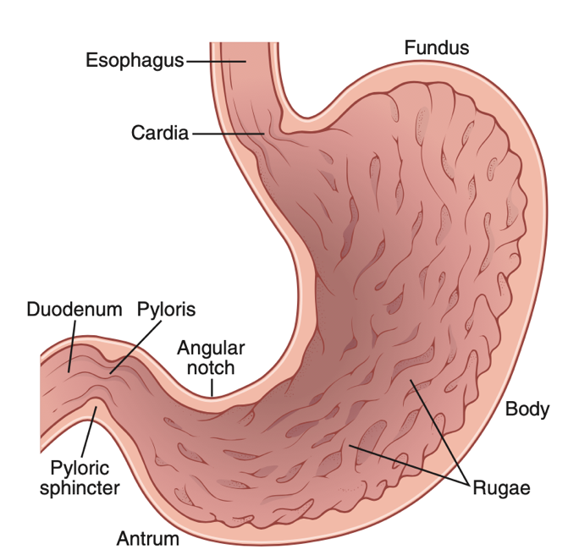
The stomach has four main regions: the cardia, fundus, body, and pyloric part. The cardia surrounds the opening of the esophagus into the stomach. The rounded portion superior to and to the left of the cardia is the fundus. Inferior to the fundus is the large central portion of the stomach, the body. The pyloric part is divisible into three regions. The first region, the pyloric antrum, connects to the body of the stomach. The second region, the pyloric canal, leads to the third region, the pylorus which in turn connects to the duodenum. When the stomach is empty, the mucosa lies in large folds, or rugae (wrinkles), that can be seen with the unaided eye. The pylorus communicates with the duodenum of the small intestine via a smooth muscle sphincter called the pyloric sphincter. The concave medial border of the stomach is called the lesser curvature; the convex lateral border is called the greater curvature.
Figure 3: Physiological anatomy of the stomach

Figure 3: Physiological anatomy of the stomach
Small intestine
Most digestion and absorption of nutrients occur in a long tube called the small intestine. Because of this, its structure is specially adapted for these functions. Its length alone provides a large surface area for digestion and absorption, and that area is further increased by circular folds, villi, and microvilli. The small intestine begins at the pyloric sphincter of the stomach, coils through the central and inferior part of the abdominal cavity, and eventually opens into the large intestine. It averages 2.5 cm in diameter, its length is about 3 m in a living person and about 6.5 m in a cadaver due to the loss of smooth muscle tone after death.
Anatomy of the Small Intestine
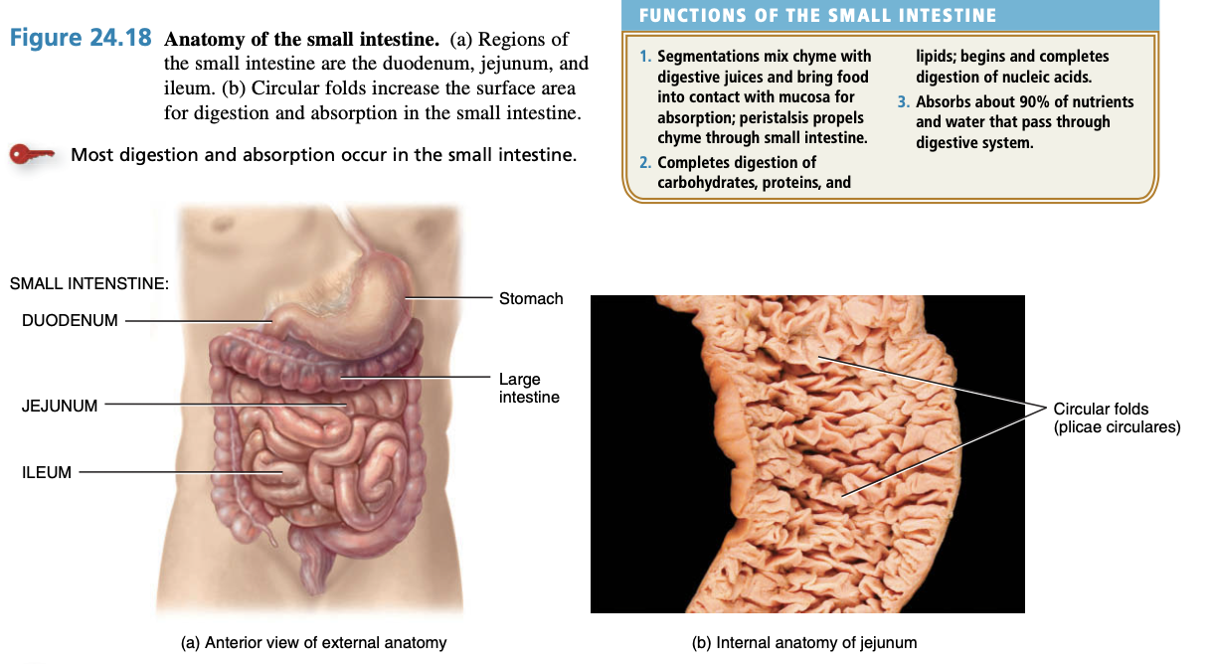
The small intestine is divided into three regions (Figure 4). The first part of the small intestine is the duodenum, the shortest region, and is retroperitoneal. It starts at the pyloric sphincter of the stomach and is in the form of a C-shaped tube that extends about 25 cm until it merges with the jejunum. Duodenum means “12”; it is so named because it is about as long as the width of 12 fingers. The jejunum is the next portion and is about 1 m long and extends to the ileum. Jejunum means “empty,” which is how it is found at death. The final and longest region of the small intestine, the ileum, measures about 2 m and joins the large intestine at a smooth muscle sphincter called the ileocecal sphincter (valve).

Figure 4: Anatomy of the small intestine

Functions of the Small Intestine
1. Segmentations, mix chyme with digestive juices and bring food into contact with mucosa for absorption, peristalsis propels chyme through small intestine.
2. Completes digestion of carbohydrates, proteins, and lipids begins and completes digestion of nucleic acids.
3. Absorbs about 90% of nutrients and water that pass through digestive system.

Large intestine
The large intestine is the terminal portion of the GI tract. The overall functions of the large intestine are the completion of absorption, the production of certain vitamins, the formation of feces, and the expulsion of feces from the body.
Anatomy of the large intestine
The large intestine (Figure 5), about 1.5 m long and 6.5 cm in diameter in living humans and cadavers, extends from the ileum to the anus. It is attached to the posterior abdominal wall by its mesocolon, which is a double layer of peritoneum. Structurally, the four major regions of the large intestine are the cecum, colon, rectum, and anal canal (Figure 5a).
The opening from the ileum into the large intestine is guarded by a fold of mucous membrane called the ileocecal sphincter (valve), which allows materials from the small intestine to pass into the large intestine. Hanging inferior to the ileocecal valve is the cecum, a small pouch about 6 cm long. Attached to the cecum is a twisted, coiled tube, measuring about 8 cm in length, called the appendix or vermiform appendix. The mesentery of the appendix, called the mesoappendix, attaches the appendix to the inferior part of the mesentery of the ileum. The open end of the cecum merges with a long tube called the colon (food passage), which is divided into ascending, transverse, descending, and sigmoid portions. Both the ascending and descending colon are retroperitoneal, the transverse and sigmoid colon are not. True to its name, the ascending colon ascends on the right side of the abdomen, reaches the inferior surface of the liver, and turns abruptly to the left to form the right colic (hepatic) flexure. The colon continues across the abdomen to the left side as the transverse colon. It curves beneath the inferior end of the spleen on the left side as the left colic (splenic) flexure and passes inferiorly to the level of the iliac crest as the descending colon. The sigmoid colon begins near the left iliac crest, projects medially to the midline, and terminates as the rectum at about the level of the third sacral vertebra. The rectum is about 15 cm in length and lies anterior to the sacrum and coccyx. The terminal 2–3 cm of the large intestine is called the anal canal (Figure 5b). The mucous membrane of the anal canal is arranged in longitudinal folds called anal columns that contain a network of arteries and veins. The opening of the anal canal to the exterior, called the anus, is guarded by an internal anal sphincter of smooth muscle (involuntary) and an external anal sphincter of skeletal muscle (voluntary). Normally these sphincters keep the anus closed except during the elimination of feces.
Functions of the large intestine
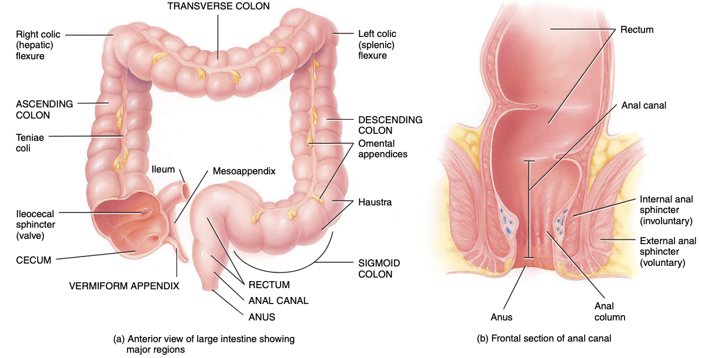
1. Haustral churning, peristalsis, and mass peristalsis drive contents of colon into rectum, 2. Bacteria in large intestine convert proteins to amino acids, break down amino acids, and produce some B vitamins and vitamin K, 3. Absorption of some water, ions, and vitamins, 4. Formation of feces, 5. Defecation (emptying rectum).

Figure 5: Anatomy of the large intestine

