Islamic University College
of Medical Technologies / Department
of Radiation Techniques
Anatomy of Respiratory system

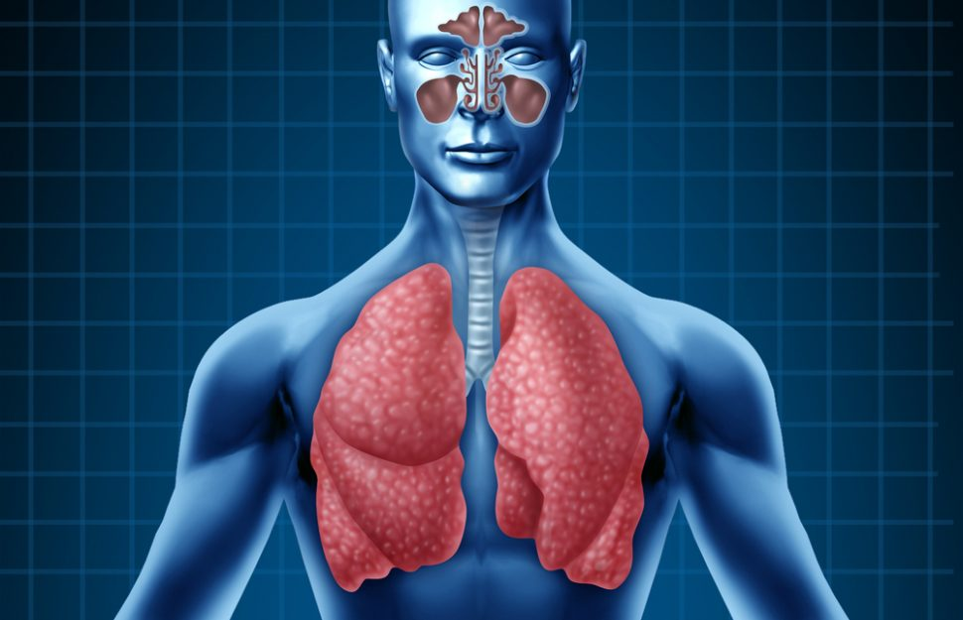

The respiratory system

-The respiratory system, which includes air passages, pulmonary vessels, the lungs, and breathing muscles, aids the body in the exchange of gases between the air and blood, and between the blood and the body’s billions of cells.
-Most of the organs of the respiratory system help to distribute air, but only the tiny, grape-like alveoli and the alveolar ducts responsible for actual gas exchange
General Functions of Respiratory System

1. O2 and CO2 exchange between blood and air
2. speech and vocalization
3. sense of smell
4. helps control acid base balance of body
5. breathing movements help promote blood and lymph flow
The respiratory system is divided into two main components:
1-Upper respiratory tract
2-Lower respiratory tract

Upper respiratory tract

Composed of the nose, the pharynx, and the larynx, the organs of the upper respiratory tract are located outside the chest cavity.
1-Nasal cavity:
Inside the nose, the sticky mucous membrane lining the nasal cavity traps dust particles, and tiny hairs called cilia help move them to the nose to be sneezed or blown out.

2-Paranasal Sinuses:
four bones of the skull contain paired air spaces called the paranasal sinuses. These air-filled spaces alongside the nose help make the skull lighter.
3-Pharynx(throat):
from base of skull to junction with esophagus and trachea 5cm. long. Both food and air pass through the pharynx before reaching their appropriate destinations. The pharynx also plays a role in speech.
Pharynx divided into three regions

- Nasopharynx:
behind nose to level of soft palate includes tonsils
(adenoids)
- Oropharynx:
behind mouth from soft palate to level of hyoid bone
- Laryngopharynx:
from hyoid bone to esophagus / larynx
4-Larynx (voice box):
it is a short, somewhat cylindrical airway the trachea, at where sound is generated. enlarged beginning portion of trachea composed of cartilage and muscles opening into larynx called glottis
prevent food from entering lower respiratory system sound, speech.
- The larynx is composed of 3 large, unpaired cartilages (cricoid, thyroid, epiglottis); 3 pairs of smaller cartilages (arytenoids, corniculate, cuneiform); and a number of intrinsic muscles. The hyoid bone, while technically not part of the larynx, provides muscular attachments from above that aid in laryngeal motion
-Thyroid cartilage: Adam’s apple largest cartilage of larynx, testosterone stimulates the growth of the laryngeal prominence so it becomes larger in males than in females = adam’s apple.
epiglottis – elastic cartilage covers glottis when swallowing

Parts of the Lower Respiratory Tract:

- Trachea:
it is the tube which carries air from the throat into the lungs. It ranges from (20-25) mm in diameter and (10-14) cm in length. The trachea is surrounded by 15-20 C-shaped rings of cartilage at the front and side which help protect the trachea and keep it open.
2-Bronchi:
The trachea divides into two tubes called bronchi, one entering the left lung and the other entering the right lung. The left bronchi is narrower, longer and more horizontal than the right.
3- Lungs:
the remainder of the respiratory system is contained within the two lungs left lung, 2 lobes // right lung, 3 lobes all organs between the two lungs are located in the mediastinum.
4-Bronchioles:
Tertiary bronchi continue to divide and become bronchioles, very narrow tubes, less than (1) millimeter in diameter. The bronchi branch from the trachea into each lung and create the network of intricate passages that supply the lungs with air.
5-Alveoli:
It is a hollow cavity contained within alveolar sacs (orducts). Alveoli have very thin walls which permit the exchange of gases Oxygen and Carbon Dioxide. There are approximately 3 million alveoli within an average adult lung..Alveoli, lung alveoli are the “functional units” of the respiratory system.
6.Diaphragm:
The diaphragm is a broad band of muscle which sits underneath the lungs, attaching to the lower ribs, sternum and lumbar spine and forming the base of the thoracic cavity

