
Islamic University College
Introduction to human anatomy
of Medical Technologies / Department
of Radiation Techniques
Dr. Safaa AL-Mosawy
M S C . Tariq Mohammed

Introduction to human anatomy
Lecture-1-

Anatomy - the study of the structure of body parts and their relationships to one another.
Physiology: the study of the function of the body's structural machinery.
Clinical anatomy: It's the study of the macroscopic structure and function of the body and its related to the practice of the medicine and other healthy science.
Macroscopic

regional - all structures in one part of the body (such as the abdomen or leg)).
Systemic - gross anatomy of the body studied by system Surface - study of internal structures as they relate to the overlying skin

Microscopic

Cytology - study of the cell .
Histology - study of tissues .
Developmental anatomy: structural changes over time Embryology - study of developmental changes of the body before birth

Specialized Branches of Anatomy

Pathological Anatomy - Study of structural changes caused by disease.
Radiographic anatomy - study of internal structures visualized by X - ray.
Molecular biology - study of anatomical structures at a sub-cellular level.
:
.
Anatomical position : 1.Body erect .
2.Feet slightly apart.
3.Palms facing forward .
4.Thumbs point away from body.
Direction and relative position
Medial x lateral
anterior x posterior
superior x inferior
external x internal
proximal x distal
palmer x dorsal
planter x dorsal
superficial x deep
supine x prone

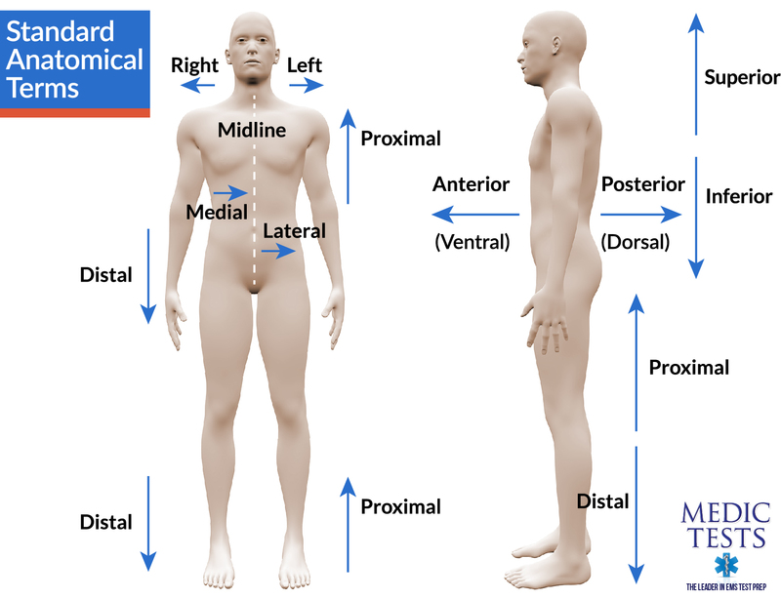
Body Planes

Sagittal - divides the body into right and left parts.
Midsagittal or medial - sagittal plane that lies on the midline .
Frontal or coronal - divides the body into anterior and posterior parts.
Transverse or horizontal (cross section) - divides the body into superior and inferior parts.

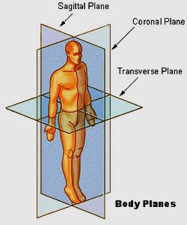
Body Cavities

Dorsal cavity : protects the nervous system , and is divided into two subdivisions
Cranial cavity : is within the skull and encases the brain --Vertebral cavity : runs within the vertebral column and encases the spinal cord

Ventral cavity : houses the internal organs(viscera ) , and is divided into two subdivisions:
-- Thoracic cavity.
-- Abdominopelvic cavity .
Thoracic cavity : is subdivided into
Pleural cavities - each houses a lung
Mediastinum : contains the pericardial cavity , and surrounds the remaining thoracic organs
Pericardial cavity : encloses the heart.
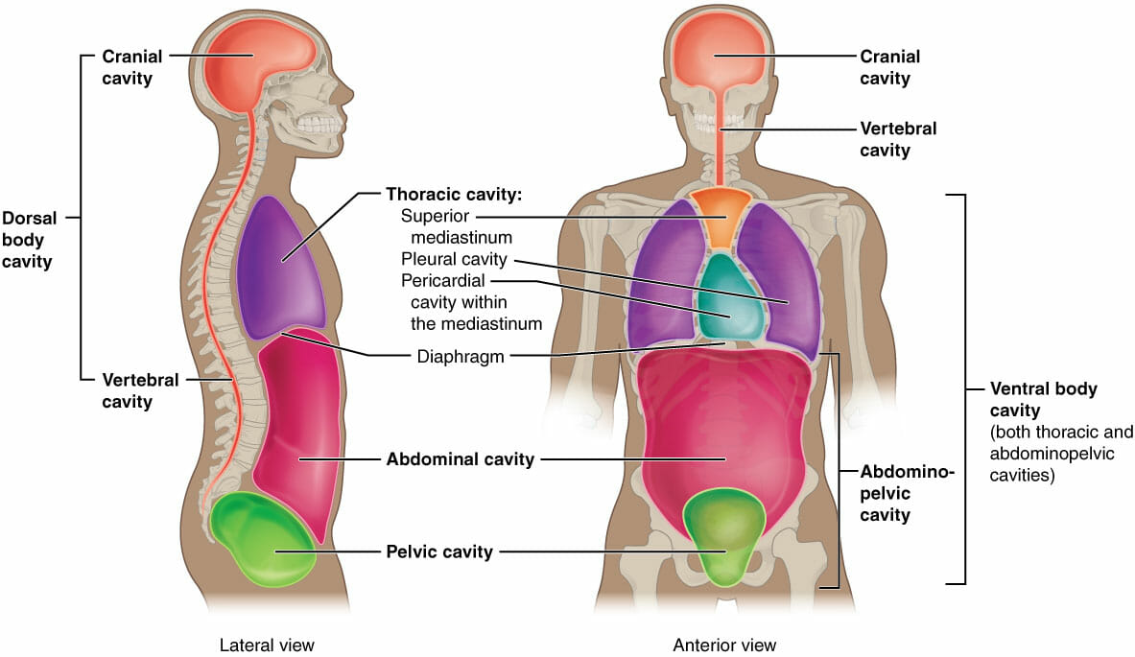
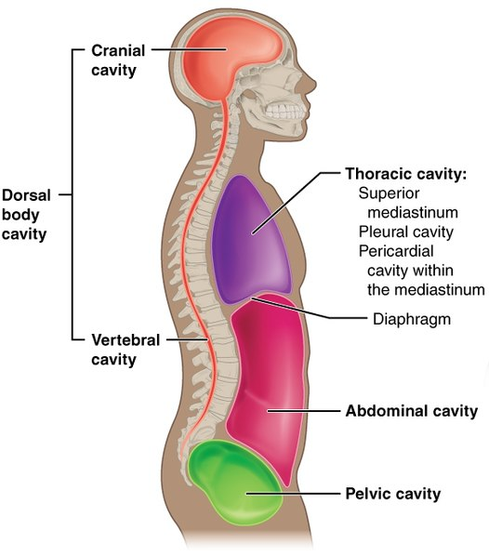

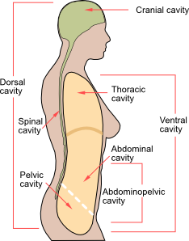

The abdominopelvic - cavity is separated from the superior thoracic cavity by The dome - shaped called diaphragm
It is composed of two subdivisions :
Abdominal cavity

contains the..
1- stomach 4-liver
2- intestines 5- other organs .
3-spleen

Pelvic cavity

lies within the pelvis and contains the…
1-bladder
2- reproductive organs
3- rectum

mouth cavity
oral cavity

Nasal cavity
located within and poster to the nose

Orbital cavity
house the eyes

Middle ear cavity
contain bones that transmit sound vibrations .

.
Synovial cavity
joint cavities
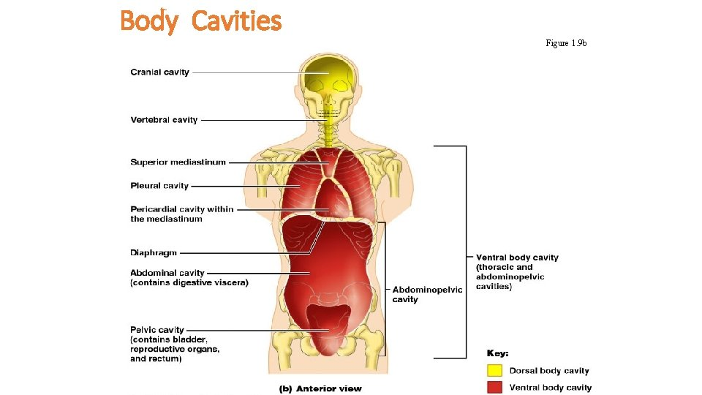
Abdominopelvic Regions

1.Umblical
2.Epigastric
3. Hypogastric
4.Right and left iliac or inguinal
5.Right and left lumbar
6.Right and left hypochondriac

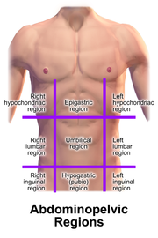
Organs of the abdominoplvic regions

