Central bones

Central bones:
The skull

The skull has (22) bones and formed of 2 sets of bones (cranium) and (face). All these bones are connected at immobile joints called sutures except the mandible which is connected to the skull by freely movable joint.
Sutures are:
1.coronal suture.
2.sagittal suture.
3.lambdoid suture.

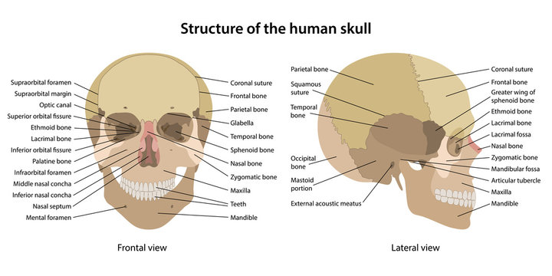

Bones of the cranium :-

Single bones :
1.Frontal bone ; In the front
2.Occipital bone ; in the back
3.Ethmoid bone ;in the base
4.Sphenoid bone ; in the base
Paired bones :-

One on each side
1.parietal bones (2) bones above.
2.Temporal bones (2) bones below.

Bones of the face :-
They hold the eyes in the anterior position and allow the facial muscles to express our feelings . They consist of ( 14) bones ( two single and (12) paired )
Single bones :- In the middle .
1.Vomer:- forms most of the nasal septum
2.Mandible:- forms the lower jaw
Paired bones :-
1.maxillae (2) :- They fuse together to form the upper jaw .
2.palatine bones (2) :- They are found behind the maxillary processes and form the posterior part of the hard palate
3.Zygomatic bones (2):-They form the bones of the cheek and also form a part of the lateral wall of the orbit (eye socket) .
4.Lacrimal bones (2): They form the bridge of the medial wall of the orbit each bone carries a groove for passage of tear(lacrima) These bones are small in size
5.Nasal bones (2):- They form the bridge of the nose.
6.Inferior conches (2):- They are thin curved bones. Each bone appear projecting from the lateral wall of the nose.

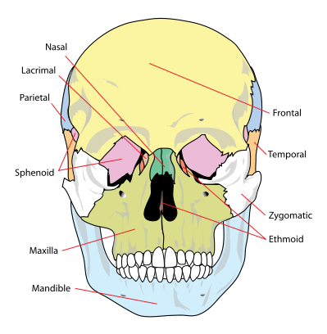
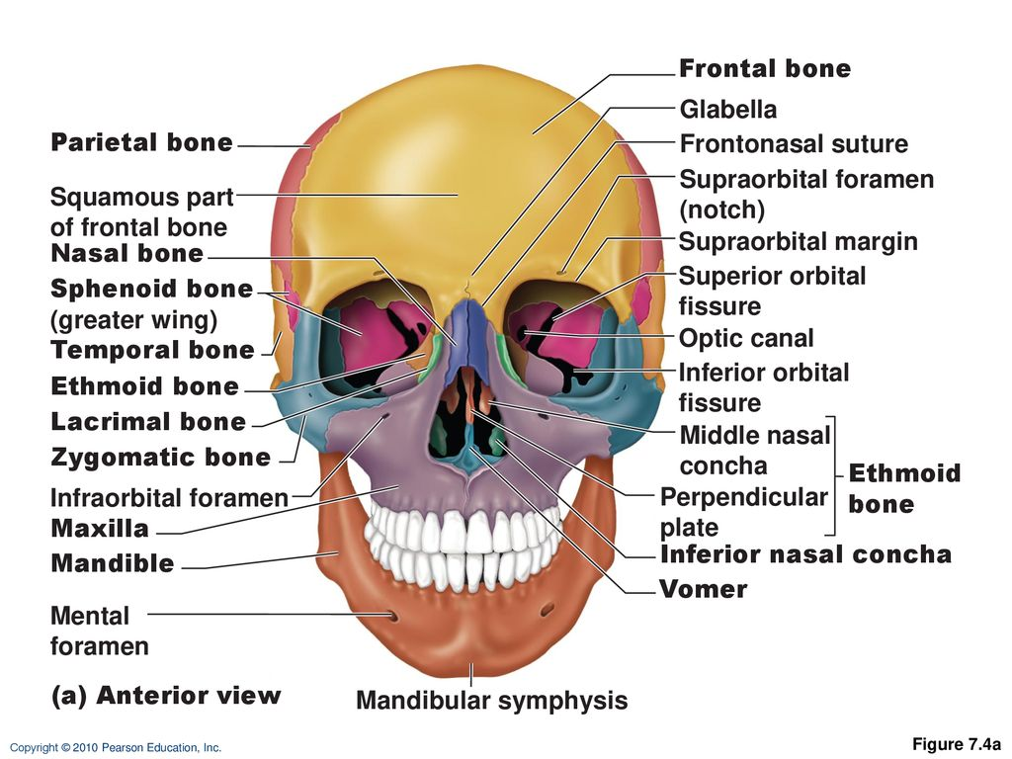

Thoracic cage:
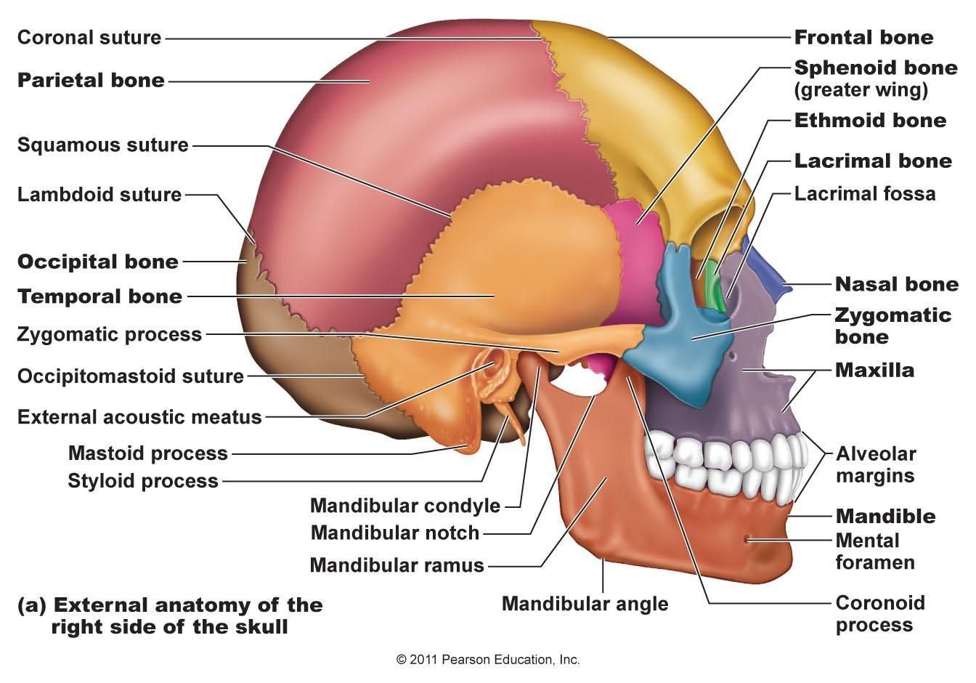
Consist of the followings:
a. Ribs
b. thoracic Vertebrae
c. sternum :consist of : manubrium .. body.. xiphoid process.
d. costal cartilages
* True ribs are directly attached to the sternum (first seven pairs) by
costal

Thoracic cage

Consist of the followings:
a. Ribs
b. thoracic Vertebrae
c. sternum :consist of : manubrium .. body.. xiphoid process.
d. costal cartilages
* True ribs are directly attached to the sternum (first seven pairs) by
costal cartilages
* false ribs are joined to the 7th rib at 7th
costal cartilage (Three pairs)
* floating ribs (Two pairs).

