BONES OF THE UPPER LIMB

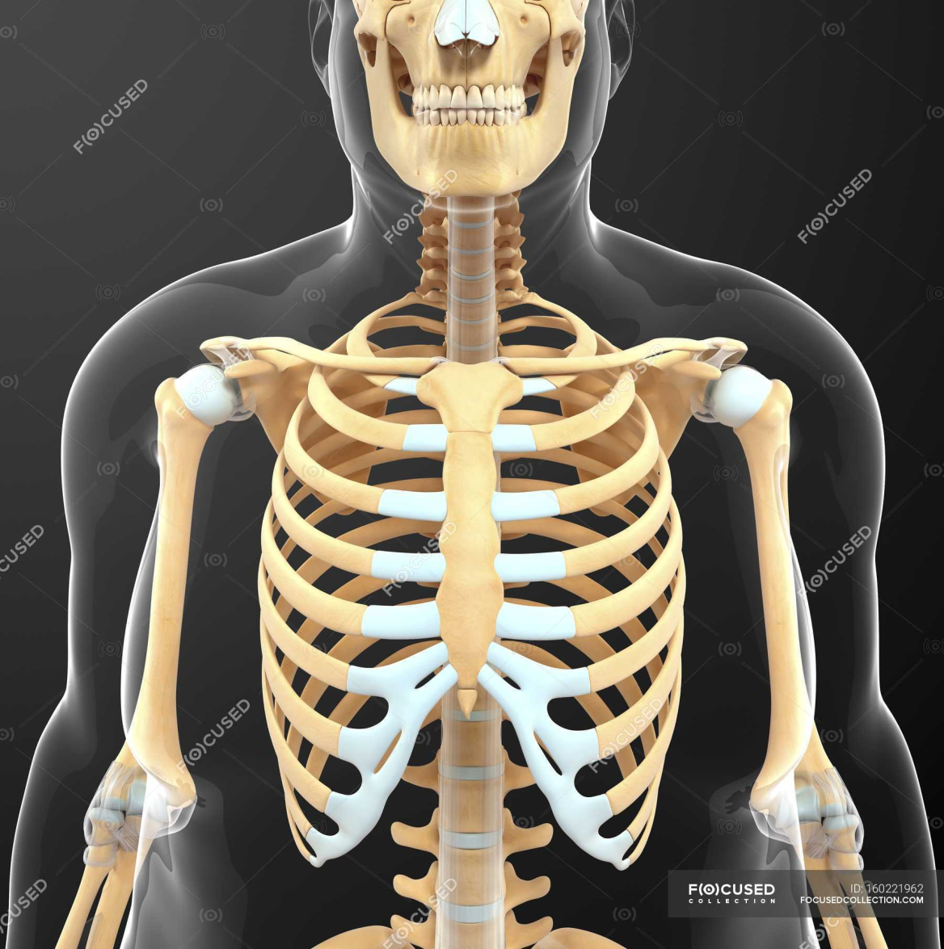
The Bones of UL are:
Pectoral Girdle.
Arm : Humerus.
Forearm : Radius & Ulna.
Wrist : Carpal bones
Hand: Metacarpals& Phalanges

Pectoral Girdle

Formed of Two Bones:
Clavicle (anteriorly) and Scapula (posteriorly).
It is very light and allows the upper limb to have exceptionally free movement.

Clavicle

It is a long bone with no medullarycavity.
It has the appearance of an elongated letter Capital (S) lying on one side.
It has Two Ends:
Medial (Sternal): enlarged & triangular.
Lateral (Acromial) : flattened.
Body (shaft):
Its medial 2/3) is convex forward.
Its lateral 1/3 is concave forward.
Surfaces:
Superior : smooth as it lies just deep to the skin.
Inferior: rough because strong ligaments bind it to the 1strib.

Articulations of Clavicle

Mediallywith the manubriumat theSternoclavicularjoint .
Laterallywith the Scapula at the Acromioclavicularjoint
Inferiorlywith the 1strib at the CostoclavicularJoint

Scapula (Shoulder Blade)

It is a triangular Flat bone.
Extends between the 2nd_ 7thribs.
It has :
Three Processes:
(1)Spine: a thick projecting ridge of bone that continues laterally.
(2) Acromion: forms the subcutaneous point of the shoulder.
(3) Coracoid: a beaklike process.
It resembles in size, shape and direction a bent finger pointing to the shoulder.
ThreeBorders: Superior, Medial (Vertebral) & Lateral (Axillary) (the thickest) part of the bone, it terminates at the lateral angle .

Three Angles :
Superior.
Lateral(forms the Glenoidcavity) : a shallow concave oval fossa that receives the head of the humerus.
Inferior.
Two Surfaces:
1.Convex Posterior : divided by the spine of the scapula into the
Smaller SupraspinousFossa
(above the spine) and the
largerInfraspinousFossa
(below the spine).

2.Concave Anterior (Costal): it forms the large Subscapular Fossa.

Humerus

A typical Long bone.
It is the largest bone in the UL
Proximal End :
Head, Neck, Greater & Lesser Tubercles.
Head:Smooth
it forms 1/3 of a sphere, it articulates with the glenoidcavity of the scapula.
Greater tubercle: at the lateral margin of the humerus.
Lesser tubercle: projects anteriorly.
The two tubercles are separated by
IntertubercularGroove.
Anatomical neck: formed by a groove separating the head from the tubercles
Surgical Neck: a narrow part distal to the tubercles.

Shaft (Body):
Has two prominent features:
1. Deltoid tuberosity:
A rough elevation laterally for the attachment of deltoid muscle.
2. Spiral (Radial) groove:
Runs obliquely down the posterior aspect of the shaft.
It lodges the important radial nerve & vessels.
Distal End:
Widens as the sharp medial and lateral Supracondylar Ridges and end in the Medial (can be felt) and Lateral Epicondyles.
They provide muscular attachment.

Structures at Distal end:
Anteriorly:
Trochlea:(medial) for articulation with the ulna
Capitulum:(lateral) for articulation with the radius.
Coronoid fossa :above the trochlea.
Radial fossa:above the capitulum.
Posteriorly:
Olecranon fossa :above the trochlea.


Ulna

Shaft:
Thick & cylindrical superiorly but diminishes in diameter inferiorly
It has Three Surfaces (Anterior, Medial & Posterior).
Sharp Lateral Interosseousborder.
Distal End: Small rounded
1. Head:lies distally at the wrist. .
2. Styloidprocess:Medial.

Radius

It is the shorter and lateral of the two forearm bones.
Proximal End:
1. Head: small & circular
Its upper surface is concave for articulation with the Capitulum.
2. Neck.
3. Radial (Biciptal) Tuberosity: medially directed and separates the proximal end from the body.
Shaft:
Has a lateral convexity.
It gradually enlarges as it passes

The upper limb muscles

The Muscles of Upper Limb

Muscles of shoulder
Deltoid
Supraspinatus
Infraspinatus
Teres minor
Teres major
Subscapularis

Major muscles of shoulder
Deltoid
Origin: lateral third of clavicle,
acromion, and spine of scapula
Insertion: deltoid tuberosity
of humerus
Action: abduction, flexion and
extension, medial and lateral
rotation of arm

Major muscles of shoulder

Teres major
Origin: dorsal surface of
inferior angle of scapula
Insertion:crest of lesser tubercle
of humerus
Action:medially rotates and
adducts arm

Arm Arm and Forearm Muscles That Move the Elbow Joint/Forearm

Anterior (flexor) compartment
Posterior (extensor) compartment
Anterior compartment
primarily contains elbow flexors
Posterior compartmentcontains elbow extensors
the principal flexors
biceps brachii, brachialis, and brachioradialis
muscles that extendthe elbow joint
triceps brachii and anconeus.

Antererior group
1-Biceps brachii
2-Coracobrachialis
3-Brachialis

Posterior group
1-triceps brachii
2-anconeus

MMuscles of arm

Biceps brachii
Origin: long head, supraglenoid
tubercle; short head, coracoid process
Insertion: radial tuberosity
Action: supinator of forearm,
flexor of elbow joint, weak flexor
of should joint

Muscles of arm

Triceps brachii
Origin:
long head, infraglenoid tubercle
lateral head, above groove
for radial nerve
medical head, below groove
for radial nerve
Insertion:olecranon of ulna
Action:extends elbow joint,
long head extends and adducts
shoulder joint
Triceps brachii

Muscles of forearm
Superficial layer
Pronator teres
Flexor carpi radialis
Palmaris longus
Flexor carpi ulnaris

Second layer
Flexor digitorum superficials

Third layer
Flexor digitorum profundus
Flexor pollicis longus
Fourth layer
Pronator quadratus
Action: flex radiocarpal joint
and fingers, pronate forearm

