

Radiology Techniques Department
Special Radiological Procedure

Musculoskeletal MRI

Lecture 14

By
MS.c Zeyad Tareq Al-Dulaimi

3rd Stage

2022-2023

Musculoskeletal MRI:
Magnetic resonance imaging (MRI) uses a powerful magnetic field, radio waves and a computer to produce detailed pictures of joints, soft tissues and bones. It is usually the best choice for evaluating the body for injuries, tumors, and degenerative disorders.
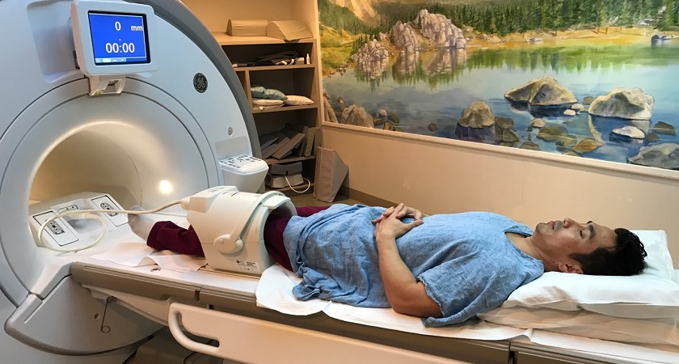

What is musculoskeletal MRI?
Magnetic resonance imaging (MRI) is a noninvasive test doctors use to diagnose medical conditions.
MRI uses a powerful magnetic field, radiofrequency pulses, and a computer to produce detailed pictures of internal body structures. MRI does not use radiation (x-rays).
Detailed MR images allow doctors to examine the body and detect disease.

What are some common uses of the procedure?
MR imaging is usually the best choice for examining the:
- major joints.
- spine for back pain.
- soft tissues (muscles, tendons and ligaments) of the extremities.

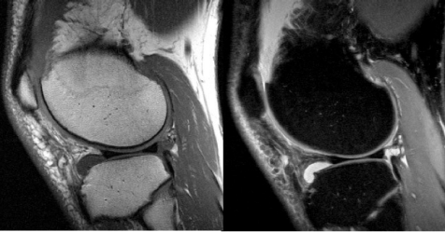
MR imaging is typically performed to diagnose or evaluate:
- joint disorders such as degenerative arthritis.
- tears of the menisci, ligaments and tendons (knee) or rotator cuff (shoulder) and labrum (shoulder or hip).
- fractures (in selected patients).
- spinal disk abnormalities (such as a herniated disk).
- the integrity of the spinal cord after trauma.
- sports-related injuries and work-related disorders caused by repeated strain, vibration or forceful impact.
- infections (such as osteomyelitis).
- tumors (primary tumors and metastases) involving soft tissues around the joints and extremities (such as muscles, bones and joints).
- pain, swelling or bleeding in the tissues in and around the joints and extremities.
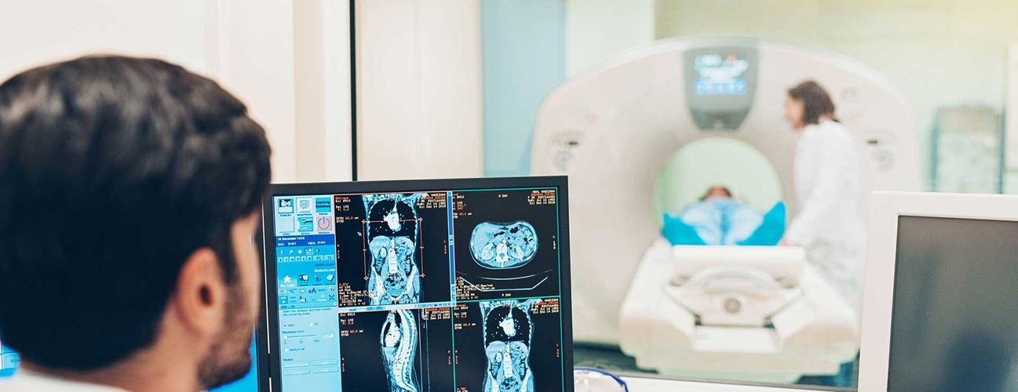

How should I prepare?
Patient will need to change into a hospital gown. This is to prevent artifacts appearing on the final images and to comply with safety regulations related to the strong magnetic field.
Guidelines about eating and drinking before an MRI vary between specific exams and facilities. Take food and medications as usual unless your doctor tells Patient otherwise.
Some MRI exams use an injection of contrast material. The doctor may ask if Patient have asthma or allergies to contrast material, drugs, food, or the environment. MRI exams commonly use a contrast material called gadolinium. Doctors can use gadolinium in patients who are allergic to iodine contrast. A patient is much less likely to be allergic to gadolinium than to iodine contrast. However, even if the patient has a known allergy to gadolinium, it may be possible to use it after appropriate pre-medication.

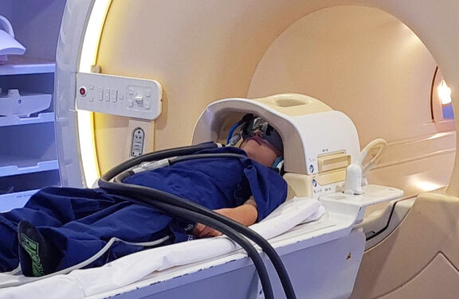

Metal and electronic items are not allowed in the exam room. These items include:
- jewelry, watches, credit cards, and hearing aids, all of which can be damaged
- pins, hairpins, metal zippers, and similar metallic items, which can distort MRI images
- removable dental work
- pens, pocketknives, and eyeglasses
- body piercings
- mobile phones, electronic watches, and tracking devices.
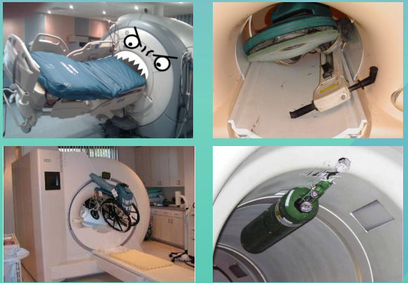

In most cases, an MRI exam is safe for patients with metal implants, except for a few types.
- some cochlear (ear) implants
- some types of clips used for brain aneurysms
- some types of metal coils placed within blood vessels
- some older cardiac defibrillators and pacemakers
- vagal nerve stimulators

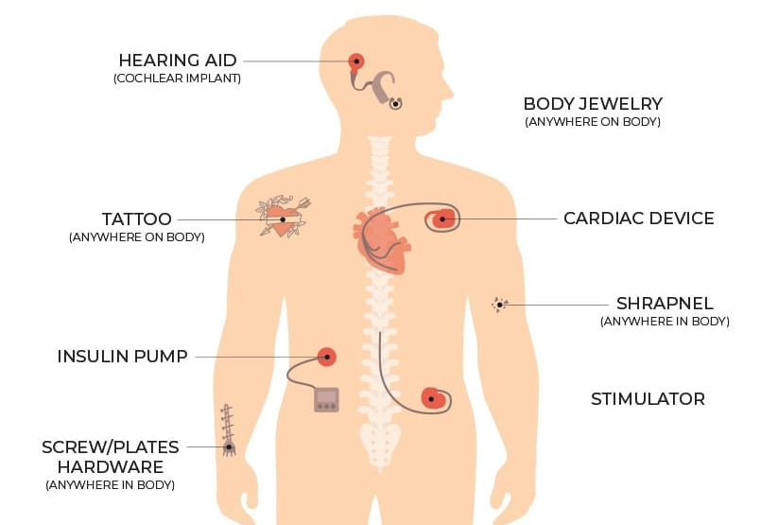

How is the procedure performed?
MRI exams may be done on an outpatient basis.
The technologist will position patient on the moveable exam table. They may use straps and bolsters to help patient stay still and maintain patient position.
The technologist may place devices that contain coils capable of sending and receiving radio waves around or next to the area of the body under examination.
MRI exams generally include multiple runs (sequences), some of which may last several minutes. Each run will create a different set of noises.
If patient exam uses a contrast material, a doctor, nurse, or technologist will insert an intravenous catheter (IV line) into a vein in patient hand or arm. They will use this IV to inject the contrast material.
patient will be placed into the magnet of the MRI unit. The technologist will perform the exam while working at a computer outside of the room. patient will be able to talk to the technologist via an intercom.
If patient exam uses a contrast material, the technologist will inject it into the intravenous line (IV) after an initial series of scans. They will take more images during or following the injection.
When the exam is complete, the technologist may ask patient to wait while the radiologist checks the images in case more are needed.
The technologist will remove patient IV line after the exam is over and place a small dressing over the insertion site.
The entire examination is usually completed within 30 to 45 minutes.

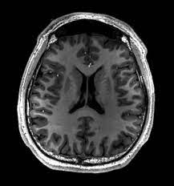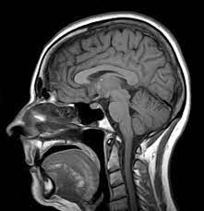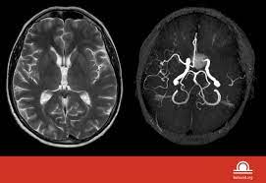

What are the benefits vs. risks?

Benefits
- MRI is an imaging technique that does not require exposure to radiation.
- MR images of the soft-tissue structures of the body (particularly muscles, bones and joints) are often clearer and more detailed than with other imaging methods.
- MRI can distinguish abnormal tissues from normal tissues much more accurately than most other imaging tests (x-ray, CT, etc.).
- The MRI gadolinium contrast material is less likely to cause an allergic reaction than the iodine-based contrast materials used for x-rays and CT scanning.
- MR images allow the physician to see even very small tears and injuries to tendons, ligaments and muscles and some fractures that cannot be seen on x-rays and CT.

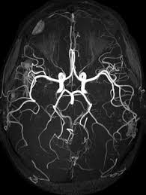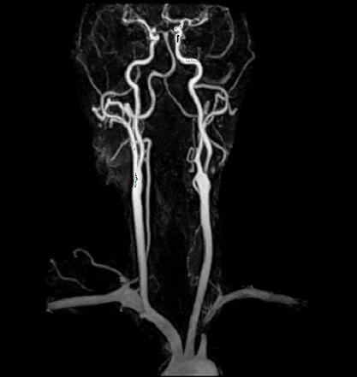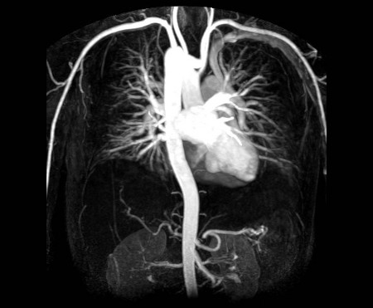

Risks
- The MRI exam poses almost no risk to the average patient when appropriate safety guidelines are followed.
- If sedation is used, there is a risk of using too much. However, your vital signs will be monitored to minimize this risk.
- The strong magnetic field is not harmful to patient.
- Nephrogenic systemic fibrosis is a recognized complication related to injection of gadolinium contrast. It is exceptionally rare with the use of newer gadolinium contrast agents. It usually occurs in patients with serious kidney disease.
- There is a very slight risk of an allergic reaction if patient exam uses contrast material. Such reactions are usually mild and controlled by medication. If patient have an allergic reaction, a doctor will be available for immediate assistance.
- If contrast material is injected into the joint, there may be related complications such as infection, bleeding or pain.
- IV contrast manufacturers indicate mothers should not breastfeed their babies for 24-48 hours after contrast material is given.



