

Radiology Techniques Department

Special Radiological Procedure

Lecture 13

Radionuclide Bone Scan Basic Principle

By
MS.c Zeyad Tareq Al-Dulaimi

3rd Stage

2022-2023

What is a bone scan?

A nuclear medicine bone scan shows the effects of injury or disease (such as cancer) or infection on the bones. A nuclear medicine bone scan also shows whether there has been any improvement or deterioration in a bone abnormality after treatment.

A radioactive material (radiopharmaceutical) is injected into a vein, attaches to the bones and is detected by a special camera (gamma camera) that takes images or pictures that show how the bones are working.

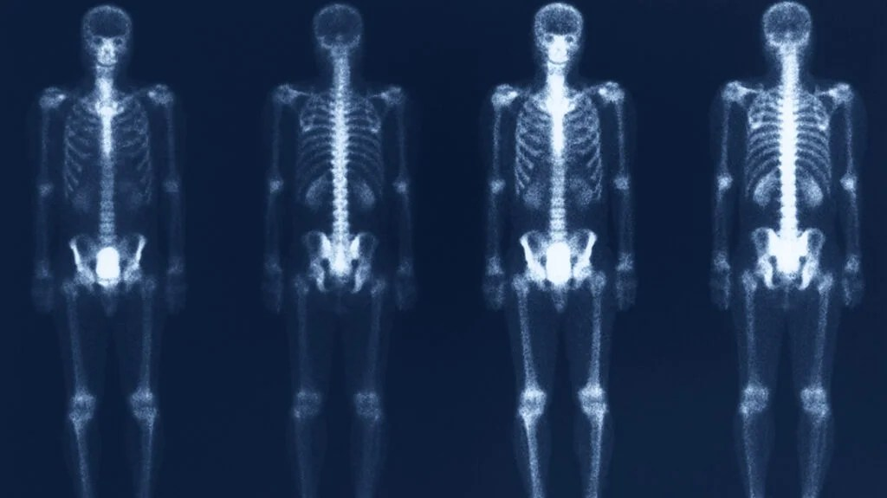

A bone scan images the metabolic activity of the skeleton. This has traditionally been accomplished by imaging a radionuclide whose physiology closely mimics a metabolic process within bone. Nuclear scintigraphy of the bone commonly utilizes the radionuclides technetium-99m (Tc-99m) or fluoride-18 (F-18).

These molecules are injected intravenously, and a nuclear camera that contains a salt crystal captures the decay of photons from the radioisotope. This is achieved through the process of scintillation or fluorescence that occurs when the photon emitted by the radionuclide hits the salt crystal within the nuclear camera.

There is an increased risk of radiation effects when a person's cumulative lifetime radiation exposure from diagnostic medical imaging exceeds 100 mSv. In an effort to further understand these potential risks, the International Atomic Energy Agency has launched a global effort to have individuals track their cumulative radiation exposure from medical imaging.

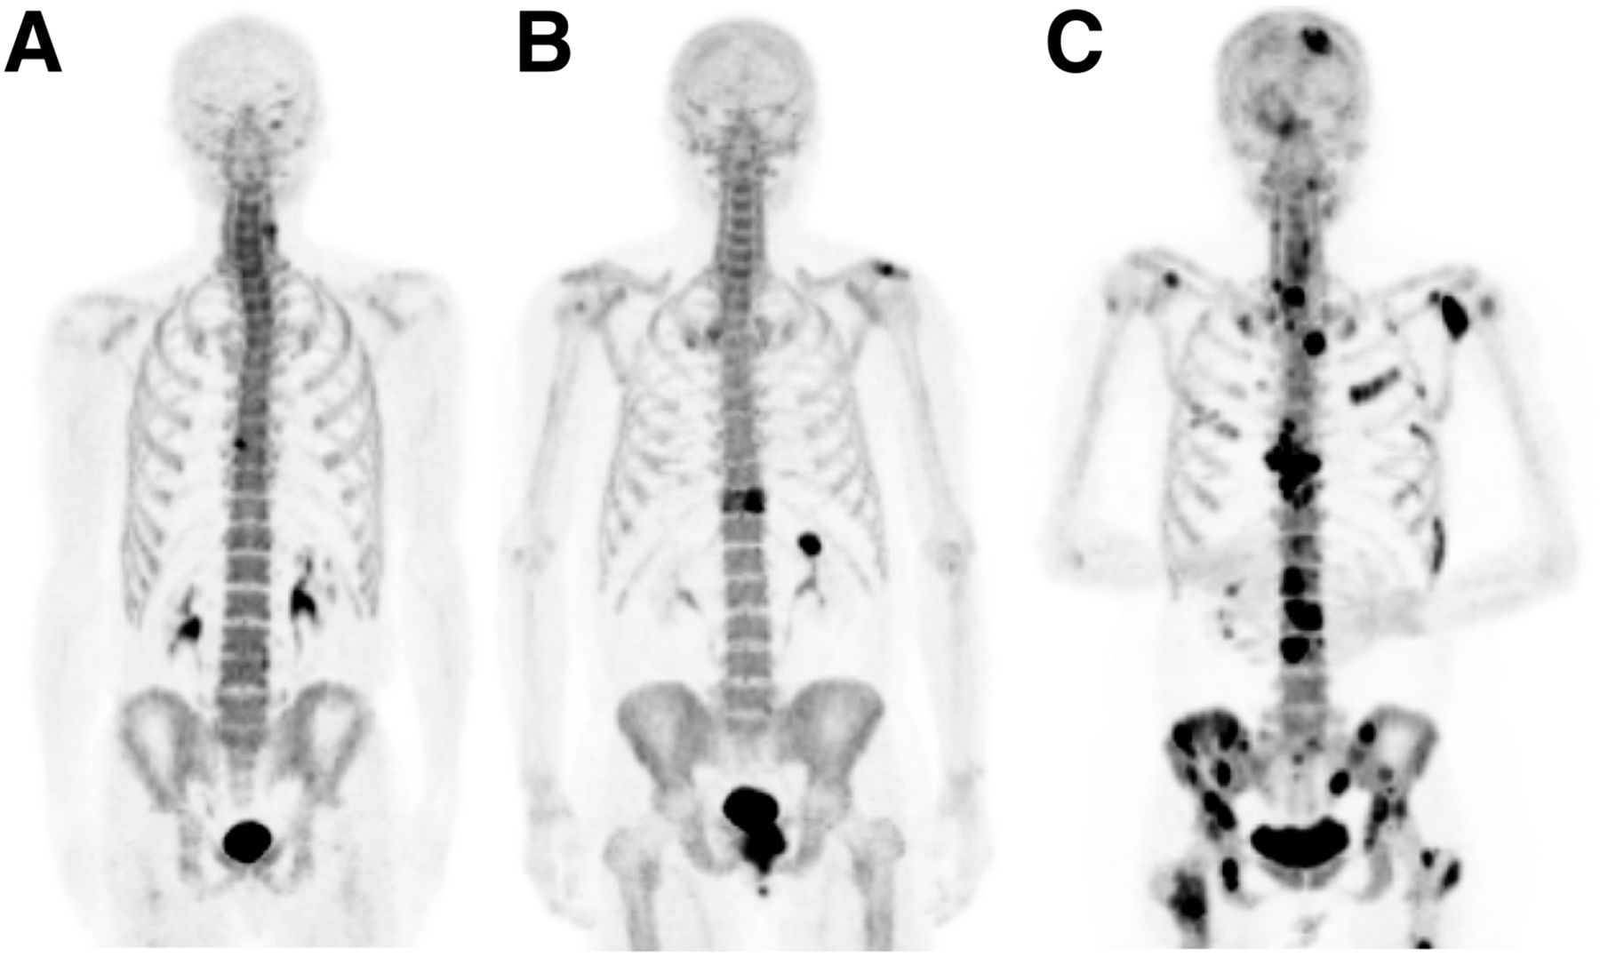

¹⁸F-NaF PET/CT maximum-intensity-projection images illustrating appearance of

(A) anterior osteophyte, (B) solitary metastasis, and (C) multiple metastases in 3 different patients.

Why would doctor refer patient to have this procedure?

Nuclear medicine bone scans are carried out for many different reasons.

Bone scans image both the structure and the active cell growth of the bones, so are often used in conjunction with other imaging e.g. X-rays, computed tomography (CT) or magnetic resonance imaging (MRI).

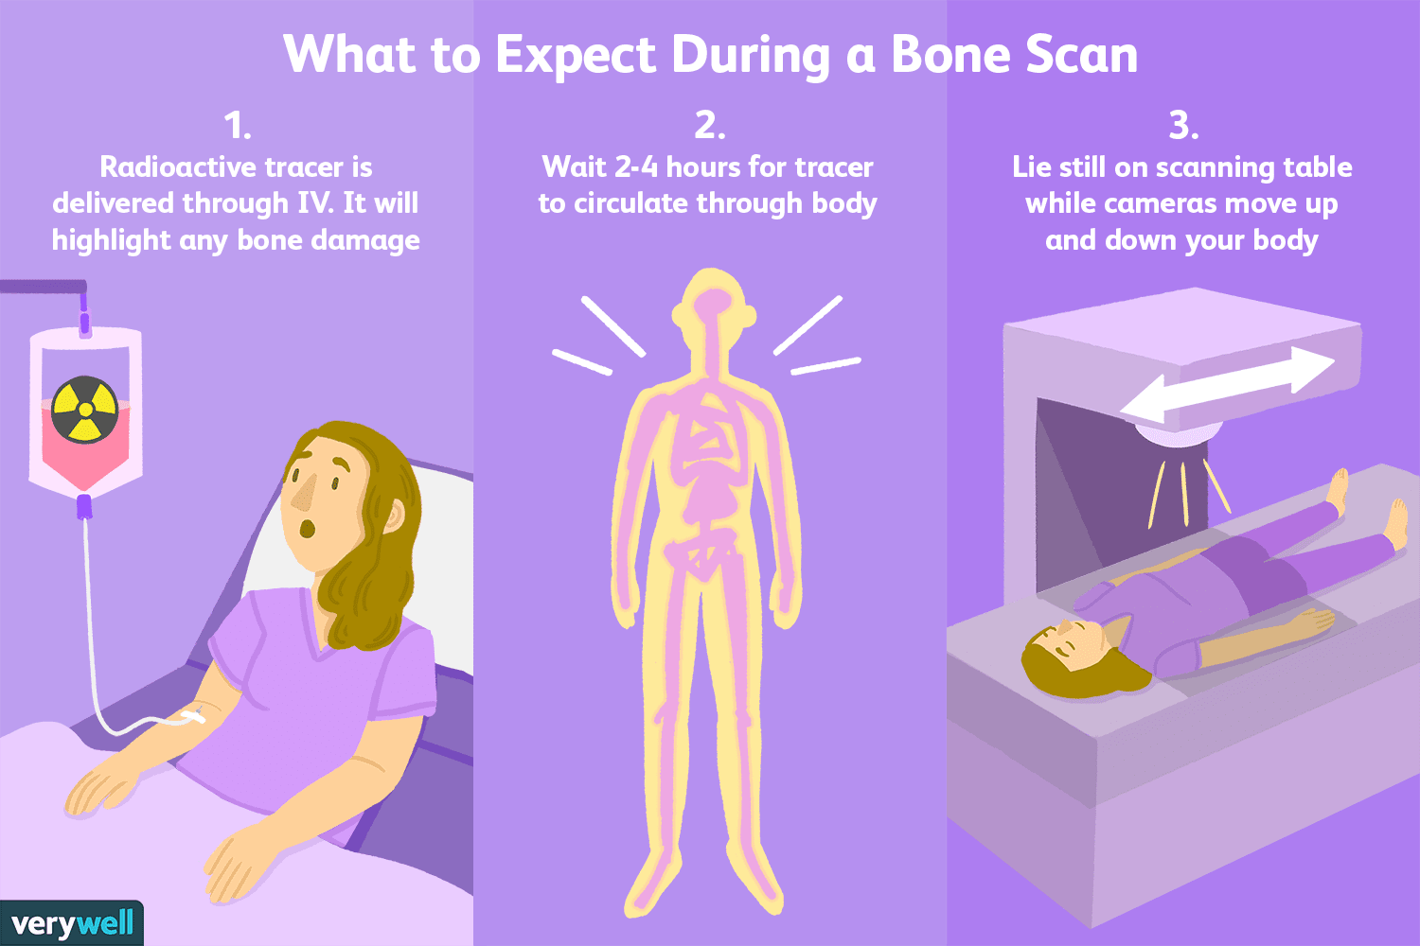
They are often used as a follow-up test when the cause of your pain or symptoms needs to be clarified, for example:
- to evaluate the source of bone pain; for example, foot or hip pain
- to evaluate the findings from other diagnostic images or abnormal laboratory results.
Listed below are some common reasons why your doctor may refer you for a bone scan:
- difficult to find fractures, stress fractures, shin splints
- osteomyelitis (infection of the bone), cellulitis (infection of the skin) or to assess a response to treatment (e.g. antibiotics) you might be having
- arthritis, Paget’s disease, fractures from osteoporosis (where bones become fragile and are more likely to break)
- to assess the presence or spread of cancer in bone, then to follow up on the response to treatment
- complex regional pain syndrome (CRPS or previously known as reflex sympathetic dystrophy), avascular necrosis, prosthesis loosening or infection.
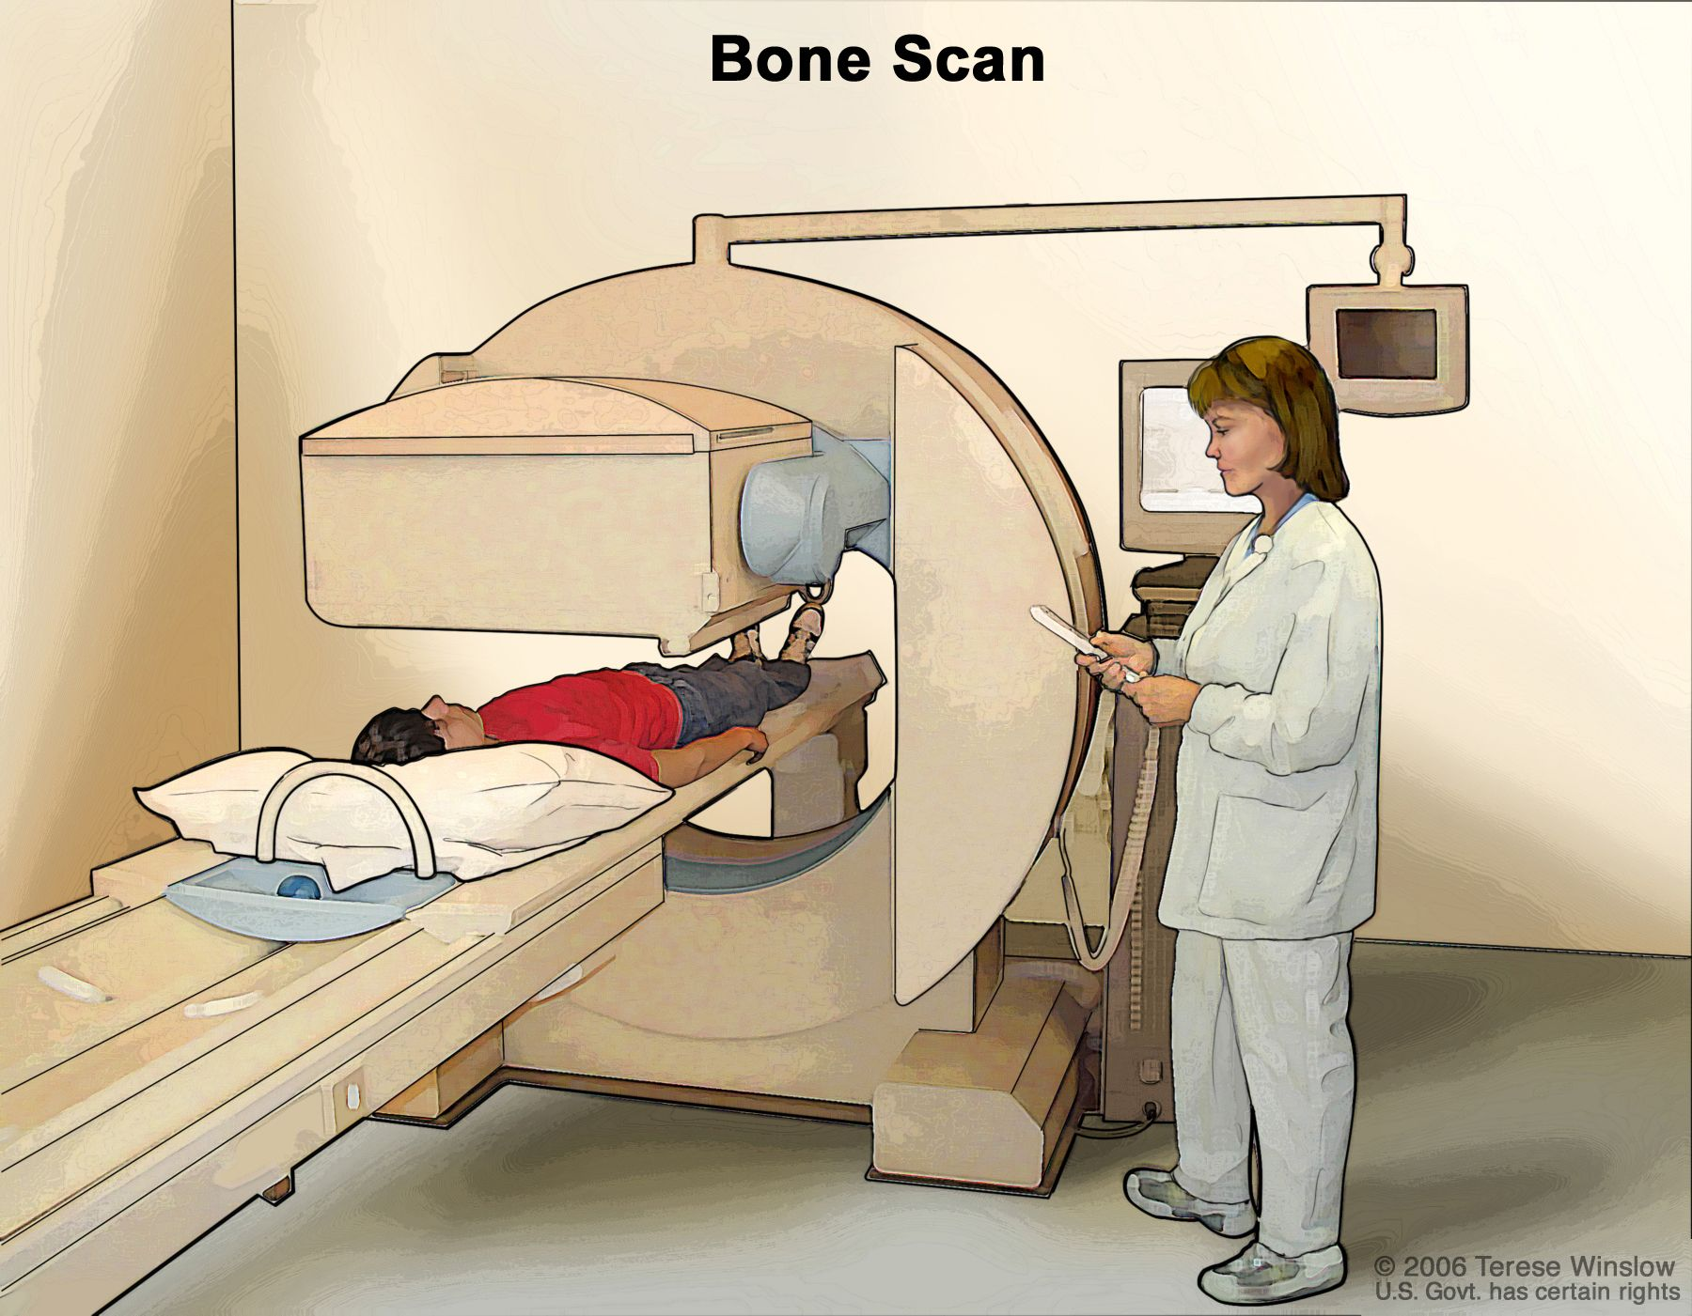
Bone scan. A small amount of radioactive material is injected into the patient's bloodstream and collects in abnormal cells in the bones. As the patient lies on a table that slides under the scanner, the radioactive material is detected and images are made on a computer screen or film.

What happens during a bone scan?
There are two parts to a bone scan – an injection of radiopharmaceutical into a vein (sometimes accompanied by ‘early’ imaging) and then ‘delayed’ imaging between 1–4 hours later.
Part 1
Patient will receive an injection of a small amount of radiopharmaceutical into a vein. Sometimes images are taken with the gamma camera immediately after the injection to look at the blood flow to the area being scanned. These images are referred to as ‘early’ (blood flow or blood pool) imaging. Whether or not Patient have ‘early’ imaging will depend on why Patients doctor has requested the scan.

Part 2
after 2–4 hours for adults and 1–3 hours for children, Patient return to have the ‘delayed’ images. These images show how the bones are working. The reason for the length of time between the injection and the ‘delayed’ images is to give the radiopharmaceutical time to be absorbed into the bones. Some specific images might need to be taken; that is, single-photon emission computed tomography (SPECT; images taken in 3-D showing the height, width and depth of the part of the body being scanned) or SPECT-CT (a combination of SPECT and CT), which can take slightly longer.
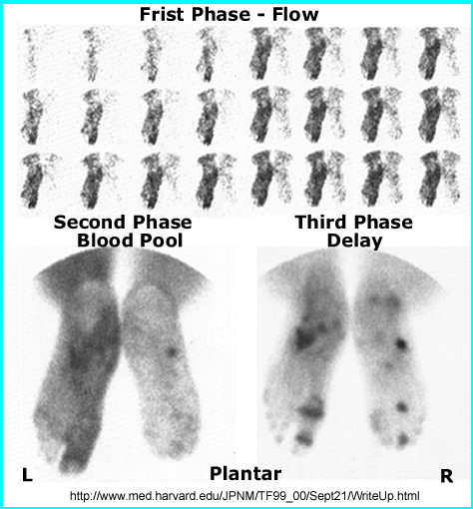
The radiopharmaceutical Patient receive for the bone scan is eliminated from patient body through the urine. For that reason, Patient should drink plenty of fluids and urinate frequently after the injection. How much fluid will depend on each individual, but Patient should be well hydrated, and for an adult this could be three to four glasses of water. Patient urine will not change color. Patients’ urine will contain the radioactive material, so it is recommended that Patient wash his hands well after going to the toilet.
In the case of babies and youngsters in nappies who are having a bone scan, there will be a small amount of radioactivity in the urine and therefore in the child’s nappy. The radioactive material will not affect the child’s skin, but carers should wash the child’s bottom and wash their own hands thoroughly. Cloth nappies need to be washed thoroughly and disposable nappies tied in a plastic bag before binning.
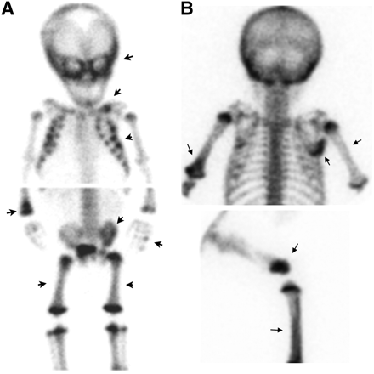
Nonaccidental trauma. (A) On ^{99m}Tc-MDP scan of 2.5-mo-old boy, skeletal injuries from child abuse are seen. Multiple regions of increased tracer uptake (arrows) are seen in left skull, left clavicle, several ribs bilaterally, right distal radius and ulna, some phalanges of both hands, left iliac bone, femurs, and left tibia. (B) On ^{99m}Tc-MDP scan of 3.5-mo-old girl, multiple regions of increased uptake (arrows) are seen in both humeri, right scapula, right distal femur, and right tibia.

Are there any after effects of a bone scan?
Normally, there are no after effects of a nuclear medicine bone scan.
The radiopharmaceutical used in a bone scan is not known to have any adverse interaction with food or medication patient might be taking. patient should feel no effect from the injection of radiopharmaceutical. patient can carry out normal activities between the injection and the delayed images, and after the scan.
If patient is breast-feeding or caring for young children, see the ‘how do I prepare’ section for more information about special precautions patient might need to take.

What are the risks of a bone scan?
There are minimal risks involved in the nuclear medicine bone scan procedure.
The scan involves a small dose of radiation from the radiopharmaceutical injected into patient vein. See Radiation Risk of Medical Imaging for Adults and Children. The dose is similar to CT and fluoroscopy procedures.

What are the benefits of a bone scan?
A bone scan helps doctor to evaluate how patient bones are working, and provides information to help diagnose and treat patient condition. It can show injury to the bones, the effects of disease such as cancer or infection, as well as any improvement or deterioration in a bone abnormality after any treatment patient might be having.
