

Radiology Techniques Department

Special Radiological Procedure

Lecture 12

18F-FDG PET/CT Scanning

By
MS.c Zeyad Tareq Al-Dulaimi

3rd Stage

2022-2023
18F-FDG PET/CT scanning
PET is a tomographic scintigraphy technique in which a computer-generated image of local radioactive tracer distribution in tissues is produced through the detection of annihilation photons that are emitted when radionuclides introduced into the body decay and release positrons.

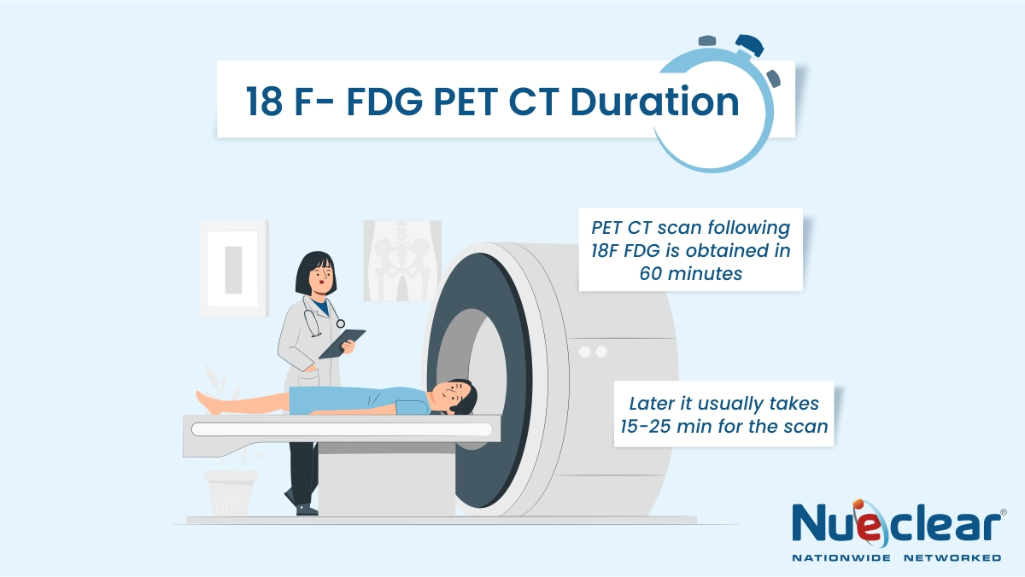

18F-FDG PET is a tomographic imaging technique that uses a radio labeled analog of glucose,18F-FDG, to image relative glucose use rates in various tissues. Because glucose use is increased in many malignancies, 18F-FDG PET is a sensitive method for detecting.

18F-FDG PET and CT are proven diagnostic procedures. Although techniques for registration and fusion of images obtained from separate PET and CT scanners have been available for several years, the readily apparent and documented advantages of having PET and CT in a single device have resulted in the rapid dissemination of this technology in the United States. This Procedure Guideline pertains only to combined PET/CT devices.

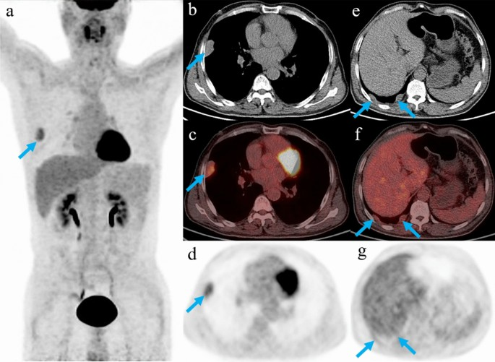
Definitions:
- A PET/CT scanner is an integrated device containing both a CT scanner and a PET scanner with a single patient table and therefore capable of obtaining a CT scan, a PET scan, or both. If a patient does not move between the scans, the reconstructed PET and CT images will be spatially registered.
- PET/CT registration is the process of aligning PET and CT images for the purposes of combined image display (fusion) and image analysis
- PET/CT fusion is the combined display of registered PET and CT image sets.
- Superimposed data typically are displayed with the PET data color coded to the CT data in gray scale.
- PET/CT acquisitions can include the whole body, an extended portion of the body, or a limited portion of the body.

- These acquisitions are defined in Current Procedural Terminology 2005 as follows:
1-Whole-body tumor imaging: from the top of the head through the feet.
2-Skull base–to–midthigh tumor imaging.
3-Limited-area tumor imaging.
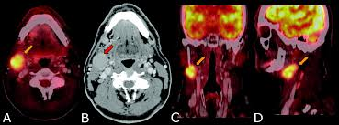
Patient Preparation:
1-Pregnancy and breast-feeding: see the Society of Nuclear Medicine Procedure Guidelines for General Imaging.
2-Before arrival
Patients should be instructed to fast and not consume beverages, except for water, for at least 4–6 h before the administration of 18F-FDG to decrease physiologic glucose levels and to reduce serum insulin levels to near basal levels.

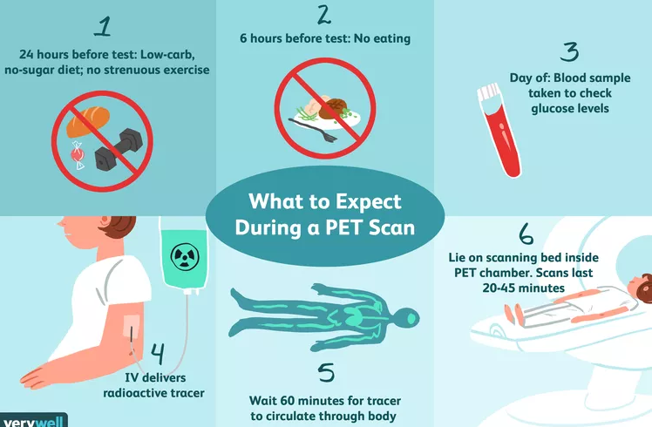
Oral hydration with water is encouraged. Intravenous fluids containing dextrose or parenteral feedings also should be withheld for 4–6 h.
When intravenous contrast material is to be used, patients should be screened for a history of iodinated contrast material allergy, use of metformin for the treatment of diabetes mellitus, and renal disease. Intravenous contrast material should not be administered when the serum creatinine level is above 2.0 mg/dL
Before injection:

- For brain imaging, the patient should be in a quiet and dimly lit room for 18F-FDG administration and the subsequent uptake phase.

- For body imaging, the patient should remain seated or recumbent for 18F-FDG administration and the subsequent uptake phase to avoid muscular uptake.

- The blood glucose level should be checked before 18F-FDG administration. Tumor uptake of 18F-FDG is reduced in hyperglycemic states.

Most institutions reschedule the patient if the blood glucose level is greater than 150–200 mg/dL. Reducing the serum glucose level by administering insulin can be considered, but the administration of 18F-FDG should be delayed after insulin administration (with the duration of the delay being dependent on the type and route of administration of insulin).

- For either a CT scan done for attenuation correction/anatomic localization (AC/AL) or a diagnostic CT scan of the abdomen or pelvis, an intraluminal gastrointestinal contrast agent may be administered to provide adequate visualization of the gastrointestinal tract unless it is medically contraindicated or unnecessary for the clinical indication.
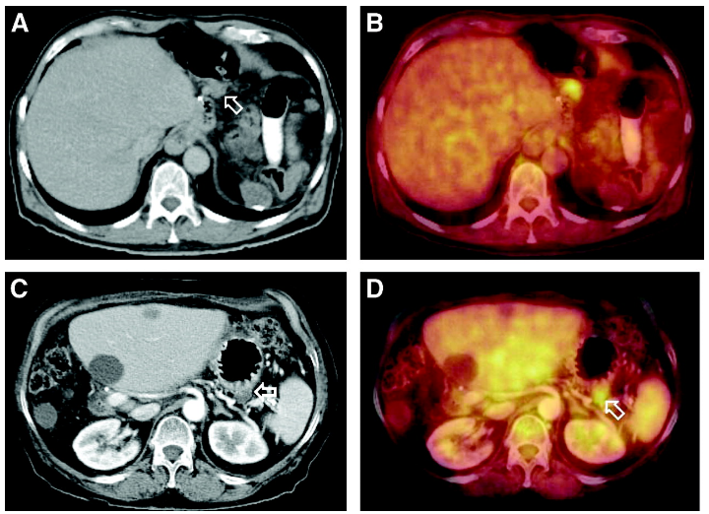
(A and B) On nonenhanced images, differentiation of lymph node from lesion (arrow) within stomach wall was not possible. (C and D) When applying intravenous contrast agents in a different patient, contrast enhancement of stomach wall was clearly distinguished from hypodense lesion adjacent to stomach wall, thus identifying lesion as abdominal lymph node (arrows)

Field of view, positioning, and preacquisition preparation:
A-Skull base–to–proximal thigh imaging generally is recommended to survey the body in the search for areas of abnormal 18F-FDG accumulation for most tumor types. Such PET/CT scans typically are acquired from the external auditory meatus to the midthigh region. For tumors with a high likelihood of scalp, skull, or brain involvement or lower-extremity involvement, whole-body tumor imaging is performed.

B-Limited-area tumor imaging can be considered when critical abnormalities are likely to be localized in a known region of the body (e.g., solitary pulmonary nodule, probable lung cancer, evaluation of hilar lymph node involvement, diagnosis of head and neck cancer, and monitoring of therapy of locally advanced breast cancer). However, performing whole-body tumor imaging offers the advantage of staging the entire body.

C-For optimal imaging of the body, the arms should be elevated over the head if that position can be tolerated by the patient. Arms along the side may produce beam-hardening artifacts over the torso. However, for optimal imaging of the head and neck, the arms should be positioned along the side.

D-The patient should void the bladder before the acquisition of the images to limit the radiation dose to the renal collecting system and bladder. And Metallic objects should be removed from the patient whenever possible.
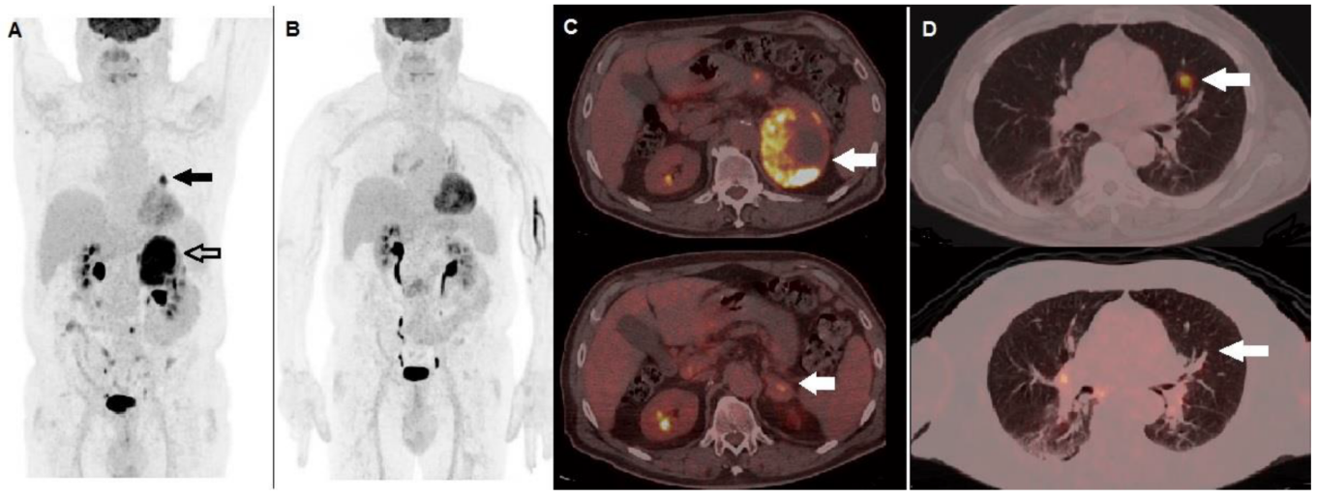
A) MIP image showed areas of increased tracer incorporation in the left lung (black arrow) and adrenal gland (black bordered arrow). (B) performed after 3 months showed metabolic response to therapy. Fused corresponding PET/CT axial of the abdominal region (C) demonstrated almost complete regression of the non-homogenously hypermetabolic lesion in the left adrenal gland when baseline (upper row, arrow) is compared with follow-up PET/CT scan (lower row, arrow). Fused PET/CT axial of the lung (D) demonstrated regression of the hyperactive nodule in the left lung when baseline (upper row, arrow) is compared with follow-up scan (lower row, arrow).
Protocol for PET emission imaging:
- The radiopharmaceutical should be injected at a site contralateral to the site of concern. Emission images should be obtained at least 45 min after radiopharmaceutical injection. The optimal 18F-FDG distribution phase is controversial. Many facilities start the acquisition of the images at 60 or 90 min after 18F-FDG administration. Some facilities obtain a second set of images to assess the change in uptake over time. The 18F-FDG uptake time should be constant whenever possible and certainly when 2 studies are being compared by use of semiquantitative parameters.
- The emission image acquisition time varies from 2 to 5 min or longer per bed position for body imaging and is based on the administered activity, patient body weight, and sensitivity of the PET scanner (as determined largely by detector composition and acquisition method).
Typically, for imaging skull to midthigh, the total acquisition time ranges from 15 to 45 min. The imaging time typically is prolonged for the acquisition of brain images or for images of a limited region of interest.

- Semiquantitative estimation of tumor glucose metabolism by use of the SUV is based on relative lesion radioactivity measured on images corrected for attenuation and normalized for the injected dose and body weight, lean body mass, or body surface area. This measurement is obtained on a static emission image typically acquired more than 45 min after injection. The accuracy of SUV measurements depends on the accuracy of the calibration of the PET scanner, among other factors. The reproducibility of SUV measurements depends on the reproducibility of clinical protocols, for example, dose infiltration, time of imaging after 18F-FDG administration, type of reconstruction algorithms, type of attenuation maps, size of the region of interest, changes in uptake by organs other than the tumor, and methods of analysis.



