The Islamic University College of Medical Technologies Department of Radiology Technologies
First Stage
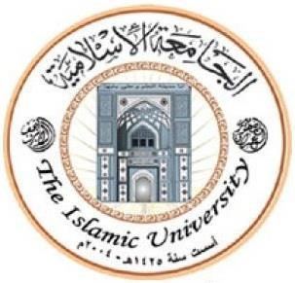
Lecture two: The Upper Limbs
MSC:Tariq Mohammed Alshybany /MSC:Mohammed.K.S.Alquraishi.
MSC:Ali nahed Abdu Alameer



Practical General Anatomy
LAB 2
The Upper Limbs

Themes of the lecture:-

1- Introduction to upper limbs.
2- Pectoral Girdle.
3- Articulations of Clavicle.
4- The upper limb muscles.
5 Triceps brachii.

The purpose of the lecture:-

(Introducing the student to the upper limbs and muscles of upper limbs)

Behavior Objectives:-

1- To know the definition of the upper limbs.
2- In order for the student to learn the details of upper limbs.
3- The student should be able to know scientific names of upper limbs.
4- The student be able to differentiate bones and muscle of upper limbs.
5- The student enumerates all parts of upper limbs and it muscles.

References of the lecture:-

https://books.google.iq/books?id=aK52DwAAQBAJ&printsec=frontcover&dq=general+anatomy+book+pdf&hl=ar&sa=X&redir_esc=y#v=onepage&q&f=false

https://books.google.iq/books?id=6bZEDwAAQBAJ&printsec=frontcover&dq=general+anatomy+book+pdf&hl=ar&sa=X&redir_esc=y#v=onepage&q&f=false

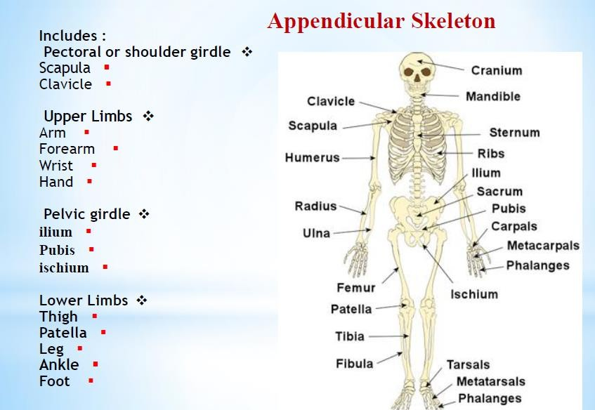

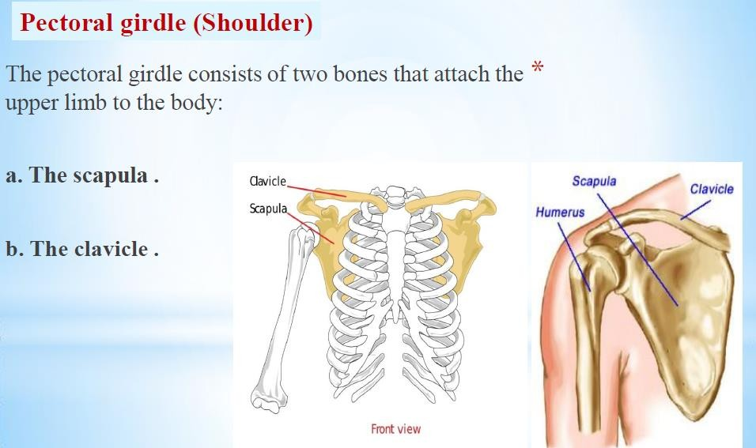

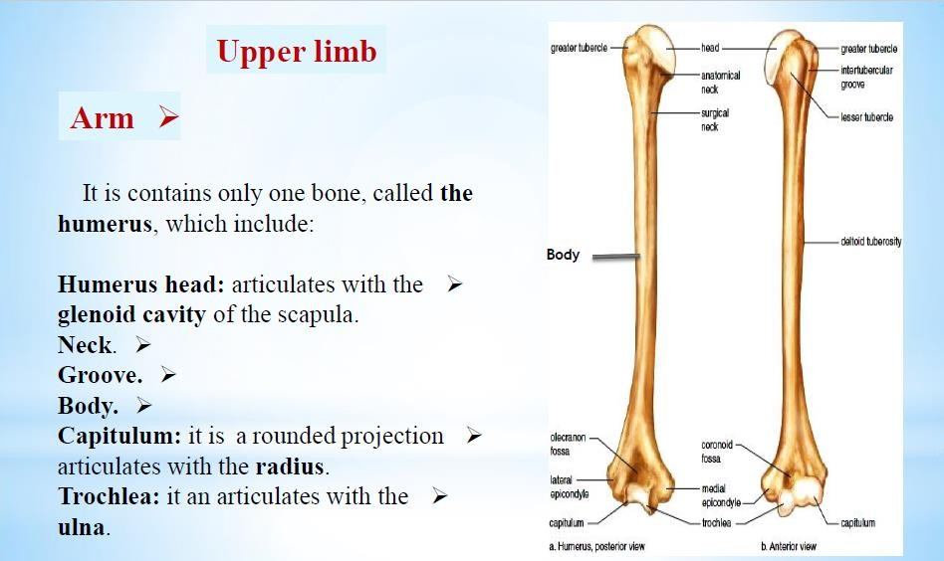

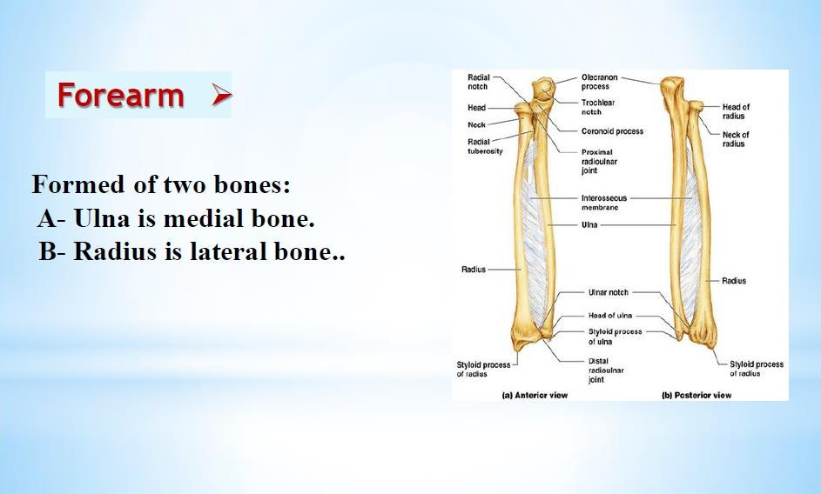

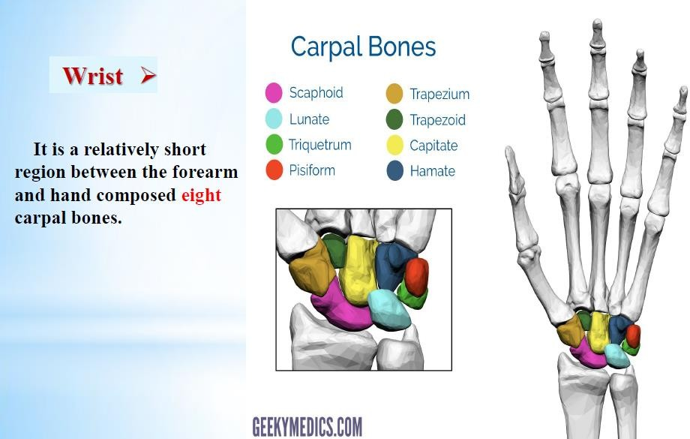

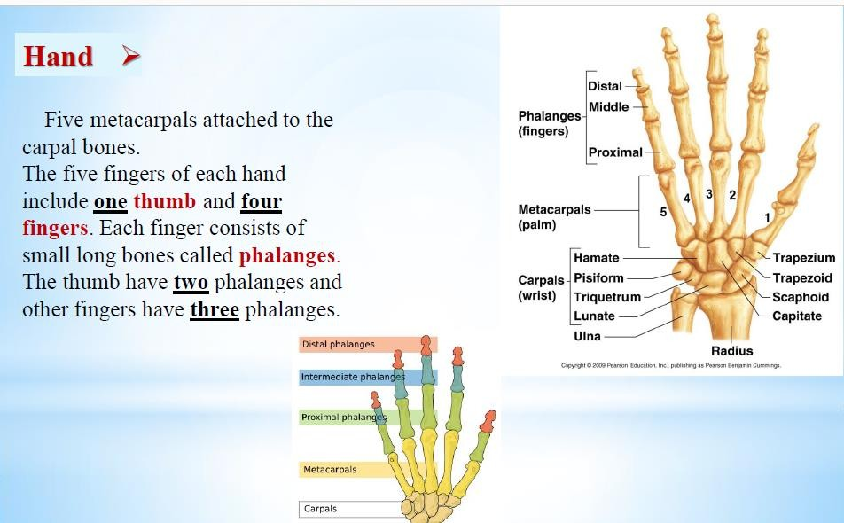

7

