
The Islamic University
College of Medical Technologies
Department of Radiology Technologies
First Stage
Lecture three: Skeleton of lower limbs
MSC:Tariq Mohammed Alshybany. MSC:Mohammed.K.S.Alquraishi.
MSC:Ali Alruaziq.

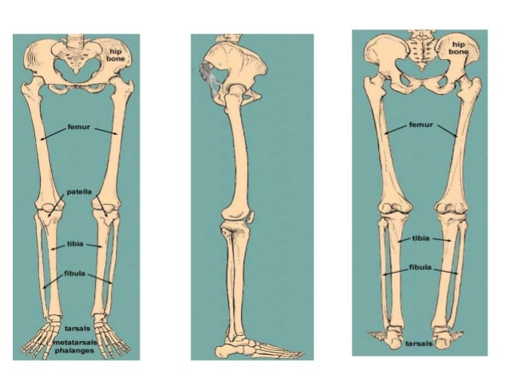

Themes of the lecture:-

Introduction to lower limbs.
Pectoral Girdle.
Bones of lower limbs.
Figures of bones.
The foot.

The purpose of the lecture:-
(Introducing the student to the lower limbs and some details)

Behavior Objectives:-

To know the definition of the lower limbs.
In order for the student to learn the details of lower limbs.
The student should be able to know scientific names of lower limbs.
The student be able to differentiate bones of lower limbs.
The student enumerates all parts of lower limbs.

References of the lecture:-
https://books.google.iq/books?id=aK52DwAAQBAJ&printsec=frontcover&dq=general+anatomy+book+pdf&hl=ar&sa=X&redir_esc=y#v=onepage&q&f=false
https://books.google.iq/books?id=6bZEDwAAQBAJ&printsec=frontcover&dq=general+anatomy+book+pdf&hl=ar&sa=X&redir_esc=y#v=onepage&q&f=false
Lower limb

The primary function of the lower limb is
1- support the weight of the body
2- provide stab in standing , walking and running .etc .
The lower limbs are divided into many regions:

1-Gluteal region . 2-Thigh .
3-Knee. 4-Leg .
5-Ankle joint . 6.foot.

Gluteal region : Which consist from:

1-- Hip bone :
The hip bone is an irregularly shaped bone, also known as the pelvic girdle. It consists of three bones; ilium, ischium and pubis. These three bones are also known as the innominate bones, pelvic bones or coxal bones.
They develop separately from each other and, in children, are connected only by cartilage.
However, they completely fuse during puberty to comprise the hip bone.
-The hip bone has two surfaces (lateral and medial) and is bounded by four margins (anterior, posterior, superior and inferior).
-The lateral surface houses the most prominent landmark of the bone, the acetabulum where the hip bone articulate with the femur and makes the hip joint.
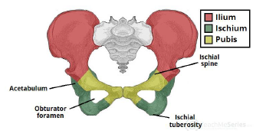

2- Sacral bone :
Which consist from (5) big vertebra connect together which is triangular in shape, its base articulate with the 5th lumber vertebra, and the apex to the down articulate with coccyx.

3-Ilium bone : Its consist from
1-Gluteal surface .
2-Iliac fosse .
3-Sacropelvic surface.
4-Pubis bone .Which consist from body , superior ramus, inferior ramus
5-Obturator foramen : (which is passage of the obturator artery and nerve
6-Ischium bone : Which is the lower part of the pelvic bone , its shape as (v)

Thigh:

Femur bone its strong and long bone ,It has (head ,neck ,greater and lesser trochanter , shaft , lower end ( lateral and medial condyle ). The lower end articulated to knee joint to articulate to patella.

Leg:
1-Patella : triangle in shape.
2-Tibia : Its medial bone consist from upper end (head), shaft , lower end ( medial malleolus).
3-Fibula :Its lateral bone has head , shaft , lower end (lateral malleolus) . Its function to Protect the tibia and in movement the foot outer and inner, between the two bones.


Its consist from.
Tarsal bones , its consist from 7th bones in two rows
1--The posterior row has two bones (Talus and Calcareous )
2-The anterior row has 4 bones (Cuneiform
bone which is medial ,lateral ,intermediate ) +Cuboids bone .
3--The 7 bone is Navicular bone
They consist from 5 metatarsal bones, each has base articulated with the anterior row of the ankle. the 1st is (big toe), the 5th (little toe).

Skeleton of the Toes

They contains of phalanges, its small bone each toe has 3 phalanges except the big toe has two .

